Instructions for changing a user’s password on Windows XP, Windows Vista, and Windows 7

Changing a password on Windows XP
Changing a user's password can only be done on a computer that is part of the network.

- Press Ctrl+Alt+Delete. The Windows Security box will pop up (see Figure 1).
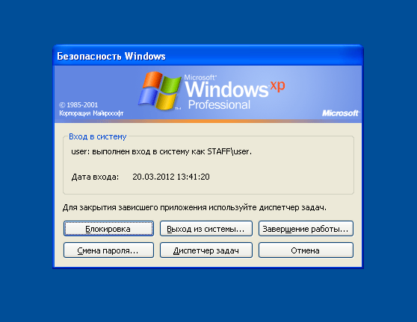
Figure 1
- Click Change Password. The Change Password window will open (see Figure 2).
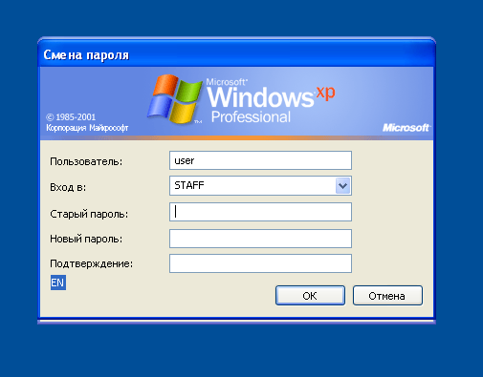
Figure 2
- In this window enter your old password. Then enter a new password and confirm it before clicking OK. The Your password has been changed window will appear (see Figure 3).
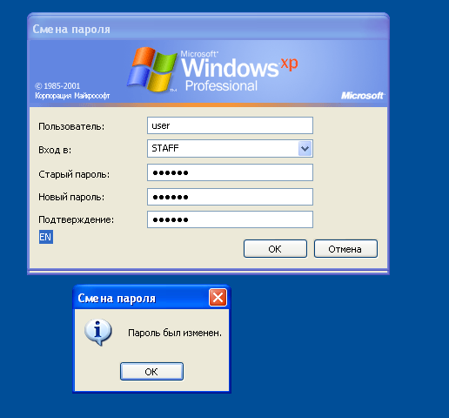
Figure 3
- Click ОK, and the Windows Security window will reappear. Click Log Off (See Figure 4).
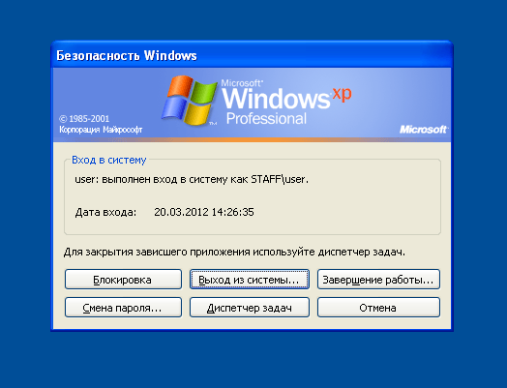

Figure 4
- Confirm that you wish to log out by clicking Log Off (see Figure 5). Then log into the system with your new password.
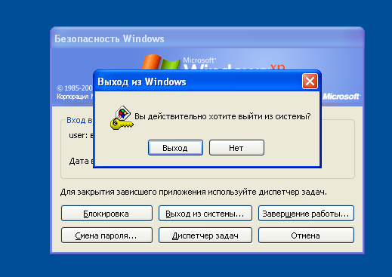
Figure 5

Changing a password on Windows Vista or Windows 7
Changing a user's password can only be done on a computer that is part of the network.

- Press Ctrl+Alt+Delete. The following box will appear (see Figure 6).
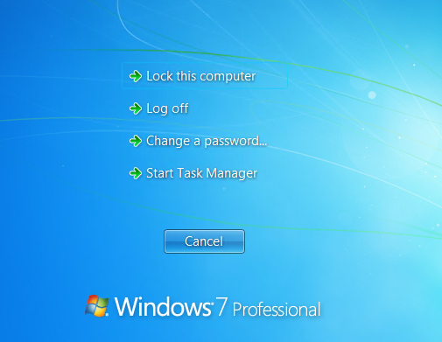
Figure 6
- Click Change a password. The following window will appear (see Figure 7). Select your user name (in this example it is STAFF\user) and click on the icon. The following window will open (see Figure 8).
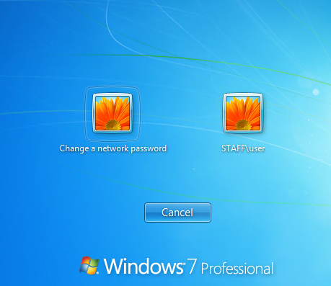
Figure 7
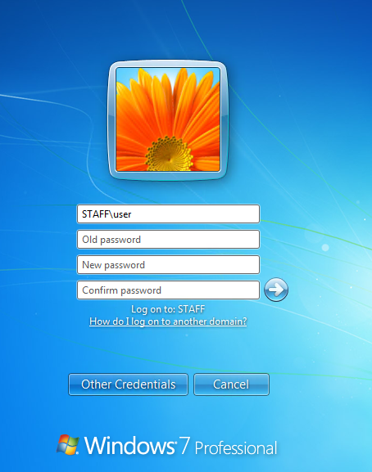
Figure 8
- In this window enter your old password. Then enter a new password and confirm it before clicking the button. The Your password has been changed window will appear (see Figure 9).
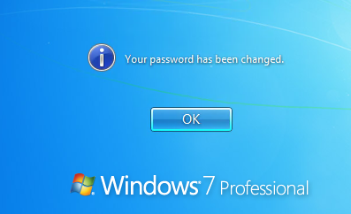
Figure 9

- Click OK.

