Instructions for changing domain/email password through OWA (Outlook Web Access)

How to change the domain (email) password on an account:

- Go to OWA by typing in mail2.hse.ru in your browser. Enter your account information and click the Sign In button.
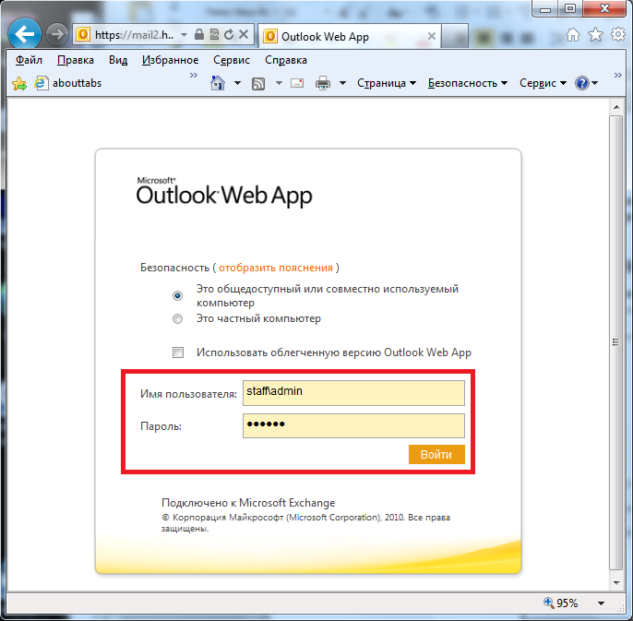

- In the open window, click Settings.

- In the menu that pops up, click Change Password.

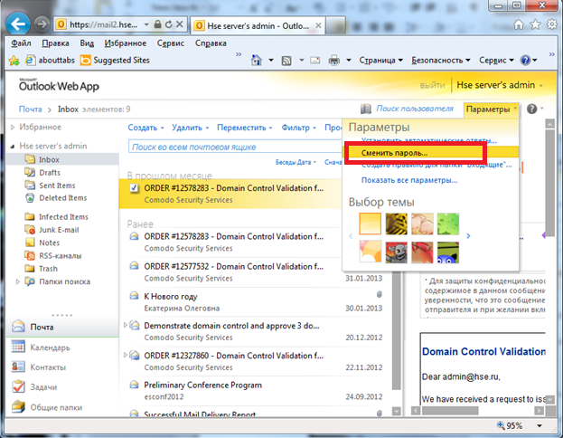

- In the window, enter your current password and your new one and click Save.

