How to enable and use the Personal Archive function:

The Personal Archive function allows you to speed up the work of very large mailboxes (over 12GB).
When this function is on, the archived mailbox will be linked to the main mailbox. All emails over two years old will automatically be moved to the archived mailbox. The user is also able to set additional archive policies independently for saving messages in the main mailbox by using tags:
A) Move elements to the archive older than 180 days (6 months)
B) Move elements to the archive older than 360 days (1 year)
C) Move elements to the archive older than 540 days (1.5 years)
D) Move elements to the archive older than 3 years
E) Move elements to the archive older than 5 years

The Personal Archive can only be used on MS Outlook 2010 and above or on OWA Full Version.
Devices that use Mac OS and IOS do not support this function!!!

- To turn on this function, you must submit a request to Computer Support 2222 with the message: ‘Please activate the Personal Archive function on the main mailbox of user “user login”.’

This request will be answered within three working days. When the request is fulfilled, you will receive an email notification. The day after the request is approved, you will be able to use the Personal Archive function.

- After the Personal Archive function is activated, you will see a new option when logging into your email through OWA or Outlook:
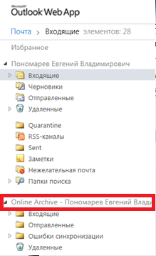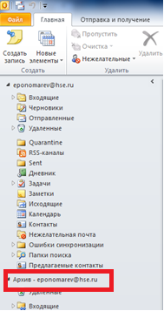
OWA Outlook 2010

To set your own tags:
- In OWA: right click the folder in which you would like emails to be processed individually, and not automatically. In the window that opens, select Archive Policy and then click the desired time for archiving the messages.

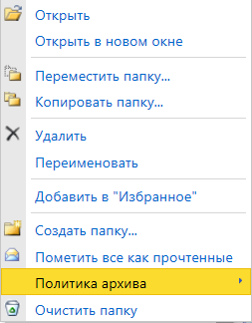
- In Outlook 2010: right click the folder in which you would like emails to be processed individually, and not automatically. In the window that opens, select Properties and then select Policy. On the drop-down menu, select the desired archive time for messages.

