Instructions for configuring your Apple iPhone's email client for HSE's server

In order to configure your built-in email programme to work with HSE’s email server, you must first change the programme’s settings.

- Open Settings on the home screen:
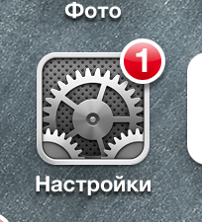

2. Select Mail, Contacts, Calendars:

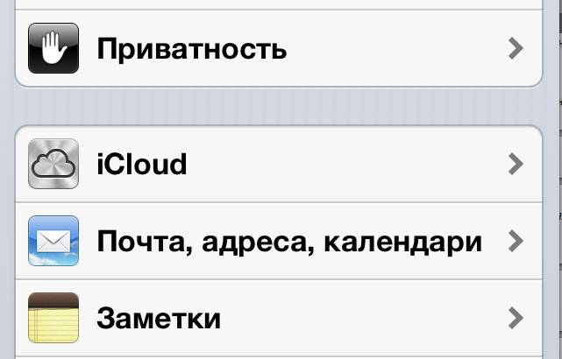
- If you did not previously set up an email account on your iPhone, you will see a list of the most popular email services, including Microsoft Exchange:
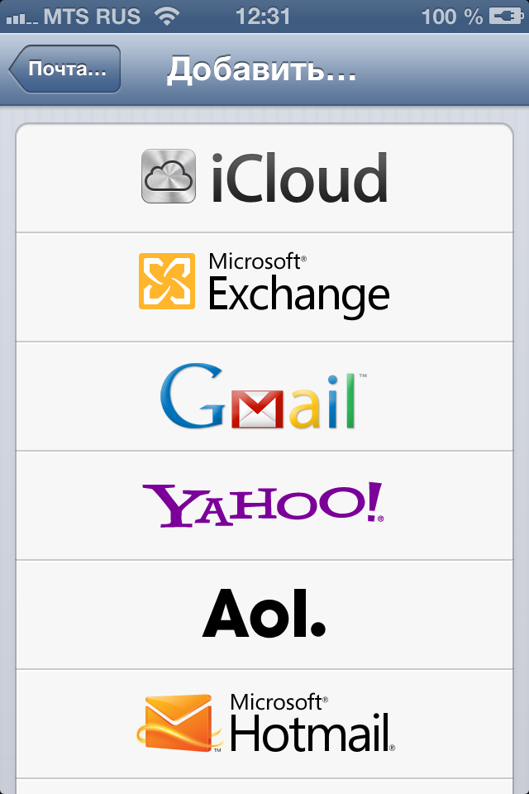
If you did in fact set up an email account, after selecting Mail, Contacts, Calendars, you will see your previous accounts, options for changing email settings and an option called Add Account:
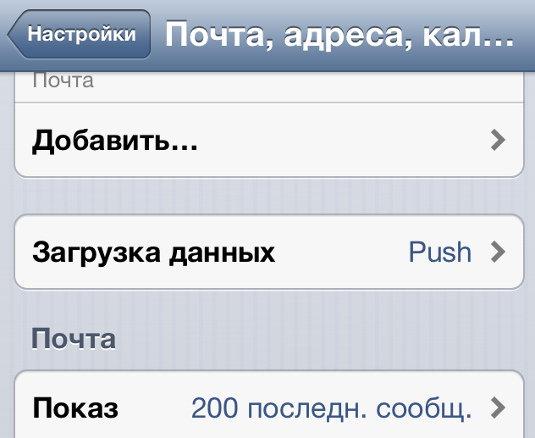
After selecting this, the list showed previously will appear. Select Microsoft Exchange.

- Complete the form by adding your account information:
- Email address: your login@hse.ru
- Password
- Description – any arbitrary name that is convenient for you and will be used as the name of the mailbox in the list of the iPhone's email accounts: 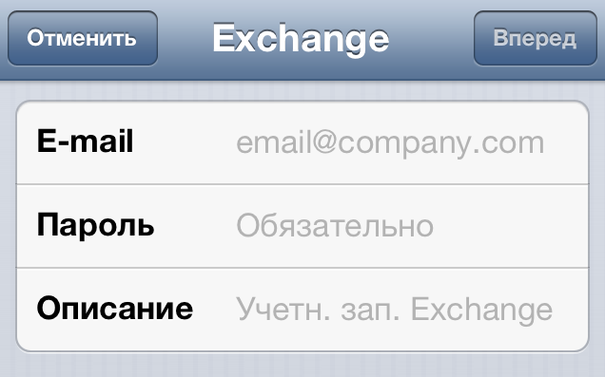
Click Next and an account profile will be preliminarily created. You will be asked to enter account information and the email server.

- The window will look like this:
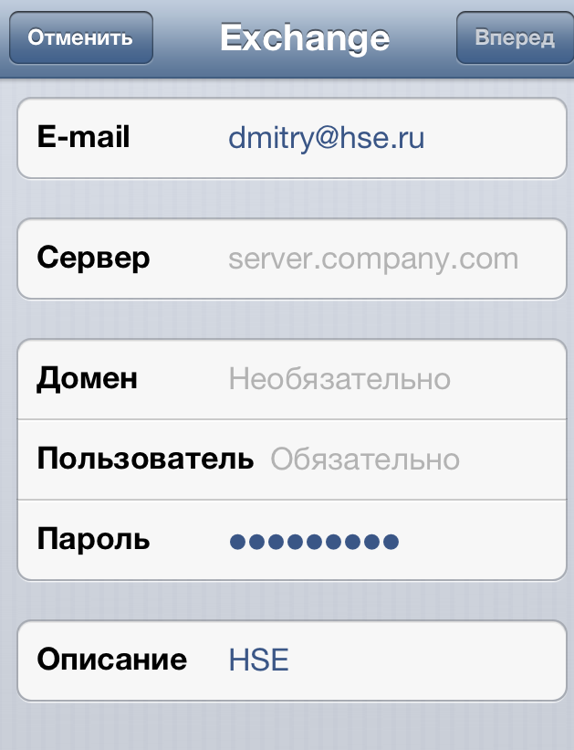

- In the section labelled Server, enter: mail2.hse.ru
- Domain: staff
- Under User enter your login (without @hse.ru)
- Then click Next.

Your telephone will attempt to connect to the email server using the account information and email server address that you entered. If successful, checkmarks will automatically appear next to all sections of this list.

- You will then be asked to select which data you would like to receive and synch between your iPhone and the HSE's email server: email, calendar notes, contacts, and reminders.

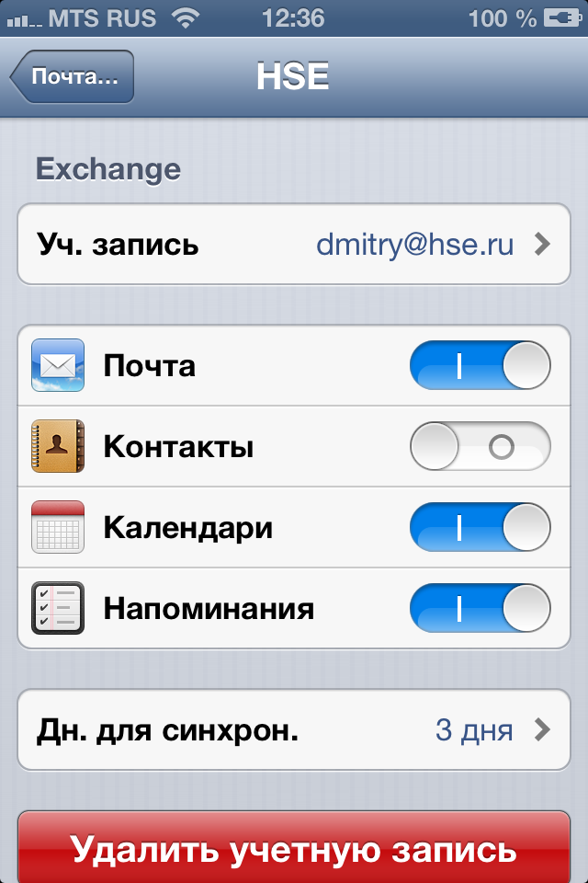

After selecting the necessary options for synching data, the settings will close and the telephone will begin synching data.

If the account information check is not successful and an error message appears, check that there is 3G/Wi-Fi connection (this does not have to be HSE's Wi-Fi network) and be sure that the SSL User option is on in the email profile settings.

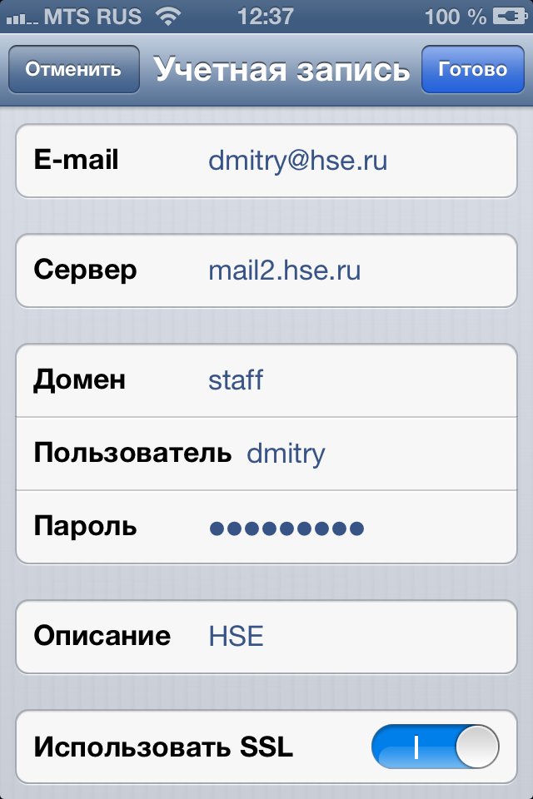

This can be done – despite the error message – if you agree to save the email profile settings by clicking Save in the upper right-hand corner of the screen, go to Mail, Contacts, Calendars, select the account from the list and then go to the Account sections, as shown below:

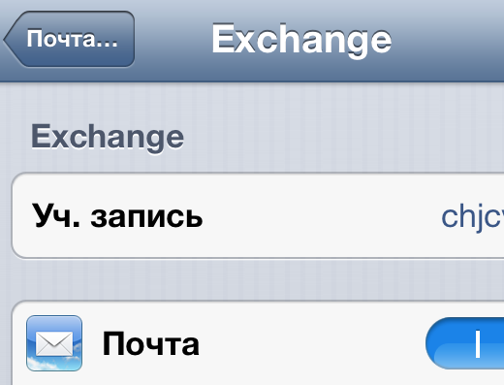
In this section, changes can be made to account data, and by clicking Done, you can try to connect to HSE's service again.

Note: you cannot connect to HSE's corporate email on Apple devices with iOS 6.1 or 6.1.1.

