E. W. Blount
Executive Director
Center for the Study of Financial Market Evolution,
and The ASTEC Consulting Group, New York
e-mail: edblount@csfme.org
website: http://www.csfme.org

The Impact of Short Sales and Securities Lending
on Capital Market Portfolios - 1990 through 2006*
* This paper has been prepared for the World Bank – International Monetary Fund Conference to be hosted by the State University, Higher School of Economics, Moscow, Russia in April 2007. This paper is not designed to make policy recommendations. Its main purpose is to serve as background material for the author’s presentation at the State University, World Bank – IMF conference.

A variety of legislative, regulatory, technological, clearing and market arrangements currently hobble the evolution of a market-based securities lending community by domestic Russian investors. As a result, domestic securities traders are unable to create efficient short positions, either for the kind of dynamic hedging strategies that are needed to service the growth of domestic institutions or for the kind of program-based proprietary strategies which support liquidity in domestic markets. Since foreign counterparts can short essentially the same Russian securities when listed on European, Asian and American exchanges or traded over-the-counter as depositary receipts in global markets, the Russian capital markets are losing an important part of their competitiveness to foreigners. While it may be true that domestic traders can substitute a repurchase agreement (repo) for the securities loan needed to cover a short position, the additional costs create transaction inefficiencies relative to world standards. In this paper, we demonstrate that major developed markets, particularly American equity markets, owe much of their vitality to the contributions of short sellers and their enabling securities lenders. Along with examples from American markets, we use Yukos and VimpelCom, two examples of globally-traded Russian securities, to demonstrate the beneficial effect on liquidity and pricing that has resulted from short/lending-enabled global trading strategies affecting these stocks.

Short Selling
Historically, analysts have disagreed sharply on whether short sellers helped or hurt investors’ portfolio values. Today, those differences are even more contentious -- while the evidence has become much more complex. Since 1990, changes in levels of aggregate U.S. short sales often followed major market movements. For that reason, we argue that many short sales were more likely to have been the effect, rather than the cause of price changes.
Many short sellers were actually brokers to large institutional investors and hedge funds, hedging market risks or rebalancing portfolios and that the chain reactions created by these transactions could have offset any negative impact on stock prices for the portfolios of well-diversified, long-term investors. In addition to the benefits to traders, improved information on the nature of short selling in domestic capital markets may give market regulators a chance to direct these powerful market forces for benevolent purposes.

Securities Lending
While there are opposing views of the merits of short selling in the functioning of the market mechanism, there is generally little debate about the value of securities lending in capital markets, especially its association with pricing efficiency and liquidity.
Today, securities lending is an integral component of nearly all active securities markets, both domestic and international.

The growth of securities lending is attributable in large measure to the positive effects securities lending has had on both investment activity and securities settlement arrangements. These benefits should continue to promote the development of liquid securities markets.
“Securities Lending Transactions,” Bank for International Settlements, Basel, Switzerland, June 1999

Do Short Sales Depress Values?
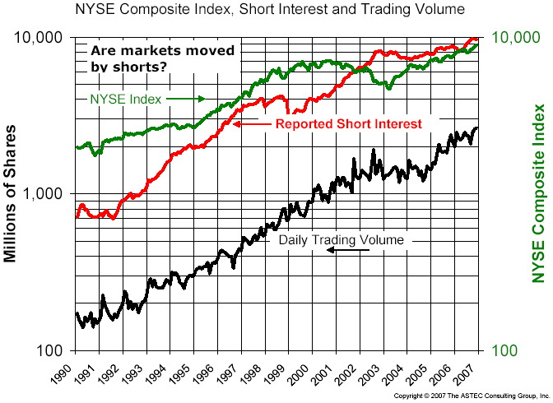
Short sales do not depress markets. Generally, fundamental short-sellers are in position before the markets move, then close out and cushion the markets’ downward price corrections, while technical shorts tend to create supportive, neutral liquidity at all times. To illustrate, market-wide moves in U.S. and Japanese equities during the 1990’s and 2000’s often operated independently of changes in the pressure from short selling, as measured by short interest.
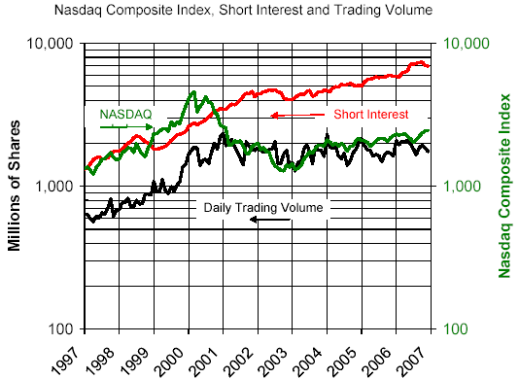
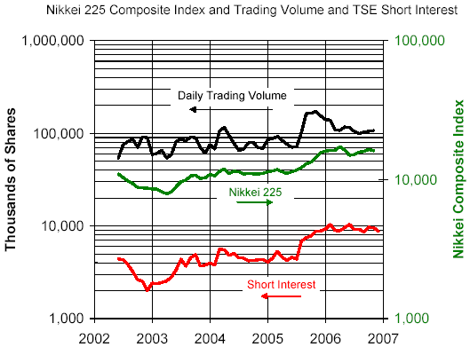
This may well have been due at least partly to the neutralizing effect of the long sides in the paired long-short trades that comprise market neutral strategies. Any deflating effect of short sales in one part of an investor’s portfolio would tend to be offset in another by the inflating effect of the traders’ paired long positions.

Short Sales drove Market Volumes, not Values.
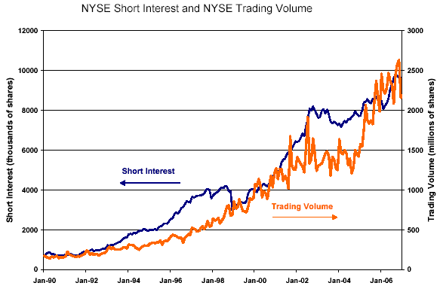
In the U.S equity markets, securities loans are made primarily to that category of short seller whose trades routinely add liquidity to markets.
The correlation between short sales and trading volume for the NYSE was .94 between 1990 and 1998 and .84 between 2003 and 2006. New loan volume and trading volume was positively correlated (.24) between January 2003 and December 2006.

Lending Volume also correlated with Trading Volume
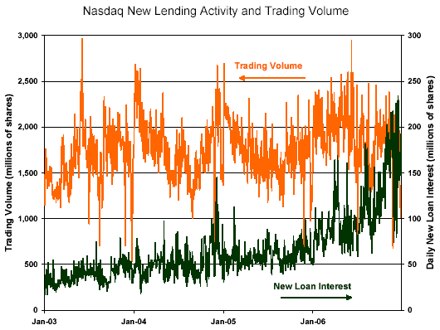

Securities Lending Helps Reduce Share Price Volatility

The operations of lenders and short sellers worked to dampen equity market volatility. The level of securities lending new loan volume was negatively correlated (-.31) with share price volatility for the Nasdaq Composite. Lenders appear to have been providing securities mainly to short sellers who were acting as counter-balancing traders, thus dampening volatility. This stability-inducing force would have been a positive benefit at any time of great uncertainty in the market system. But, in the days following September 11, 2001, those benefits, and others, were invaluable, as shown in an earlier version of this paper.

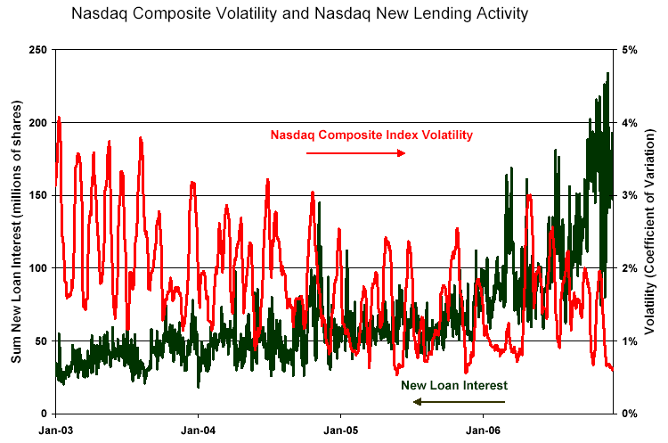

Did Sell Programs Act to Cap the Market’s Top?
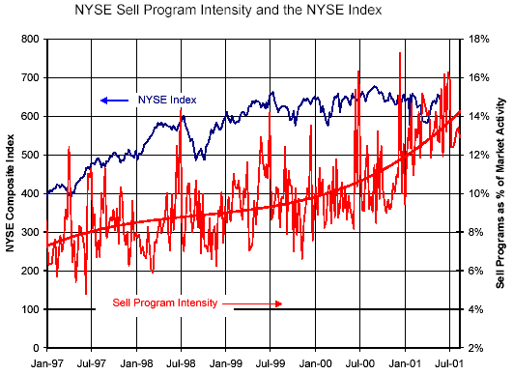

Since sell programs generate short sales, a critic might suppose that periods of greater sell program intensity would have closer correlations to falling market values. Indeed, the -49.7% correlation (3Q97 to 1Q98), seems to support a contention that short sales in program trades hurt market values. Yet, during a similar nine-month period 4Q98 to 2Q99), the index-intensity correlation became positive, at +43.3%. Although this activity period tended to restrain the upward trajectory of market prices, perhaps even using the effect of the correction twelve months later, there has been no overarching believed or lack between short interest in share prices during the last 15 years in US markets.

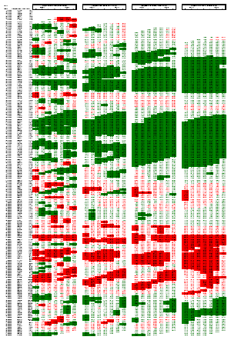
NYSE Lead and Lag Correlations – Composite Index Share Price and Short Interest (1990 through 2006)

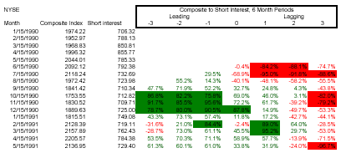
Share prices and short interest on the NYSE moved up and down in the 1990’s as positively linked forces. This trend reversed in October 2000 when share prices and short interest were more negatively correlated. However, as the overall US equity market declined, many borrowers took out short positions to hedge their long positions. Short interest and share prices were negatively correlated regardless of whether short interest was a leading or lagging indicator. Shorts have not driven down share prices. From June 2004 through the present, short interest and share prices have demonstrated positive correlation.

Russian securities were supported by global short-sellers

Global investors are very active in borrowing shares of major Russian securities firms, particularly those of Yukos and VimpelCom, in order to create short positions. Many outsiders might automatically assume that short sales would tend to depress the prices of these two Russian companies and translate negatively into the Russian domestic markets. In fact, by using a proprietary database of global securities loan activity, precisely the opposite can be shown to have happened.
Just as was evident for American securities in American markets, many global short-sellers created market liquidity for Russian securities and contributed to price cushioning when market prices turned downward. In all likelihood, the arbitrage effect of this activity also translated its beneficial impact to the Russian domestic markets. Equally likely, a similar cushioning in the domestic markets could have taken place directly, if the Russian markets enabled the borrowing and shorting of domestic Russian securities, not just for these two issues, but also for many other liquid Russian securities issues.

Yukos Oil Company (YUKOY)
At one time, Yukos was the largest Russian oil company and one of the 10 largest energy companies in the world. The company's share price declined dramatically after the chairman was arrested on tax fraud and embezzlement charges on October 25, 2003. From January 2004 through January 2007, the share price and lending volume of Yukos moved together with fairly high correlation (.60). For most of the past 3 years, lending activity acted as a cushion for declining share prices as borrowers returned large loan positions and provided price support.

Vimpel Communications
VimpelCom, headquartered in Moscow and founded in 1992, offers mobile telecommunications services, wireless handsets and accessories to over 50 million subscribers in Russia, Kazakhstan, Ukraine, Tajikistan, and Uzbekistan. In 1996, VimpelCom became the first Russian company to list its shares on the New York Stock Exchange. Lending activity and share prices for VimpelCom were not closely correlated over the past 3 years (.07). However, borrowers provided price support at certain times, by covering their shorts with newly-purchased shares.

Yukos Oil Company
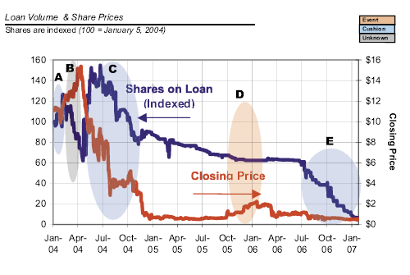
A. On January 28, 2004, share prices hit a low of 9.90 (down 10.77% from a week earlier). This fall in share price was cushioned by a decrease of 13.2% in loan interest over the same period.
B. Borrowers closed out their short positions by returning loans, which provided important price support. Loan interest declined 44%, while stock prices rose 33%.
- Another example of cushioning occurred between May 20 and August 23, 2004. Stock prices fell by 49.12% while borrowers returned 34% of their outstanding loans. The fall in share price was linked to the July 2004 controversy over Yukos’ $3.4 billion tax bill, which resulted in the seizure and sale of 60% of Yukos oil producing assets as payment. The price support from borrowers comparing their shorts help the stock price to stabilize at $4 per share.
D. Stock prices rose 48% and loan interest remained steady, as investors reacted positively to news showing that Yukos’ Siberian oilfields were three times more valuable than previously thought.
E. From July 2006 to January 2007, share prices fell 57.40%. A huge drop in loan interest (down 89.57%) helped cushion this fall. Prices would likely have fallen even lower, if borrowers had not provided price support by covering their short positions. On August 2, 2006, Yukos declared bankruptcy.
Vimpel Communications
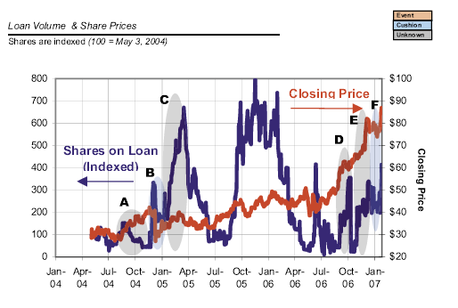
A. As share prices rose in September 2004, borrowers became eager to close out their short positions. By November, with prices up 25% since early September, more than half of loans on the books in September were returned. In buying back shares, borrowers provided pricing support.
B. As market prices hit $42, borrowers turned bearish. Over 10 days, loan volume rose fivefold. Soon after, prices fell sharply. So did loan volume as borrowers, eager to take their profits, began to return their loans. Their buy-ins again cushioned falling prices.
- In January 2005, loan volume began a two and a half-month climb. By mid-March, loan interest tripled while prices rose only 2.5%. As soon as prices started to fall, borrowers began to cover their positions. By late June, with prices remaining fairly steady, loan interest fell steeply from the mid-March peak.
- Share prices rose by more than 5%, following an announced 23% increase in second-quarter profits. Simultaneously, loan interest surged as skeptical short-sellers reacted to potential overenthusiasm.
- Good news abounded in November 2006, with 38% increase in third-quarter profits and board approval to acquire 90% of CJSC Armenia Telephone Company. Share prices rose from $64.75 to $82.05 in December, while lending activity stayed fairly constant.
F. Borrowers hesitantly closed out positions in the beginning of December 2006. Loan interest declined by about 10% and stock prices fell back by 3.7%, suggesting that short sellers had partly cushioned the fall, but were still waiting for further news.
Conclusion

For investors holding capital market portfolios, that is, investments widely diversified across a range of international and domestic securities, the activities of short-sellers tend to provide market liquidity and pricing support. Often, the liquidity is contributed by technical short-sellers whenever sufficient volatility exists to create arbitrage opportunities and the pricing support follows actions by fundamental short-sellers to close out previously-established positions by purchasing shares on the open market and returning borrowed positions to lenders. These benefits can be shown to operate in regulated markets across broad time frames, as well as in over-the-counter markets during relatively short intervals.

To the extent that participants and regulators of evolving capital markets, particularly the Russian markets, wish to retain sufficient liquidity and stability in their domestic markets, especially for their most attractive issues, the development of an efficient securities lending community is a necessary ingredient to support those domestic short-selling activities which are, in turn, a necessary ingredient in the maintenance of a domestic derivatives market, which is a necessary facility for implementing the hedging activities of domestic dealers and institutional investors alike.

Acknowledgments

The nonprofit Center for the Study of Financial Market Evolution in New York was founded in 2006 to provide capital markets research assistance to institutions, academics and news media, as well as to participants and regulators of transitional and emerging economies.
The data used for market level analytics in this study was provided under subscription from the New York Stock Exchange, NASDAQ, and other market exchange operators, subject to their copyright protections.
The ASTEC Consulting Group of New York, London and Zürich provided pro bono access to their proprietary stock loan database of 90,000 issues and 500 million transactions for correlations of loan interest, particularly with respect to Yukos and VimpelCom.
Grateful acknowledgment is made to J.P. Morgan Chase Bank for funding and data support, as well as to three talented research associates: Robert Daigle, Aaron Gerdeman, and Andrew Shinn. Any errors are solely the responsibility of the author.

Copyright © 2007 by E. W. Blount, CSFME;
Copyright © 2000, 2002 by ASTEC Consulting Group
and J.P. Morgan Chase Bank

