Into the Wild
The Economic Crisis and
the Politics of Labour Market Stimulation:
The Canadian Case

Leslie A. Pal
(leslie_pal@carleton.ca )
Chancellor’s Professor of Public Policy and Administration
School of Public Policy and Administration
Carleton University
Ottawa, Ontario K1S 5B6
Canada

Abstract
The financial crisis of 2008 induced several different policy responses from governments, from new financial regulations to deal with the banking sector to stimulus programs to encourage economic activity and preserve jobs. In the course of those interventions, many governments have racked up enormous and unprecedented deficits (e.g., USD1.6 trillion in the United States; the possibilities of defaults or bailouts for Greece, Portugal, Spain, Italy and Ireland).
This paper will examine the Canadian experience since December 2008 to the most recent federal budget (March 2010). The Canadian experience is interesting from several perspectives. First, Canada weathered the financial crisis better than most countries because its banking system was better regulated. Second, Canadian responses to the crisis had to be coordinated with its largest trading partner, the United States, with which it shares the North American auto industry. Third, it rolled out a stimulus package and recovery plan very quickly with specific characteristics – primarily labour market stimulation rather than longer term economic restructuring. The paper will focus on the federal government’s “Economic Action Plan” – the stimulus package launched in 2009, as well as the plan to move to fiscal balance that the overall plan entailed (some CAN50 billion). Interestingly, the government was not initially either prepared for a large stimulus package, nor – as a Conservative government -- especially enthusiastic. Ironically, it was the opposition parties that forced its hand, but once forced the government realized the political advantages of spending stimulus money from coast to coast. The focus was on short-term stimulus, primarily for the labour market, and not economic restructuring, massive bail-outs (except for the automotive industry, following the US example), or effective nationalization of the financial sector. The paper will examine the administrative mechanisms that were used to deliver the program, as well as the way in which it gradually became politicized. The crisis forced a Conservative government to at first spend reluctantly, but then with growing enthusiasm as it realized that this labour market stimulus could work to its advantage. The open question is whether it will be possible to get out of deficit in the next five years, or whether the federal government now has a structural deficit.

Fiscal and Political Crisis, Fall 2008
Like most Western countries, Canada was caught unawares by the financial crisis that had been building through 2008. There were warning signs, of course, enough to indicate that some sort of recession might be on the horizon, and so the minority Conservative government headed by Stephen Harper decided to call an election in September for October 14, 2008. In addition, the opposition parties seemed weak (especially the leader of the official opposition, Stéphane Dion of the Liberals). The election call was nakedly partisan – legislation spear-headed by the government the year before had called for fixed election dates, but the Prime Minister asked the Governor-General to dissolve the House of Commons one year earlier than the scheduled date in 2009. Any hopes the Conservatives had of leveraging this advantage into a majority government faded as the campaign went along, and the result was yet another minority government, with the Conservatives gaining 19 seats over their 2006 performance, but still short of a majority in the 308 seat legislature.
The global (and US) financial crisis blew up in the middle of the campaign. The Emergency Economic Stabilization Act providing for USD700 billion in bailouts to the American financial system was debated in September and passed in early October, before Canadians voted. Harper was attacked by the opposition parties and challenged to articulate an economic strategy that would avoid the same meltdown in Canada. The government’s responses were weak – essentially that Canada had enjoyed fiscal surpluses for a decade (even though they had been declining), that it’s housing market had not bubbled and burst like the US one, and that its banks were more stable and better regulated. Somewhat remarkably, while US legislators were frantically working south of the border to stave off the worst financial crisis in a generation, the Canadian election only trained momentary attention on the economy, and was preoccupied with a host of other issues from carbon tax, to political scandals, to the war in Afghanistan.
After the election, the normal timing of parliamentary business called for a Speech from the Throne (SFT - to set the new government’s agenda) and an economic update that would precede the budget in February or March. Both these documents show how little the economic crisis or any sort of labour-market stimulus package figured in the government’s thinking. The November 19, 2008 SFT, for example, was nine pages long (not unusually long for a Canadian SFT, but much, much shorter than the one that was to follow in January 2009). The first mention of the economic crisis was on the second page, and largely self-congratulatory (it should be noted that the achievements cited in this paragraph were in large part due to the previous, Liberal, government):
In this time of global economic instability, we can be reassured that the hard work of millions of Canadians has laid a solid foundation for our country. We have pursued policies different from those of many of our trading partners. We have paid down debt and kept spending under control. We have set public pensions on a sound footing and refinanced important programs such as health care and post-secondary education. Our banks are among the strongest and best regulated in the world. Canadian households and businesses have been prudent and avoided taking on the excessive debt witnessed elsewhere.
Several vague promises were articulated. First, that Canada would work with international partners to deal with the global financial crisis. Second, that it would work specifically on reform of the global financial system, encouraging greater liquidity under the umbrella of stronger regulation of financial institutions. Second, while there was a hint that balanced budgets might not be prudent in the short-term, the tone was certainly one of fiscal rigour, “microscopic” review of all departmental spending, and carefully chosen and targeted “new measures to support the economy.” Third, there were labour market measures, but more in the way of “boutique” programming than any attempt at a strategic stimulus package. The measures would include:
- Continued support for student financing and apprenticeships, coupled with better efforts to recognize immigrants’ credentials.
- Encouraging better labour market participation by Canadian Aboriginals.
- Targeted help for workers in transition.
- Measures to encourage businesses to invest in machinery.
- Support for fisheries, mining, agriculture and forestry.
- Expanding existing programs (e.g., Building Canada) for infrastructure development.
- Encouraging trade.
- Reviewing government spending, procurement, regulation.
There were also promises about dealing with clean energy, climate change, crime, and institutional reform in the election of the upper chamber. SFT are typically quite general, but the fact that more than half of it dealt with “non-economic” matters, and that that portion that did hardly touched on job creation, stimulus, or dealing with major economic downturn, shows the government’s state of mind: it was not focused on the crisis nor on stimulus. This was corroborated with the Economic Update that was tabled on November 27, 2008. It acknowledged that while Canada had done better than most advanced industrial countries in weathering the financial storm to date, it was likely to experience a “technical recession” in the coming year. The policy suite would focus on bolstering “Canada’s solid fundamentals” and “reinforce the stability of our financial system.” Careful financial controls would be maintained, and the “Government continues to plan on balanced budgets over this and the next five years. However, given the volatility of the economic situation and the rapid decline in commodity prices, a deficit cannot be ruled out.”
The details of the Economic Update are unnecessary – it had a coherent narrative however. First, it acknowledged the downturn, the effects of the US recession on commodity prices and Canadian trade, the sector-specific impact (e.g., forestry), and some of the weaknesses in Canadian credit markets and the housing sector. But second, it persistently pointed out, in the same breath, that the Canadian version of the downturn was comparatively mild compared to other countries. Third, it highlighted previous programs such as the Community Development Trust (announced in January 2008 to provide CAN1 billion to the provinces to help resource industries hard-hit by the recession with retraining and retooling), and the Automotive Innovation Fund (providing CAN250 million over five years for research into greener, more efficient vehicles). In short, it celebrated Canada’s record and previous policies, and laid out only modest policy responses – none of which entailed strong labour market stimulus. The summary of measures was:
This Economic and Fiscal Statement announces a number of steps to protect Canada’s fiscal position and the ongoing stability of the financial system in Canada.

- Important, measured action is being taken to ensure the effectiveness and reduce the cost of government operations.
- The Government is introducing legislation that will ensure sustainable federal public sector wage rates for four years.
- Equalization is being put on a sustainable growth path. The Canada Health Transfer and the Canada Social Transfer will remain unchanged and continue to grow as before.
- Actions are being proposed that will enable the Government to meet its Group of Twenty (G20) responsibilities to ensure financial sector stability.
- Measures are being proposed to provide temporary relief to seniors with Registered Retirement Income Funds and to private pension plans affected by the global financial turmoil.
While the Update acknowledged that deficits might occur, it pledged that these would be temporary, and moreover that it was aiming for five consecutive years of continued surplus, based in large part on a combination of prudent spending (through a new expenditure management regime) and targeted cuts. The projected surpluses were razor-thin however: CAN.1 billion (2009-2010 and 2010-2011), CAN1.1 billion (2011-2012), and CAN4.2 billion (2012-2013).
Buried almost literally in the middle of the Update – page 51 of 127 – were 60 words that that almost brought down the government.
Political parties now receive taxpayer support in three ways: (a) tax credit for contributions to political parties; (b) the reimbursement of eligible election expenses; and (c) a quarterly subsidy based on votes cast. In keeping with the focus on spending management, the quarterly subsidy that benefits political parties is no longer justifiable. The Government will eliminate this subsidy as of April 1, 2009.
Embedded in a section on making government more effective, this provision would have saved the fisc some CAN30 million per year, but had the potential to cripple the opposition parties. Canada’s election rules provide a subsidy of CAN1.95 per vote for a federal political party if it wins at least 2 per cent of the national vote. Canadian federal political parties can raise funds from individuals, and the Conservatives have a much more efficient machine than their competitors. By cutting off public funding, the government would have cut off as much as 63 per cent of Liberal funding, and 86 per cent of the Bloc Québécois (ironically, the separatist party that runs only in Quebec). The opposition parties were enraged as well as frightened, and on December 1, 2008 they announced that they were prepared to work together as a coalition government and that they would vote non-confidence in the Harper Conservatives in one week. The Prime Minister, in a tense, private and lengthy conversation with the Governor-General, succeeded in persuading her to prorogue Parliament (i.e., suspend the legislature, purge pending legislation, but not dissolve it and require an election) until January 26, 2009.

The Politics of Labour Market Stimulation: Canada’s Economic Action Plan
The threat of a coalition government was a near-death experience for the Conservatives. Despite having come close to a majority government, they had almost squandered the victory in a petty political maneuver. Just as important, however, had been the relative complacency of the Economic Update. Iceland, for example, was teetering on the edge of national bankruptcy, and through November and December the American administration under the new President-elect Obama was frantically trying to stick fingers into a crumbling financial dike. The good news was that the Canadian version of the crisis was not financial, and indeed some of the self-congratulation of the government was warranted – low national debt levels, reasonably low private debt, low unemployment, and a financial sector that seemed stable and did not require bailouts. However, the opposition kept hammering at the importance of stimulus, and the impending and building recession. They demanded that the Canadian government do something dramatic to deal with the sagging economy, and since the financial sector was reasonably healthy, the main damage was going to be in the labour market, with sagging job numbers due to the US recession (80 per cent of Canadian exports go to the US).
The government got the message. It tabled a SFT on January 26, 2009 that was dramatically different from the one it had issued only two months before. In terms of text, this SFT was only three and half pages long. The first page had two stark paragraphs that set a completely different tone from November 2008:
In these uncertain times, when the world is threatened by a struggling economy, it is imperative that we work together, that we stand beside one another and that we strive for greater solidarity. …
Today we meet at a time of unprecedented economic uncertainty. The global credit crunch has dragged the world economy into a crisis whose pull we cannot escape. The nations of the world are grappling with challenges that Canada can address but not avoid.
The global financial crisis had deepened since the last election, and indeed since the last SFT. This time, the SFT highlighted the issue of jobs, and referred specifically to a new “economic stimulus plan” that would be announced the next day. In addition to measures that had already been introduced in early 2008 and “re-announced” in the Economic Update in November 2008, the government now said that it would stimulate the economy, invest in infrastructure, and support key industries and the jobs dependent on them. The sombre tone of the opening paragraphs were echoed now in a statement that Canada might face several difficult years, though the stimulus would be directed to long-term growth and avoid “permanent” deficits.
This was a dramatic reversal from the government’s policy stance only two months earlier. Clearly, the accelerating crisis in the United States (particularly around the automotive industry – GM and Chrysler received USD17.5 billion in December 2008) had captured the Canadian government’s attention. By March 2009 the Obama administration had all but nationalized the US industry (with the exception of Ford). Canada’s automotive industry, along with forestry, mining, and most other exports, depend heavily on US markets, so the fact of recession had now replaced the perception two months earlier. However, the political momentum had changed dramatically as well. The Harper Conservatives had enjoyed the balanced budget situation created by the Liberals in 1998, and though they had spent down that surplus (principally through cuts to the Goods and Services Tax, the Canadian version of the VAT) since 2006, they continued to be ideologically committed to balanced budgets and to spending restraint. This was also a political marker – the Prime Minister had worked hard to create an image of the Conservatives as sound fiscal managers. So in all likelihood, the Economic Update of November 2008 was the product both of ideological conviction and simple incomprehension of the actual magnitude of the global financial crisis and its potential impact on Canada.
However, by January 2009, the bald facts of recession were painfully clear, and the government realized that it had to appear to be as active as the American administration to the south, or the Brown government in the UK. November-December 2009 changed a lot about how capitalist governments operate – the “conservative” option of doing little if nothing, or allowing market forces to prevail, of simply cutting taxes, of admiring the “titans of industry” as they gathered huge bonuses while their companies sank beneath the waves of bankruptcy and default – this was not an option any longer, no matter what the ideological proclivities of a given government in power. But the Harper conservatives realized something else. Stimulus – in the Canadian version – was politically attractive. Unlike the US, where stimulus was associated in the public mind with bail-outs and corporate bonuses, in Canada it would not. Banks were stable, and did not need bail-outs, and whatever they wished to pay to their executives was their business. The automotive industry was different of course, but unique in the Canadian case, while it formed a part of a pattern in the US, accompanying lifelines to banks and credit corporations. Moreover, the iconic status of these industries (particularly GM and Chrysler) in the US mind, plus the unprecedented scope and size of expenditures, made the US (and some European) stimulus packages seem more like favours to high industry and fat banks than actual labour market stimulus.
So, just as it had been with its surpluses, low taxes, and its firm financial regulations, the Canadian government was poised for a stimulus package that could avoid the political fallout of the worst excesses of the Obama administration, and possibly reap the benefits of a soft blanket of warm money spent across the country. This section will summarize the highlights of the package – space does not allow touching on each detail. A point that should be kept in mind as we review the Action Plan is that this was and is, by recent standards, a massive stimulus package. Within one year it had contributed to placing Canada’s federal government in a deficit position of over CAN50 billion – from a surplus the year before. The Parliamentary Budget Office, after an analysis of the budget and the economy argued that Canada was now facing a structural deficit that would take many more years to expunge than the government projected, and with much more pain. The package had been hastily assembled – in somewhat over two months from November 2008 to January 2009. It was conceptual only, but projected hundreds of job-creating and labour market stimulus projects across the country. This posed enormous strains on the bureaucracy to ensure that due process was being followed, legal requirements met, procurement safeguards in place. It also created opportunities, as we describe below, for political benefit. The irony of this narrative is that the government was initially reluctant to get into the stimulus game, but once it saw the political advantage, embraced it warmly.
Highlights:
- CAN200 billion for an Extraordinary Financing Framework that would improve credit access to individuals and businesses “to create jobs.”
- CAN8.3 billion to assist with jobs transition.
- CAN7.8 billion for housing tax credits and tax relief for renovations.
- CAN12 billion in new infrastructure spending, “including funding for shovel-ready projects that can start this upcoming construction season, including roads, bridges, clean energy, broadband internet access and electronic health records across the country.”
- CAN7.5 billion in sectoral adjustment funds for sectors, regions, and communities.
The sectoral adjustment funds were the most micro-policy measures. The rest worked through existing institutions or ministries. But the funds would have to be tailored to specific infrastructure and labour market needs in various parts of the country. The CAN12 billion in infrastructure spending, for example, claimed to be investing in more modern and greener infrastructure by:
- Establishing a two-year, $4-billion Infrastructure Stimulus Fund that will provide funding to renew infrastructure.
- Providing $1 billion over five years for the Green Infrastructure Fund to support projects such as sustainable energy.
- Providing $500 million over two years to build and renew community recreation facilities across Canada.
- Accelerating up to $1 billion in payments over two years under the Provincial-Territorial Base Funding Initiative to expedite “ready-to-go” infrastructure projects.
- Providing up to $500 million over the next two years for infrastructure projects in small communities.
The investment in knowledge infrastructure would involve:
- Dedicating up to $2 billion to repair, retrofit and expand facilities at post-secondary institutions.
- Providing $750 million for leading-edge research infrastructure through the Canada Foundation for Innovation.
- Providing $50 million to the Institute for Quantum Computing in Waterloo, Ontario to build a new world-class research facility.
- Allocating $87 million over the next two years to maintain or upgrade key Arctic research facilities.
- Providing $250 million over two years to address deferred maintenance at federal laboratories.
- Providing $500 million to Canada Health Infoway to encourage the greater use of electronic health records.
- Providing $225 million over three years to develop and implement a strategy on extending broadband coverage to unserved communities.
Investments in federal infrastructure would include:
- Increasing funding to VIA Rail Canada by $407 million to support improvements to passenger rail services, including higher train frequencies and enhanced on-time performance and speed, particularly in the Montréal–Ottawa–Toronto corridor.
- Investing $7.9 million for new capital projects of two First Nations railways: the Keewatin Railway Company in Manitoba and the Tshiuetin Rail Transportation in Quebec and Labrador.
- Providing $72 million over five years to improve railway safety.
- Providing $130 million to Parks Canada for twinning a section of the Trans-Canada Highway through Banff National Park.
- Allocating $212 million to renew the Champlain Bridge in Montréal, Canada’s busiest bridge.
- Providing up to $14.5 million for two bridges at two of the busiest U.S–Canada border crossings: the Blue Water Bridge in Sarnia and the Peace Bridge in Fort Erie.
- Setting aside up to $42 million for other federal bridges in need of rehabilitation throughout Canada.
- Providing up to $217 million to accelerate the construction of the Pangnirtung Harbour in Nunavut and repair core small craft harbours across Canada.
- Allocating $323 million over two years for the restoration of federally owned buildings.
- Providing $20 million in each of two years to improve the accessibility of federally owned buildings for people with disabilities.
- Committing $2 million to develop a plan for the future of the historic Manège Militaire in Québec City, destroyed by fire in 2008.
- Increasing funding by $80 million over the next two years to manage and assess federal contaminated sites, facilitating remediation work totalling $165 million over two years.
- Providing funding to modernize and expand border service facilities at Prescott, Ontario; and at Huntingdon, Kingsgate, and the Pacific Highway in British Columbia.
- Supporting the development of aviation security plans, improving operations of the Canadian Air Transportation Security Authority, and implementing a new air passenger assessment system and a new security program for air cargo.
There was more, but the point is clear: from a policy stance of modestly adjusting pre-existing programs from early 2008, and avoiding deficits, the government had gone into a mode of micro-stimulus policy, naming individual cities and institutions that would receive funding. The budget forecast, while carefully framed in terms of eventual surplus redemption, now projected deficits of CAN33.7 billion in 2009-2010, and CAN29.8 billion in 2010-2011, with balance only coming after 2014.
Before discussing details of the Action Plan, three of its broader characteristics should be noted. First, as we pointed out earlier, the Action Plan was explicitly designed as a labour market stimulus package – it was about jobs. “The main focus of the Economic Action Plan has been to help protect and create jobs during the global economic downturn. The Plan attempts to limit the number of Canadians and their families who will have to go through the experience of job loss.” Second, the Plan was designed to be temporary – all the monies under the Plan were to be spent by March 2011. This was based on the assumption that the financial crisis, while deep, would be short and that the world economy (and Canada’s) would rebound by 2010. As well, the monies would have to be spent quickly if they were to have a stimulating effect – and this meant that hundreds of projects had to be approved and the money out the door as quickly as possible, and certainly starting early in the summer of 2009 (see Appendix A for a list of projects as of February 2010). The logic also was that a short (if intense) burst of stimulus would allow projects to be terminated or completed quickly so that the government could begin to move back towards balanced budgets and eventually, surpluses. The third characteristic of the Action Plan was that it had to be implemented in cooperation with provinces, municipalities, and local groups and businesses (e.g., Aboriginal communities) if it was to succeed. Canada is a federation, and many of the projects would be aimed at infrastructure that was under the jurisdiction of sub-national governments. Just as important, the stimulus package was aimed at tangible building projects (“shovel ready”) like bridge reconstruction, or new buildings for universities, and only the municipalities and universities themselves would know what they needed.

Partly as a result of opposition pressure, the government promised to table quarterly reports on the Action Plan, and the first report (at time of writing there have been four) was released on March 10, 2009. It reviewed the categories of initiatives that had been outlined in the budget in January. New initiatives and programs – like the CAN12 billion to support infrastructure, had first to receive legal approvals, await the legislature’s passing of the budget, and issue “requests for proposals” to which municipalities and provinces and other entities (e.g., universities, companies) could apply. However, some programs that were already in place could be mobilized for the Action Plan, such as the Building Canada program. With existing programs, monies could be spent immediately, so with Building Canada, the government was able to accelerate CAN1.5 billion in joint funding for over 480 projects in smaller communities in British Columbia, Alberta, Saskatchewan, New Brunswick and Ontario.
The second report was tabled on June 11, 2009. Like the first one, the announcement of the report was made directly by the Prime Minister himself, indicative of the political importance the government place on the Action Plan. The second report argued that 80 per cent of the initiatives outlined in the plan were either flowing or had been committed (critics claimed that in fact very little money was being spent at this point, and the Plan consisted largely of agreements rather than tangible activities). However, the government did admit that the projected deficit for 2009-2010 would now be over CAN50 billion, or almost CAN20 billion more than it had projected only seven months earlier. Almost CAN23 billion of that deficit would come from the stimulus package. The change in the fiscal/deficit position was largely due to falling revenues, but also to unanticipated commitments to prop up the automotive sector. When President Obama announced over US50 billion in support for GM and Chrysler (with most of the money going to GM, as the government effectively nationalized it, ousted its CEO and replaced him with another, and orchestrated union concessions), the Canadian government pledged a proportional (to its population and the size of the sector in Canada) amount to support plants north of the border. The Canadian package (co-financed by the federal and the Ontario governments) initially was to be about CAN4 billion, but by July had grown to CAN15 billion if all loans and other instruments were included.
Figure 1: Summary of Changes to Deficit Position
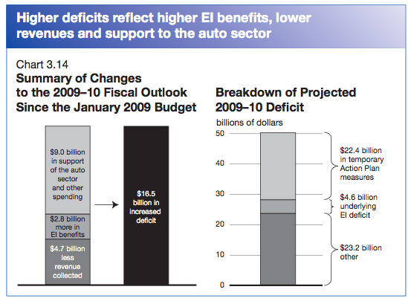
Source: Canada’s Economic Action Plan: A Second Report to Canadians (March 10, 2009), p. 217. Retrieved on February 21, 2010 from http://www.plandaction.gc.ca/eng/index.asp
The third report was announced by the Prime Minister on September 28, 2009, and the fourth report was released on December 2, 2009, again with an announcement by the Prime Minister. Predictably, the two reports repeated the positive conditions that had surrounded Canada’s experience with the financial crisis: entering it with a well-regulated and stable financial industry, balanced budgets, lowered taxes in 2007 and 2008, and lower household debt ratios. The IMF had stated that of the G-7 countries, Canada would be the least affected by the downturn and would have the strongest recovery. Indeed, the unemployment rate in Canada by December 2009 was one full percentage point lower than the US rate – the first time that this had happened in a generation.
Figure 2: Total Employment, Canada and the United States
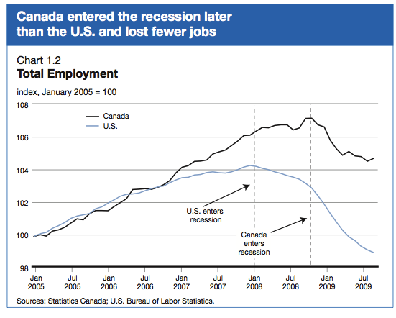
Source: Canada’s Economic Action Plan: A Third Report to Canadians (September 28, 2009), p. 9. Retrieved on February 21, 2010 from http://www.plandaction.gc.ca/eng/index.asp
The third report stated that almost 90 per cent of the stimulus package had been spent, on a bewildering array of projects: over 4,700 provincial, territorial and municipal infrastructure projects; 1,150 projects to repair and renovate federal buildings; 447 projects to improve infrastructure at colleges and universities, and some 300 social housing projects. The fourth report went further, stating that about 12,000 projects had been launched and were underway across the country.
Funds have been committed to more than 12,000 projects across the country, of which approximately 8,000 have begun. Projects committed include:

- Over 6,700 provincial, territorial and municipal infrastructure projects, including over 1,500 Recreational Infrastructure Canada projects.
- 1,150 projects to renovate and repair federal buildings.
- 536 projects to improve infrastructure at colleges and universities across the country.
- Over 1,800 social housing projects.
- 260 projects to improve small craft harbours.
- About 1,000 projects to assist communities hardest hit by the recession through the Community Adjustment Fund.
- Support for 56 major Canadian festivals and events.
- 80 cultural infrastructure projects.
- More than 120 projects to upgrade facilities at National Parks and National Historic Sites.
- Over 300 First Nations infrastructure and housing projects.
From an objective point of view, the Economic Action Plan seems to have worked. As the various reports testify, Canada seemed to have a more shallow recession than any of its G-7 partners, and certainly less sharp than the United States and the United Kingdom. The rebound was faster in 2010, and the unemployment rate did not break 10 per cent as it did in the United States. There was some debate about whether the deficits that the government was projecting could in fact be rolled back over three or four years – the Parliamentary Budget Officer (a new position that gives Parliament an independent capacity to review and assess government spending, similar to the Congressional Budget Office) argued that in fact Canada’s deficit was “structural” and deeper that the government’s estimates.
We turn now to the politics or optics of the Economic Action Plan. As pointed out earlier, even in November 2009 the federal Conservatives were not prepared to embark on an emergency stimulus package of any significant size. Ideologically, the party is disinclined towards large scale, highly interventionist and expensive programs. In three years in office, the party had indeed spent some of its budget surpluses on favourite boutique programs for political advantage, but these were completely eclipsed by the Economic Action Plan. With over 12,000 projects across the country aimed squarely at labour market stimulation through “shovel ready” projects, the Plan presented an unprecedented opportunity for political marketing and spending in virtually every community in the country. There is clear evidence that in addition to its bona fide policy rationale, the Economic Action Plan was used to political advantage.
The Politics of the Economic Action Plan
As we mentioned earlier, there were several peculiarities about Canada’s experience of the crisis and the Economic Action Plan – the speed, amount, and focus on labour markets being the most prominent. But the fact that the entire plan was temporary, and would be wound down by 2011, put a premium on speed and rapid roll-out. However, the Conservative government had invested a great deal of political capital in creating an image (even they spent as willing as the previous government) of fiscal probity. In addition, in the 2006 election, the key Conservative message was accountability, especially for spending. This stemmed from a political scandal in the two previous years (the “sponsorship scandal”) that the Conservatives had hammered relentlessly as evidence of government spending gone amok. If they were to embark in 2009-2011 on a massive spending program, it would have to be framed equally carefully in terms of fiscal prudence and accountability. We have noted that the government was at pains to stress the temporary nature of the relief and the importance of moving back to balanced and even surplus budgets after 2011. Complementing this was a strong emphasis on reporting and underscoring the benefits to all Canadians of the stimulus package.
We cited the four reports on the Economic Action Plan above – these were reports or “report cards” that had been demanded by the opposition parties in exchange for supporting the budget and not defeating the government. Ironically, however, they ended up become useful platforms for the government to highlight all its hard work and the success of the plan. The announcements for each report were made initially by the Prime Minister himself, and at events and not in the House of Commons. The government also established a dedicated web site for the Action Plan (http://www.plandaction.gc.ca/eng/index.asp ). Web sites are not unusual of course, but this one had several interesting features. First, because it covered virtually every department and agency that managed any kind of labour market program, it was a “whole of government” tool that listed all projects as well as all participating departments and agencies. Second, it pulled together all press releases and advertisements regarding the Plan. There were four television ads that ran in 2009 that highlighted tax credits for home renovations, a basket of other tax incentives for a host of activities (e.g., renovations but also transit passes), but always with an emphasis on the impact on jobs, benefits, retraining – in short on different aspects of the Canadian labour market. Each ad urged viewers to go to the Economic Action Plan web site to see what benefits might be there for them. Third, the website used the latest social networking tools to allow visitors to share whatever they might find, but also to get regular e-mail updates on the evolution of the plan.
There were two other features to the web site that clearly highlighted the importance of ensuring that Canadians new how beneficial this program would be for them. On the home page, at the bottom, were a series of categories entitled “What is in the Plan for Me?” There were four categories listed – individual or family; business; educational or non-profit organization, and government or aboriginal community. If one clicked on “individual or family” for example, another list appeared to its right with new sub-categories: worker, family, homeowner, and student. Clicking on one of these then revealed a colourful list of projects and programs under that category. Selecting just from the workers tab, here are five quick descriptions of new programs under the Action Plan:
Through Canada's Economic Action Plan, the federal government has implemented the Career Transition Assistance (CTA) initiative to help long-tenured workers update and acquire new skills. This initiative, implemented in partnership with provinces and territories, has two components and will cost an estimated $500 million over two years. It is expected that thousands of long-tenured workers will benefit from the Extended Employment Insurance and Training Incentive (EEITI) and participate in the Severance Investment for Training Initiative (SITI).
As part of Canada's Economic Action Plan, the federal government made a commitment to encourage skilled trades and apprenticeships by investing $40 million per year in a new Apprenticeship Completion Grant (ACG), which complements the existing Apprenticeship Incentive Grant (AIG). It is estimated that approximately 20,000 apprentices who complete their apprenticeship program and become certified in a designated Red Seal trade will be eligible for the ACG each year.
On November 3, 2009 the Government of Canada tabled legislation, the Fairness for the Self-Employed Act, to provide Employment Insurance (EI) maternity, parental/adoption, sickness and compassionate care benefits to self-employed Canadians on a voluntary basis. This legislation, which received Royal Assent on December 15, 2009, will allow the self-employed to opt into the EI program in January 2010, while benefits will start being paid in January 2011. This measure responds to the Government's 2008 pledge to provide access to EI maternity and parental benefits to the self-employed.
Through Canada's Economic Action Plan, the federal government is investing $500 million in a two-year Strategic Training and Transition Fund (STTF). The fund will support provincial and territorial initiatives that help workers retrain to retain employment or transition to new jobs in communities and sectors affected by the economic downturn. It will also ensure that individuals affected by the downturn are eligible to participate in the training or other employment initiatives that they need during difficult times.
Through Canada's Economic Action Plan, the federal government will freeze the Employment Insurance (EI) premium rate for 2010 at $1.73 per $100 of insurable earnings-the same level as in 2009 and its lowest level since 1982. Keeping the EI premium at the same level in 2009 and 2010, rather than raising it to the break-even level, will achieve a projected combined economic stimulus of $4.5 billion.
Canada, like most countries, has regional sensitivities, and so the government put special efforts into providing detailed information on not just the content of different programs and initiatives, but their distribution as well. The map is interactive (see Appendix B). The first, national map shows the distribution of projects, the second map is the result of clicking on a group of projects, in this case in southern Ontario. The third map shows projects around the small town of Belleville in southern Ontario. Even some of the icons in map 3 represent group projects, and could keep clicking further until single projects became visible. Clicking on individual project sites brings up information about the project budget, objectives, and links to the larger program that is funding the project. The large majority of this small informational windows carry a photo of a beaming Prime Minister, framed against building signs and men in hard hats.
All this raises the issue of how the stimulus spending was used to enhance the government’s popularity. There was sufficient anecdotal evidence to suggest that the Economic Action Plan was being used precisely in this way – as of course previous and similar plans under the Liberals had also been used to the same purpose. We have already discussed the government’s web site as a masterful tool for political communication of the benefits of the program to specific groups and regions. Added to this was the opportunity to have “announceables” almost every week. With projects being rolled out as rapidly as possible through the summer and fall. The government had a golden opportunity to fan out its ministers and MPs to actually be at the photo-ops and reveal the cheques and the projects. This was largely innocent, but one MP took it to a new level.

In the photo above, Mr. Gerald Keddy, Conservative MP for South Shore-St. Margaret’s in Nova Scotia, was shown handing a CAN300,000 cheque to the local community for the upgrading of a hockey facility in one of the communities in his riding. The cheque does not bear any evidence that it comes from the government of Canada, and in the top left sports the Conservative Party logo. As well, the cheque has Mr. Keddy’s signature on its, implying that somehow the funds were coming from him personally instead of taxpayers. Once this surfaced, it appeared that at least three other MPs had done similar things – identifying the project monies directly with the Conservative party. Opposition parties were outraged, but the Prime Minister admitted that this was a mistake and would not happen again. The furor died down, but it’s unclear how many other examples – perhaps not as blatant – played themselves out across the country as Conservative MPs (opposition representatives were typically not invited to announcements of new projects) tried to leverage the Plan with their own political agenda.
Another way in which the stimulus package could have been used for political purposes was to skew the projects into Conservative as opposed to Liberal ridings. The government – despite the sophisticated web site – does not release precise information on locations and budgets, at least not together. In November 2009, a team of journalists from the Halifax Chronicle Herald, the Ottawa Citizen, and journalism students from Ottawa’s Algonquin college conducted an analysis of different databases on the stimulus package, and then collated that with mapping software to see if they could pinpoint how many projects had been located in Conservative and opposition ridings, and what the correlation might be between unemployment rates and the financial size of stimulus projects. The investigation was somewhat ambiguous, but there did seem to be some anomalies.
Focusing just on the Building Canada infrastructure program, the journalists found the Conservative ridings had received almost half (CAN4.7 billion of a total of CAN8.5 billion) of total expenditures. At minimum, Conservative ridings received CAN3.3 million more on average per riding than did non-Conservative ridings. A complicating factor, however, was the large transit projects in major cities, many of which are in the ridings of opposition members. The single largest project under Building Canada, for example, was in the riding of a Liberal MP, but involved commitments to metro line extension promised in 2007, well before the economic crisis. There were also some projects that, due to timing and other complications, had not been announced at the time that the study was done, and once rolled out might actually change the distribution of funding in a more even fashion.
Nonetheless, when we add the efforts around the web site, the careful staging and the sheer number of announcements, ham-handed attempts to make the stimulus look like the beneficence of either the government or individual Conservative MPs, and the visible if not overwhelming tilt in spending by ridings, it’s clear (and unsurprising) that the government did try to leverage the stimulus package – something it had been reluctant to engage in – for political advantage. As we noted at the outset of this paper, this was in part due to the nature of the plan itself – a set of micro-initiatives operating (at least the construction and infrastructure part) at the local level. There were myriad and constant opportunities to engage with provincial governments, municipalities, local community groups, NGOs, trade unions, individual businesses and business associations, universities, hospitals – and all on the basis of good news. Lots of money to generate, keep and stimulate jobs.
By March 2010, the narrative had to begin to shift towards some of the bad news – reminding Canadians that the stimulus had been temporary, and that while it would continue to operate through to mid-2011, it would be wound down and the hard work of deficit reduction would begin. This opened another interesting policy chapter – from reluctance to spend in November 2009, to gusto and enthusiasm in 2009, the government now had to reduce expectations and design a budget that would pave the way to balance and re-assert the government’s reputation for fiscal firmness. That came with the budget of March 4, 2010.

Throne Speech and Federal Budget, March 2010
On December 30, 2009 the Prime Minister telephoned the Governor-General and asked her to prorogue Parliament until March 3, 2010. The rationale was that the government needed to “recalibrate” its agenda, as it was switching from emergency measures to stave off recession to a longer term strategy of policies to build the economy. Prorogation suspends Parliament, and so requires a new session and a new SFT. In this instance, it also required a new budget (which traditionally in Canada is handed down in February or March). The government decided to have the SFT read on March 3, and table the budget the next day.
In contrast to the terse SFT a year earlier which focused exclusively on the financial crisis, the March 2010 SFT ran to 6000 words and was almost five times as long as its predecessor. Like the 2009 version, this one emphasized the continued importance of job creation, but also highlighted the successes of the Economic Action Plan, and the new need to concentrate on “fiscal balance.”
Our Government’s first step toward restoring fiscal balance will be to wind down stimulus spending as economic activity rebounds. It will work with its provincial, territorial and municipal partners to ensure that measures under Canada’s Economic Action Plan come to an end by March 31, 2011. And as chair of the G8 and G20 this year, our Government will lead the call for a globally coordinated approach to the withdrawal of economic stimulus.
The second step toward restoring fiscal balance will be to restrain federal program spending overall, while protecting growth in transfers that directly benefit Canadians, such as pensions, health care and education.
Interestingly, the government promised to use its role as host for the upcoming G8 and G20 meetings to press for a globally coordinated strategy to wind-up stimulus spending.
If this was the main theme of the SFT, it was accompanied by election style promises across a range of fields: innovation and building the economy; a host of family-friendly items; law-and-order provisions; measures to support retired servicemen; and some nationalistic provisions such as re-writing the national anthem.
The Budget was tabled the next day, and it was a behemoth running to over 400 pages, in part because it included a 5th report to Canadians on the Economic Action Plan. An important point about the budget was that it was delivered at the beginning of the second year of the stimulus package – the Economic Action Plan was a two-year strategy, and projects and spending would continue until March 2011. So it was a somewhat unusual document – preaching austerity and frugality (in the face of a CAN54 billion deficit) while the money spigots were wide open and gushing for at least another twelve months, at which point they would be turned off. The budget highlights were:
- Continued stimulus spending through the next year of CAN25 billion, but terminated in March 2011.
- Close to CAN1 billion in new spending on a wide variety of projects, most connected to encouraging innovation in the economy (this was the smallest spending increase in a federal budget in over a decade).
- A reduction in the federal deficit by 50 per cent by 2011-12, and to CAN1.8 billion in 2014-15.
- No tax increases or cuts to transfers to provinces or to individuals.
How was this to be achieved? Almost half of the projected savings would come from ending stimulus spending, and almost half would come from freezing government department budgets for three years – again, the first time that this had been done in a decade. While public service wage increases in 2010-11 would be honoured, they would have to come from departmental operating budgets. The following two years would see freezes in pay, and possibly in hires, so that the overall public service might shrink through attrition. While military spending would continue to increase, it would grow at a slower rate (by only CAN.7 billion over two years on a budget base of CAN19 billion). Finally, all the budget numbers are based on economic growth projections (which themselves are based on an average of 15 private sector forecasts) of 2.6 percent in 2010 and 3.2 percent in 2011, with continued stable growth thereafter, with an average of 2.1 percent from 2009 to 2014.

Conclusions
It is true that Canada has so far weathered the economic and financial crisis considerably better than its G7, G8 and G20 partners. According to the IMF, as a percentage of GDP, Canada’s total government net debt is projected to grow by only 5.9 percent to 2014, the lowest of the G7 (Japan’s will grow by 63.1 percent, the United Kingdom by 53.5 percent, and the United States by 42.6 percent). The United States’ interest payments will increase by 170 percent in the next five years, while Canada’s will stay stable. The current Canadian deficit is 3.5 percent of GDP, while the United States’ is hovering at 11 percent. Some of the credit for this situation should be given to previous governments, but some as well should be directed at the current one.
The paradox however, is that this government was reluctant to engage in stimulus spending, and only its December 2009 near-death experience converted it from a covert spender (it had increased expenditures consistently each year from 2006) in a extrovert spender for 2010-2011. It focused on labour market stimulus of the sort that would get shovels into the ground quickly and start employing workers as rapidly as possible. In a sense, the policy context in late 2009 should have created real liabilities for a conservative-minded government, and those liabilities were clearly on display in December 2009. And yet, as The Economist has pointed out, the crisis of capitalism did not become a political crisis for the centre-right. The Economist explains this in terms of ideas – the European centre-right retains some dirigiste and paternalistic instincts, and so was prepared to intervene in markets during the crisis. New World polities, such as the United States, Australia and Canada, it argues, have more of a market orientation and so greater difficulty in defending robust state action. Canada’s success is dismissed as a result of a minority parliament, and having to adjust to three centre and left-centre parties.
This however is not the entire story. More interestingly, we can see how a recession of this magnitude can actually create political opportunities that run against the instinctive grain of a conservative government like Canada’s. We might term these the five rules of recession politics and public policy (the rules depend, however, on starting with a reasonably favourable position like Canada’s):
- Spending quickly to boost employment means “shovel-ready” programs that are visible and tangible to voters.
- The emphasis on small, quick projects means a wide regional disbursement (even though there was special and large package to deal with the automotive industry), and again, visibility and local impact.
- These two factors provide an unparalleled platform for government advertising and publicity.
- A conservative government can plausibly project disinclination, caution, and even grim strength in the face of spending challenges – they are reluctant virgins dragged to the altar of stimulus.
- The return to fiscal discipline has three virtues or reaffirmations. First, it is a reaffirmation for the political base of its party’s true colours. Second, it is a reaffirmation of the evils of deficits, and plays strongly into a narrative of sin (limited deficit financing) and redemption (getting back to “fiscal balance”). And finally, it highlights a sense of control and sober management, putting the centre-left off balance as it inevitably complains of insufficient spending and limp stimulus.

APPENDIX A

CANADA’S ECONOMIC ACTION PLAN
ALL INITIATIVES LISTED ALPHABETICALLY

Note: The initiative titles below are also hyperlinks to more information about the initiative. Readers with an electronic version of this paper can go directly to the specific initiative sites by clicking on the title. Also, each initiative is the basis for several projects, so the number of actual projects is much higher than the number of initiatives. Nonetheless, the list provides a sense of scope.

A
- Aboriginal Skills and Employment Partnership
- Aboriginal Skills and Training Strategic Investment Fund
- Accelerating Approval Processes for Building Canada Fund Major Projects
- Accelerating Forest Transformative Technologies Research in the Forest Sector
- Accelerating Provincial/Territorial Base Funding for Infrastructure
- Accelerating the Federal Contaminated Sites Action Plan
- Accounts Receivable Insurance for Auto Parts Manufacturers
- Addressing First Nations' Housing Needs
- Agricultural Flexibility Program
- Apprenticeship Completion Grants
- Arctic Research Infrastructure Fund

B
- Blue Water Bridge Plaza Improvements
- Broadband Program
- Building a Small Craft Harbour in Pangnirtung, Nunavut
- Business Credit Availability Program

C
- Canada Foundation for Innovation
- Canada Graduate Scholarships Program
- Canada Health Infoway
- Canada Prizes for the Arts and Creativity
- Canada Small Business Financing Program
- Canada Summer Jobs
- Canada Wood Export Program
- Canadian Agricultural Loans Act
- Canadian Lenders Assurance Facility and Canadian Life Insurers Assurance Facility
- Canadian Secured Credit Facility
- Canadian Television Fund and Canada New Media Fund
- Canadian Youth Business Foundation
- Career Transition Assistance Initiative
- Champlain Bridge
- Clean Energy Fund Program
- Communities Component of the Building Canada Fund
- Community Adjustment Fund
- Consulting on Accelerated Capital Cost Allowance for Carbon Capture and Storage
- Consulting on an Arrivals Duty-Free Program at Airports
- Cultural Spaces Canada

E
- Eastern Ontario Development Program
- ecoENERGY Retrofit - Homes
- Employment Insurance and Extended Benefits
- Employment Insurance Premium Rate
- Employment Insurance Special Benefits for the Self-Employed
- Enhancing Rail Safety
- Enhancing the Accessibility of Federal Buildings
- Enhancing the Working Income Tax Benefit
- Extending Assistance for Canada's Manufacturing and Processing Sector
- Extending the Life of Multi-Tasked Coast Guard Vessels
- Extending the Mineral Exploration Tax Credit
- Extraordinary Financing Framework

F
- Facilitating the Movement of Goods in International Shipping Containers
- Feasibility Study for the High Arctic Research Station
- Federal Economic Development Agency for Southern Ontario
- Federal Public Service Student Employment Programs
- First Nations Child and Family Services
- First Nations Schools
- First Nations Water and Wastewater Projects
- First-Time Home Buyers' Tax Credit
- Foreign Credential Recognition
- Funding for the Canadian Tourism Commission

G
- Greater Flexibility for the Canada Deposit Insurance Corporation
- Green Infrastructure Fund

H
- Helping All Sectors Invest in Computers
- Helping Consumers of Financial Products
- Helping Municipalities Build Stronger Communities
- Home Renovation Tax Credit
- Housing for Low-Income Seniors
- Housing for Persons with Disabilities

I
- Improvements to National Capital Area Bridges
- Improving Canada's Competition and Investment Policy Frameworks
- Improving Parks Canada's National Historic Sites and Visitor Facilities
- Improving the Peace Bridge Plaza
- Increases to the National Child Benefit Supplement and Canada Child Tax Benefit
- Increasing Withdrawal Limits Under the Home Buyers' Plan
- Industrial Research and Development Internship Program
- Industrial Research Assistance Program and Youth Employment Program
- Infrastructure at Ports of Entry
- Infrastructure at Remote Ports of Entry
- Infrastructure Stimulus Fund
- Institute for Quantum Computing
- Insured Mortgage Purchase Program
- Investing in Atomic Energy of Canada Limited
- Investing in Federal Bridges
- Investing in Federal Buildings
- Investing in Inter-City Passenger Rail Service
- Investing in Remote Rail Passenger Services
- Investing in the Canadian Business Network
- Investing in the Canadian Space Industry

K
- Knowledge Infrastructure Program

L
- Labour Market Development Agreements
- Large-Scale Wood Demonstration Projects in Targeted Offshore Markets
- Le Manège Militaire de Québec

M
- Magazines and Community Newspapers
- Marquee Tourism Events Program
- Modernizing Federal Laboratories
- Moving Financial Literacy Forward
- Moving Forward with Public Private Partnerships
- Moving Toward a New Canadian Securities Regulator

N
- National Arts Training Contribution Program
- National Historic Sites of Canada Cost-Sharing Program
- National Recreational Trails
- National Tourism Strategy
- New 47-foot Motor Lifeboats for the Coast Guard
- New Environmental Response Barges for the Coast Guard
- New Flexibilities and Resources for Financial Crown Corporations
- New Inshore Fisheries Science Vessels
- New Small Boats for the Coast Guard
- North American Wood First Program
- Northern Housing

P
- Personal Income Tax Relief for All Taxpayers
- Policing Infrastructure in First Nations Communities
- Protecting the Financial System from Illicit Financing
- Providing Temporary Relief for Pension Plans and Reviewing the Regulatory Framework

R
- Recreational Infrastructure Canada
- Reducing Taxes for Small Businesses
- Refitting Large Coast Guard Vessels
- Regional Economic Development for the North
- Renovation and Retrofit of Social Housing

S
- Small Craft Harbours Program
- Special Olympics Canada
- Strategic Investments in Northern Economic Development
- Strategic Training and Transition Fund
- Strengthening Aviation Security
- Strengthening Canada's Financial System
- Strengthening the Competitiveness of Canada's Meat Packing Sector
- Supporting the Development of International Cruises Along the St. Lawrence and Saguenay Rivers

T
- Targeted Assistance for the Automotive Sector
- Targeted Initiative for Older Workers
- Targeted Tax Relief for Seniors
- Tariff Relief on Machinery and Equipment
- Transformative Technologies Demonstration Projects in the Forest Sector
- Twinning the Trans-Canada Highway Through Banff National Park

V
- Value to Wood Program

W
- Wage Earner Protection Program
- Work Sharing

Y
- YMCA and YWCA Grants for Youth Internships

Source: Canada’s Economic Action Plan. Retrieved on February 21, 2010 from http://www.actionplan.gc.ca/initiatives/eng/index.asp?mode=7

APPENDIX B

CANADA’S ECONOMIC ACTION PLAN
GEOGRAPHICAL DISTRIBUTION OF PROJECTS

MAP 1: National

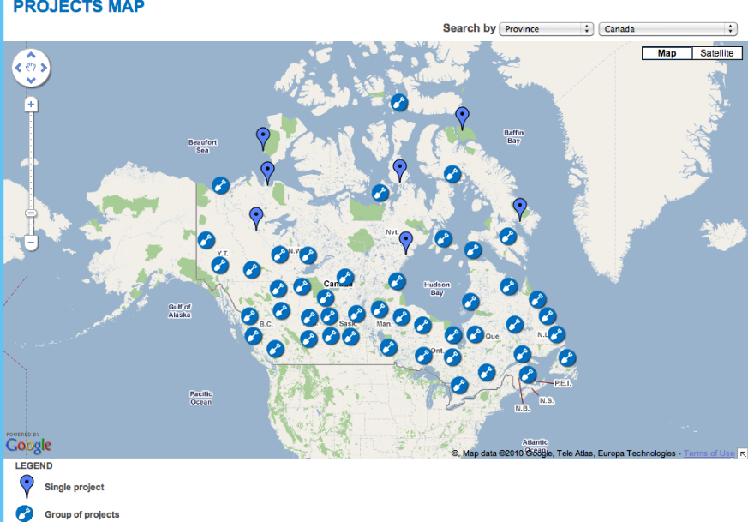
MAP 2: REGIONAL (SOUTHEAST ONTARIO)
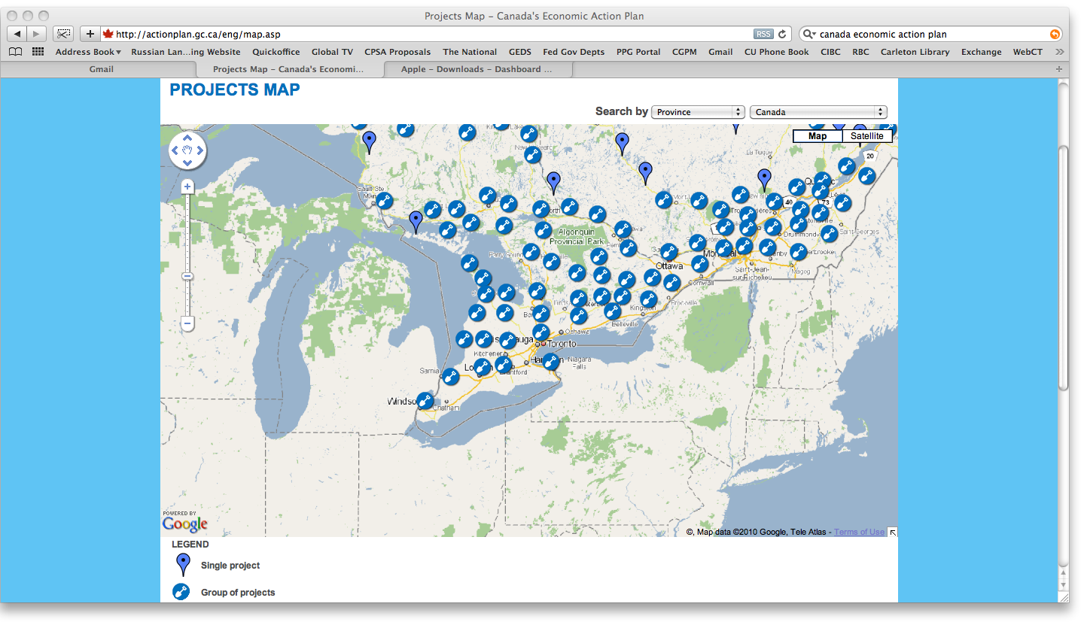
MAP 3: BELLEVILLE AREA (IN SOUTHEAST ONTARIO)
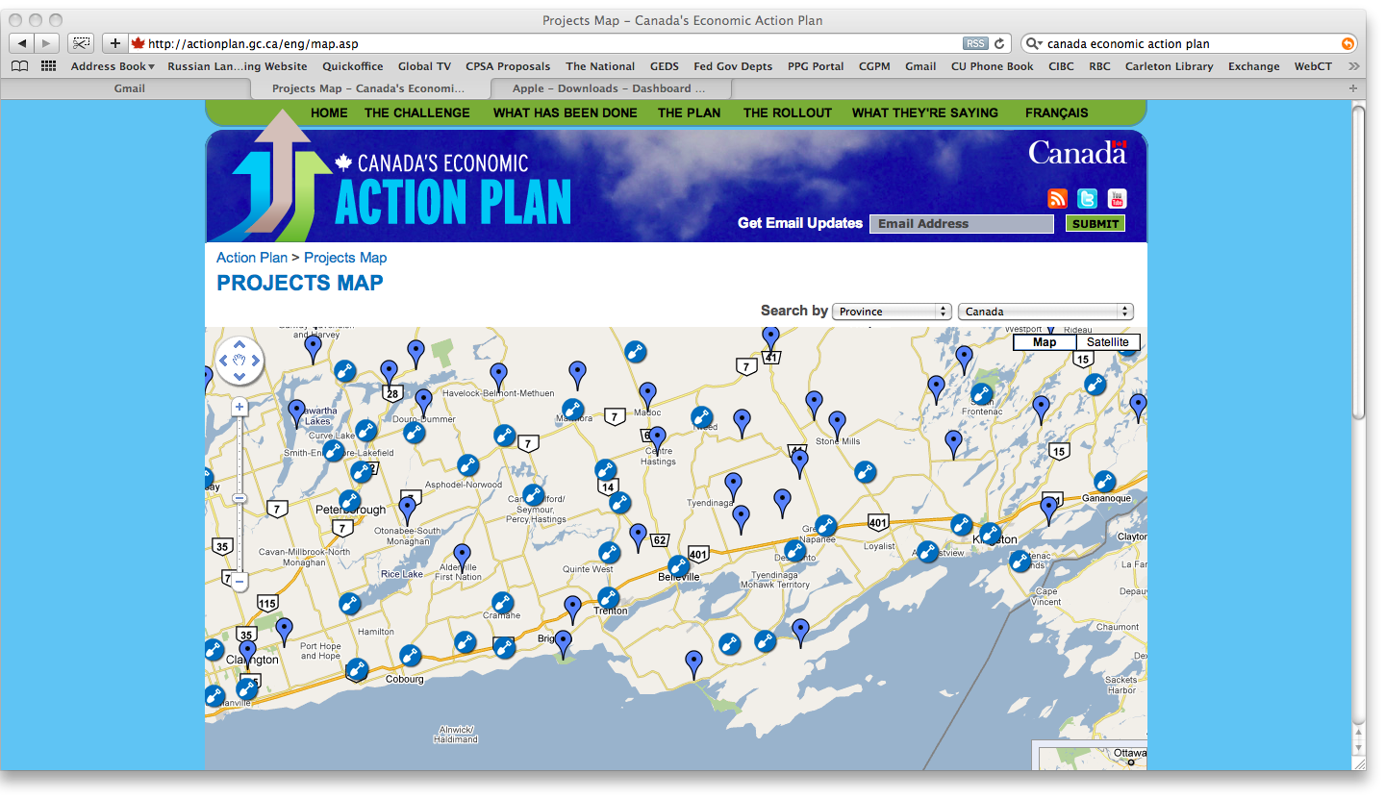

Xx

Canada, Speech from the Throne, Protecting Canada’s Future, November 19, 2008. Retrieved on February 12, 2010, from http://www.sft-ddt.gc.ca/includes/send_friend_eMail_print.asp?langFlg=e&URL=/eng/media.asp&id=1364
The following is taken from Canada, Economic and Fiscal Update, Protecting Canada’s Future, November 27, 2008. Retrieved on February 15, 2010 from http://www.fin.gc.ca/ec2008/pdf/EconomicStatement2008_Eng.pdf
CBC News, “Flaherty to Axe Subsidies to Political Parties in Updates,” November 26, 2008. Retrieved February 15, 2010, from http://www.cbc.ca/canada/story/2008/11/26/update-subsidy.html
Canada, Speech from the Throne, January 26, 2009. Retrieved on February 12, 2010, from http://www.sft-ddt.gc.ca/grfx/docs/sft-ddt-2009_e.pdf
Canada’s Economic Action Plan, January 27, 2009. Retrieved on February 10, 2010 from http://www.actionplan.gc.ca/eng/index.asp
Canada’s Economic Action Plan. Retrieved on February 21, 2010 from http://www.actionplan.gc.ca/eng/feature.asp?featureId=18
Canada’s Economic Action Plan: A First Report to Canadians, March 10, 2009. Retrieved on February 21, 2010 from http://www.plandaction.gc.ca/eng/index.asp
Canada’s Economic Action Plan: A Second Report to Canadians, June 11, 2009, p. 217. Retrieved on February 21, 2010 from http://www.plandaction.gc.ca/eng/index.asp
Canada’s Economic Action Plan: A Third Report to Canadians, September 28, 2009, p. 16. Retrieved on February 21, 2010 from http://www.plandaction.gc.ca/eng/index.asp
Canada’s Economic Action Plan: A Fourth Report to Canadians, December 2, 2009, p. 14. Retrieved on February 21, 2010 from http://www.plandaction.gc.ca/eng/index.asp
Canada, The Office of the Parliamentary Budget Officer, Estimating Potential GDP and the Government’s Structural Budget Balance, January 13, 2010. Retrieved on February 21, 2010 from http://www2.parl.gc.ca/Sites/PBO-DPB/documents/Potential_CABB_EN.pdf
Restoring Accountability (the Gomery Report), February 1, 2006. Retrieved on March 5, 2010 from http://www.cbc.ca/news/background/groupaction/gomeryreport_phasetwo_full.html
CBC News, “Tory Logos on Federal Cheques Draw Fire,” October 14, 2009. Retrieved on February 23, 2010 from http://www.cbc.ca/canada/nova-scotia/story/2009/10/14/ns-keddy-cheque.html
Glen McGregor and Stephen Maher, “Dangling Dollars: Where the Federal Stimulus Money Went,” Ottawa Citizen, November 7, 2009.
As we noted earlier, a prorogation suspends the legislature, purge pending legislation, but not dissolve it and require an election. It has been used by other Prime Ministers, but two in a row, both in December, seemed odd. Moreover, the Prime Minister traditionally visits the Governor-General personally for such matters, so a telephone call seemed an affront to regal dignity. The government had been under pressure in the House over the issue of how Canadian soldiers had handled Afghanistan detainees, and it was widely assumed that the prorogation was a ploy to shut down daily criticism in the House. There was a surprising discontent with the maneuver, but that was soon eclipsed by the Vancouver Olympics. Nonetheless, the prorogation required a new Speech from the Throne (a legislative agenda).
Canada, Speech from the Throne, A Stronger Canada. A Stronger Economy. Now and for the Future. March 3, 2010. Retrieved on March 5, 2010, from http://www.speech.gc.ca/grfx/docs/sft-ddt-2010_e.pdf
Canada, Department of Finance, Canada’s Economic Action Plan Year 2: Budget 2010: Leading the Way on Jobs and Growth, March 4, 2010. Retrieved on March 5, 2010 from http://www.budget.gc.ca/2010/home-accueil-eng.html
“Old Dogs and New Tricks,” The Economist, February 11, 2010.

