National Scientific Research University Higher School of Economics

Management

General and Strategic Management

Paper
«SD model for understanding long-term effect of price policy for a division of carrier company»

Student: Anna Kolchugina
group 623

Professor Filinov N.B.

Moscow 2011

Applying System Dynamic Model to Forecast Sales of Carrier Service Company Division in Small- or Medium-Sized City
Abstract
Paper present a system dynamics approach for modeling carrier service competitive market in Small- or Medium-Sized City and understanding long-term effect of price policy of one of competitors. The model includes dynamic competition between companies. Pricing strategy, service quality, customer base, potential customers, etc influence their number of customers.
Introduction
System dynamics was founded over 30 years ago and grew rapidly during the 1960s and early 1970s [7]. This early growth was primarily driven by the application of system dynamics to the analysis of social and macro-economic problems, although the method was also used as a management tool. During the last 10 years there has been a renewed interest in applying system dynamics to business policy and strategy problems [5, 6, 11, 12]. This interest has been driven by a number of factors. New, user friendly, high level graphical simulation programs (iThink, Powersim and Vensim) have been developed, enabling the decision maker (or the model user) to get a better understanding of the model. New popular books describe the use of the method and its results. Finally, a process has been developed which allows the user of a model to get actively engaged in its development. This process has been used extensively over the last 10 years and has been shown to be very effective [10].
Applications of SD can be found in a variety of industries, for example in health care, energy, utilities, chemicals, telecommunications, bio-technology, financial services, and Business Process Re-engineering [8, 9, 12]. Although a lot of publications were made for market forecasting and policy making in logistics and transportation, there are no models made for logistic market for B2C and C2C delivery, which became very popular in Russia with development of Internet-shopping. It is a dynamic market with a big potential of growth, and a company needs to understand dynamics of this market and use this knowledge to define its policy appropriately [3].
The aim of this paper is to use system dynamics approach to analyse carrier service market model and to consider the problem of optimal price policy synthesis.
The model includes competition between target company and its competitors. The pricing policy, service quality, customer base, potential customers, and other variables, describing market, are included in the model.

Carrier Service Market Model Description
The model includes dynamic competition between target company and its competitors (Figure 1). The pricing policy, service quality, customer base and its characteristics, etc influence its number of customers. Time unit is a month (to implement seasonality), and a whole period of simulation is 100 month.
Figure 1. Carrier service competitive market SD model
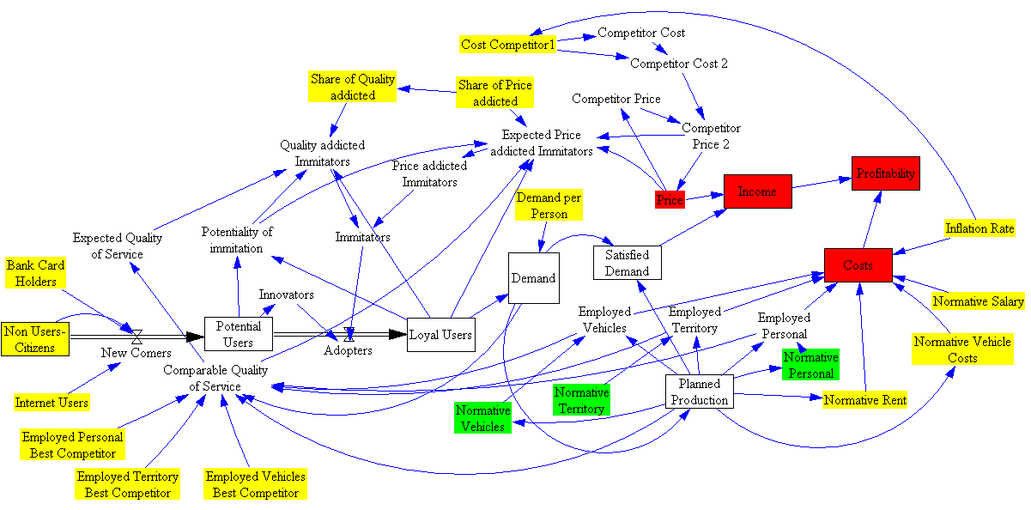
Model consists of two interactive “sub-models”: model of market and model of target (our) company.
Model of market show a dynamics of loyal customers base and provide information about costs on a particular market.
Target (our) company described by financial indicators (price, costs, profitability), assets (employed personal, employed territory, ect) and policy-describing variables (planned production, normative vehicles, ect). There is technology-improving mechanism included into model (with a growth of production automatization could be implemented).
Input variables, information for which should be taken from marketing research, are coloured with yellow, and influenced by company’s policy – green.
Model includes three levels:
Non-Users-Citizens – all citizens;
Potential Users – citizens, who more or less frequently use carrier service (influenced by share of bank card holders and internet users, because among non-organizations most users of carrier service in Russia are Internet-buyers) [2];
Loyal Users – loyal customers of target (our) company.
Loyal Users – number of loyal customers of a target (our) company. Their number influenced by number of innovators (customers, attracted by advertising) and imitators (customers, attracted by word-of-mouth, introduced in this model by Bass-model [4]), derived to quality-addicted (prefer better quality of service and does not affected by price) and price-addicted (choose service with minimal price and level of quality not lower than minimal in this market).
Loop Number 18 of length 9
Loyal Users - Demand - Planned Production - Normative Personal - Employed Personal - Comparable Quality of Service - Expected Quality of Service - Quality addicted Immitators - Immitators - Adopters
Number of loyal users multiplied by average number of delivery orders per month (from a statistical data [1]) is a demand in particular month. Through planning mechanism it influence plans of production, and in case of planned production higher then 500 planning units (planning units – standardized unit for planning) per month [1], automatization should be implemented and normative per one staff member (Normative Personal) increases, number of employees decreases, which through quality influence number of loyal users (balancing loop).
Number of Loyal Users increases, limited by total number of citizens, share of internet users and bank card holders, according to S-shaped curve (Figure 2). First 20 months it increases faster (up to 30000 people), because of advertising and growing number of innovators.
Figure 2. Dynamics of number of loyal users.
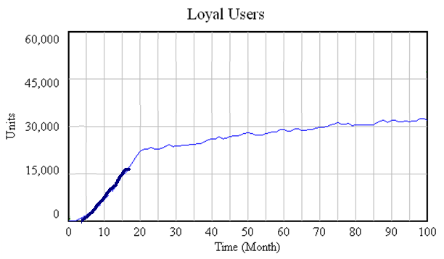
- prediction of number of loyal users in model
- statistical data [1]
Price – controlled only by headquaters [1], set on national (Ukraine, Kazakhstan) or macroregional level (Ural, South of European Part, Povolzhye, North-West, Centre). Price decisions are influenced by price-changes made by competitors. Company tries to keep price lower than price of nearest competitor.
Loop Number 1 of length 2
Price - Competitor Price - Competitor Price 2
Company decreases its price to make it lower than competitor’s, competitor, having the same pricing policy, decreases its price too, but overall costs increases, which makes both companies increase their prices. Price also influenced by total predicted costs on the territory of a whole region, not one town. Its included in the model indirectly as a prediction of growth of a competitor’s costs.
Quality, describes by variable Comparable Quality of Service – comparison between normatives of territory of warehouse and front office, employed personal and vehicles of target (our) company and its competitor with best quality and without forecasting mistakes – “best possible service in a region”. Instead of best quality competitor for policy making purpose nearest competitor or level of a minimal required service (if no competitors) could be employed.
Equation: ((Planned Production/Employed Personal)/(Demand/Employed Personal Best Competitor)+(Planned Production/Employed Territory)/(Demand/Employed Territory Best Competitor)+(Planned Production/Employed Vehicles)/(Demand/Employed Vehicles Best Competitor))/3
Change of level of quality does not influence immediately number of customers, only after period of time (to get them know and make a decision to switch to or from this company). For this purpose variable Expected Quality of Service (it is delay of variable Comparable Quality of Service ) is introduced in model.
Loop Number 14 of length 9
Comparable Quality of Service - Expected Price-Addicted Imitators - Price addicted Imitators - Imitators - Adopters - Loyal Users - Demand - Planned Production - Normative Vehicles - Employed Vehicles
This loop shows how through “minimal quality choice” quality influence number of price addicted imitators, then through behaviour of company affects comparable quality (balancing loop).
Profitability changes monthly between -50% and 150%, but average is 42% (Figure 3). Without changing policy average does not rise from year to year, because even in case of cutting costs company needs to drop price.
Figure 3. Dynamics of profitability (monthly).
Model was checked with a Reality Check (using variables planned production, price, comparable quality of service), checked with price deviation > 0 (our price is always higher than competitor’s), and accordance with statistical data [1].
Optimal price policy.
To find an optimal price policy (price deviation and delay of price change) there were used a number of experiments with different scenarios. There were made 20 experiments per scenario [13] and counted average output (income) by mode.
Input
Constant variables:
Variable | Input
Non-Users Citizens | 50 000
Normative Salary | 20 000
Normative Rent | If Planned Production >500; 326; 526
Normative Vehicle Cost | If Planned Production >500; 74; 105
Cost Competitor 1 | 150
Share of Price Addicted | 0,6
Normative Territory | If Planned Production >1000; 124; 56
Normative Personal | If Planned Production >500; 174; 153
Normative Vehicles | If Planned Production >500; 524; 225
Demand per Person | Data-file (statistic [1])

Inconstant variables (built on random function; forecast):
Bank card holders
Internet Users
Employed Personal Best Competitor
Employed Territory Best Competitor
Employed Vehicle Best Competitor
Inflation Rate

Scenarios
- Price deviation (Delay of price change=0,5)
Scenario | Input | Average output
1 | +10 | 28 474 502
2 | +5 | 23 927 241
3 | +2 | 28 286 899
4 | -1 | 41 375 859
5 | -2 | 44 256 732
6 | -3 | 72 753 406
7 | -4 | 76 511 713
8 | -5 | 77 955 968
9 | -9 | 77 610 644
10 | -10 | 77251734
11 | -11 | 76 892 830
12 | -15 | 75 457 161,6
13 | -20 | 73 662 591
14 | -25 | 71 868 013

Figure 4. Total income for 100 months with different pricing policy (different price deviation from competitor’s price).

Customers are sensible to price difference only if it is more than 2 roubles. If company makes price higher than competitor’s, it loses price-addicted customers, but still has income because of quality-addicted customers and high price (Figure 4). If deviation is more than about -5 roubles, income start to decrease because of too low price.
- Delay of price change (Price deviation=-4)
Scenario | Input | Average output
1 | 0,25 | 76 511 713
2 | 0,5 | 76 511 713
3 | 1 | 76 511 713
4 | 1,5 | 73 765 916
5 | 2 | 73 8421 92
6 | 3 | 73 915 468
7 | 5 | 73 915 468

Figure 5. Total income for 100 months with different pricing policy (different delay of price change with constant price deviation from competitor’s price).

If delay of price changes of competitor is one month it is no sense for a company to make its delay less, but difference between target company’s and competitor’s delays +0.5 month makes income fall sharply to the level of income from quality-addicted customers (Figure 5).
Best policy with this type of market and firm behaviour is price deviation some more than sensibility of customers and delay of price change as a competitor’s).

Conclusion.
In this paper there was illustrated how system dynamics can be used to help understand the growth of a carrier service company’s division in region and how price policy can influence shape of this growth. Simulation model was developed, starting from a map of the inter-connections between a number of factors that relate customer-perceived quality, price, market behaviour. This model enabled us to reproduce a growth pattern not unlike the one experienced by the real carrier service company’s division. The model includes examples of how soft variables, such as service quality, can be included in what many perceive as hard models.
We illustrated how the model can be used for 'what-if' analysis. Specifically, we discussed the impact on growth of changing prices faster or slower, and making price deviation from a competitor more or less. This gave a feel for how the model can be used to explore the impact of important policy variables.
Model could be improved in a number of ways:
- more detailed segmentation of customers;
- more detailed definition of level of quality;
- include region- or nation-level costs in model.

References
- Annual report of Leninsk division of Baikal-Service.
- Astrov K. Dynamics of Internet-shopping in Russia. 2007 http://www.int-surf.ru/science.aspx?CatalogId=222&d_no=18799
- A.T. Kearney Insight to impact. 1999 Bruxelles http://www.elalog.org/publications/publications.html
- Bass F. A new product growth model for consumer durables Management Science. 1969. Vol. 15.
- A system dynamics model for dynamic capacity planning of remanufacturing in closed-loop supply chains / D. Vlachos, P. Georgiadis, E. Iakovou http://www.cob.unt.edu/slides/Pany/Simulation_paper/System_dynamic2.pdf
- Blinov A.B., Koblov A.I., Shiryaev V.I. Applying Models to Forecast Mobile Service Market Development http://www.mendeley.com/research/applying-models-forecast-mobile-service-market-development/
- Decision Making in Reverse Logistics Using System Dynamics / P. Georgiadis, D. Vlachos http://www.doiserbia.nb.rs/img/doi/0354-0243/2004/0354-02430402259G.pdf
- Development Of System Dynamic Model To Diagnose The Logistic Chain Performance Of Shipbuilding Industry In Indonesia / A. Cakravastia, L. Diawati http://www.systemdynamics.org/conferences/1999/PAPERS/PARA74.PDF
- Dynamic Logistics Model for Optimal Delivery / S. Soehodho http://www.systemdynamics.org/conferences/2001/papers/Soehodho_1.pdf
- Dynamics in spatial logistic chains / B. Groothedde http://www.systemdynamics.org/conferences/2000/PDFs/groothed.pdf
- Impact of Freight Transport Costs and Pricing on Logistical Systems / V. Gacogne http://www.systemdynamics.org/conferences/2004/SDS_2004/PAPERS/202GACOG.pdf
- Simulation in manufacturing and business: A review / M. Jahangiriana, T. Eldabib, A. Naseera, L. K. Stergioulasa, T. Young. European Journal of Operational Research, № 203, 2010.
- Javorsky V.A. Planning of scientific experiment and processing of scientific data http://urai.net.ru/crystal/DswMedia/experiment.pdf

