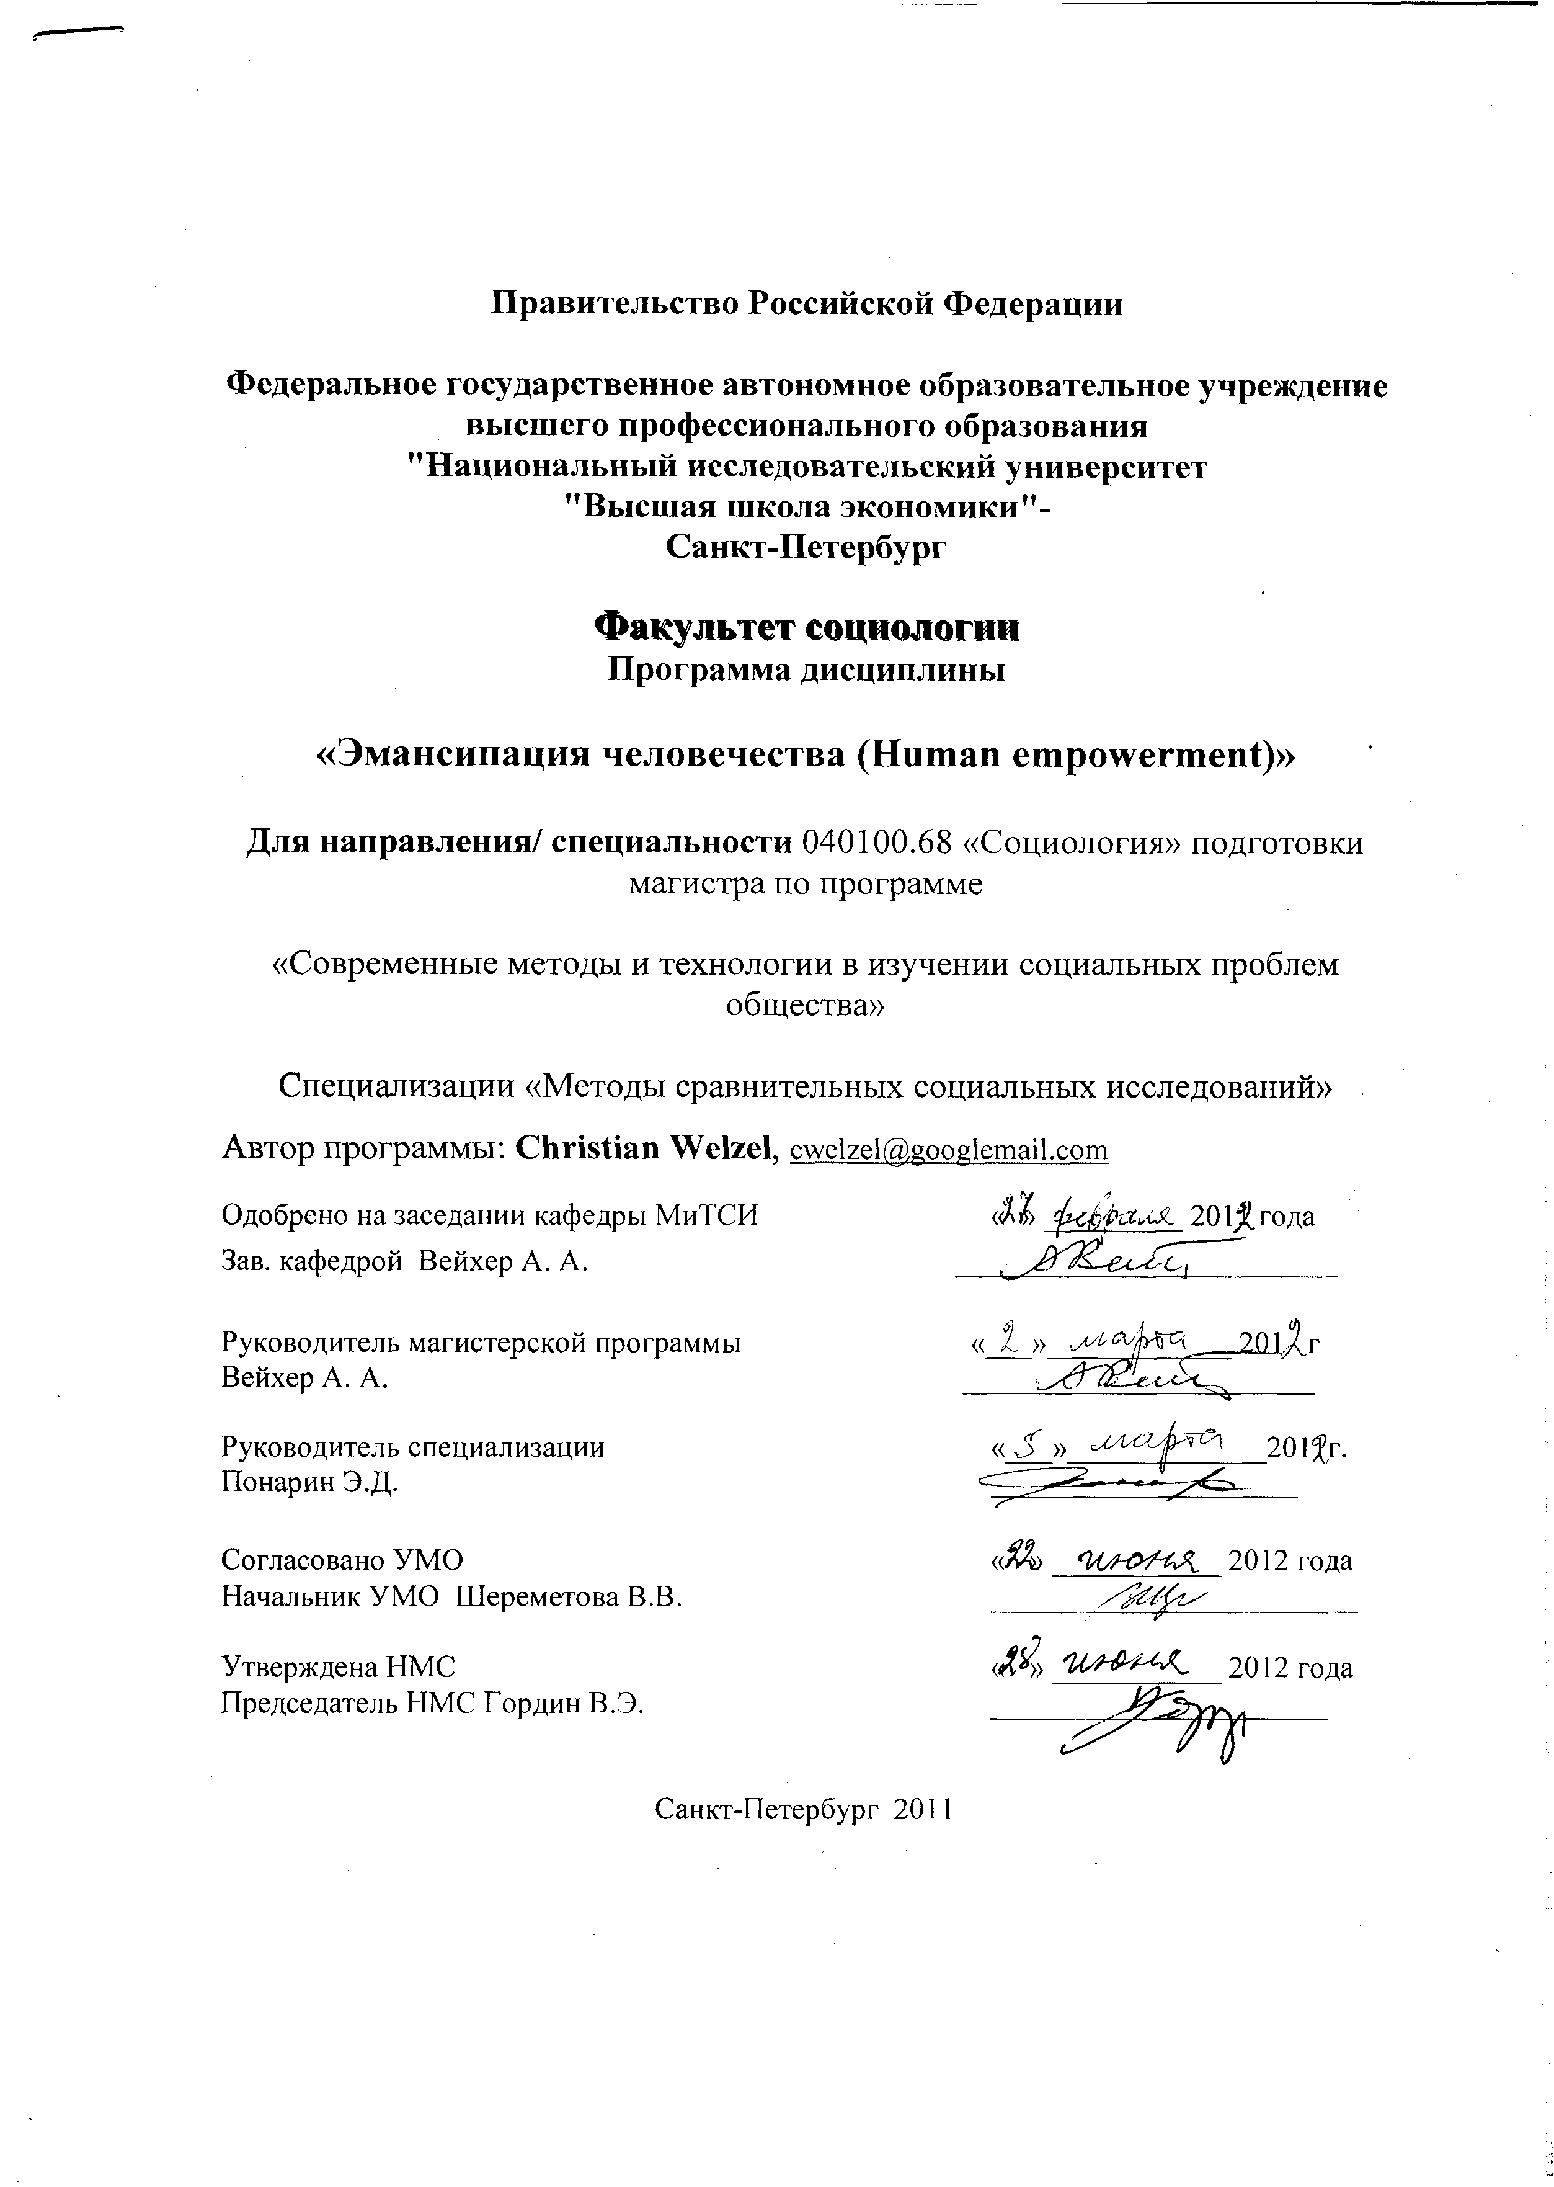

I. OVERVIEW

1. PROGRAM AUTHOR
Christian Welzel has Ph.D. (distinction) in Political Science, is an Professor-pro-tempore, Higher School of Economics St. Petersburg, Russia. Dr. Welzel is also Chair for Political Culture Research, Leuphana University Lueneburg (Germany) and, Vice President of the World Values Survey Association, Stockholm (Sweden).
2. SUMMARY
Thematic Overview
The seminar deals with the rise of emancipative values as the cultural component of a global trend towards human empowerment. At the outset, emancipative values are discussed within the framework of human empowerment. Then we examine how these values can be measured across societies from various cultural backgrounds, using nationally representative data from the World Values Survey. Based on these data, we will map cross-cultural differences in people’s emphasis on emancipative values. From a dynamic point of view, we will see to what extent emphasis on these values has been strengthened throughout the postindustrial world during the past twenty-five years. Next, the drivers of rising emancipative values will be examined, focusing on the role of emerging knowledge societies. After this, the broader implications of emancipative values for people’s life strategies, wellbeing, civic mindedness and civic activism are analyzed across cultures. The following sessions then focus on the democratizing consequences of emancipative values, discussing (a) how the rise of these values helped to democratize previously authoritarian regimes, (b) how emancipative values sharpen people’s understanding of democracy, and (c) how they advance women’s positional empowerment. After that, we will use the concept and measurement of emancipative values to evaluate the conflicting positions of cultural relativism and developmental universalism. Finally, we discuss the role of emancipative values within the ‘Great Redirection’ of the civilization process’s lead theme from the cementation of human exploitation towards the advancement of human empowerment.

Organization
Each session starts with a ten minute presentation of the key contents of the assigned reading by a student, followed by a ten minutes critical discussion of these contents by another student. Yet another ten minutes are reserved for a direct exchange of arguments by the presenter and discussant. Then we enter an instructor-moderated open class discussion. One student is asked to write down take-home points from the discussion on the whiteboard. Another student is asked to minute these points for distribution in the next session. The topics and readings for each week can be taken from the Session Plan (below).

Course Material
The required reading is a draft book manuscript authored by the course instructor. The manuscript and the respective illustrative material are distributed electronically in two PDF-files. The bibliography at the end of the manuscript provides an exhaustive list of additional readings. To enable students to reproduce and deepen the analyses presented in the manuscript, a dataset with WVS data and other data will be distributed.

Grading
Grading will be based on the students’ performance in presentations and open class discussion and a short data analysis on one of the topics of the course, to be handed in as a research paper of about 5,000 words. Deadline is two weeks after the final session.

II. THEMATIC PLAN OF THE COURSE

№ | Theme | Total hours in theme | Hours in classroom |  | Independent Work
№ | Theme | Total hours in theme | Lecture | Seminar | Independent Work
1 | Introduction | 10 | 2 | 0 | 8
2 | Emancipative Values in the Theory of Human Empowerment | 10 | 2 | 0 | 8
3 | Measuring and Mapping Emancipative Values | 12 | 2 | 2 | 8
4 | Drivers of Emancipative Values | 10 | 2 | 0 | 8
5 | Emancipative Values, Human Agency, and Life Strategies | 10 | 0 | 2 | 8
6 | Emancipative Values as a Civic Form of Individualism | 10 | 2 | 0 | 8
7 | Emancipative Values, Collective Action, and Expressive Publics | 10 | 0 | 2 | 8
8 | Emancipative Values and Substantive Democracy | 10 | 2 | 0 | 8
9 | Emancipative Values in the Process of Democratization | 10 | 2 | 0 | 8
10 | Emancipative Values and Democratic Orientations | 12 | 2 | 2 | 8
11 | Emancipative Values, Women’s Rights, and Female Empowerment | 10 | 2 | 0 | 8
12 | Emancipation between Cultural Relativism and Developmental Universalism | 10 | 0 | 2 | 8
13 | Human Empowerment in the Civilization Process | 10 | 2 | 0 | 8
14 | Conclusion | 10 | 0 | 2 | 8
 | Total | 144 | 20 | 12 | 112

SESSION PLAN

Session 1:
Introduction
Reading: Emancipative Values and the Human Empowerment Process: Introd.

Session 2:

Emancipative Values in the Theory of Human Empowerment
Reading: Emancipative Values and the Human Empowerment Process: Chapter 1.

Session 3:
Measuring and Mapping Emancipative Values
Reading: Emancipative Values and the Human Empowerment Process: Chapter 2.

Session 4:
Drivers of Emancipative Values
Reading: Emancipative Values and the Human Empowerment Process: Chapter 3.

Session 5:
Emancipative Values, Human Agency, and Life Strategies
Reading: Emancipative Values and the Human Empowerment Process: Chapter 4.

Session 6:
Emancipative Values as a Civic Form of Individualism
Reading: Emancipative Values and the Human Empowerment Process: Chapter 5.

Session 7:
Emancipative Values, Collective Action, and Expressive Publics
Reading: Emancipative Values and the Human Empowerment Process: Chapter 6.

Session 8:
Emancipative Values and Substantive Democracy
Reading: Emancipative Values and the Human Empowerment Process: Chapter 7.

Session 9:
Emancipative Values in the Process of Democratization
Reading: Emancipative Values and the Human Empowerment Process: Chapter 8.

Session 10:
Emancipative Values and Democratic Orientations
Reading: Emancipative Values and the Human Empowerment Process: Chapter 9.

Session 11:
Emancipative Values, Women’s Rights, and Female Empowerment
Reading: Emancipative Values and the Human Empowerment Process: Chapter 10.

Session 12:
Emancipation between Cultural Relativism and Developmental Universalism
Reading: Emancipative Values and the Human Empowerment Process: Chapter 11.

Session 13:
Human Empowerment in the Civilization Process
Reading: Emancipative Values and the Human Empowerment Process: Chapter 12.

Session 14:
Conclusion
Reading: Emancipative Values and the Human Empowerment Process: Conclusion.

LITERATURE:

Welzel C. Emancipative Values and the Human Empowerment Process. Unpublished manusript

