Еженедельный семинар Лаборатории Алгебраической геометрии и ее приложений

Семинар состоится 17 августа 2012 года. Начало в 17:00.
Семинар будет проходить по адресу: ул. Вавилова, д.7, аудитория 1001, 10 этаж.
На семинаре выступит  Christian Boehning | 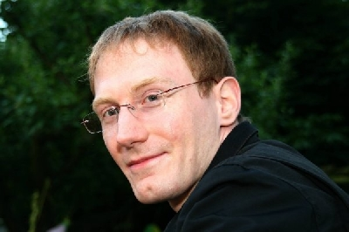

(Georg-August Universität Göttingen)

с докладом:

On the derived category of the classical Godeaux surface
http://arxiv.org/abs/1206.1830

Abstract: We construct an exceptional sequence of length 11 on the classical Godeaux surface X which is the Z/5-quotient of the Fermat quintic surface in P³. This is the maximal possible length of such a sequence on this surface which has Grothendieck group Z¹¹+Z/5. In particular, the result answers Kuznetsov's Nonvanishing Conjecture, which concerns Hochschild homology of an admissible subcategory, in the negative. The sequence carries a symmetry when interpreted in terms of the root lattice of the simple Lie algebra of type E₈. We also produce explicit nonzero objects in the (right) orthogonal to the exceptional sequence. If time permits, we will include some speculations on phantom categories on the Barlow surface.

Приглашаются все желающие!

