Frequently Asked Questions about WTO official documentation
and its dissemination on the Internet via

Documents online

This document is available in Documents online as a web help file; to open it, click on Help in the navigation bar at the top of the screen. It can also be downloaded from the Members' site in either WORD or pdf format - go to WTO Resources > WTO Documents > Guides

Last updated: June 2004
Table of Contents

Passwords 5
Getting started 6
Languages 7
Official working languages 7
Posting of documents by language 7
Document archive 8
Extent of archive 8
Electronic archive 8
Paper archive 8
Document posting on the Internet 8
WTO documents 9
Uruguay Round documents 9
Latest documents posted 9
Document formats 10
WTO documents 10
Uruguay Round documents 11
Document nomenclature 12
Document collections 12
What is a document collection? 12
WTO document collections 12
GATT document collections 12
Document series 13
What is a document series? 13
WTO document series 13
GATT / Uruguay Round document series 13
Tokyo Round Agreements document series 13
Document types 13
What is a document type? 13
Document status 14
What is a document status? 14
Document symbols 14
What is a document symbol? 14
ISO country codes 15
What is an ISO country code? 15
WTO document series in which ISO codes are used in the symbol 16
List of ISO codes 16
Browse documents 19
Introduction 19
What can you find in Browse documents? 19
Recently distributed 20
Documents recently posted 20
Documents recently modified 20
Frequently consulted 21
Official records of WTO Bodies 21
JOBS (informal restricted documents) 22
Meetings agendas and "Daily Bulletin" 23
Legal Texts and Agreements 23
Ministerial Sessions 24
Special Meetings 25
Background papers 25
Relating to specific meetings 26
Meetings 26
Relating to a specific subject area 27
Documents by Subject 27
Searching for documents 29
Introduction 29
Simple search 30
Search by Symbol 30
Search by Title 31
Search by Document number 32
Search by Countries 33
Search by Full text 33
Search by Document date 35
Advanced search 35
Advanced Search by Collection 35
Advanced Search by Symbol 36
Advanced Search by Document date 38
Advanced Search by Document number 38
Advanced Search by Access level 39
Advanced Search by Title 40
Advanced Search by Subject 41
Advanced Search by Full text 41
Advanced Search by Catalogue 43
Advanced Search by Countries 43
Advanced Search by Organizations 44
Advanced Search by Products 44
Advanced Search by WTO/GATT Articles 46
Advanced Search by WTO/GATT Bodies 47
Advanced Search by Type 47
Advanced Search by Derestriction date 47
Advanced Search by Meeting date 48
Advanced Search by Posting date 48
Advanced Search by Hits per page 48
Notifications (CRN) search interface 48
Searching for notifications 49
Trade coverage 51
Consulting notification documents 56
Refining search results by means of a full-text search 58
Consulting documents 60
Understanding the results list 60
Sorting the results list 61
Viewing documents online 61
Catalogue records 62
Downloading documents 64
Introduction 64
All documents retrieved by a search 66
Selected documents retrieved by a search 69
Results list only (no documents) 70
Organizing documents on your computer 71
Printing documents 72
Derestriction of documents 73
Documents issued after 14 May 2002 73
Documents issued before 15 May 2002 73
Derestriction procedure in Docsonline 73
Contacts 74
Contacts for WTO documentary resources on the Internet 74
Documents online 74
IDB/CTS Internet Facilities 74
Index 75

Passwords
For whom?
A small number of official documents are first issued with a restricted status; access to these items is reserved for WTO Members and selected Observers. Restricted documents are posted in a protected version of Documents online, accessible via the WTO Members' site. A login ID and password are required to access this database.
Accredited representatives of WTO Member countries, other official authorized Agencies and selected Observers only are issued with a login ID and password, upon request.
How to obtain a password
User IDs and passwords are issued to the Heads of Delegations to the World Trade Organization only; to obtain a password, please contact the appropriate Delegation directly.
For security reasons, passwords are modified every six months. Heads of Delegations are informed well in advance of the date of modification so that all users can be informed of the forthcoming change. It is the responsibility of Heads of Delegations to inform all users of the change in password.
The same user ID and password allow access to Documents online and all the protected resources available on the WTO Members' site except the IDB/CTS Internet Facilities, for which separate passwords are available to authorized users upon request.
For contact details, see: Contacts

Getting started

Documents online is a database that provides two distinct Internet services:

- document dissemination
- documentary research.

The first offers WTO Members, Observers and the general public the possibility of accessing the output of WTO documentation. Users can consult and download official documents as they are circulated by the Secretariat. Each day's production of documents is normally posted in Documents online by 00.00 GMT. The second service offers Members the possibility of performing both simple and more complex data searches.
Documents online contains the majority of official documents distributed by the WTO and is available in three different language interfaces: English, French and Spanish. In response to requests from Members, Uruguay Round documents and a small selection of GATT documents have been included in the database. All documents are posted in the three official languages of the Organization as soon as the respective language version becomes available¹. Irrespective of the language of interface used, the results of a search always present the user with the choice of previewing and/or downloading the documents retrieved in all of the existing language versions (unless the search was made in the title or full-text fields, which are language-dependent).
Documents online is accessible via the Internet web site of the World Trade Organization and also through the WTO Members' site (for documents that have not yet been released to the public).

Please note
For maintenance reasons, Documents online is not available on Sundays from 00h00 until 08h00 (GMT).
¹ In accordance with the provisions of WT/L/452 (16/05/2002): "Procedures for the Circulation and Derestriction of WTO Documents - Decision of 14 May 2002"

Languages

Official working languages
The official working languages of the WTO Secretariat are English, French and Spanish.
All formal documents (i.e. documents bearing a symbol) are produced and disseminated in the three official languages of the WTO, with the following exceptions:

WT/DAILYB/… | "Daily Bulletin", distributed only in English
G/TMB/SPEC/…  G/TMB/W/… | Distributed only in English (the working language of the Textiles Monitoring Body is English)
PANELIST/… | CVs of Panelists, distributed in the language of submission (not translated into the other official languages)

Posting of documents by language
Most official documents are not generally circulated simultaneously by the WTO in the three languages. Documents are first disseminated in English (or in their original language of submission when the English version is not available) and then distributed in the other official languages after the translation process is complete.
A small number of document series, however, are always distributed simultaneously in the three official languages of the Organization:

OFFICE(YEAR)/… | External vacancy notices
WT/DSnumber/… | Dispute settlement
WT/LET/… | Protocols and Lists of Concessions
WT/TPR/G/… | Trade Policy Reviews – Government reports
WT/TPR/S/… | Trade Policy Reviews – Secretariat reports
WTO/AIR/… | Airgrams

Document archive

Extent of archive

Electronic archive
Documents online provides access to the official documentation of the World Trade Organization, including the legal texts of the WTO agreements. Documents may be retrieved and consulted online and also downloaded from the site to a local computer. Documents online makes available a descriptive catalogue record for every document stored in the archive.
The database contains WTO documentation from 1995 onwards and is updated daily. It also contains selected material for the period 1986-1994, principally Uruguay Round documents and a small number of GATT documents. There are currently over 150,000 documents in the database in the three official languages of the organization.
Documents online does not contain references to WTO sales publications; these are available from the Publications Section which is accessible via the WTO public web site at: WTO Boutique (https://secure.vtx.ch/shop/boutiques/wto_index_boutique.html)

Paper archive
A complete printed archive of WTO and GATT documents is available for consultation in the WTO library, which is located in the headquarters building in Geneva, Switzerland. Those documents which are incomplete in electronic text form in Documents online are preserved in their complete form in the Library. A range of WTO and GATT documents is also stored on microfiche which may also be consulted in the WTO library.

Document posting on the Internet
Documents are posted on the Internet at the end of each working day and are available for consultation by 00h00 GMT. Each day's quota of documents appears in the results list with the indicator underneath the document date.
Most official documents are not generally circulated simultaneously by the WTO in the three languages. Documents are first disseminated in English (or in their original language of submission when the English version is not available) and then distributed in the other official languages after the translation process is complete.
A small number of document series, however, are always distributed simultaneously in the three official languages of the Organization:

OFFICE(YEAR)/… | External vacancy notices
WT/DSnumber/… | Panel Reports
WT/LET/… | Protocols and Lists of Concessions
WT/TPR/G/… | Trade Policy Reviews - Government reports
WT/TPR/S/… | Trade Policy Reviews - Secretariat reports
WTO/AIR/… | Airgrams

A small number of document series are not posted on the Internet:

G/TMB/SPEC/… | Textiles Monitoring Body
WT/BFA/CONT/… | Committee on Budget, Finance and Administration
WT/BFA/SPEC/… | Committee on Budget, Finance and Administration
OFFICE(YEAR)/… | except: External Vacancy Bulletins; WTO Library: New Acquisitions
Internal jobs

Not all documents posted on the Internet are complete in electronic text form (WORD or WordPerfect). For these, a companion PDF image version, the paper copy or a microfiche version must be consulted if the complete text of the document is required.

WTO documents
Documents in the following series are often incomplete:

IP/N/1/MEMBER/… | Intellectual Property - Article 63.2 notifications
WT/ACC/… | Accessions documents
WT/ACC/MEMBER/… | Working Party documents of acceding countries
WT/ACC/SPEC/MEMBER/… | Working Party documents of acceding countries
WT/LET/… | Protocols and Lists of Concessions

For more information on this section, see: Document formats

Uruguay Round documents
Most of the documents in this collection were produced using a word-processor which did not support graphics; the electronic versions of the documents, therefore, are incomplete.

Latest documents posted
This section provides direct access to an interface for retrieving the latest documents posted by date or by topic.
Documents are posted on the Internet at the end of each working day and are available for consultation by 00h00 GMT.
Each day's posting of new documents appears with the indicator beneath the document date in the results list display; this indicator is replaced at the time of the next update (24 hours later)
For more information on this section, see: Documents recently posted

Document formats

WTO documents
WTO documents are posted in Microsoft Word 97 format except for those distributed before 2 June 1998; these are stored in WordPerfect 5.2 format. Uruguay Round documents are stored either in RFT or in WordPerfect 5.2 formats.
Not all WTO documents posted on the Internet are complete in electronic text form (i.e. WORD). Documents in the following series are often incomplete:

IP/N/1/MEMBER/… | Intellectual Property - Article 63.2 notifications
WT/ACC/… | Acessions documents
WT/ACC/MEMBER/… | Working Party documents of acceding countries
WT/ACC/SPEC/MEMBER/… | Working Party documents of acceding countries
WT/LET/… | Protocols and Lists of Concessions

For these documents, either a companion PDF image version or an alternative file format version (such as Excel, PowerPoint or Access) is posted in Documents online, together with the original incomplete text version. Documents for which a second format exists are marked with an asterisk (*) in the original format column of the results list display:
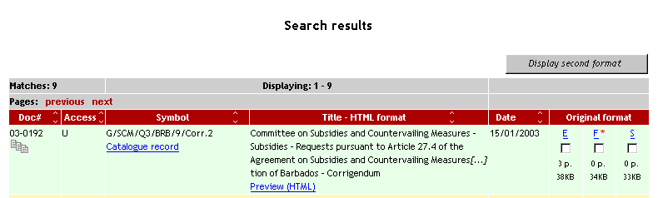
To display the second format of a document, click on :
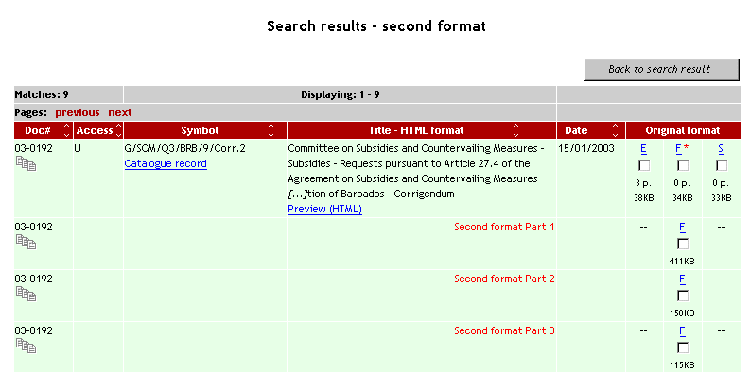
Second formats have been posted in Documents online for all incomplete text documents distributed since August 31 2003. In the near future, second formats for all incomplete WTO documents issued since 1995 will be made available in Documents online.
Portable Document Format files (.pdf)
Portable document format was designed to preserve a document's page layout, regardless of the computer platform being used. To view or download these files you need Adobe® Acrobat® Reader® which can be downloaded for free from the Adobe site:
http://www.adobe.com/products/acrobat/readstep.html
Note that you cannot modify pdf documents even if you download them.

Uruguay Round documents
Most of the documents in this collection were produced using a word-processor that did not support graphics; the electronic versions of the documents, therefore, are incomplete. For these, either the paper copy or a microfiche version must be consulted if the complete text of the document is required. It is planned to post companion PDF image versions of all these documents in Documents online.
For further information on document formats used in Documents online and on the WTO web site, see:
Guide to downloading files from the WTO website

Document nomenclature

Document collections

What is a document collection?
A broad grouping of individual document series. In WTO document series, collections are usually identified by letters which appear as the first characters in document symbols.

WTO document collections
WTO documents are currently organized into seven collections, one for each sector of activity and one for administrative matters pertaining to the Secretariat. The letters identifying these collections all appear as the first characters in the document symbol:

G Trade in Goods (1994 - )
IP Intellectual Property (1995 - )
JOBS Informal restricted documents (1999 - )
S Trade in Services (1994 - )
TN Trade Negotiations (2002 - )
WT World Trade Overseeing Bodies (1995 - )
OFFICE Secretariat - administrative (1995 - )

Two additional 'notional' collections have been created (notional since no specific letters appear in the symbol identifying the collection to which the document belongs) to facilitate electronic storage within the Secretariat of the Schedules of concessions and documents relating to the Plurilateral Agreements:

SCHD Schedules of Concessions (1994 - )
PLURI Plurilateral Agreements (1994 - )

GATT document collections
GATT documents are organized into five 'notional' collections (notional since no specific letters appear in the symbol identifying the collection to which the document belongs):

BISD * Basic Instruments and Selected Documents (1947 - )
GG * ° GATT47 General (1988 - 1995)
TR + Tokyo Round Agreements (1988 - 1996)
UR Uruguay Round Negotiations (1986 - 1994)
JCR Jurisprudence, Council and related (1947 - )

* Documents issued in these collections are not currently available on the Internet
+ Documents issued in this collection, with the exception of those distributed in the period 1994-96, are not currently available on the Internet
° Certain document series in this collection ran concurrently with WTO series for a number of years or are still active:

active up to 1996 BOP/; C/M/; GATT/AIR/; INF/; L/; LIC/; SCM/; TBT/
active up to 1997 ADP/; GPR/
active up to 1998 ICITO/
still active CPC/

Document series

What is a document series?
Each document collection is made up of certain classes of documents which share a common framework. The different classes of documents are called series.

WTO document series

G/ADP/... Anti-Dumping
IP/N/... Intellectual Property Notifications
S/FIN/... Trade in Financial Services
TN/CTD/… Committee on Trade and Development, Special Session
WT/DS/... Dispute Settlement

GATT / Uruguay Round document series

BOP/... Balance-of-Payments Restrictions (GATT)
MTN.GNS/... Negotiating Group on Services (Uruguay Round)
DS/… Dispute Settlement (GATT)
NTM/… Non-Tariff Measures and Quantitative Restrictions (GATT)

Tokyo Round Agreements document series

ADP/... Anti-Dumping
GPR/... Government Procurement
IMC/... International Meat Council
VAL/… Customs Valuation

Document types

What is a document type?
Standard abbreviations are used in the document symbol to denote documents that share certain attributes, eg. a common structure or a specific type of data content:

GEN General
INF Information
M Minutes
N Notification
Q Questions and Replies
R Report - in some document series, R is also used to denote Minutes of meetings
W Working Paper

Document status

What is a document status?
The following suffixes are used in the symbol to denote the status of a document:

Add. Addendum
Corr. Corrigendum
Rev. Revision
Suppl. Supplement

Examples:

G/TMB/N/447/Add.4 (the fourth addendum issued to this document)
WT/DSB/W/215/Corr.1 (the first corrigendum issued for this document)
IP/N/3/Rev.6 (the sixth revision issued of this document)
S/CSS/W/67/Suppl.2 (the second supplement issued to this document)
G/SPS/7/Rev.2/Add.1/Corr.1 (the first correction of the first addendum to the second revision of this document)

Document symbols

What is a document symbol?
The unique and most commonly-referred to identifier of a WTO official document. The symbol is the counterpart of the call number or shelf number that is used commonly in libraries to identify books and other loan items. Based on the WTO Document Nomenclature (or classification scheme), the symbol can be more or less complex according to the series in which the document is being issued, its subject or its type.
Examples of WTO document symbols:

G/L/71
GPA/SPEC/2/Rev.1
IP/C/W/15
OFFICE(00)/39
S/ENQ/9
WT/CTE/W/31

Each symbol is made up of a combination of letters, numbers and suffixes. Letters are used to identify collections, series, types and the status of documents while numbers are used to indicate sequential order. Three-letter ISO standard codes are also used to identify Members (e.g. POL for Poland, ZWE for Zimbabwe, etc.). All documents are numbered in chronological order of issue and some documents may have more than one symbol.

Example 1

IP/C/W/34/Add.3/Suppl.3
Explanation: the third supplement to the third addendum to the thirty-fourth working document issued by the Council for Trade-Related Aspects of Intellectual Property Rights (part of the Intellectual Property document collection):

IP = Collection
C = Series
W = Type
34; 3; 3 = Sequential numbers
Add.; Suppl. = Status

Example 2

WT/ACC/SPEC/LVA/7/Add.2/Corr.1
Explanation: the first corrigendum of the second addendum to the seventh document relating to Latvia issued in the WTO Accession special series (part of the World Trade Overseeing Bodies document collection):

WT = Collection
ACC; SPEC = Series
LVA = ISO country code
7; 2; 1 = Sequential numbers
Add.; Corr. = Status

ISO country codes

What is an ISO country code?
A unique three character alphabetical descriptor that has been assigned to every country in the world. These descriptors are used to identify WTO Members and prospective Members in certain document symbols. The WTO nomenclature uses three digit codes for one country for which an alphabetical descriptor has not yet been assigned:

Democratic Republic of the Congo 180

A four character alphabetical descriptor is used to designate the Separate Customs Territory of Taiwan, Penghu, Kinmen and Matsu (Chinese Taipei)

Separate Customs Territory of Taiwan, Penghu, Kinmen and Matsu TPKM

WTO document series in which ISO codes are used in the symbol

G/ADP/N/… | G/SG/Q/… | IP/N/…
G/ADP/Q/… | G/SPS/N/… | IP/Q/…
G/AG/N/… | G/STR/N/… | S/DCS/W/…
G/LIC/N/… | G/STR/Q/… | TN/S/O/…
G/LIC/Q/… | G/TBT/N/… | WT/ACC/…
G/SCM/N/… | G/TRIMS/N/… | WT/ACC/SPEC/…
G/SCM/Q/… | G/VAL/N/… | WT/DSnumber/R/…
G/SECRET/HS02/… | GPA/ACC/… | WT/DSnumber/RW/…
G/SG/N/… | GPA/MOD/…

List of ISO codes

Albania | ALB
Algeria | DZA
Angola | AGO
Antigua and Barbuda | ATG
Argentina | ARG
Armenia | ARM
Australia | AUS
Austria | AUT
Azerbaijan | AZE
Bahamas | BHS
Bahrain | BHR
Bangladesh | BGD
Barbados | BRB
Belarus | BLR
Belgium | BEL
Belize | BLZ
Benin | BEN
Bhutan | BTN
Bolivia | BOL
Bosnia and Herzegovina | BIH
Botswana | BWA
Brazil | BRA
Brunei Darussalam | BRN
Bulgaria | BGR
Burkina Faso | BFA
Burundi | BDI
Cambodia  Note: CAM was used in one  document - WT/ACC/CAM/1 | KHM
Cameroon | CMR
Cape Verde | CPV
Canada | CAN
Central African Republic | CAF
Chad | TCD
Chile | CHL
China | CHN
Chinese Taipei | TPKM
Colombia | COL
Congo | COG
Costa Rica | CRI
Côte d'Ivoire | CIV
Croatia | HRV
Cuba | CUB
Cyprus | CYP
Czech Republic | CZE
Democratic Republic of the Congo | 180
Denmark | DNK
Djibouti | DJI
Dominica | DMA
Dominican Republic | DOM
Ecuador | ECU
Egypt | EGY
El Salvador | SLV
Estonia | EST
Ethiopia | ETH
European Communities | EEC
Fiji | FJI
Finland | FIN
Former Yugoslav Republic of Macedonia  Note: 807 was used for Accession documents – WT/ACC/807/…;  FYM was used in one  document - WT/ACC/FYM/1 | MKD
France | FRA
Gabon | GAB
The Gambia | GMB
Georgia | GEO
Germany | DEU
Ghana | GHA
Greece | GRC
Grenada | GRD
Guatemala | GTM
Guinea Bissau | GNB
Guinea | GIN
Guyana | GUY
Haiti | HTI
Honduras | HND
Hong Kong, China | HKG
Hungary | HUN
Iceland | ISL
India | IND
Indonesia | IDN
Iran | IRN
Ireland | IRL
Israel | ISR
Italy | ITA
Jamaica | JAM
Jordan | JOR
Japan | JPN
Kazakhstan | KAZ
Kenya | KEN
Korea, Republic of | KOR
Kuwait | KWT
Kyrgyz Republic | KGZ
Lao People's Democratic Republic | LAO
Latvia | LVA
Lebanon | LBN
Lesotho | LSO
Lithuania | LTU
Liechtenstein | LIE
Luxembourg | LUX
Macao, China | MAC
Madagascar | MDG
Malawi | MWI
Malaysia | MYS
Maldives | MDV
Mali | MLI
Malta | MLT
Mauritania | MRT
Mauritius | MUS
Mexico | MEX
Moldova  Note: MOL was used for accession  documents - WT/ACC/MOL/… | MDA
Mongolia | MNG
Morocco | MAR
Mozambique | MOZ
Myanmar | MMR
Namibia | NAM
Nepal | NPL
Netherlands | NLD
New Zealand | NZL
Nicaragua | NIC
Niger | NER
Nigeria | NGA
Norway | NOR
Oman | OMN
Pakistan | PAK
Panama | PAN
Papua New Guinea | PNG
Paraguay | PRY
Peru | PER
Philippines | PHL
Poland | POL
Portugal | PRT
Qatar | QAT
Romania | ROM
Russian Federation | RUS
Rwanda | RWA
Saint Kitts and Nevis | KNA
Saint Lucia | LCA
Saint Vincent & the Grenadines | VCT
Samoa  Note: WSM was used in one  document - WT/ACC/WSM/1 | SAM
Saudi Arabia | SAU
Senegal | SEN
Serbia and Montenegro  Formerly: Federal Republic  of Yugoslavia - FRY was used in 9 documents | SCG
Seychelles | SYC
Sierra Leone | SLE
Singapore | SGP
Slovak Republic | SVK
Slovenia | SVN
Solomon Islands | SLB
South Africa | ZAF
Spain | ESP
Sri Lanka | LKA
Sudan | SDN
Suriname | SUR
Swaziland | SWZ
Sweden | SWE
Switzerland | CHE
Tajikistan | TJK
Tanzania | TZA
Thailand | THA
Togo | TGO
Tonga | TON
Trinidad and Tobago | TTO
Tunisia | TUN
Turkey | TUR
Uganda | UGA
Ukraine | UKR
United Arab Emirates | ARE
United Kingdom | GBR
United States | USA
Uruguay | URY
Vanuatu | VTU
Venezuela | VEN
Vietnam | VNM
Yemen | YEM
Zambia | ZMB
Zimbabwe | ZWE

Browse documents

Introduction

What can you find in Browse documents?
A selection of pre-programmed queries of the Documents online database permitting the easy retrieval of core and frequently requested documents. No knowledge of the database or of search techniques is required of the user - just click on the different text links to display the corresponding documentation. Relevant new documents are automatically retrieved by these queries as soon as they are posted in Documents online.
The following categories of information are available in this section:

- Recently posted/modified: retrieve the latest documents posted or those that have been modified subsequent to their first posting in Documents online
- Official records: minutes and reports of meetings of the Councils, Committees, Negotiating and Working Groups and other official bodies of the WTO, as well as other regularly-produced reports and documents
- Jobs (informal restricted documents): informal restricted documents produced by WTO bodies and circulated with a JOB(YEAR)/... symbol
- Legal texts and Agreements: quick alphabetical access to the Agreements, Decisions, Declarations and Protocols of the WTO and the GATT, also re-grouped by broad subject category
- Background papers: selected WTO documents that provide a basic introduction to key topics monitored by the Secretariat
- Ministerial Sessions: preparatory, formal and informal documents produced for the WTO Ministerial Conferences
- Meeting agendas: official airgrams (WTO/AIR/...) circulated by the Secretariat containing draft agendas of forthcoming meetings of WTO bodies; the Daily Bulletin, produced in English only by the Secretariat, containing summary reports of these meetings
- Documents for Meetings: quick access to the list of meetings of official bodies of the WTO, by date or by subject; retrieve, consult and download documents relating to the meetings cited. Data available from January 2003 onwards
- Special meetings: press releases and information documents relating to miscellaneous conferences, meetings, seminars, symposia and workshops conducted both by the WTO and by other organizations and bodies
- Documents by Subject: quick access to WTO or GATT and Uruguay Round documents by year and by subject using the online thematic help file of Documents online

Recently distributed

Documents recently posted
This section provides direct access to an interface for retrieving the latest documents posted by date or by topic.
How to find this section
go to Browse documents > Recently distributed and then
click on Latest documents posted.

- users can view the documents retrieved on screen before downloading them or, alternatively, they can choose to download all items immediately in a compressed file
- choose a time-frame - from 1 day (the default) to 1 month
- chose a topic if you want to limit the search to a specific area of work of the Secretariat
- click on [Find] if you want to view the documents on screen first and then make a further selection for downloading, otherwise leave the default setting "All topics"
- click on [Download] if you want to download the results of the search directly in a compressed file. A compressed file of all documents retrieved will be generated automatically and you will be prompted to save the file to your computer. The .exe file format is the default compression format used by Documents online; you can choose to download the documents as a .zip file by selecting the appropriate option
- all downloads include an index which contains basic descriptive information about each document included in the compressed file; the index also contains hyperlinks to the documents downloaded - if the documents and the index are always stored in the same directory on your computer, you will be able to open each document directly from the index list
Please note
1) Each day's posting of new documents appears with the indicator beneath the document date in the results list display; this indicator is replaced at the time of the next update (24 hours later)
2) Online help is available when using this section; in the search interface, click on to the right of the field for which you require help.

Documents recently modified
This section permits the retrieval of documents that have been modified subsequent to their first posting in Documents online. It is primarily of interest to users who regularly download documents for local storage and who wish always to have available in their archive the latest version of each document distributed by the Secretariat.
How to find this section
go to Browse documents > Recently distributed and then
click on Recently modified documents.
- you can search on documents modified in the last 5 days or 1 (2, 3) weeks or 1 month

Please note
1) Modified documents appear with the indicator beneath the document date in the results list display; this indicator remains in place for one calendar month after the document has been re-posted on the Internet
2) Only the last version of a modified document is stored in Documents online; all previous versions are deleted from the database
3) Online help is available when using this section; in the search interface, click on to the right of the field entitled "Documents modified in the last…"

Frequently consulted

Official records of WTO Bodies
What is available here?
Pre-programmed queries of the Documents online database permitting the easy retrieval of the minutes and reports of meetings of the Councils, Committees, Working and Negotiating Groups and other official bodies of the WTO, as well as other regularly-produced reports and documents

How to find this section …
go to Browse documents > Frequently consulted and then
click on Official Records (WTO Bodies and Committees).

How does it work?
Documents are arranged by type of body and then alphabetically by name within each type.
There are four types of body:

- Committees / Sub-Committees | [committees]
- Negotiating Groups / Working Groups / Working Parties | [working groups]
- Other Bodies | [other bodies]
- Overseeing Bodies | [councils]

Use the bookmarks at the top of the page to move directly to each section:

Click on a link to display the associated documents, eg. Minutes to retrieve all the minutes of meetings of the respective Body:
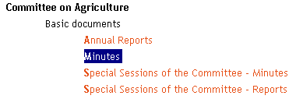
Regular and occasional reports issued by the Director-General can be found under:

JOBS (informal restricted documents)
What is available here?
Pre-programmed queries of the Documents online database permitting the easy retrieval of informal restricted documents produced by WTO bodies and circulated with a JOB symbol. Jobs are basically the same as any other official document except that they remain permanently restricted and are accessible only by Members and Secretariat staff. This section is not available in Documents online on the Internet Web site of the World Trade Organization.

How to find this section
go to Browse documents > Frequently consulted and then
click on Jobs (informal restricted documents).

How does it work?
The JOB symbol is composed of a two digit number indicating the year of distribution of the document in question, followed by a sequential serial number (up to five digits):
JOB(YEAR)/serial number: JOB(02)/12345 (job 12345, issued in the year 2002)
JOBS are organized into two sections:

- all jobs by year: click on a time-frame to retrieve the documents;
- all jobs by topic (broad subject or WTO Body): click on a topic to retrieve the documents.

Please note
The Secretariat issues other informal restricted documents for paper distribution in WTO meetings or for dispatch to Delegations; these documents are also referred to as (internal) jobs although they do not bear a JOB symbol, nor are they distributed electronically via Documents online. Members requiring an electronic copy of such documents should contact the responsible division directly.

Meetings agendas and "Daily Bulletin"
What is available here?
Pre-programmed queries of the Documents online database permitting the easy retrieval of WTO official airgrams (WTO/AIR/…) in which draft agendas for meetings of WTO official bodies are circulated.
The Daily Bulletin, produced in English only by the Secretariat, contains summary reports of these meetings.
This section is not available in Documents online on the Internet Web site of the World Trade Organization.

How to find this section
go to Browse documents > Frequently consulted and then
click on Meeting agendas and Daily Bulletin.

How does it work?
Airgrams are arranged by type of body in reverse chronological order. There are four types of body:

- Committees / Sub-Committees
- Negotiating Groups / Working Groups / Working Parties
- Other Bodies
- Overseeing Bodies

Click on a link to retrieve the documents
The Daily Bulletin is arranged in reverse chronological order by year and then by month:
Click on a month to retrieve the respective documents

Legal Texts and Agreements
What is available here?
Pre-programmed queries of the Documents online database permitting the easy retrieval of WTO and GATT Agreements, Decisions, Declarations, Protocols and Understandings; a number of older legal texts are also available here (Havana Charter, the GATT Enabling Clause and selected Kennedy Round texts).
Documents are organized alphabetically by organization; they are also re-grouped into broad subject categories.

How to find this section
go to Browse documents > Frequently consulted and then
click on Legal Texts and Agreements.

How does it work?
Choose a section by clicking on a bookmark at the top of the page:
Click on a name in the list of legal texts to retrieve the document from the database, which is then displayed on screen in the standard Documents online format.

Ministerial Sessions
What is available here?
Pre-programmed queries of the Documents online database permitting the easy retrieval of preparatory, formal and informal documents produced for the WTO Ministerial Conferences.

How to find this section…
go to Browse documents > Frequently consulted and then
click on Sessions of the Ministerial Conference.

How does it work?
Documents are arranged in reverse chronological order by Ministerial Session and then by type of information produced; click on a link to retrieve the documents:

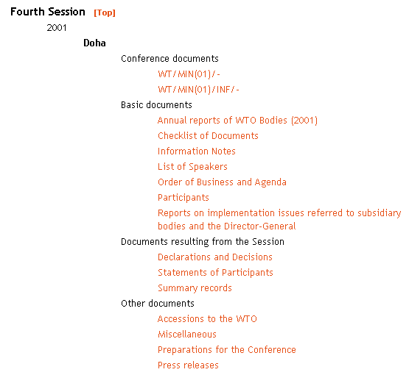

A section of the WTO public web site is also dedicated to WTO Ministerial Conferences and contains additional documentary information.

Special Meetings
What is available here?
Pre-programmed queries of the Documents online database permitting the easy retrieval of press releases, reports and other information documents relating to miscellaneous conferences, seminars, symposia, meetings and workshops organized by the WTO.
Pre-programmed queries of the Documents online database permitting the easy retrieval of press releases, reports and other information documents relating to miscellaneous conferences, seminars, symposia, meetings and workshops organized by other organizations that are of relevance to the work of the WTO.

How to find this section
go to Browse documents > Frequently consulted and then
click on Special meetings.

How does it work?
Documents are arranged in reverse chronological order by category of meeting and then by type of information produced.

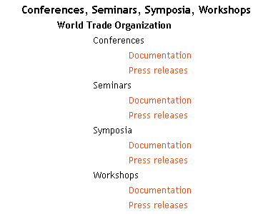
Click on a link to retrieve the respective documents.

Background papers
What is available here?
Pre-programmed queries of the Documents online database permitting the easy retrieval of selected WTO documents which provide a basic introduction to key topics monitored by the Secretariat.

How to find this section…
go to Browse documents > Frequently consulted and then
click on Background Papers.

How does it work?
Documents are arranged by broad subject and then alphabetically by topic within each subject:

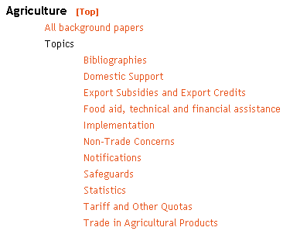
Click on a link to retrieve the respective documents.

Relating to specific meetings

Meetings
What is available here?
Quick access to the list of meetings of official bodies of the WTO, by date or by subject, with the possibility of retrieving, consulting and downloading documents connected with the meetings cited.
Data are available from January 2003 onwards.

How to find this section
go to Browse documents > Relating to specific meetings

How does it work?
Browse meetings by date
Build your query step by step:
Click on [Find]
- All meetings recorded for the current year and month are automatically displayed on screen
- Choose a year and a month to modify the selection
- Meetings for which document associations exist appear as active links in the list; click on a link to display the documents. When a large number of documents are associated with a meeting, additional links will appear at the top right of the search results page. Click on Part 1, 2 etc. to display the subsequent pages of documents
- To download all associated documents directly without displaying them, click on Download to the right of the meeting in question. The documents are compressed and stored in a self-executing .exe file, together with an index of all items included. Note that if you are in the French interface, the French versions of documents will be included in the file; when a document does not yet exist in French, the English or Spanish version will be included, depending on availability
Browse meeting by subjects and date
Build your query step by step:
Click on [Find]
- Click on a subject to display the list of meetings associated with that subject
- All meetings recorded for the current year are automatically displayed; choose a year and a month to modify the selection
- Meetings for which document associations exist appear as active links in the list; click on a link to display the documents. When a large number of documents are associated with a meeting, additional links will appear at the top right of the search results page. Click on Part 1, 2 etc. to display the subsequent pages of documents
- To download all associated documents directly without displaying them, click on Download to the right of the meeting in question. The documents are compressed and stored in a self-executing .exe file, together with an index of all items included. Note that if you are in the French interface, the French versions of documents will be included in the file; when a document does not yet exist in French, the English or Spanish version will be included, depending on availability
Please note
Online help is available when using this section; in the search interface, click on to the right of the field for which you require help.

Relating to a specific subject area

Documents by Subject
What is available here?
Quick access to WTO or GATT and Uruguay Round documents by year and by subject using the online thematic help file of Documents online.
How to find this section…
go to Browse documents > Relating to a specific subject area and then
click on WTO document series or GATT - Uruguay Round document series.
How does it work?
Choose a year - when searching in either document collection, the user is always required to specify a year since a wider search of the database will generally retrieve more documents than can be displayed in the results list (the maximum is 750 items). To facilitate searching in the Uruguay Round document collection, a help file indicating the time-period in which each Negotiating Group was active is available on the search page behind .
Click on [Find] to choose a topic.
Each topic is organized hierarchically; to expand the data tree for a specific subject, click once on . To expand the data tree for all subjects, click once on Complete List.
Once a topic has been selected, the search is launched automatically and the results are displayed on screen in the standard format.
Please note
The Documents by subject interface is intended to provide users who are unfamiliar with Documents online and the structure of WTO documentation with a quick introduction to the retrieval of material by topic. To perform a detailed search of Documents online using more specific criteria, go to SEARCH FOR DOCUMENTS.

Searching for documents

Introduction
Documents online offers two types of search technique: full-text searching and database (catalogue) searching.
Full-text searching permits the identification of a single word or words or phrase within the text of an official document; database searching enables the identification of documents on the basis of specified criteria such as symbol, title, country, circulation date, subject, official body, meeting dates, etc. When applied in tandem, these techniques enable the user to perform very precise searches, which filter out documents that do not correspond to the search criteria.
Two search modes are available: simple and advanced.
Simple
In this mode, the search is constructed by entering criteria in one or more of several key data fields
(C) = catalogue data field:

Document symbol (C)
Document title (C)
Document number (C)
Countries (C)
Full text search criteria
Document date (C)

Advanced
In this mode, the search is constructed by entering criteria in one or more of the full range of catalogue data fields. In addition to the key fields of the simple interface, the following data fields are available:

Collection (C)
Access level (C)
Subject (C)
Countries (C)
Organizations (C)
Products (C)
WTO/GATT Articles (C)
WTO/GATT Bodies (C)
Type (C)
Derestriction date (C)
Meeting date (C)
Posting date (C)
Hits per page

Click on [Search] in the top left-hand corner of the screen The simple mode is proposed by default; click on [Advanced] or [More fields] to change to the more detailed search screen.
Please note
Catalogue data for WTO documents are currently only available in English. When using the French or Spanish interfaces, the names of the fields which require text to be entered in English appear in bold type.

Online help
A considerable effort has been made to ensure that Documents online is as "user-friendly" as possible. Specific help files are available on-screen behind to assist users in the interrogation of the database. They can be used, for example, to identify document symbols, country names, product names, the numbering conventions of Articles in WTO Agreements, the names of WTO bodies, etc.
In the "Browse documents" section, users can quickly retrieve and view the "most frequently consulted documents" in the database simply by clicking on hyperlinks. This kind of searching requires no prior knowledge of the structure of WTO documentation or of the current nomenclature.

Simple search

Search by Symbol
Purpose of field: to limit the search for documents by document symbol.
If you are familiar with the WTO document nomenclature, you can type the symbol search criteria directly in the field. A symbol can be retrieved by searching on its full form or by its constituent parts. Boolean operators (and, or, and not) can be used to combine different criteria. The wildcard * may also be used.

Example 1

To retrieve: all documents in the WT/ACC/… series relating to Estonia
Type: WT/ACC/* and EST*
This will retrieve the following symbols: WT/ACC/EST/… and also WT/ACC/SPEC/EST/…

You can also type: (WT/ACC/* or WT/ACC/SPEC/*) and EST*

Do not type: ACC/EST* (the first part of the symbol is required in the search query)

Example 2

To retrieve: all documents in the IP/Q/… series
Type: IP/Q*
This will retrieve the following symbols: IP/Q/…; IP/Q2/…; IP/Q3/…; IP/Q4/…

To retrieve: all documents in the IP/Q2/… or IP/Q3/… series relating to the USA
Type: (IP/Q2* or IP/Q3*) and USA*
This will retrieve the following symbols: IP/Q2/USA/… and IP/Q3/USA/…

Example 3

To retrieve: all documents in the G/SPS/… series
Type: G/SPS*
This will retrieve the following symbols: G/SPS/...; G/SPS/ENQ/...; G/SPS/GEN/...; G/SPS/GN/...; G/SPS/INF/...; G/SPS/N/MEMBER/...; G/SPS/N/MEMBER/P/...; G/SPS/NNA/...; G/SPS/R/...; G/SPS/W/...

To retrieve: all documents in the G/SPS/… series that are notifications by Turkey or Germany
Type: G/SPS/N* and (TUR* or DEU*)
this will retrieve the following symbols: G/SPS/N/DEU/… and also G/SPS/N/TUR/…

Search by Title
Purpose of field: to limit the search for documents by a word or words in the title.
You can search by full title, by phrases from the title or by entering individual keywords from the title separated by boolean operators. To search for words in the title of documents in French or Spanish, you must use the corresponding language interface in Documents online.
Examples
full title:
Committee on Technical Barriers to Trade - Survey on the Electronic Facilities Available in National Enquiry Points - Supplement
phrases from the title:
National Enquiry Points
keywords separated by boolean operators:
technical and electronic and available
Using the Boolean "and" feature means that both elements of the search have to be found in the title for it to be retrieved. Booleans are not case sensitive. When searching in French or Spanish, the boolean operator must be written in English .

and Finds documents containing all of the specified words or phrases: cooperation and intergovernmental finds documents with both the word cooperation and the word intergovernmental
or Finds documents containing at least one of the specified words or phrases: cooperation or intergovernmental finds documents containing either cooperation or intergovernmental. The found documents could contain both items, but not necessarily
and not Excludes documents containing the specified word or phrase: cooperation and not intergovernmental finds documents with cooperation but not containing intergovernmental. Not must be used with another operator, like and. Documents online does not accept cooperation not intergovernmental; instead, specify cooperation and not intergovernmental
* the asterisk is a wildcard; any letters can take the place of the asterisk. Import* would find import, imports, importation, importation, imported, importing, etc.
( ) use parentheses to group complex boolean phrases. For example, (notification and motor) and (Canada or Japan) finds documents with the words notification and motor, and Canada or Japan, or both

Search tip
WTO document titles are often long and repetitive and do not always clearly reflect the subject content. Search preferably on a word or words appearing in the title combined with the boolean operator "and" rather than on full titles (one error in a word in the title will return a zero result!). Performing a search using data fields other than the title field will probably yield a more pertinent result.

Search by Document number
Purpose of field: to limit the search for documents by document number.
All official documents bear a unique serial (document) number constructed as follows:

02-12345
02- = 2002
12345 = a sequential document number

The serial (document) number appears on the first page, directly beneath the symbol and date, in the top right-hand corner of the document.
Examples:

94-2930 | 1994
95-0001 | 1995
96-1123 | 1996
97-3210 | 1997
98-4321 | 1998
99-2876 | 1999
00-1965 | 2000
01-2764 | 2001
02-10409 | 2002
03-2356 | 2003

Search tip
A quick way to search for all documents issued in a specific year is to enter the year element of the document number, followed by an asterisk (*): 99* will retrieve all documents for the year 1999.

Search by Countries
Purpose of field: to limit the search for documents by country name.
You can type the country search criteria directly in the field if you wish; an online help file is also available. To activate, click on to the right of the countries field in the search interface. The help file is organized alphabetically; if you click on a country name, it will be added to the search form. You can make multiple selections; Documents online will automatically combine your criteria in an or statement.
Please note
When you search in the countries field, you are using an element of the document catalogue record. The catalogue record is only available in English; country search criteria, therefore, must always be entered in English in the search form, regardless of the language of the interface being used. When you use the French or Spanish interfaces, country names are presented in the online help file in French or Spanish; when you make a selection, however, the English form of the country name is copied into the search form.

Country names change over time; when you select a country name through the online help file, previous versions of the name are automatically copied into the search form to enable the retrieval of all documents relevant to the country in question:
Examples
If you select Czech Republic from the list, "Czech Republic" OR "Czech and Slovak Federal Republic" OR "Czechoslovakia" will be copied into the countries field in the search form.
If you select Serbia and Montenegro from the list, "Serbia and Montenegro" OR "Federal Republic of Yugoslavia" OR "Yugoslavia" will be copied into the countries field in the search form.
The countries field is used to index documents which contain significant references to specific countries in the text. For example:
- a document which is an agricultural notification from Canada will be indexed "Canada";
- a document which contains questions from Hungary about an existing notification document from Canada will be indexed "Canada", "Hungary".
It is not possible to distinguish references in which a country is communicating information on its own behalf from those in which a country is in fact the subject of the document. Consequently, some searches using the countries field will retrieve documents that are not relevant to the search criteria - this is especially true of notification documents where, generally, the prime interest in searching by country is to retrieve only those documents which are notifications submitted by the specified country. Since notifications are for the most part catalogued in Documents online with a reference to the notifying country in the title, it is possible to retrieve these items by country by performing a country name search in the title field. It is also possible to perform country-specific searches for notification documents using the Notifications (CRN) search interface of Documents online.

Search by Full text
Purpose of field: to limit the search for documents by a word or words in the body of the text of the document.
Type the text that you are looking for within the documents posted in Documents online and then click on [Search]. Remember to enclose the text in double quotes ("…") if you want to search for a specific string of characters, otherwise the search will be performed on each individual word entered in the full text field.
Select an item from the list of documents displayed on screen and click on Preview (HTML) to view the results of the search in context. Each occurrence within the document of the search criteria is numbered; this number appears at the top of the screen and the search criteria are high-lighted in the body of the text. Documents online automatically positions the cursor on the first occurrence of the search criteria; click on a number to navigate between "hits" in the document.
Example
Type: "environment-related measures"
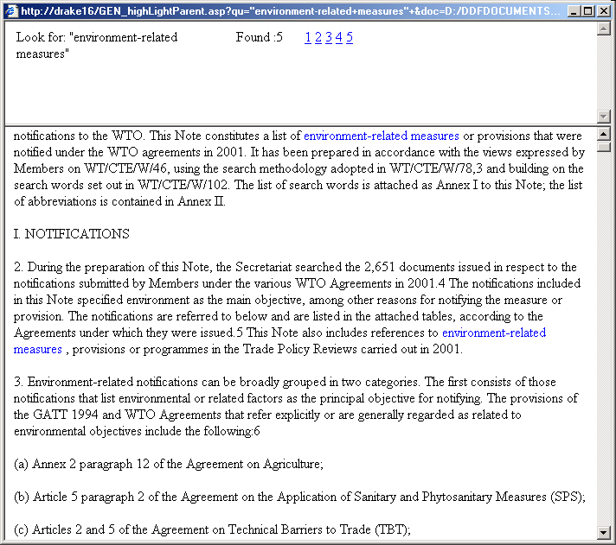

Simple searches
- At its simplest, a search query can be just a word; with the tips on this page, you can refine your search to give you more complete results.
- Look for a phrase by typing the whole phrase. Example - type "developments in international trade" to find the exact phrase developments in international trade. Since the search is not case-sensitive, this is equivalent to Developments in International Trade . Without the double quotes, this query would search for occurrences of all words anywhere in the document instead of where they appear adjacent to each other.

Complex searches
Booleans
- Look for two or more words at once by using the and operator. Example - type measures and butter to find documents that have both the word measures and the word butter anywhere.
- Limit your search by using the and not operator to exclude words. Example - type safeguards and not questions posed to find all instances of safeguards, as long as the phrase questions posed does not appear in the document.
- Use and, or, and not literally by employing double quotes ("..."). Example - type "compile and update" to retrieve and as a word and not as a boolean operator. Without the double quotes, this query would search for occurrences of all words anywhere in the document instead of the specific phrase.
- Use the or operator to look for several unconnected words in a document. Note that if you don't use the or operator and search using multiple words, the words are treated as a phrase. Example - type bananas or salmon to find the word bananas or the word salmon, but not necessarily both.
- Look for words that begin with the same letters by using a single asterisk (*). Example - type import* to find import, imports, importation, importation, imported, and so on.

Please note
By definition, the full text field is language dependent; to search for portions of text within documents in French or Spanish, therefore, you must use the corresponding language interface in Documents online.

Search by Document date
Purpose of field: to limit the search for documents by the date of distribution.
You can type the date directly in the start and end fields, respecting the prescribed format: (dd/mm/yyyy).
You can also use the online calendars to select dates. To activate, click on to the right of the start date and end date fields in the search interface.
Search tip
A quick way to search for all documents issued in a specific year is to enter the year element of the document number in the document number field, followed by an asterisk (*): 99* will retrieve all documents for the year 1999.

Advanced search

Advanced Search by Collection
Purpose of field: to limit the search for documents by document collection.
You can type the collection search criteria directly in the field if you wish; an online help file is also available.
To activate, click on to the right of the Collection field in the search interface. The help file is organized into two groups of collections, one corresponding to GATT documents and the other to WTO documents. If you click on a collection name, it will be added to the search form. You can make multiple selections; Documents online will automatically combine your criteria in an or statement.
Search tip
If you click on GATT or WTO in the online help file, all the individual collections corresponding to each group will be automatically copied into the Collection field on the search form.

Advanced Search by Symbol
Purpose of field: to limit the search for documents by document symbol.
If you are familiar with the WTO document nomenclature, you can type the symbol search criteria directly in the field. A symbol can be retrieved by searching on its full form or by its constituent parts. Boolean operators (and, or, and not) can be used to combine different criteria. The wildcard * may also be used.

Example 1

To retrieve: all documents in the WT/ACC/… series relating to Estonia
Type: WT/ACC/* and EST*
This will retrieve the following symbols: WT/ACC/EST/… and also WT/ACC/SPEC/EST/…

You can also type: (WT/ACC/* or WT/ACC/SPEC/*) and EST*
Do not type: ACC/EST* (the first part of the symbol is required in the search query)

Example 2

To retrieve: all documents in the IP/Q/… series
Type: IP/Q*
this will retrieve the following symbols: IP/Q/…; IP/Q2/…; IP/Q3/…; IP/Q4/…

To retrieve: all documents in the IP/Q2/… or IP/Q3/… series relating to the USA
Type: (IP/Q2* or IP/Q3*) and USA*
This will retrieve the following symbols: IP/Q2/USA/… and IP/Q3/USA/…

Example 3

To retrieve: all documents in the G/SPS/… series
Type: G/SPS*
This will retrieve the following symbols: G/SPS/...; G/SPS/ENQ/...; G/SPS/GEN/...; G/SPS/GN/...; G/SPS/INF/...; G/SPS/N/MEMBER/...; G/SPS/N/MEMBER/P/...; G/SPS/NNA/...; G/SPS/R/...; G/SPS/W/...

To retrieve: all documents in the G/SPS/… series that are notifications by Turkey or Germany
Type: G/SPS/N* and (TUR* or DEU*)
this will retrieve the following symbols: G/SPS/N/DEU/… and also G/SPS/N/TUR/…

If you are unfamiliar with the structure of WTO document symbols, an online thematic help file is available for this field. To activate, click on to the right of the symbol field in the search interface. The thematic help file is organized into broad subject categories; each category breaks down into a hierarchical listing of topics and associated symbols. If you click on a subject, the symbol criteria for this subject (which appear to the right of the window) will be added to the search form. Warning! this type of search will retrieve large numbers of documents, it is advisable, therefore, to perform more specific searches

Top level list of subjects in the Thematic list help file

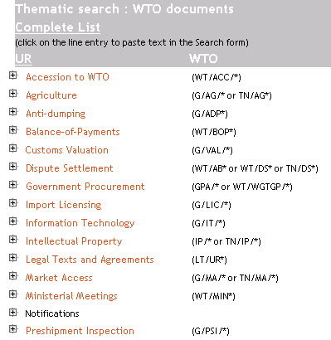

Each topic is organized hierarchically under the broad subject; to expand the data tree for a subject, click once on and then navigate through the list that appears on screen. Click on a line entry to select it for searching - you can make multiple selections; Documents online will automatically combine your criteria in an or statement. To display the full list of topics, click on Complete List. The thematic help file window closes when you launch your search.

Hierarchical breakdown of the top level list subjects

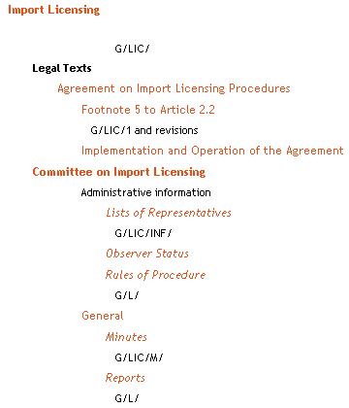

Advanced Search by Document date
Purpose of field: to limit the search for documents by the date of distribution.
You can type the date directly in the start and end fields, respecting the prescribed format: (dd/mm/yyyy).
You can also use the online calendars to select dates. To activate, click on to the right of the start date and end date fields in the search interface.
Search tip
A quick way to search for all documents issued in a specific year is to enter the year element of the document number in the document number field, followed by an asterisk (*): 99* will retrieve all documents for the year 1999.

Advanced Search by Document number
Purpose of field: to limit the search for documents by document number.
All official documents bear a unique serial (document) number constructed as follows:
02-12345
02- = 2002
12345 = a sequential document number

The serial (document) number appears on the first page, directly beneath the symbol and date, in the top right-hand corner of the document.

Examples:

94-2930 | 1994
95-0001 | 1995
96-1123 | 1996
97-3210 | 1997
98-4321 | 1998
99-2876 | 1999
00-1965 | 2000
01-2764 | 2001
02-10409 | 2002
03-2356 | 2003

Search tip
A quick way to search for all documents issued in a specific year is to enter the year element of the document number, followed by an asterisk (*): 99* will retrieve all documents for the year 1999.

Advanced Search by Access level
Purpose of field: to limit the search for documents by security access level.
All official WTO documents bear a security access level for distribution purposes. A document may be:

U - Unrestricted: freely available to the public;
R - Restricted: for the use of WTO Members and selected WTO Observers only;
D - Derestricted: freely available to the public; documents in this category were originally restricted.

You can type the security access level search criteria directly in the field if you wish; an online help file is also available. To activate, click on to the right of the Access level field in the search interface.

Please note
Document derestriction: most restricted documents are derestricted and released to the public by means of a regular process of derestriction.
For further information, see: Derestriction of documents

Advanced Search by Title
Purpose of field: to limit the search for documents by a word or words in the title.
You can search by full title, by phrases from the title or by entering individual keywords from the title separated by boolean operators. To search for words in the title of documents in French or Spanish, you must use the corresponding language interface in Documents online.
Examples
full title:
Committee on Technical Barriers to Trade - Survey on the Electronic Facilities Available in National Enquiry Points - Supplement
phrases from the title:
National Enquiry Points
keywords separated by boolean operators:
technical and electronic and available

Using the Boolean "and" feature means that both elements of the search have to be found in the title for it to be retrieved. Booleans are not case sensitive. When searching in French or Spanish, the boolean operator must be written in English.

and Finds documents containing all of the specified words or phrases: cooperation and intergovernmental finds documents with both the word cooperation and the word intergovernmental
or Finds documents containing at least one of the specified words or phrases: cooperation or intergovernmental finds documents containing either cooperation or intergovernmental. The found documents could contain both items, but not necessarily
and not Excludes documents containing the specified word or phrase: cooperation and not intergovernmental finds documents with cooperation but not containing intergovernmental. Not must be used with another operator, like and. Documents online does not accept cooperation not intergovernmental; instead, specify cooperation and not intergovernmental
* the asterisk is a wildcard; any letters can take the place of the asterisk. Import* would find import, imports, importation, importation, imported, importing and so on
( ) use parentheses to group complex boolean phrases. For example, (notification and motor) and (Canada or Japan) finds documents with the words notification and motor, and Canada or Japan, or both
Search tip
WTO document titles are often long and repetitive and do not always clearly reflect the subject content. Search preferably on a word or words appearing in the title combined with the boolean operator "and" rather than on full titles (one error in a word in the title will result in a zero result!). Performing a search using data fields other than the title field will probably yield a more pertinent result.

Advanced Search by Subject
Purpose of field: to limit the search for documents by subject.
You can type the subject search criteria directly in the field if you wish; an online help file is also available. To activate, click on to the right of the Subject field in the search interface. The help file is an alphabetical list of subjects. If you click on a subject, it will be added to the search form. You can make multiple selections; Documents online will automatically combine your criteria in an or statement.

Advanced Search by Full text
Purpose of field: to limit the search for documents by a word or words in the body of the text of the document.
Type the text that you are looking for within the documents posted in Documents online and then click on [Search]. Remember to enclose the text in double quotes ("…") if you want to search for a specific string of characters, otherwise the search will be performed on each individual word entered in the full text field.
Select an item from the list of documents displayed on screen and click on Preview (HTML) to view the results of the search in context. Each occurrence within the document of the search criteria is numbered; this number appears at the top of the screen and the search criteria are high-lighted in the body of the text. Documents online automatically positions the cursor on the first occurrence of the search criteria; click on a number to navigate between "hits" in the document.
Example
Type: "environment-related measures"

Simple searches
- At its simplest, a search query can be just a word; with the tips on this page, you can refine your search to give you more complete results.
- Look for a phrase by typing the whole phrase. Example - type "developments in international trade" to find the exact phrase developments in international trade. Since the search is not case-sensitive, this is equivalent to Developments in International Trade . Without the double quotes, this query would search for occurrences of all words anywhere in the document instead of where they appear adjacent to each other.

Complex searches
Booleans
- Look for two or more words at once by using the and operator. Example - type measures and butter to find documents that have both the word measures and the word butter anywhere.
- Limit your search by using the and not operator to exclude words. Example - type safeguards and not questions posed to find all instances of safeguards, as long as the phrase questions posed does not appear in the document.
- Use and, or, and not literally by employing double quotes ("..."). Example - type "compile and update" to retrieve and as a word and not as a boolean operator. Without the double quotes, this query would search for occurrences of all words anywhere in the document instead of the specific phrase.
- Use the or operator to look for several unconnected words in a document. Note that if you don't use the or operator and search using multiple words, the words are treated as a phrase. Example - type bananas or salmon to find the word bananas or the word salmon, but not necessarily both.
- Look for words that begin with the same letters by using a single asterisk (*). Example - type import* to find import, imports, importation, importation, imported, and so on.

Please note
By definition, the full text field is language dependent; to search for portions of text within documents in French or Spanish, therefore, you must use the corresponding language interface in Documents online.

Advanced Search by Catalogue
Purpose of field: to limit the search for documents by language.
When you open the search form in Documents online, all language catalogues are automatically selected to ensure that documents existing in the three official languages of the WTO are immediately retrieved by any search – this does not apply if the search was made in the title or full-text fields, which are language-dependent):
You can restrict the search to retrieve documents in English only, or in a different combination of languages (French and Spanish, English and French. etc.), by deselecting the checkboxes on the search form as follows:

Advanced Search by Countries
Purpose of field: to limit the search for documents by country name.
You can type the country search criteria directly in the field if you wish; an online help file is also available. To activate, click on to the right of the countries field in the search interface. The help file is organized alphabetically; if you click on a country name, it will be added to the search form. You can make multiple selections; Documents online will automatically combine your criteria in an or statement.
Please note
When you search in the countries field, you are using an element of the document catalogue record. The catalogue record is only available in English; country search criteria, therefore, must always be entered in English in the search form, regardless of the language of the interface being used. When you use the French or Spanish interfaces, country names are presented in the online help file in French or Spanish; when you make a selection, however, the English form of the country name is copied into the search form.

Country names change over time; when you select a country name through the online help file, previous versions of the name are automatically copied into the search form to enable the retrieval of all documents relevant to the country in question:
Examples
If you select Czech Republic from the list, "Czech Republic" OR "Czech and Slovak Federal Republic" OR "Czechoslovakia" will be copied into the countries field in the search form.
If you select Serbia and Montenegro from the list, "Serbia and Montenegro" OR "Federal Republic of Yugoslavia" OR "Yugoslavia" will be copied into the countries field in the search form.
The countries field is used to index documents which contain significant references to specific countries in the text. For example:
- a document which is an agricultural notification from Canada will be indexed "Canada";
- a document which contains questions from Hungary about an existing notification document from Canada will be indexed "Canada", "Hungary".
It is not possible to distinguish references in which a country is communicating information on its own behalf from those in which a country is in fact the subject of the document. Consequently, some searches using the countries field will retrieve documents that are not relevant to the search criteria - this is especially true of notification documents where, generally, the prime interest in searching by country is to retrieve only those documents which are notifications submitted by the specified country. Since notifications are for the most part catalogued in Documents online with a reference to the notifying country in the title, it is possible to retrieve these items by country by performing a country name search in the title field. It is also possible to perform country-specific searches for notification documents using the Notifications (CRN) search interface of Documents online.

Advanced Search by Organizations
Purpose of field: to limit the search for documents by organization.
You can type the organization search criteria directly in the field if you wish; an online help file is also available. To activate, click on to the right of the Organizations field in the search interface. The help file is organized alphabetically; if you click on the name of an organization, it will be added to the search form. You can make multiple selections; Documents online will automatically combine your criteria in an or statement.
Please note
When you search in the Organizations field, you are using an element of the document catalogue record. The catalogue record is only available in English; organization search criteria, therefore, must always be entered in English in the search form, regardless of the language of the interface being used.

Advanced Search by Products
Purpose of field: to limit the search for documents by product name.
You can type the product search criteria directly in the field if you wish; an online help file is also available. To activate, click on to the right of the Products field in the search interface. The help file is organized alphabetically; if you click on a product name, it will be added to the search form. You can make multiple selections; Documents online will automatically combine your criteria in an or statement.

Please note
When you search in the product field, you are using an element of the document catalogue record. The catalogue record is only available in English; product search criteria, therefore, must always be entered in English in the search form, regardless of the language of the interface being used.

Data are only entered in this field when a product or products make up a significant part of the document content; documents containing numerous and repeated references to many products are NOT indexed.

Examples

Indexed with a product entry

- G/TBT/N/THA/45 Committee on Technical Barriers to Trade - Notification - Thailand – Jewellery.
Products: jewellery; precious stones.

- WT/DS18/R Australia - Measures Affecting Importation of Salmon - Report of the Panel.
Products: salmon.

- G/ADP/N/70 Committee on Anti-Dumping Practices - Reports under Article 16.4 (October 2000) - Note by the Secretariat.
Products: ammonium nitrate; batteries; equipment (electric); magnesium; meat (bovine); microwave ovens; potatoes; salmon; stainless steel bars; steel products; synthetic fibre products; tin; yarn (synthetic).

- G/SPS/GEN/377 Committee on Sanitary and Phytosanitary Measures - Evolution of the Foot-and-Mouth Disease Eradication Plan in Argentina - Communication from Argentina.
Products: bovine animals; goats; live animals; sheep.

NOT indexed with a product entry

- G/ADP/N/98/IND Committee on Anti-Dumping Practices - Semi-Annual Report under Article 16.4 of the Agreement – India.
- GPA/W/229 Committee on Government Procurement - Communication from Canada - Responses from Canada to Questions from Hong Kong, China (GPA/W/218) Regarding Proposed Modifications to Canada's Annex 1 of Appendix I (GPA/W/203.
- WT/TPR/S/110 Trade Policy Review Body - Trade Policy Review - Maldives - Report by the Secretariat.
- WT/ACC/SPEC/RUS/25/Rev.1/Add.1 Working Party on the Accession of the Russian Federation - Draft Report of the Working Party on the Accession of the Russian Federation to the World Trade Organization – Addendum.

Advanced Search by WTO/GATT Articles
Purpose of field: to limit the search for documents by articles of the WTO agreements.
You can type the articles search criteria directly in the field if you wish; an online help file is also available. To activate, click on to the right of the WTO/GATT Articles field in the search interface.
The help file is organized alphabetically by agreement acronym:
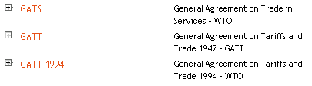
If you click on the acronym of an agreement, it will be added to the search form and the search will retrieve all documents in the database that have been indexed with a reference to the WTO agreement selected. Warning! this type of search will retrieve large numbers of documents, it is advisable, therefore, to perform more specific searches.
If you wish to search by individual articles of a specific agreement (eg. the General Agreement on Trade in Services), once you have opened the online help file, first click on to the left of the acronym GATS. A list of all articles in the agreement that have been used to index records in the database will appear in the popup window:
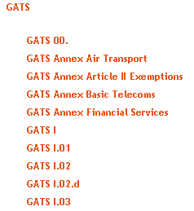
Click on an article in the list. You can make multiple selections; Documents online will automatically combine your criteria in an or statement.

Please note
When you search in the WTO/GATT Articles field, you are using an element of the document catalogue record. References to articles of agreements appear in a number of different forms in official documents; using this field will ensure that your search retrieves all documents for which an entry for an article has been made in the document catalogue. A full text search using the criteria (GATS and article II), for example, will not necessarily retrieve all relevant documents since the Article in question may be referenced in different ways in the text of documents - "Article II of the General Agreement on Trade in Services", "GATS, Article II", etc.)

Advanced Search by WTO/GATT Bodies
Purpose of field: to limit the search for documents by names of official bodies of the WTO and GATT.
You can type the bodies search criteria directly in the field if you wish; an online help file is also available. To activate, click on to the right of the WTO/GATT Bodies field in the search interface. The help file is organized alphabetically; if you click on the name of a body, it will be added to the search form. You can make multiple selections; Documents online will automatically combine your criteria in an or statement.

Advanced Search by Type
Purpose of field: to limit the search for documents by type of document.
You can enter the type of document search criteria directly in the type field if you wish; an online help file is also available. To activate, click on to the right of the Type field in the search interface. The help file is organized alphabetically; if you click on a type, it will be added to the search form. You can make multiple selections; Documents online will automatically combine your criteria in an or statement.

Search tip
"notification" appears as a document type and also as a subject in the online help file for the subject field. Note the difference in meaning:

searching on notification as a type will retrieve all documents that are notifications made to the Secretariat by Members;
searching on notification as a subject will retrieve all documents that describe the notification procedure in some way.

Advanced Search by Derestriction date
Purpose of field: to limit the search for documents by date of derestriction.
You can type the date of derestriction directly in the start and end fields, respecting the prescribed format (dd/mm/yyyy); you can also use the online calendars to select dates. To activate, click on to the right of the start date and end date fields in the search interface.
Please note
Document derestriction: most restricted documents are derestricted and released to the public by means of a regular process of derestriction.
For further information, see: Derestriction of documents

Advanced Search by Meeting date
Purpose of field: to limit the search for documents by the date of a meeting.
You can type the date directly in the meeting date field, respecting the prescribed format (dd/mm/yyyy); you can also use the online calendar to select a date. To activate, click on to the right of the Meeting date field in the search interface.
Please note
It is not possible to perform date range searches in the Meeting date field (i.e. searches between two specified dates); if a meeting takes place over two or more days, enter only one date that corresponds to a day of the meeting and launch your search.

Advanced Search by Posting date
Purpose of field: to limit the search for documents by date of posting on the Internet.
You can type the date directly in the start and end fields, respecting the prescribed format (dd/mm/yyyy); you can also use the online calendars to select dates. To activate, click on to the right of the start date and end date fields in the search interface.

Advanced Search by Hits per page
Purpose of field: to modify the number of documents displayed in the results list.
When you perform a search of Documents online, a maximum of 21 documents (in all language versions) is displayed in the list of results. To facilitate downloading, you can modify the number of items displayed per page so that all the results of your search appear in one list.
To modify the list, enter 999 as the number of hits to be displayed.

Notifications (CRN) search interface
Purpose of interface: to permit the retrieval of notification documents by means of specific kinds of search.
There are two ways of searching for notification documents: either through the advanced search interface of Documents online or by using the Notifications (CRN) search interface.
advanced search interface
- always type "notification" in the type field
- if you know the symbol of the document, you can type it directly in the document symbol field (a symbol can be retrieved by searching on its full form or by its constituent parts; boolean operators [and, or, and not] can be used to combine different criteria; the wildcard * may also be used)
- if you wish to limit the search by date, you can type dates directly in "start" and "end" of the document date field, respecting the prescribed format: (dd/mm/yyyy). You can also use the online calendars to select dates. To activate, click on to the right of the start date and end date fields in the search interface.
Search tip
A quick way to search for all documents issued in a specific year is to enter the year element of the document number in the document number field, followed by an asterisk (*): 99* will retrieve all documents for the year 1999.
- if you wish to limit the search to notification documents submitted by a specific WTO Member, enter the corresponding name either in the countries field or in the title field – see below.
Please note
In the countries field, it is not possible to distinguish references in which a country is communicating information on its own behalf from those in which a country is in fact the subject of the document. Consequently, some searches using the countries field will retrieve documents that are not relevant to the search criteria - this is especially true of notification documents where, generally, the prime interest in searching by country is to retrieve only those documents that are notifications submitted by the specified country. Since notifications are for the most part (but not exclusively) catalogued in Documents online with a reference to the notifying country in the title, it is possible to retrieve these items by country by performing a country name search in the title field.
- if you wish to search for a specific word or words in the body of the text of the document, type the text that you are looking for in the full text search criteria field. Remember to enclose the text in double quotes ("…") if you want to search for a specific string of characters, otherwise the search will be performed on each individual word entered in the full text field.
- click on [Search] to launch the query

Notifications (CRN) search interface

Searching for notifications
- this interface permits the retrieval of notification documents using specific data fields of the CRN (Central Registry of Notifications) database. The search mechanism operates in the same way as the standard search interface of Documents online, and offers similar online help features to assist the user in formulating his/her queries. Documents retrieved by a search are presented in the standard display format of Documents online and may be consulted directly on-screen or, alternatively, downloaded to a local computer.
- to perform a search, enter specific criteria in one or more of the fields in the search mask, then click on [Search] to launch the query.

Search fields
- Notification number
Purpose of field: to limit the search for documents by the notification's unique numeric identifier.
This number consists of six digits, the first two corresponding to the year in which the notification was recorded in the database: 023280 = notification 3280 for 2002.
- Reception date
Purpose of field: to limit the search for documents by the date of reception of the notification in the CRN Registry.
You can type the date directly in the start and end fields, respecting the prescribed format: (dd/mm/yyyy). You can also use the online calendars to select dates. To activate, click on to the right of the start date and end date fields in the search interface.

- Requirement
Purpose of field: to limit the search for documents by WTO legal requirement.
You can type the requirement search criteria directly in the field if you wish; an online help file is also available. To activate, click onto the right of the Requirement field in the search interface. The help file is an alphabetical list of the WTO Divisions responsible for preparing notification documents; each division is associated with a number of requirements.
If you click on a division name, criteria corresponding to all the requirements managed by that division will be copied into the requirement field on the form for searching:
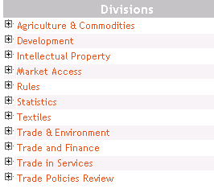
Each requirement is organized alphabetically under the corresponding division name; to expand the data tree for a division, click once on and then navigate through the list that appears on screen. Click on a line entry to select it for searching - you can make multiple selections; Documents online will automatically combine your criteria in an or statement. To display the full list of topics, click on the Back button. The requirement help file window closes when you launch your search:
Clicking on Trade & Environment will display the following requirements:
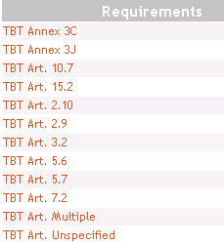

- Members Notifying
Purpose of field: to limit the search for documents by notifying Member name.
You can type the Member search criteria directly in the field if you wish; an online help file is also available. To activate, click on to the right of the Members notifying field in the search interface. The help file is organized alphabetically; if you click on a Member name, it will be added to the search form. You can make multiple selections; Documents online will automatically combine your criteria in an or statement.
Please note
When you search in the Members notifying field, you are using an element of the document catalogue record. The catalogue record is only available in English; Member search criteria, therefore, must always be entered in English in the search form, regardless of the language of the interface being used. When you use the French or Spanish interfaces, Member names are presented in the online help file in French or Spanish; when you make a selection, however, the English form of the Member name is copied into the search form.
- Requirement subject

Purpose of field: to limit the search for documents by subject.
You can type the subject search criteria directly in the field if you wish; an online help file is also available. To activate, click on to the right of the Requirement Subject field in the search interface. The help file is an alphabetical list of subjects. If you click on a subject, it will be added to the search form. You can make multiple selections; Documents online will automatically combine your criteria in an or statement.
- Document date
Purpose of field: to limit the search for documents by the date of distribution of the notification document.
You can type the date directly in the start and end fields, respecting the prescribed format: (dd/mm/yyyy). You can also use the online calendars to select dates. To activate, click on to the right of the start date and end date fields in the search interface.

Trade coverage
Purpose of field: to limit the search for documents by the trade coverage of notifications recorded in the database.
Notifications have been indexed in the areas of product information, trade in services and trade and the environment using three separate classification schemes.
Please note
For details of indexing procedures and the currency of trade coverage data, click on [About trade coverage] in the CRN search interface.

Product coverage using the Harmonized Commodity Description and Coding System (HS02)
Notifications describing measures that affect specific products are indexed where possible according to the HS02. You can type the classification search criteria directly in the field if you wish; an online help file is also available. To activate, click on to the right of the HS field in the Trade coverage section of the search interface. The help file is a hierarchical list of product categories; if you click on a section, it will be added to the search form. You can make multiple selections; Documents online will automatically combine your criteria in an or statement:
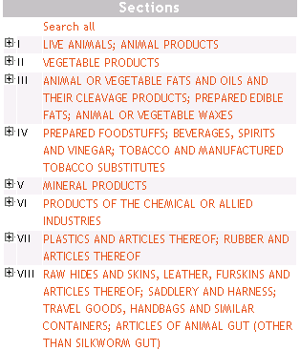

To expand the data tree for a section, click once on and then navigate through the list that appears on screen. Click on a line entry to select it for searching - you can make multiple selections. For example, click on VEGETABLE PRODUCTS to display:
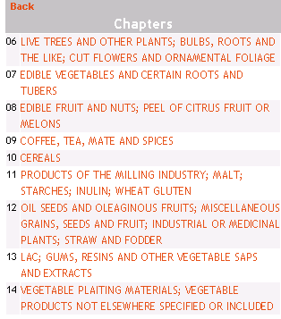
To display the full list of topics again, click on the Back button.
To search on any element of the product classification, open the help file by clicking on , select Search all and then click on [Search] to launch the query.

Trade in Services coverage using the Services Sectoral Classification List (SSCL)
All notifications on trade in services recorded in the database from 1995 onwards have been indexed according to the SSCL (MTN.GNS/W/120, 10 July 1991). You can type the classification search criteria directly in the field if you wish; an online help file is also available. To activate, click on to the right of the Services field in the Trade coverage section of the search interface. The help file is a hierarchical list of topics; if you click on a topic, it will be added to the search form. You can make multiple selections; Documents online will automatically combine your criteria in an or statement:
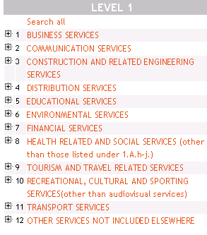
To expand the data tree for a topic, click once on and then navigate through the list that appears on screen. Click on a line entry to select it for searching - you can make multiple selections. For example, click on COMMUNICATION SERVICES to display:
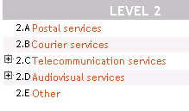
and note that levels 2.C and 2.D break down into a further level of display; click once on to continue – eg. 2.C:
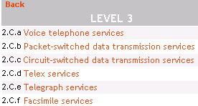
To display the full list of topics again, click on the Back button.
To search on any element of the services classification, open the help file by clicking on , select Search all and then click on [Search] to launch the query.

Environmental coverage using the INFOTERRA Thesaurus Database (UNEP)
All notifications relating to trade and the environment recorded in the database from 1995 onwards have been indexed according to the INFOTERRA classification (designed and maintained by UNEP). You can type the classification search criteria directly in the field if you wish; an online help file is also available. To activate, click on to the right of the Environment field in the Trade coverage section of the search interface. The help file is a hierarchical list of topics; if you click on a topic, it will be added to the search form. You can make multiple selections; Documents online will automatically combine your criteria in an or statement:
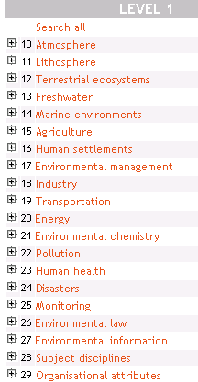
To expand the data tree for a topic, click once on and then navigate through the list that appears on screen. Click on a line entry to select it for searching - you can make multiple selections. For example, click on Environmental management to display:
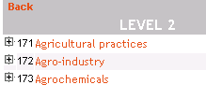

and note that all break down into a further level of display; click once on to continue:

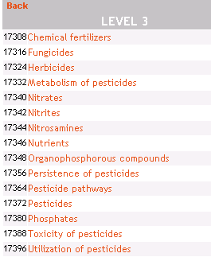

To display the full list of topics again, click on the Back button.
To search on any element of the environment classification, open the help file by clicking on , select Search all and then click on [Search] to launch the query.

Consulting notification documents

The results of a notifications (CRN) search of Documents online are presented in a standard display in which the notification documents are organized by requirement:

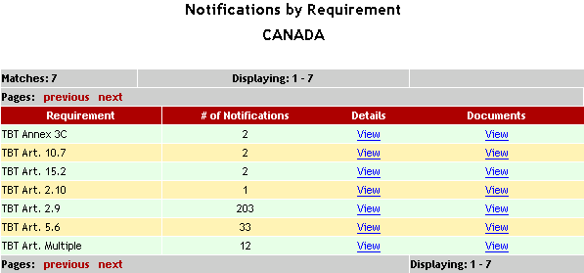

The total number of individual notification documents recorded per requirement is indicated in the second column of the display.
Clicking on View in the Details column displays the full list of notifications associated with the selected requirement, together with their respective catalogue records; the documents appear in reverse chronological order and are sorted by document symbol:
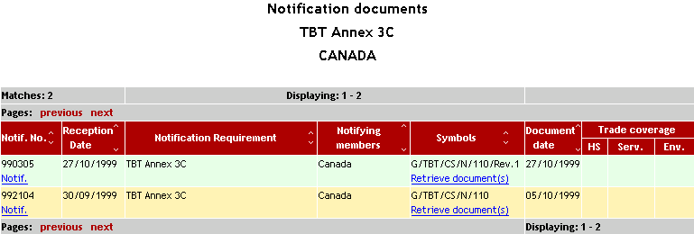

Clicking on Notif. in the Notif. No. column displays the descriptive catalogue record for the selected document.
Clicking on View in the Documents column displays the full list of notification documents associated with the selected requirement using the standard display of Documents online. In this display, the full range of downloading options is available to the user - for further information, see: Consulting documents:
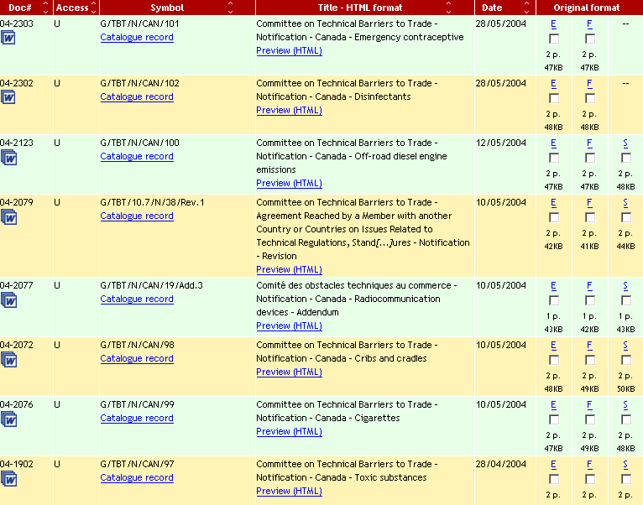

Refining search results by means of a full-text search
The results of a notifications (CRN) search may be further refined by applying full text criteria to the set of documents retrieved by the original query.
To refine the results of a search, follow the procedure described in the example below:
- perform a search for all TBT Article 2.9.2 notifications relating to Canada
- enter "colouring agents" in the Full text search criteria field at the bottom of the page
- click on View in the Documents column to launch the search:

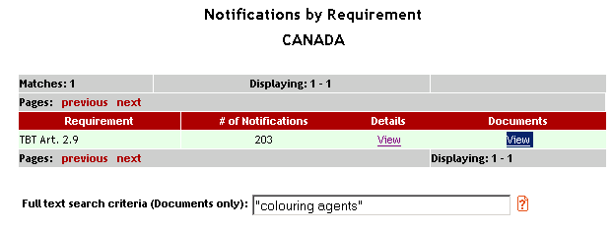
- the results of the search appear on screen in the standard display of Documents online - only three documents contain a reference to "colouring agents":
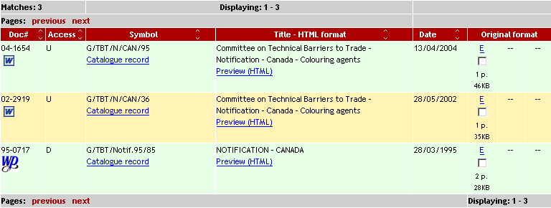

It is also possible to perform a full text search from the "Notification documents" page:
- perform a search for all TBT Article 2.9.2 notifications relating to Canada
- enter "colouring agents" in the Full text search criteria field at the bottom of the page:
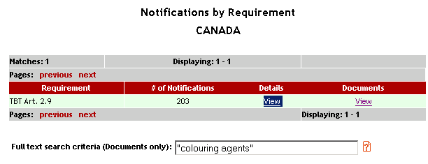
- click on View in the Details column to launch the search
- the results of the search appear on screen in the standard Documents online display – note that the Full text search criteria field contains the criteria that were entered in the previous screen; to retrieve all documents containing a reference to "colouring agents", click on Part 1 at the bottom of the screen:
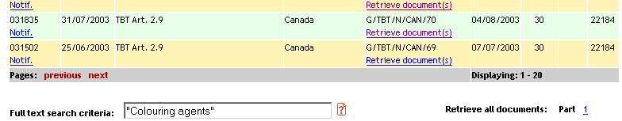
- navigate through the full list of results by clicking successively on the links displayed at the top of the results' page:

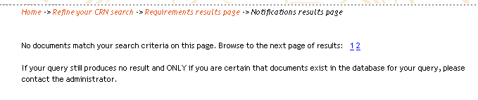

Consulting documents

Understanding the results list
The results of a search of Documents online are always presented in a standard display, whether the query was performed using the Browse or the Search interfaces.
The results appear in reverse chronological order and are sorted by document symbol. The maximum number of documents that may be retrieved by a search is 250 per language (750 in total). The results list provides the following information for each document retrieved:

Doc#: the unique serial number of the document
Access: the restriction status of the document -
R = restricted
U = unrestricted
D = derestricted
Symbol: the unique identifier (symbol) of the document
Title: the truncated title of the document
Date: the date of distribution of the document
Original format: the language versions of the document that currently exist; the number of pages contained in the paper copy of the document; the size in bytes (KB) of the electronic version of the document
The number of matches found by the search appears at the top left corner of the list; note that one document is recorded as 3 matches when it exists in all three official languages of the WTO. Twenty-one (21) documents only are displayed on screen at one time; the [previous] and [next] buttons at the top and bottom of the results display allow the user to navigate through the previous and subsequent pages of the full list of results:
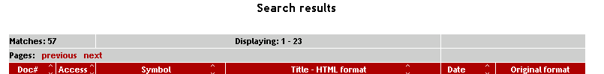

To modify the number of documents displayed per page, click on the drop-down list at the bottom right of the results display and choose a number:
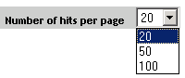

The results list also displays additional document-specific information when appropriate:

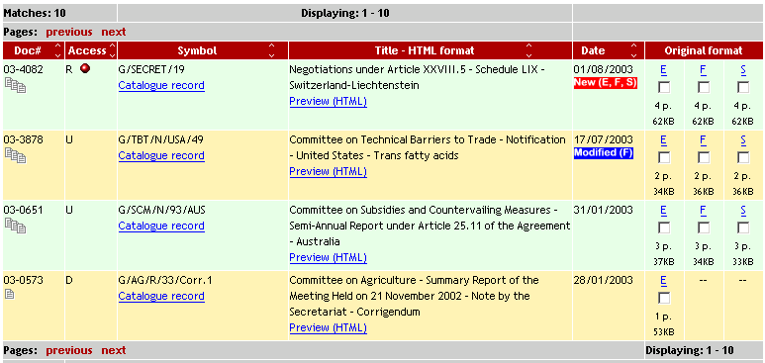

In the above example
in the Access column indicates that the document in question is restricted and for the use of Members and selected Observers only
in the Date column indicates that the document is new today in English, French and Spanish
in the Date column indicates that the text of the French version of the associated WORD document has been modified subsequent to its first posting in Documents online
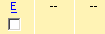 in the Original format column indicates that the English version only of the associated WORD document is available for consultation and/or downloading

Sorting the results list
The results list may be sorted in ascending or descending order by clicking on the arrows in the label at the head of the following display columns: Doc#, Access, Symbol, Title, Date.

Viewing documents online
Documents can be viewed on screen in two ways:
- Display an HTML version of the document by clicking on Preview (HTML) in the Title – HTML format column. Text from the document can be copied into memory or printed directly (without formatting) using the standard print features of the Internet browser.
Please note
The conversion to HTML format is quite rudimentary and is only suitable for displaying plain text; tabular and graphical elements contained in the document are lost or distorted in this view.

- Display the document in its original word-processing format by clicking on E (for English) or F (for French) or S (for Spanish) in the Original format column. This option requires WORD to be installed on your computer.
Please note
Printing a document directly from the Internet display in Documents online may be time-consuming, especially if the document is voluminous. It is advisable, therefore, to first download the document, then open it locally for printing.

Catalogue records
Documents online makes available a descriptive catalogue record for every document stored in the archive. The record is completed in two phases: when the document is first posted in Documents online, basic data fields only are completed:

collection, document symbol, document number, date of distribution, access level, electronic status, filename; title; type

All remaining data fields are completed by the cataloguers in the course of the next 48 hours and the full catalogue record is then posted in Documents online with an updated status and date:

To view a record, click on Catalogue record in the results display.
The catalogue record has three main sections:
- the top part provides basic bibliographical data for the document in question:
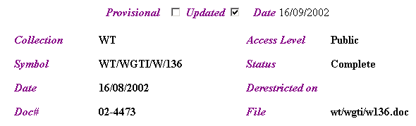

- the main body of the record reproduces the title of the document in the three official languages and provides a brief summary of the content:
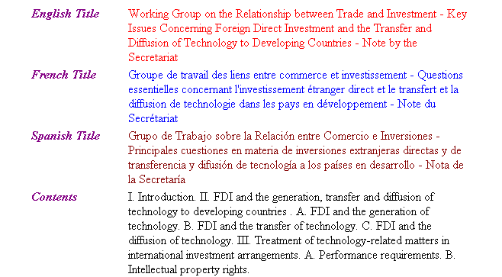

- the last part of the record presents a range of cataloguing data that have been used to describe the document – this information can be used in the search interface for retrieving documents:
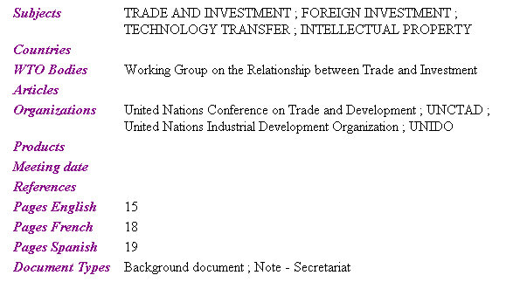

To view consecutively on screen the catalogue records of documents retrieved by a search, click [View all records] at the top of the page.
To print a catalogue record, first open it by clicking on Catalogue record in the results display and then use the standard print features of the Internet browser.

Downloading documents

Introduction
How does it work?
Two options exist for the downloading of documents: unstructured and structured.

Unstructured downloads
The default option which is selected automatically when the user clicks on [Download]. Note that the checkbox "Structured" at the top of the results display in Documents online is not selected:

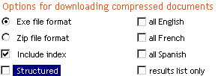

- All documents identified for downloading (by checking one or more language selections, i.e. all English, all French, all Spanish) are saved in a compressed self-executing file (.exe), together with an accompanying index that contains hyperlinks to these documents.
- Clicking on the downloaded .exe file launches a decompression procedure which places the documents in separate language directories (English, Français or Español) in a specified location on the user's computer:
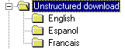
- The index file can be used to identify and open directly the accompanying documents once they have been downloaded and decompressed. For the hyperlinks to work, it is essential that the index and the documents are stored in the same top directory on the user's computer – unstructured download in the illustration.

Structured downloads

- This, the original procedure for downloading documents in the first version of Documents online, enables users to download and store documents in an automatically-generated directory structure that emulates the WTO official document archive. To select this option, check the box marked "Structured" at the top of the results display in Documents online:

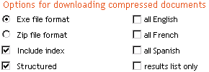

- When the user clicks on [Download], all documents identified for downloading will be saved in a compressed self-executing file (.exe), together with an accompanying index that contains hyperlinks to these documents.
- Clicking on the downloaded file launches a decompression procedure which places the documents in separate language directories (English, Français or Español). Within each directory, a structure is created identifying each document by its symbol and name. In the illustration below, a single document in each of the G/ADP/ and G/AG/ series has been downloaded in the three languages using the structured option:
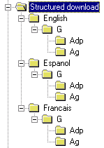
- English corresponds to the document language, G to the document collection and ADP and AG to the document series within that collection. The index file can be used to identify and open the accompanying documents directly. For the hyperlinks to work, it is essential that the index and the documents are stored in the same top directory on the user's computer - Structured download in the illustration.
- If you always use the Structured download option and always place the downloaded files in the same top directory, Documents online will maintain and update your document archive automatically; whenever you download documents in new collections/series, the decompression routine will insert the items in the appropriate place in the tree structure.

All documents retrieved by a search
Select all English, (as in the example below) or all French or all Spanish language versions of documents retrieved through a search by checking the appropriate box at the top of the results display:

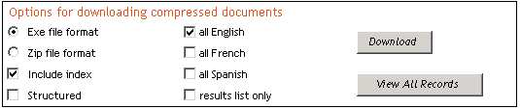

To clear a selection, click a second time in the all English (French, Spanish) check boxes. Once you have made a selection, click [Download]. The "Include index" box is checked by default so that you will always download an index list of the results of your search together with the corresponding documents. If you have made no selection of documents prior to clicking on the download button, an error message will appear requesting you to make a selection.
Documents are automatically compressed when downloaded to accelerate the transfer to disc and are available either as self-executing .exe files or as standard .zip files. A dialogue box appears with an indication of the size of the compressed file that has been prepared – click [OK] to continue:

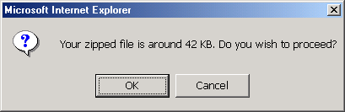

The .exe format is proposed by default. If you wish to modify this option to the .zip format, select the corresponding box at the top of the results list page and then press the download button. If you select the .zip option when downloading files you will require a software on your computer which decompresses files.
The compressed file is automatically named WTODOCS.exe (you can modify the name if you wish). Click [Save] to copy the file to disc:

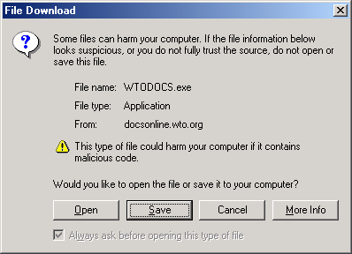

Another dialogue box opens; choose a location on your computer in which to store the file that is about to be downloaded (in the example below, the directory selected is My Downloads) – don't forget to take note of the location!

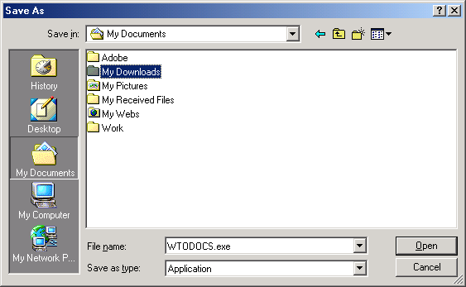

Double-click on the downloaded WTODOCS.exe file on your computer and follow the instructions that appear on screen to decompress. The documents are stored in individual directories by language with the accompanying index file which allows you to navigate directly between documents in the directories (in the example below, ENGLISH and SPANISH directories have been created for the documents originally selected for downloading):
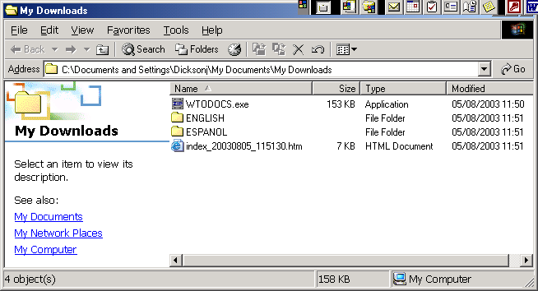

Please note
The results of a search appear on screen in separate pages, with a maximum of 21 documents displayed per page. When the download button is pressed, only the contents of the current page are processed according to the user's selection. To download the remaining documents retrieved by the search, click [next] to turn the page, then repeat the document selection and download procedure. In advanced mode searching, it is possible to increase or decrease the number of documents displayed per page by using the Hits per page field.

The maximum number of documents that can be retrieved by a search is 250 per language (750 in total).

Selected documents retrieved by a search
Download a single document, uncompressed
To download a single document uncompressed, place the cursor over the letter indicating the language version of the document of your choice in the results display and right click once; if you are using Internet Explorer, use the [Save target as] option to download the uncompressed document in its native format (i.e. WordPerfect, Word, Lotus etc) – follow the instructions that appear on screen to copy it to disc. If you are using Netscape Communicator, perform the same operation by using the [Save link as] option.
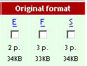

Download two or more documents in compressed format
Select a document or documents in the list of search results by checking the corresponding box beneath the language version(s) of your choice (in the example below, the English and Spanish versions of G/SCM/N/95/SLV have been selected):
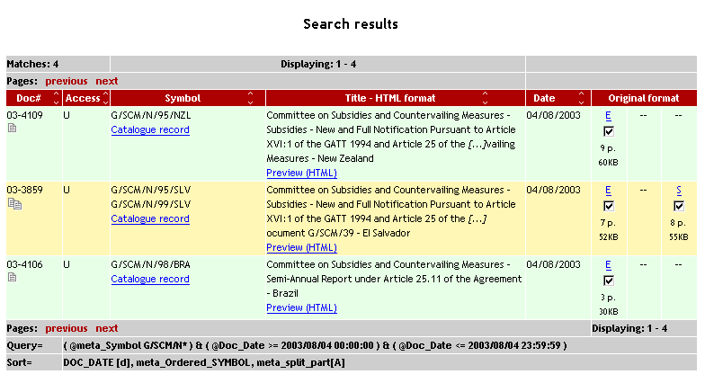

To clear a selection, click a second time in the boxes that have been checked. Once you have made a selection, click [Download]. The "Include index" box is checked by default so that you will always download an index list of the results of your search together with the corresponding documents. If you have made no selection of documents prior to clicking on the download button, an error message will appear requesting you to make a selection.
Documents are automatically compressed when downloaded to accelerate the transfer to disc and are available either as self-executing .exe files or as standard .zip files. The .exe format is proposed by default. If you wish to modify this option to the .zip format, select the corresponding box at the top of the results list page and then press the download button. If you select the .zip option when downloading files you will require a software on your computer which decompresses files.
The downloading procedure for Selected documents retrieved by a search is the same from this point onwards as for All documents retrieved by a search – please see this section for full details of the procedure.

Please note
The results of a search appear on screen in separate pages, with a maximum of 21 documents displayed per page. When the download button is pressed, only the contents of the current page are processed according to the user's selection. To download the remaining documents retrieved by the search, click [next] to turn the page, then repeat the document selection and download procedure. In advanced mode searching, it is possible to increase or decrease the number of documents displayed per page by using the Hits per page field.
The maximum number of documents that can be retrieved by a search is 250 per language (750 in total).

Results list only (no documents)
To download a copy of the list of search results, check "Results list only" at the top of the search results page, and then click [Download]:

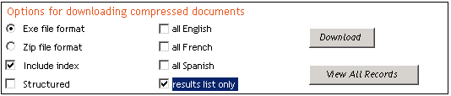

The list is automatically compressed as a .exe file to accelerate the transfer to disc. If you wish to modify this option to the .zip format, select the corresponding box at the top of the results list page and then press the download button. If you select the .zip option when downloading files you will require a software on your computer which decompresses files.

Viewing and printing the Results list
To view the results list on screen and print it without first having to download it:

- perform a search of Documents online and display the results list on screen
- sort the list if the default sorting is not appropriate (in reverse chronological order and by symbol)
- select the "Zip file format" option

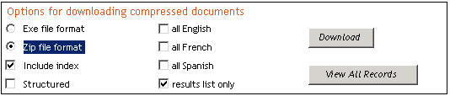

- select the "results list only" option
- click on [Download]
- click[open] in the dialogue box that appears on screen (do not click [save])
- double-click on the index file that is posted to open it
- print the list of results that appears on screen using the standard print features of the Internet browser.

Organizing documents on your computer
In the course of the downloading procedure, Documents online requires you to indicate where the documents should be placed on your computer (a drive name and directory). For practical purposes, it is best to create a specific storage directory for your documents and always to download to that directory. This will enable you to locate your documents quickly and, in addition, the hyperlinks in the index file that accompanies the downloaded documents will always work.

Building and maintaining a structured document archive
If you choose to download documents using the Structured option, Documents online will build an organized archive on your computer which emulates the design of the electronic archive used to store official documents in the WTO Secretariat. This option will automatically incorporate all documents downloaded in the appropriate position in the structure, on condition that the download is always made to the same location on your computer.
For more information on structured v unstructured downloading, see: Downloading documents

Printing documents
Printing
As a rule of thumb, it is best to first download a document to your computer and then open it to print. This is especially true for documents of more than a few pages in size. Printing large documents directly over the network can be very time-consuming.
To print data displayed on any screen of Documents online, use the standard print features of the Internet browser (Ctrl P).

Derestriction of documents

Documents issued after 14 May 2002
Revised procedures for the circulation and derestriction of WTO documents (WT/L/452) were adopted by the General Council on 14 May. These procedures are described in the following document:
WT/L/452

Documents issued before 15 May 2002
Procedures for the circulation and derestriction of WTO documents (WT/L/160/Rev.1) were adopted by the General Council on 18 July 1996 and were applied retroactively to all WTO documents circulated after the date of entry into force of the WTO Agreement, and also apply to all documents circulated up to and including 14 May 2002. These procedures are described in the following document:
WT/L/160/Rev.1

Derestriction procedure in Docsonline
for documents issued after 14 May 2002
- the derestriction of documents for which a date of derestriction can be predicted in accordance with the procedure described in WT/L/452 is automatic and the documents become publicly available in Documents online on the prescribed date;
- all other restricted documents are derestricted individually by the responsible Body when appropriate, in accordance with the procedure described in WT/L/452.

for documents issued before 15 May 2002
- periodically, all restricted documents are reviewed for derestriction by the Organization in accordance with the procedure described in the previous section entitled "Documents issued before 15 May 2002";
- the changed status of newly-derestricted documents is announced in a WTO document which is circulated in the WT/DER/… series. This document is posted on the Internet and is accessible to the general public;
- the Internet database is then updated and the documents are made available to the general public. Normally this procedure is complete within 24 hours of the circulation of each WT/DER/ document issued;
- a list of documents remaining restricted is issued occasionally in the WT/DER/RM/ series.

Contacts

Contacts for WTO documentary resources on the Internet

Documents online

General and technical enquiries +41 (22) 739 5122
Docsonline@wto.org

E-mails may be sent directly from within Documents online by clicking on in
the navigation bar at the top of the screen

IDB/CTS Internet Facilities

IDB Submissions +41 (22) 739 5162
CTS database +41 (22) 739 5195
Technical questions & use of the facilities +41 (22) 739 5864
idb@wto.org

Index

A
Access level 39
Advanced search 35
B
Background papers 25
Booleans 30, 31, 32, 35, 36, 40, 42, 48
Browse documents 19
C
Catalogue records 57, 62
Catalogue searching 29
Central Registry of Notifications 49
Classifications - Environment 54
Classifications - Products 52
Classifications - Services 53
Consulting documents 60
Consulting notification documents 56
Contacts 74
Countries field 33, 43, 51
D
Daily Bulletin 7, 23
Derestriction of documents 73
Directory structure 64
Document archive 8
Document collections 12
Document formats 10
Document number 32
Document posting 8
Document series 13
Document status 14
Document symbols 14
Document types 13
Documents by subject 27
Downloading documents 64, 66, 69
E
EXE file format 64
F
Frequently consulted 21
G
GATT document collections 12
H
Harmonized System (HS) 52
Hits per page 48, 60
HTML format 61
I
Index file 64
INFOTERRA 54
Internet web site 6
ISO country codes 15
J
JOBS (non-symbol documents) 22
L
Latest documents posted 9, 20
Legal Texts and Agreements 23
M
Maintenance 6
Meetings 26
Meetings agendas 23
Microfiche 8
Microsoft Word 97 10
Ministerial Sessions 24
Modified documents 21
O
Observers 5, 6
Official records of WTO Bodies 21
Official working languages 7
Online help 30
Organizing documents on your computer 64, 71
Original format 62
P
Passwords 5
PDF 10, 11
Pre-programmed queries 19, 21, 22, 23, 24, 25
Printing catalogue records 63
Printing documents 72
Printing the results list 70
Product field 45
R
Results list 48, 60, 70
RFT 10
S
Search by Access level 39
Search by Catalogue 43
Search by Collection 35
Search by Countries 33, 43
Search by Derestriction date 47
Search by Document date 35, 38, 51
Search by Document number 32, 38
Search by Full text 33
Search by Full Text 41, 58
Search by Hits per page 48
Search by Meeting date 48
Search by Member notifying 51
Search by Notification number 49
Search by Organizations 44
Search by Posting date 48
Search by Product 51
Search by Products 44
Search by Reception date 49
Search by Requirement 50
Search by Requirement subject 51
Search by Subject 41
Search by Symbol 30, 36
Search by Title 31, 40
Search by Trade coverage 51
Search by Type 47
Search by WTO/GATT Articles 46
Search by WTO/GATT Bodies 47
Searching for documents 29
Searching for notifications 48
Services classifications 53
Simple search 30
Sorting the results list 61
Special Meetings 25
Structured downloads 64
T
Thematic help file 37
Translation process 7
U
Unstructured downloads 64
Uruguay Round documents 11
V
View all catalogue records 63
Viewing documents online 61
W
WordPerfect 5.2 10
WTO document collections 12
WTO documents 10
WTO Members' site 5, 6
WTO sales publications 8

