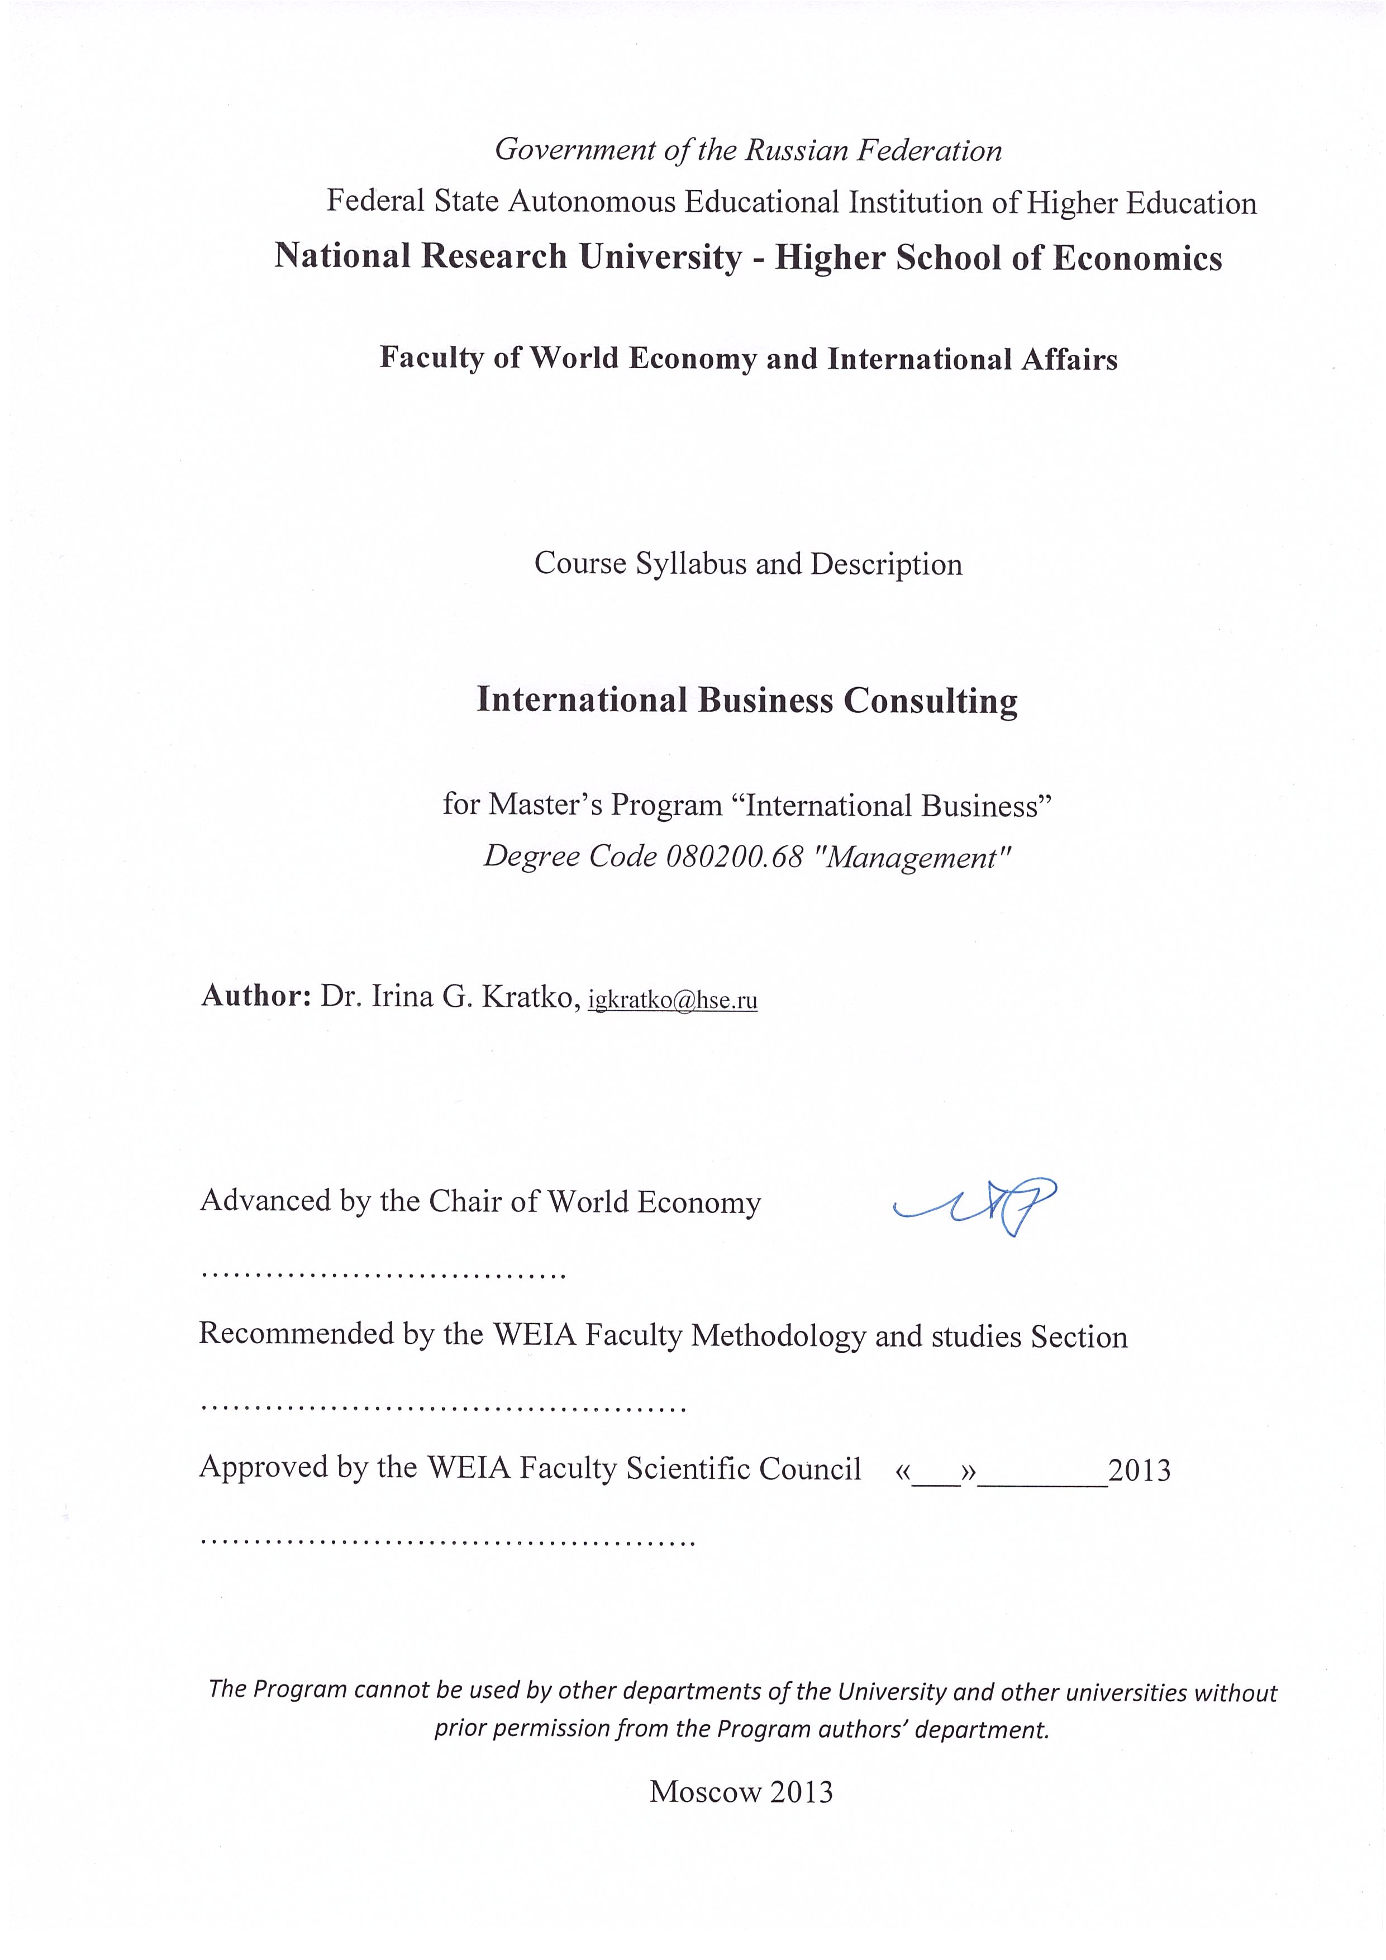
I. Course Overview
The course syllabus sets minimal requirements for student’s knowledge and skills and determines the content and forms of study and performance evaluation.
The course syllabus is designed and suitable for faculty teaching this course, teaching assistants and students studying at the Master’s program “International Business”, Degree code 080200.68 "Management".
The syllabus is developed according to:
- the standard educational requirements of the Federal State Autonomous Educational Institution of Higher Education «National Research University «Higher School of Economics» (HSE) for the Degree code 080200.68 "Management";
- the education program 080200.68.
- the University working curriculum of the Degree code 080200.68 "Management", Master’s Program “International Business”, approved in 2012.

The course was developed with the help of Christopher Tunnard, Professor of the Fletcher School of Law and Diplomacy, Tufts University, USA. Dr. Tunnard kindly provided teaching materials and instructions for the course.

«International Business Consulting» is the program's key consulting seminar. This is an ideal opportunity for students to submerge in the real business world as consulting interns and to carry out real-life client-oriented consulting projects for participating international companies. For the purpose of this field study a project portfolio of the existing and potential business partners – sponsoring international companies – is formed. While working on this project students apply the knowledge and skills they acquired during their studies in the master program.

The international companies participating in the “International Business Consulting” project also represent the base for student practical training and internships and the potential employers for the master program graduates.

COURSE OBJECTIVES

The main goal of the course is to introduce students to consulting process, raise their interest in this area of business activities and provide the necessary expertise and consulting skills. Students gain additional practical experience through the business consulting project.

2. Course Description:
This is a new initiative where students from this course work with sponsoring organizations develop solutions for international corporations and organizations seeking to make strategic decisions. Sponsors get the benefit of actionable and insightful, multi-disciplinary consulting and exposure to a representative sample of HSE talent pool for consideration as interns or employees, while students gain valuable experience working on real-life issues.

This seminar helps students to learn the analytical, project management, and interpersonal skills used in consulting to further their managerial potential. Students in this seminar learn in two ways—through classroom instruction and discussion, and through hands-on work with sponsoring firms. The projects are the focus of the seminar: your assessment of their work represents the majority of their course grade, with professorial input and team self-evaluations counting for the rest.

Projects are meant to provide students with relevant exposure to the consulting activity, including:
- negotiating the scope of the project;
- creating and refining the work plan;
- distributing the roles among the team members;
- planning and executing the required research and analysis;
- reporting the findings on a regular basis;
- producing a final deliverable, typically a presentation setting forth the main recommendations and supporting arguments, and an appendix.

At the end of four months, each team makes a final presentation to the seminar instructor, program liaison, and the sponsoring company. Sponsor representatives have the opportunity to give their feedback at this meeting, which accounts for eighty percent of students‘ final grades.

Student consulting teams are grouped into teams of five and are self-chosen; they work under the supervision of the instructor. We provide sponsor companies with résumés of the consulting team members.
COURSE STRUCTURE
The course consists of two parts. The first part gives instructions to consulting activities. The Seminar instructor teaches skills during the first part of the course; he then switches to a coaching role, meeting weekly with each team to review progress and discuss the next steps.

The second part represents the consulting project itself. As the focus of this course is to give students real-world, practical experience, the student teams are given full responsibility for client contact, including the negotiation of the project scope and deliverables.
COURSE POSITION
The course is taught at the Master’s program “International Business”, in modules 3-4 of the first year of studies.
Status: compulsory course.

PREREQUISITES

The following prerequisites are required for this course:
- World Economy
- International Corporate Finance
- International Marketing

CORE COMPETENCES DEVEPOLED WITHIN THE COURSE

As a result of the course, the student should have the following knowledge and skills:
- ability to develop programs for working with clients and organize their execution, including:
    - ability to collect and process data necessary for completing a specific task;
    - ability to select and use instruments and technologies for data processing, analyze the calculation results and provide recommendations;
    - knowledge of methods of quantitative and qualitative analysis and modeling, and of theoretical and experimental research;
    - ability to form and manage teams for consulting projects;
    - ability to form and manage consulting projects;
    - ability to present research result reports for the consulting projects.

As a result of the course, the student should possess the following competences:

General (Common) Competences

Competence | Descriptors – main features of learning (achievement criteria) | Forms and methods of study. Evaluation methodology
Ability to analyze statistical data and other information. | Able to critically evaluate the client’s proposal and provide recommendations. | Focus groups  Discussions  Test
Ability to generate new ideas and products, creativity and leadership | Able to speak in public on professional topics. Clearly and with reason formulates ideas and articulates thoughts. | Group discussions

Special (Subject-oriented) Competences

Competence | Descriptors – main features of learning (achievement criteria) | Forms and methods of study. Evaluation methodology
Able to polish up and develop an intellectual and cultural level and build a carrier path. | Uses theoretical knowledge and its applications in consulting. | Full-bodied study of compulsory and additional recommended books and articles  Presentations  Group discussions

3. Course Topics:
This innovative course has no analogues and is not available at any other Russian university examined by the author.

Breakdown of topics and hours

№ | Topic | Hours total | Contact Hours |  |  | Homework
№ | Topic | Hours total | Lectures | Semi-nars | Total | Homework
1 | Introduction to consulting | 40 | 20 |  |  | 20
2 | Team consulting project implementation | 140 |  | 60 |  | 80
Overall total: |  | 180 | 20 | 60 | 80 | 100

TEACHING MATERIALS
We will use:
- Research articles of foreign authors.
- Books and textbooks of foreign authors.
- Materials provided by the lector.

COURSE TOPICS DESCRIPTION

1. Introduction to consulting
The first part of the course includes an introduction to and practice in the essential business skills that form the core of professional development for consultants:
• Creating and managing teams
• Understanding, structuring, and solving problems
• Data gathering and analysis
• Interviewing skills
• Structuring presentations and effective communications

Recommended readings (compulsory):
- Minto, Barbara. The Pyramid Principle: Logic in Writing and Thinking. Third ed. London: Pitman Publishing, 1995.
- Publications of McKinsey and Company, Inc. consultants.
- Instructor’s materials

2. Team consulting project implementation
On this stage students employ their skills by completing a team consulting project for a sponsoring organization. In these projects, students will be expected to manage both the substance of the project and work plan, as well as the team’s relationship with the project sponsor, specifically the designated decision-maker and champion. Client sponsor decision makers can be Presidents/CEOs, EVPs, SVPs, VPs, Directors, Managing Directors. The overall satisfaction of the sponsoring client and the project’s ability to be put into action will be of equal importance to the material that the students deliver.

Recommended readings (compulsory):
- Client’s proposal

Seminar Requirements

The seminar requires extensive and intensive classroom participation. Students will lead class discussions, and take an active role in skill-building exercises building up to the group project; early sessions will have frequent in-class exercises in order to assure that participants have a good grasp on the skills and processes being presented and practiced.
The emphasis during the initial sessions will be on in-class performance, supplemented by a selection of readings about the main processes being learned and actual consulting cases. Once the group projects are assigned, the emphasis will shift from individual to team effort, with the class format becoming tutorials with teams to work on their consulting projects.

4. Performance Evaluation
The class will meet once a week for 4 hours. Typically, there will be instructions during the first part of the course and discussions of the consulting projects during the second part. Attendance and participation in the classes are required.
The course concludes with a final presentation describing the results of students’ consulting project.
Each team will receive a grade for their project, input for which will come primarily from the client. The team grade will count for 80% of an individual’s grade; 20% will come from individual assessment by fellow team members. In addition, individual grades may be raised (or lowered) for exceptional performance at the instructor’s discretion.

SAMPLE Project Proposal
Projects typically follow this outline:
- Background information on sponsor
- Current situation
- Key questions to be answered by project
- Implications/decision outcomes of the project/key decision-maker(s)
- Key deliverables and timeframe
- Logistics and collaboration (including identification & contact information of client champion, senior decision- maker)

