Правительство Российской Федерации

Федеральное государственное автономное образовательное учреждение высшего профессионального образования

Национальный исследовательский университет
"Высшая школа экономики"

Факультет философии, отделение востоковедения

Магистерская диссертация

Основные задачи современной иммиграционной политики Японии и их осуществление

Студент группы МА-2
Помелова А. Д.

Научный руководитель
Кандидат наук Щербаков Д. А.

Москва, 2014 г.

Government of the Russian Federation

National Research University Higher School of Economics

Faculty of Philosophy, School of Asian Studies

MASTER’S THESIS

The main tasks of Japanese immigration policy and its implementation

Written by
Pomelova A.D.
Group MA-2

Supervisor
Ph. D. World Economics
D. A. Shcherbakov

Moscow, 2014

Table of contents
Introduction 5
1) Relevance of the topic 5
2) Review of reference literature 7
3) Object and subject under study 8
4) Hypotheses and research tasks 9
5) Review of sources 10
6) Research methods used 11
Main part 12
1. Demographic changes in Japanese society 12
1) Increasing Life Expectancy 12
2) Falling birth rates 13
3) Aging of population, decreasing share of children and those of working age 14
4) Decreasing of whole population 16
5) Foreign population in Japan 17
6) Conclusions 20
2. Social and economic impact 22
1) Rising of social welfare benefit expenditures 22
2) Rising extra burdens on the working age population 23
3) Need in caregivers and new infrastructure 24
4) Labours shortage 25
5) Slowdown of economics 28
6) Conclusions 28
3. The main policies of current immigration control policies. 30
1) Historical background and general framework of IP 30
2) Promotion of measures against illegal foreign residents aiming for the realization of a safe and secure society 33
3) Smooth introduction of a new system of residence management 34
4) Promotion of appropriate and prompt refugee protection 34
5) Smooth acceptance of foreign nationals vitalizing Japanese society 35
4. Analysis of Immigration policies 38
1) Progress in the programmes concerning control and management of foreign residents 38
2) Refugee protection 39
3) Points based system 40
4) Acceptance of medical personnel 41
5) Acceptance of nikkeijin 43
6) Trainee program 45
1. Findings 47
1) Fail to answer the challenges 47
2) No general vision of immigration policy strategy 50
3) Change in social consensus 52
Conclusion 54
References 55
1. Primary sources 55
2. Reference literature 58
Appendix 1 61
Appendix 2 62
Appendix 3 63

Introduction

Relevance of the topic
The steady process of globalization in the last century has contributed a lot to the diminishing of boundaries between the countries and opening doors to the increasing international flows of goods, cultural exchange and migrants.
Although migration existed since the ancient times, the development of modern transport facilities in the last century and favourable international policy factors have promoted mobility of population and have multiplied the amount of migrants in several times. Nowadays about 3.2% of total world population are migrants. To a greater or a lesser extent, nearly all countries are enrolled in the process of human resources’ exchange, and the share of immigrants reaches in some cases composes nearly one third of the country’s population (see appendix 1).
Table 1.
Amount of international migrants 1990-2013, persons.
Year | Estimated number of international migrants at mid-year
1990 | 155 518 065
1995 | 165 968 778
2000 | 178 498 563
2005 | 195 245 404
2010 | 213 943 812
2013 | 231 522 215
Source: United Nations, Department of Economic and Social Affairs, Population Division (2013). Trends in International Migrant Stock: The 2013 revision (United Nations database, POP/DB/MIG/Stock/Rev.2013).
The research of Japanese immigration policy’s case can be interesting at the present time for several reasons. First of all it implements a very unique immigration policy. Unlike most other developed countries it has one of the lowest percentages of the immigrant population. (About 1.76% from total population).
While other states during the industrialization period attracted numerous immigrants in order to sustain high growing rates and now have a problems with a large foreigners community within their borders (exempli gratia civil unrest in France in the year 2005 or England riots in 2011), Japan developed its economy employing mostly the forces of its own population and preserve its homogeneity.
Another reason for studying Japanese immigration policy in the current moment is the upcoming severe demographic crisis in the country. Both the prolong life expectancy (which is one of the most high in the world) and low fertility rates contribute to shrinking and aging of the population. Japanese young and middle-aged population continuously declines and on the contrary, the number of elderly persons increases. That is why Japan is going to face the unprecedented labour lack in the nearest future, and one of the possible decisions of this problem Japanese government has is to increase the number of immigrants. Moreover, some other processes like world globalization, including the culture sphere, and economic interdependence as well leads to “reopening” of Japan to the new immigrants. On the other hand, this decision can cause plenty of other problems. To begin with, Japanese is a very small country with a very limited territory to live in and high density of population. Furthermore, Japanese are not willing to acquire a large amount of immigrants due to cultural and historical peculiarities: they presume that it would be very difficult for the last to become an integrated part of the Japanese society
So it is a very complex and diversified problem. Mr. Wu Hongbo, UN Under-Secretary-General for Economic and Social Affairs stressing the role of the wise immigration policy said, “Migration, when governed fairly, can make a very important contribution to social and economic development both in the countries of origin and in the countries of destination”. So from the way of the implementation of the immigration policy depends not only the share of foreign citizens in the country, but also socio-demographic stability of the country, specificity of national identity, size of its whole population and consequently competitiveness of Japanese economy at the global arena in the future. The example of Japan can show a unique approach towards the problems of immigration policy, which may become useful even for other developed countries, because they also are going to face the same problems connected with population aging in the not so far future.

Review of reference literature
As immigration policy is a vital question for the Japanese society, so there are plenty of books and articles on this issue. My research is based mostly on the English and Russian language with some articles written in Japanese. The most significant works on this question in Russian are two articles in the monograph Japan and the Global Challenges: the Strategy of the struggle and article by S. Markaryan in the monograph Japan: the economy and society in the ocean problems. These articles outline general facts about current state of affairs in immigration policy in Japan and most common problems connected with it, though they do not provide profound analysis of the situation, its reasons and future perspectives.
More explicit are articles in English. The work by Mackie specifically shows connection between questions of border control to Japanese domestic policy’s problems.
Although there are quite a lot of works devoted to the description of suppression and violation of human rights of foreign people in Japan (articles by Debito Arudou, NGO Report Regarding the Rights of Non-Japanese Nationals, Minorities of Foreign Origins, and Refugees in Japan 2010), fewer works suggested specified variants of future development of Japanese immigration policy. Among them the most valuables ones is Sakanaka’s book The Future of Japan’s Immigration Policy: a battle diary.
The authors, who deliberate upon the problem of better way of future development of immigration policy, may be divided into the two camps. The first group assumes that Japanese society should change in order to acquire greater amount of immigrants in order to sustain its economic growth (e.g. Sakanaka 2005, Markaryan 2012, Mackie 2010, Bustamante 2011). While other researchers are opponents of massive immigration and are more confidant that Japan would be able to fulfil the future demand for the workforce by its own “latent” resources, at list partly (Komai 2003, Coulmas 2007, Kobayashi 2009,).
So there is plenty of works dedicated to Japanese immigration policy and majority of them connect it with the aging of population. However, none of them examines the full scope of challenges caused by demographic crises and how they influence government decisions. In my work I am going to fill this vacuum and find out what problems immigration policy is taking into consideration and working on them and what problems it avoids.

Object and subject under study
The object of my work is the analysis of the current Japanese immigration policy, and speaking more precisely, the subject of the work is the efficiency of the implemented policies. This research is focused on the current (from 2010 to 2013) stage of immigration policy and provides an overview of the main steps undertaken by the immigration bureau policy, however the general facts about the immigration policy and demographic changes in the second part of the xx century would be also reflected in the work.
The limitation of my work is that the main focus of the current research is put on the socio-economical and partly cultural aspects of the implementation of immigration policy, whiles such factors as Japanese position and objectives on the international arena or situation on the foreign labour market and other factors external to Japan are left aside the study.

Hypotheses and research tasks
So in my current research I am going to analyse Japanese immigration policy and see how it deals with challenges, what task does immigration bureau set behind itself and how does it put their implementation into the practice. Therefore I want to answer the question whether Japan uses immigration policy’s tools to solve current demographic problems (population aging and shrinking). In order to receive the answer I assign following tasks:
- Determine the main challenges for immigration policy
- Determine the main goals of Japanese immigration policy
- Compare proclaimed policies with the real figures of their implementation
- Through comparison find the weak and strong points of immigration policy, in other words estimate its effectiveness
- If there are unanswered challenges, find for which reasons immigration policy does not answer them.
By fulfilling these tasks I am going to prove following hypothesis:
- Despite what Japanese IP is proclaiming, in reality it does not use IP tools to solve questions of aging and declining population
- Moreover, Japan has no established long-run strategy should it use IP to solve these questions or not
- Inconsistences in IP’s implementation are related to the changes in social consensus towards immigration issue

Review of sources
The current research is mainly based on the analysis of the documents prepared by Immigration Bureau of Ministry of Justice of Japan, in which its general policy is outlined.
Therefore, they comprise the fourth edition of Basic Plan for Immigration Control issued in 2010, which provide the main objectives and priorities for the future Japanese immigration policy and set the development program for the following five years (So from 2010 to 1015). Another major source is the Report on the Immigration Control 2012 issued in the 2013, which contains detailed statistic data concerning foreign population in Japan, and description of the particular measures Japanese government has implemented or is going to implement in the sphere of immigration control in the years 2011 - 2013. The details of the new points-based system for the talented foreigners were examined according to the leaflet on Points-based system that provides highly skilled foreign professionals with preferential immigration treatment.
So these documents present a good perspective on the state of affairs in the modern Japanese immigration policy.
In the work I have also used the various documents which were made by other Japanese ministries and contain statistic data on the dynamic of Japanese population aging and the changes of the labour force market within the country or certain policies concerning foreign residents or population aging. (e.g. White paper on aging population for the 2013 year and Annual Health, Labour and Welfare Reports 2011-2013).

Research methods used
The main method I have used in this paper is the comparison between the proclaimed policies of immigration control, fixed in the official papers, and real figures taken from the statistics. My arguments are also supported by reading of relevant academic literature as well as up to date critic reviews from the newspapers. In the analysis I strengthened focus onto the long-term perspective of the development of the immigration policy. Since my topic of research is considerably wide, I undertook mostly quantitative analysis of the major tendencies without deepen engagement into the motivation of the independent agents (e.g. immigrants). In addition, the abundance of statistic data and official documents leads me to using generalization and classification methods in order to find main objectives and be able to analyse them.
Therefore, the main body of my work is divided into the five sections. In the first one the general statistics facts upon the transformation of the Japanese demographic situation, population ageing, the share of foreigners and trends in the workforce are presented. The second chapter provide an overview of the main challenges, which come from the current demographic situation. The third chapter is devoted to the description of the main directions of the current Japanese immigration policy and outlines the main objectives which immigration bureau sets to itself. The forth chapter describes how these objectives are being implemented in the practice. The fifth chapter is dedicated to the analysis of the immigration policy’s effectiveness, so it provides examination of how implementation of it corresponds with the main challenges of demographic situation. The projects for future and possible ways of the development of the policies are represented in the fifth chapter.

Main part

Demographic changes in Japanese society
In the recent years Japanese society is experiencing drastic demographic changes. Since the middle of the 20th century Japan has turned from the society with large portion of young population and several children in one family into the aging society where people are living longer and there are more and more elder people. The similar processes are ongoing in other developed countries over the World as well. However, Japanese case is exceptional due to profundity and rapidity of the changes.
In this section I am going to outline the main trends in recent Japanese demographic development concerned mainly population aging and shrinking population. Also I will speak about the changes of the share of foreign people in Japanese population. My further analysis of immigration policy would be based upon the challenges, which these changes bring.

Increasing Life Expectancy
Since the period after WW2 life length of Japanese people steadily increased and nowadays Japan is considered to be a nation with one of the most long living population. WHO estimated the life expectancy on birth for Japan in 2012 year to be about 80 years for men and about 87 years for women. It is the 12 and the 1st places in the world respectively. Japan succeeded to increase the average life length for more than by 20 years since the middle of the previous century. And moreover, Japan Ministry of Health, Labour and Welfare predicts that it will continue to develop further and reach about 91 year for women and more than 84 year for men in the year 2060.
Chart 1. Trends and future projections of average life expectancy
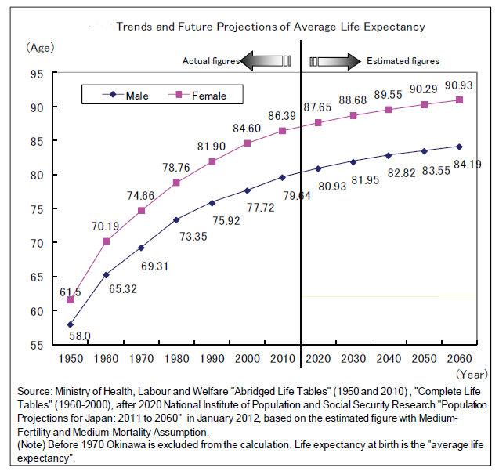

Falling birth rates
Since the end of WW2 the total fertility rate (the average number of children born to a woman during her lifetime) in Japan is drastically falling from more than 4 children per one woman in the 1950s to about 1.3 in the beginning of 21 century. And for more than 40 years TFR stays steady below the replacement level (which is believed to be about 2-2.1 children per woman), leading to the population shrinking. Although the most recent figures demonstrate a slight growth of TFR, (in the year 2012 there was a 16-years maximum of 1.41, compared with historical minimum of 1.26 in the year 2005) the absolute number of total birth has a continuous and strong decreasing tendency and reached a new record low of 1 037 000 in 2012.
Chart 2. Trends in live births and total fertility rates, 1899-2012
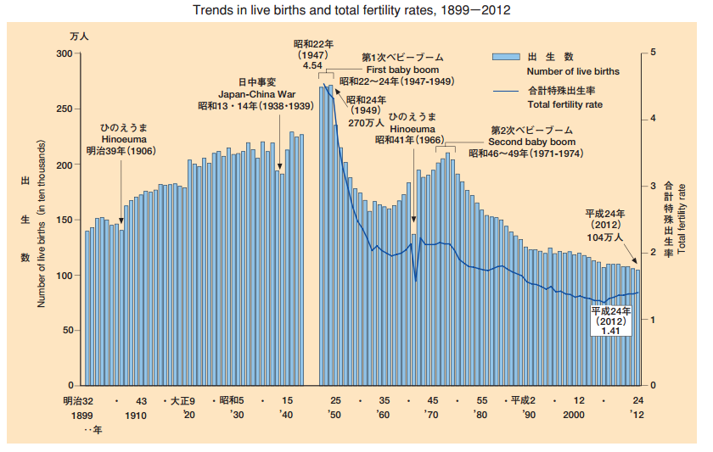
Source: Ministry of Health, Labour and Welfare, Vital Statistics in JAPAN -The latest trends. Available at: http://www.mhlw.go.jp/english/database/db-hw/dl/81-1a2en.pdf

Aging of population, decreasing share of children and those of working age
The major demographic effect of the prolonged life expectancy and falling birth rates is changing in proportions between elder and young population. In other words, less people die and less people are born, and this shift transforms the whole population structure. As in the middle of the 20th century a population pyramid represented a figure with a wide base of young population shrinking toward the top with elder population. However nowadays this image is completely distorted and by the middle of the 21st century it is projected to be reversed and the share of elder people is would be much larger than share of children.

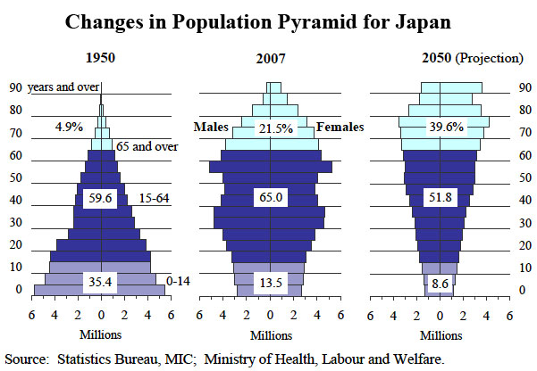
Chart 3

Even today, Japan is one of the quickest aging societies in the world. For the 2012th year the share of the people over 65 years is estimated to be 24.1% of total population and to the year 2060 it will reach almost 40%. On the contrary, share of young population (between 0-14 years) is constantly shrinking from more than 35% after WW2 to 13.1% at the present moment and about 9% in 2050. But what is more important, the number of working age population (20-64 years) supporting each retiree is shrinking even more drastically, from 10 in 1950 to 2.6 nowadays and it would run up to about 1.2 by the year 2060 . In addition, there are fewer replacements in sight.

Chart 4
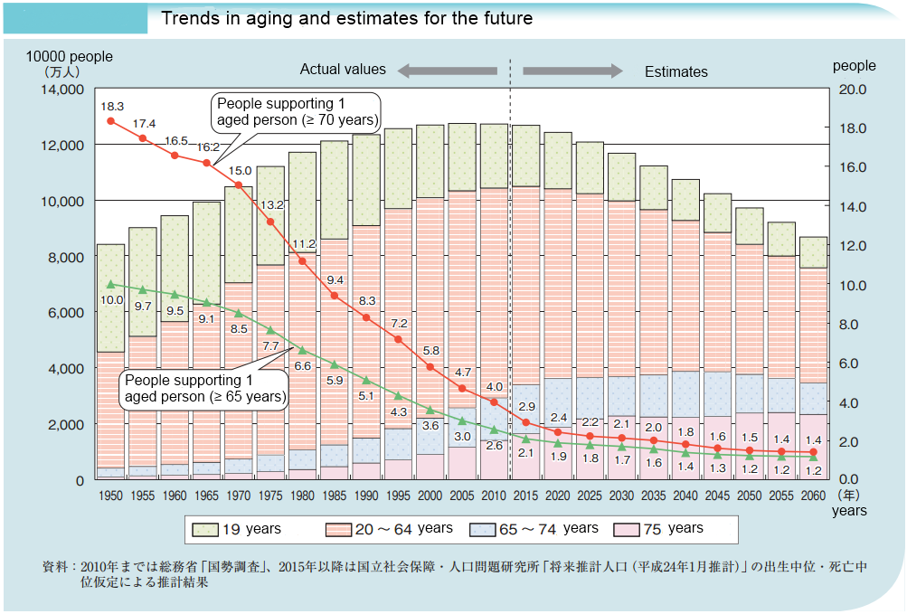
Source: White paper on aging population for the 2012 year. Cabinet Office Japan 2013. Available from http://www8.cao.go.jp/kourei/whitepaper/w-2012/gaiyou/24pdf_indexg.html

Decreasing of whole population
Japan is not only facing aging of population, but also is experiencing its decline. With larger share of old population number of death is also increasing. Moreover, nowadays its quantity surpassed the number of new-borns, which result in population shrinking. Japanese population reached its maximum point in the year 2004 with 127,787 thousand inhabitants and since then is steadily getting smaller. Although now it is only several percent drop (population for 2012 is considered to be 127,515 thousand people), by 2060 it is considered to drastically shrink by one third and plummet to 86,737 thousands. This tendency leads to massive depopulation, which can be already perceived in the rural areas and affects social, economic situation in the country.

Foreign population in Japan
Japan for ages was an isolated island country, which was forced to open its borders for wider world international influence only in the middle of 19th century during Meiji restoration. So traditionally it was a monoethnic country with unprecedentedly homogeneous population and limited number of foreign residences, with the only exceptions for Ainu and Okinawa people who inhabited the fringes of the country and was mostly assimilated by the end of 19th century. Throughout the 20th century, the amount of immigrants steadily increased, but even nowadays the share of foreigners has never exceeded 2% of total population (Chart 1). The major shift in the growth of the share of foreigners can be observed in the years 80th when Japanese economy continued to expand and started experience the shortage of local manual industrial workers (so called bleu-collars). At that time, some laws welcoming foreign labour force were issued.
In the past 7 years, the share of foreign residence almost stabilised around 1.6-1.7% of total population, or slightly more than 2 million of residence. However after peak at 2008 a slight drop in amount of foreigners is observed. It can be explained mainly by the economic recession since the year 2009 and the fact that people are cautious about entering and living in Japan due to the Great East Japan Earthquake disaster and the consequences of the accident at the Fukushima Daiichi Nuclear Power Plant. Now the amount of foreign residence in the country is about 1.76% from the total population or 2 249 720 people.
Chart 5 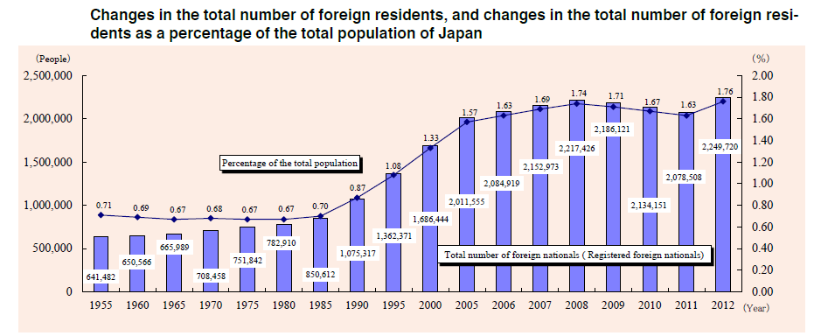 Source: The 19th report “2013 Immigration Control” by Immigration Bureau, Ministry of Justice, JAPAN http://www.moj.go.jp/nyuukokukanri/kouhou/nyuukokukanri06_00042.html p53.
The majority of foreign residence in Japan comes from the neighbour Asian countries: they comprise the Chinese (about 32.5%), Koreans (26.2%) and Philippines (10.1%). It includes so called “old immigrants” - the descents of about 600 thousands of Koreans which migrated (or were forced to migrate) from Japanese colonies to mainland during the Japanese rule in Korea (1910-1945) and remained into the country after the end of the Second World War. At that time, it was considered as internal migration, but according to the San Francisco Peace Treaty in 1952 Japan abandoned its territorial claim to the Korean peninsula and therefore Koreans were deprived of Japanese nationality. The majority of those who rested in Japan was not naturalized and did not receive Japanese citizenship.
The next large group is represented by nikkeijin (People with Japanese roots) - the descendant of people who went to the Latin America in the beginning of the 20th century in search of better life (as Japan of that time was developing poor country) and now want to return to their homeland. So Brazilians compose 10.1% of foreign residents and Peruvian make up about 2.5%. Nikkeijin form a separate privileged group (comparing to other foreigners) of immigrants due to their Japanese origin. Their number rose dramatically in the 1990 year, when the Immigration Control and Refugee Recognition Act was amended, which permits Japanese descendants up to the third generation who live abroad to enter Japan under status of special permanent resident and stay within the county and work without any restrictions. However, due to economic resection in the years 2008-2009, many of those who work in the manufacturing industry lost their job and the government suggested paying for their way back in the condition they will not try to return to Japan. So starting from these years their number declined.
Chart 6. Changes in the number of registered foreign nationals y major nationality 2 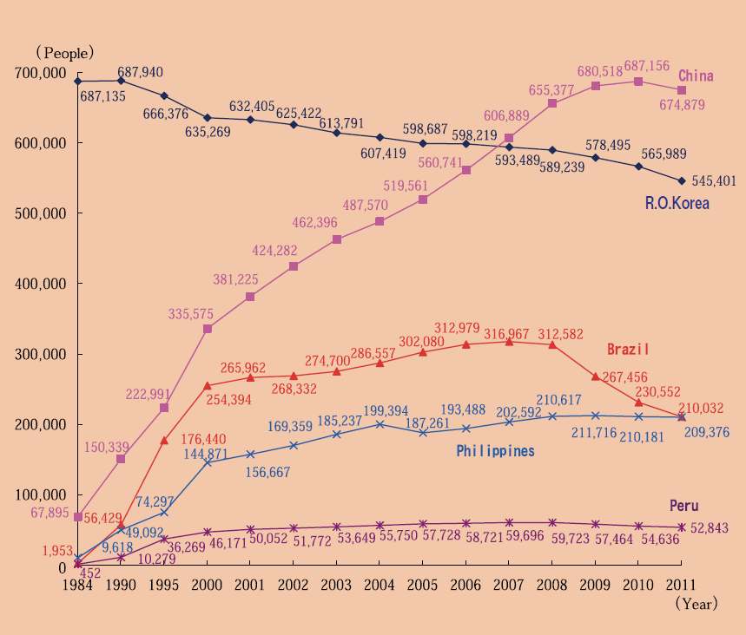
Source: p24. The 18th report “2012 Immigration Control” by Immigration Bureau, Ministry of Justice, JAPAN http://www.moj.go.jp/nyuukokukanri/kouhou/nyuukokukanri06_00025.html

Conclusions
So in this section I outlined the major demographic changes in Japan nowadays: increasing in share of elder people together with shrinking share of working people and children leads to decrease of the whole population. In addition, stable low rate of foreign population in the country only exacerbates an issue. These changes come along with demographic transition theory by, which establish correlation between demographic changes and industrialization in the country. According to it, many other developed countries are going to face in the nearer future the same problems of large share of elder people and tiny share of children.
These profound shifts in the demographic structure of the country create economic as well as political and social challenges that have no precedents in the previous history of the nation. The major ones I will describe in the next section.

Social and economic impact

Rising of social welfare benefit expenditures
As share of elder people is going to increase, the social expenditures are also expected to rise. In the begging of 1970s the ratio of social security benefits to national income constitute only about 5.8%, but by 2010 it rises in five times and is equal to almost 30% or 103 billion yen in absolute figures.
Chart 7
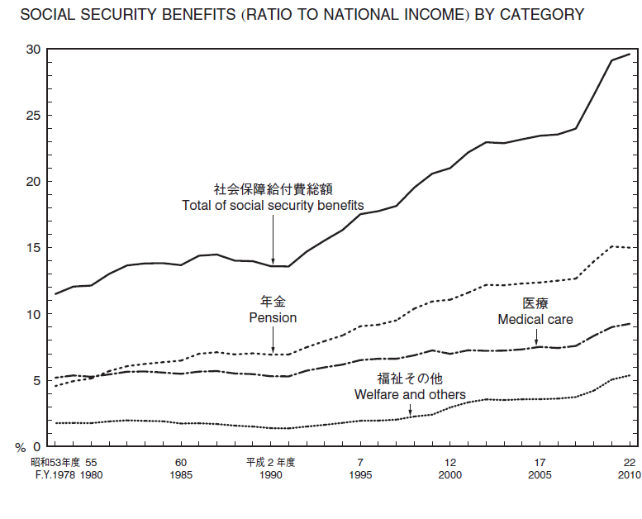
The structure of social expenditures is changing toward increasing share of pension expenditures. In 1965 they form about 22% of total social security benefits, in 1980 they surpassed the level of medical care expenditures and by 2010 the amount of pension benefits was more than a half of total sum of welfare benefit or 52 billion yen.
Overall, about 68.1% from total welfare expenditures are being used to support elder people needs. Most notably that even medical care expenditures are rising due to population aging. So the expenses for contagious diseases and epidemiological fight are being cut. On the other hand, the spending for chronic disease, intrinsic to elder people, are growing up.

Rising extra burdens on the working age population
As social welfare expenditures are going to grow, it needs more taxpayers or individuals’ contributions to the system are going to multiply in several times. The situation becomes even more acute if we keep in mind the shrinking workforce and increasing dependency ratio of elder people.
In a different way, burdens may rise for women. Today in Japan mainly women are engaged in housekeeping and childrearing activities: the number of hours husband spend for child care per day is about half an hour, which is one of the lowest in the World. So women will need to spend more time within the family, if they have more children in order to sustain fertility rate and population size, which is promoted by government. On the other hand, current Prime Minister Shinzo Abe wants to turn from male-oriented society and vitalize economics by promoting women employment. According to his plan, about 12.5% of GDP could be lifted if female employment rate would be equal to that of males and it would be a prominent answer for shrinking population. However, if care-giving personnel would not be hired, wife would be also expected to provide care for her and husband senior parents. So her burdens could rise in three times.
Chart 8. Time Spent on Housework and Child Care by Husbands with a Child or Children under Six Years Old (per day).
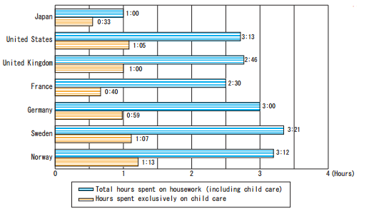
Source: http://www.gender.go.jp/english_contents/pr_act/pub/pamphlet/women-and-men12/pdf/1-4.pdf

Need in caregivers and new infrastructure
As the population is getting aged, the demand for health care providers will also rise. The elder people are more subjected to different diseases, many of them become disabled and require constant medical surveillance. The healthier ones still require assistance in everyday life or just some companion to talk with and not feel lonely, which sometimes family can not provide. For all these duties the additional personal would be needed. However even nowadays experts outline the shortage of nurses and caregivers and their unsustainable wages. So Jeff Kingston points out that the annual turnover rate for caregivers is more than 20 percent, and some 500,000 Japanese with licenses have given up working in the field . Moreover, Japan has the insufficient ratio of two doctors per 1000 citizens, which is the lowest among G8 countries. So not so many Japanese desires to work in this sphere.

Labours shortage
Chart 9. Japan unemployment
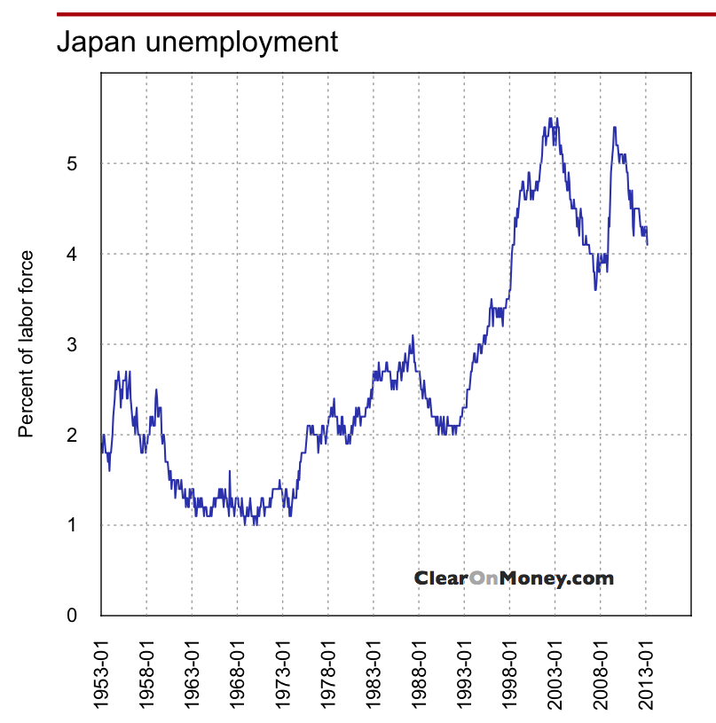
Source : Japan Employment ClearOnMoney Available at: http://www.clearonmoney.com/dw/doku.php?id=public:japan_employment.
Japan has traditionally low unemployment rates, mainly due to the system of life lifetime employment and special government efforts in this sphere. This indicator has fluctuated in the past several years but never rose far above 5% and was falling for the past 3 years. This is one of the lowest figures among the developed countries and tells about stable workforce market. However looking at the Chart 5 we can see that since the recovery from the financial crisis of 2008 Japanese economy demand for more workers steadily increased and starting from the mid of the year 2011 country began to lack the working hands, especially of the part-time and low-paid ones. Unfortunately, no more statistics is available upon the exact spheres and figures of labour shortage in Japan.

Chart 10. Shortage and surplus of workers
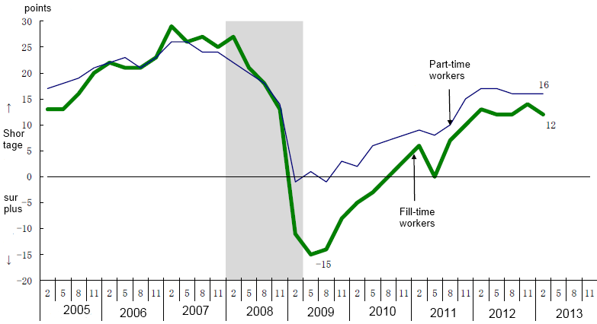
Source: Ministry of Health, Labour and Welfare, Survey on the Labour Economy Available at: http://www.mhlw.go.jp/toukei/itiran/roudou/koyou/keizai/1302/
On the other hand the women’s participant rate in labour force is relatively low – it consists about 70% from the men’s. From the Chart 6 we can see the drop of the number of employed women in ages from 25 to 45, which fit the childbirth period. Not all women return to their previous work after giving birth. A great deal of them remains housewife and is engaged only in the household chores and taking care for the elderly relatives. It has negative impact on the Japanese economy because in this case women have less money to spend and pay lower taxes.

Chart 11
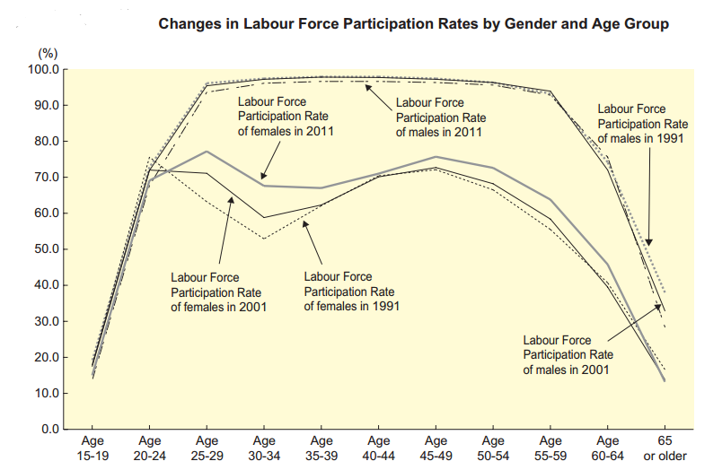Source: Annual Health, Labour and Welfare Report 2012-2013. Ministry of Health, Labour and Welfare Japan. Available at: http://www.mhlw.go.jp/english/wp/wp-hw7/dl/01e.pdf
From there we can see that Japan nowadays generally manages to fulfil its demand for the working hands. Moreover, such concealed human recourses as unemployed women or elder people (those, who are able and still want to work) are not being used at their full strength and leave a room to government for manoeuvre. On the other hand, less Japanese are willing to work at low-paid or not prestigious job (so called 3-d in English: dangerous, dirty, demanding or 3-k in Japanese: kitsui, kitanai, kiken, 汚い, 危険 , きつい). In addition, this demand is going to become even more acute as aging population develops. Moreover, experts argue that additional working force would be need in the construction sector for preparation for 2020 Tokyo Olympics games.

Slowdown of economics
There are different theories whether economic growth depends upon the population growth, or could be achieved without it. However, if we look at the Japanese example we can see, that the periods of high economic development coincided with the fast pace of population growth, and on the contrary GDP growth slowed down when population size stabilized. Even if the productivity of labour increase significantly, in the conditions of shrinking population the consumer demand would be falling. Especially it will affect such important market as real estate, as number of inhabitants will drop. Even nowadays one can observe the reduction of apartments’ prices. Moreover, many foreign investors are now reluctant to provide Japan with additional investments due to bad prognosis of shrinking population and fear of recession.

Conclusions
I outlined the most significant economic and social challenges of population aging, but this is a complex problem and it may change the whole pattern of life of the society. Aging of population can lead to such consequences as structural changes in the consumers demand, depopulation of rural areas, need for new more elder-oriented city infrastructure, widen generation gap, applying more conservative and cautious political decisions, change in family relationships, solitude senility and many others.
While different answers to these challenges, are possible, and most likely there would be need for a complex of different measures in different spheres, some researches point out that the most simple and logical solution is welcoming more immigrants. They are reasoning, that newcomers are generally young and become not only additional workforce or increase share of young people, but also they can revitalize social life and economics with new approaches and energy. On the other hand, their opponents argue, that immigration cannot solve the demographic problem and it is only able to provide temporally relief to aging society. Although newcomers are often of working age and they come from the countries with high fertility rates, in the second or third generation they are likely to adapt reproduction model of their new mother country and create extra burden on social and pension systems. Moreover opponents of immigration claims, that foreign people could bring new problems to the society, like multi-ethnic conflicts, high crime rates or diffusion of culture integrity.
Further in the paper I will focus at what of these two variants Japanese government is implementing. What country is declaring as its immigration policy incentives and what measures and for what reasons does it undertake in reality.

The main policies of current immigration control policies.

Historical background and general framework of IP
For ages Japan was an isolated island state with strict control and limitation upon accepting foreigners. For example, during the period of country isolation “sakoku” the overseas traders were denied to enter the mainland Japan and were limited to use only one Japanese harbour in Nagasaki and reside only the Dejima Island.
Even nowadays Japan to a large extent remains inaccessible country closed to massive immigration flows from outer world. However the modern shape of Japanese immigration policy and structure of foreign residents began to form only after the WW2 . At that moment there were about two millions of Korean immigrants residing inside Japan. Great part of them migrated (or were forced to migrate) from Japanese colonies to mainland during the Japanese rule in Korea (1910-1945) and remained into the country till the end of the Second World War. At that time, it was considered as internal migration of Japanese citizens across the empire. However, after Japanese defeat in 1945 about 1.5 million of Korean gained the opportunity to return to their homeland, while 600 thousands decided to remain inside Japanese territory. Nevertheless, in 1947 they were required to register as foreign nationals. And after it, in 1952 according to the San Francisco Peace Treaty Japan abandoned its territorial claim to the Korean peninsula and therefore residing Koreans were deprived of Japanese nationality and became the first and most numerous part of Japanese immigrants.
At the same time in 1952, government passed the first law for management Japanese immigrant population. It was Immigration Control and Refugee Recognition Law, which follows the norms of American immigration system, but unlike the last, it does not permit immigrants to settle permanently or to demand Japanese citizenship. In addition, an alien registration system was established, which requires long-term residence (including Koreans) to register in it in 90 days since arrival and notify government of they change the address and to apply for re-entry if they leave the country.
Up until 1980s, immigration was not considered as topical question, because the share of foreign people in the society was tiny and country was able to develop its economy by employing domestic resources. The country fulfil labour demand by increasing working hours and overtime work, involving part-time workers, enhancing productivity and automation, relocating production plants to outside of Japan’s territory. As part of internationalization at this time there was also an important process of joining of Japan to international conventions. For example, the procedures for recognition of refugee status were added to the responsibilities of the immigration control administration and Japan signed the Convention Relating to the Status of Refugees in 1981. The International Convention on the Elimination of All Forms of Racial Discrimination was ratified in 1995.
However starting from the end of 1980s Japanese business fighting for competitiveness on the world market was in need for cheaper labour force. At that time wages of Japanese workers were higher than in neighbouring countries. Japanese also became reluctant to perform duties connected with service industry jobs or manual labour, as they were not well paid and did not provide opportunity for social mobility. So cheap foreign workers, mainly from Iran and Bangladesh, started to appear in the country. Although entrance of unskilled foreign workers in Japan was illegal, government ignored it in order to support local industries. Such workers often were paid only per hour salaries and were excluded from the welfare and insurance systems. (Even zainichi Koreans were ineligible to receive public pension until 1982, although they were obliged to pay into the system). However, after “bubble”, shock and slowdown of Japanese economy foreign workers became less welcomed and large part of them was deported from country as illegal immigrant.
In answer to this situation the revised Immigration Control Act was issued in 1990. It contains two main amendments: more strict control and penalties for illegal foreign immigrants and their employee. And the second one was new policy of welcoming nikkeijin, or Japanese descendants leaving abroad, in up to third generation. It was believed that due to blood relationship they can better get accustomed to the Japanese reality, even though most of them was born outside country and hasn’t ability to speak Japanese, or at least they look like Japanese. The law vests them a right to apply for long-term Japanese visa and do any work without restrictions. This policy is often mention under the name of “side door for unskilled labour force”, because it counterbalance between demand for cheaper workers and at the same time bring in people, who do not very differ from the local citizens.
The revisions of Immigration Control Act in 2004 and 2009 mainly put more control on illegal and unskilled immigration, while providing ease for skilled newcomers and students.
In addition to these documents immigration bureau is issuing an annual reports about the implementation of the policy and main changes in the sphere of immigration occurred in the precedent year. Also since 1992 immigration bureau is publishing Basic Plans for Immigration Control, where major objectives of immigration policy for upcoming years are outlined. In this chapter I will outline the main incentives of current immigration policy relying upon the latest 4th edition of the Basic Plan for Immigration Control (4th Basic Plan further).
The Basic Plan was published in the year 2010 and it contains the major objectives of the current immigration policy for the next five years up until year 2015. It sets the priorities of the reaching “more vital and prosperous society”, “a safe and secure society” and “a harmonious society coexisting with foreign nationals” . In order to reach these objectives it points out 4 main directions of its future policy: Smooth acceptance of foreign nationals vitalizing Japanese society, Promotion of measures against illegal foreign residents aiming for the realization of a safe and secure society, Smooth introduction of a new system of residence management and expansion of immigration control administration based on the system and Promotion of appropriate and prompt refugee protection. Further, I am going to stop on each of these concepts in more details and tell about their implementation.

Promotion of measures against illegal foreign residents aiming for the realization of a safe and secure society
The Basic Plan is stressing the importance of proper immigration policy in provision of safety and security for the society. In this sphere such objectives are set as prevention of illegal entry in the country, eradication of foreign illegal employment and other illegal activities of foreign residents, fight against terrorism and stowaways, reducing the number of illegal and false foreign residents. For reaching these goals the vast scope of measures are being implement or are planning to be implement. Among them there are tightened control at the ports of entry, restriction of landing examination, including utilization of personal identification information, increasing coordination with International Criminal Police Organization and putting greater attention towards illegally entering using vessels. Moreover, measures for more strict surveillance on foreign residence are being imposed, including improvement of the system for collection and analysis of information, closer contacts with local police, special detection officer units, proper operation of special permission to stay, implementation of aggressive detection and revocation of the statuses of residence of those under the guise of legitimate residency. (Those, who use, for example, fake marriage or fake study to reside in Japan illegal).

Smooth introduction of a new system of residence management
The second objective of Basic Plan is establishment of new system of residence management. It is constructed as an answer to the increasing amount of foreigners visiting and residing in the country and the diversification of the purposes of their visit and activities inside the country. This system is expected to provide better monitoring of foreign nationals, simplify issuance of a residence card, changes of status of residence and also improve provision of information about foreigners. Under this system both foreign resident and organizations of affiliation (for example place of work or study) are obliged to provide information to the Minister of Justice about any changes in his circumstances, such as change of place of living of work. As a result, the management of immigrants should become more arranged accurately and would be able to keep information accurately and continuously. Moreover, as prefectures would receive more up to date information about foreign residents, it is believed, that municipalities would be able to provide better public services for immigrants, such as health insurance, pensions and child benefits.

Promotion of appropriate and prompt refugee protection
In the year 1981 Japan ratified the Convention relating to the Status of Refugees of 1951 and proclaimed her desire to fulfil in such a way its role in the international community. Further measures of refugee protection included establishment in 2005 new system of refugee examination counsellors. The current objectives in this sphere are setting a standard period of time for processing of the application for refugee recognition, training personnel capable to fair refugee examination and starting program of accepting refugees through resettlement to a third country.

Smooth acceptance of foreign nationals vitalizing Japanese society
  - Points based system
Being aware of the problems of the future population shrinking and aging, and also seeking to revitalize Japanese economy after long period of recession, immigration bureau is proclaiming its desire to attract into Japan more foreigners “who meets the needs of society” and are eager to contribute to the development of Japanese economy. In order to achieve this goal it launches several programs, among which introduction of a preferential points based system for highly qualified immigrants is the most promoted one. It was put into effect on May 7, 2012 and was designed to bring into the country highly qualified professionals, who are believed can help Japan to strength its international competitiveness and sustain economic growth. They were devised in three fields: academic research activity, advanced specialized or technical activity and business management activity. Each category is evaluated according to such criteria as “academic background”, “business career” and “annual income.” The person, who manages to acquire more than 70 points in one of the categories, will receive a privileged treatment: a visa to the prolong five-year period of stay, permission for multiple purposes of activities, simplification of applying for permanent residence status after several years of living inside Japan and several others.
Among other foreigners who meet the needs of Japanese society are named all kinds of professionals, technicians and nursing and medical personal. The previous believed to be able to revitalize Japanese economy and are mostly welcomed, whereas the concern is raised upon the second that they might take the places designated to the local human resources and their participation in the Japanese work market may be reconsidered.

Acceptance of medical and caregiver personnel
In a view of upcoming aging and shrinking of population, Japan decided to accept certain amount of medical personnel from other countries. So the 4th Basic Plan stipulates objective of acceptance of nurses and caregivers from Indonesia, Philippines and Vietnam according to the Economic Partnership Agreement (EPA) with these countries. The general framework for obtaining work in Japan is the follow. After studying for about 6 month Japanese language at home, candidates in nurses and caregivers are allowed to work and study at medical institutions in Japan (for 3 years for nurses and 4 years for caregivers). In the end of this term, they are expected to pass the exam for national qualification, the same one as for the local nurses, and start working.

Acceptance of nikkeijin
After revision of Immigration Control Act in 1990 descent of those Japanese, who emigrated to Brazil and Peru in the beginning of 20th century, were given legal opportunity to return to homeland under the long-term resident status and be engaged in work activities without any restrictions. Their visa allows them to stay in Japan up to three years and it could be renewed infinitely upon condition there was no violation of the law. In the 4th Basic Plan also mentioned the valuable contribution of nikkeijin to the Japanese economy in the previous years and suggested a range of policies for improvement of their integration into local life. They include education for their children, establishing Japanese language schools for non-speakers and improvement of the working conditions.

Others
The 4th Basic Plan also set priorities on the increasing of international cooperation in the spheres of tourism and students exchange. Their numbers have significantly increased in recent years. (See the Appendix 2)
The special attention was paid to the reorganisation of the trainee and technical internship programs. Originally, the aim of the program is to transfer technology and skills to the workers of less developed countries and in such a way make international contribution to the development of human resources. Nevertheless, the program is largely criticized for being a measure to import into Japan source of low-paid unskilled workforce, who is forced to work in unsustainable conditions. Under these program foreigners from the developed countries are invited to become a trainee for the first year (without any wages) and then practise as technical intern for maximum of two years term.
According to the new regulation (the detailed scheme of the renewed program is provided in the Appendix 3) internships are required to work under contract of employment, and fall under the jurisdiction of Labour Standards Act, therefore their minimum wages and insurances in case of accidents are guaranteed. Moreover the supervision of the implementation of the program has also been restricted and as a result the numbers of misconduct plummet in the last two years.

Analysis of Immigration policies

Progress in the programmes concerning control and management of foreign residents
The Japanese polices aiming at the providing of the safe and secure society can be measured as relatively successful. As a result of implementation of the plan of “halving the number of illegal foreign residents within five years” which was established in the “Action Plan for the Actualization of a Society Resistant to Crime” in the end of 2003, the number of overstaying residents in the 2004 (which stood at 220,000 person) was cut significantly down to 113,000 people in 2009. Moreover, by the year 2013 their number again was cut in half and reached 62 thousands.
Table 2
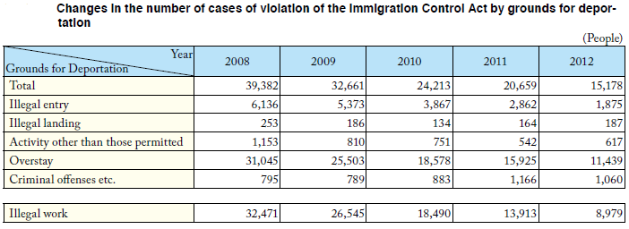Source: Immigration Bureau, Ministry of Justice, JAPAN (2013) Immigration Control 2013 report
Furthermore, the number of people, who were deported due to different violations of Immigration Control Act, was also decreasing on year to year basis. In 2012 it was more than two times less than in 2008 and equal about 15 thousand people. So we can see that the percentage of lawbreaker among the whole number of foreign residence nowadays is tiny small, and we can conclude that government is implementing sufficient measures and is coping with the task of proving safety for the society.
As for the implementation of the new residency management system, at the current moment there is not valid statistic data whether it improves efficiency and provides better immigrants’ management. The system was only inaugurated on July 9, 2012 and there was not enough time to evaluate it. However more than 642 thousand residents have already obtained the residence card according to the new system.

Refugee protection
The Japanese policy concerning refugees is ambivalent. On the one hand, Japan fulfilled the objectives it set: the standard period of refugee examination was stabilized and fixed at six months, and Immigration Bureau does not exceed it. Moreover, country improves officer training in order to provide equitable examination of every case.
Table 3.
Number of applications for refugee and number of approvals. Persons.
 | 2007 | 2008 | 2009 | 2010 | 2011 | 2012
Number of application for recognition as refugee | 816 | 1599 | 1388 | 1202 | 1867 | 2545
Recognized as a refugee | 41 | 57 | 30 | 39 | 21 | 18
Source : Immigration Control 2013 report, p. 99
On the other hand, no targets were established concerning the quantity of refugees’ acceptance. The amount of refugee that Japan accepts almost does not change from year to year and remains infinitesimal, despite the fact, that amount of applications constantly grows. So out of 2545 application the status of refugee acquire only 18 persons, which make less than 0.6%. Furthermore, in 2012 no one was accepted through the program of resettlement to a third country. So Japan is still reluctant to open its borders to refugee.

Points based system
The points based system can be reasonable in terms of inviting to Japan persons capable to create innovative and high value added products within Japanese economy, however some specialist are suspicious about the productivity of the program. For example, Debito Arudou, a columnist for the Community Page at Japan Times newspaper, argues that extremely hard and controversial recruitments to the program, which focuses on non-Japanese speakers, who would experience hurdles in assimilating, make the project unrealistic and should not bring any significant number of foreigners. In fact, people who earn more than 40000$ in a year (the minimum requirement of the program) and have a good performance at the local work market might choose the country with more liberal immigration policy, more easy language and more hospitable local residents or rest in the motherland. Therefore, it is not very likely that this program will attract a lot of aliens, who will be able to become later an integrated part of Japanese society. Speaking in the press conference about this system the minister of Justice Makoto Taki also tells that the amount of high-skilled foreigners they are planning to attract by the program does not surpass 2000 people in a year. It means that it is unlikely that the system would influence seriously the amount of foreigners entering the country or demographic situation.
And indeed according to the latest statistics, for eleven month of working only 433 persons were able to use the system and were recognized as highly-skilled professionals. After the first year of the implementation of the program it is going to be reconsidered: income standards and time period before receiving permanent resident status should be reduced. However even with relaxed requirements it is unlikely that program attracts a lot of immigrants.
Moreover, nor in Basic Plan for Immigration Control nor in Immigration Control 2012 report provide any sufficient evidence for what reason exactly this kind of reach well-educated foreigners is what Japan is need at the moment or estimation how exactly their talent would help Japanese economy to improve. On the contrary, looking on the table of employment of foreigners according to their status or on the incentives imposed by the aging population on the one can conclude, that Japan needs more low-paid workers who would be able to undertake low skilled or connected to the medicine works which Japanese citizens are unwilling to do.

Acceptance of medical personnel
The program of accepting nurses and caregivers under EPA agreement began to implement for Philippines and Indonesia in 2010, and first Vietnamese nurses came to Japan in 2014. In total in the five years, 1869 candidates took part in this program (figures for the year 2013). However, the number of those, who successfully have gained the desirable job in Japan, was very low. For all the time of the existence of the program, the national qualification exam passed for both countries only 128 nurses and 241 caregivers. The main reason given for falling exam is difficulties of candidates with the written Japanese language. In response to this hurdles, in 2012 the Ministry of Health, Labour and Welfare decided to extent period of stay for the candidates for one year, lengthened the time of the exam and provided text of it with furigana (characters’ readings) so they have more opportunities to pass an exam . However, it has not changed the situation and passing rates still remained low at 11.3 percent and 9.6 percent in 2012 and 2013 respectively.
These figures look even more negligible, if contrast them with 40000 nurses Japan is lacking presently, especially in the rural areas. Therefore, one may conclude, that at the current moment Japan does not consider partnership under EPA as effective and appropriate answer to labour shortage in medical and care-providing personnel. Although this pilot program is important first step towards opening doors for foreign workers in such a field, where previously only Japanese were accepted, Japan does not use the program at full strength and prolong it for already five years without any structural changes. Meanwhile, the concerns, which are expressed in the 4th Basic Plan, that this tiny amount of medical personal may threaten the local labour market, turned out to be ungrounded. On the contrary, Philippines and Indonesian nurses are going to undertake such work, which local residents are reluctant to engage in.
Moreover, a lot of reports about burdens and inconsistence in implementation of the program are published in mass media recently. For example, all applied persons are certificated nurses and caregivers in their home countries; however, during their stay in Japan they are assigned tasks that do not require professional training, such as bathing patients and table setting. Taking into consideration the world population aging trend and good performance of Philippines nurses in other countries, due to their competence and good knowledge of English, it is possible, that they would choose other than Japan country to work with less strict requirements, not so difficult language and brighter career opportunities.

Acceptance of nikkeijin
From the year 1990 a dramatic flow of nikkeijin began to arrive in Japan. So in 1988 within the country there was only 4159 Brazilians, but by 2004 their number boosted to 287 000. At that time the decision to accept foreigners of Japanese descent was perceived as compromise between industries’ incentives for cheaper unskilled workforce (especially in construction, car manufactory and service spheres) and society reluctance to acquire foreigners who are completely strangers. It was believed that due to common ancestry nikkeijin are not totally alien, and comparing with other foreigners they can better adopt to Japanese norms and traditions and therefore would fit better into society and could assimilate. So the logic was the follow: if Japan really need unskilled immigrants, then nikkeijin would be the best choice.
At the beginning of the program the great part of nikkeijin arriving in Japan was a single male, who worked in the manufacture industry and was planning to return home to South America after raising money for several years. Generally they were paid on per hour basis and therefore their salary was smaller than of Japanese workers, as they have no health insurance and bonus payments. Many of them received their jobs through the brokers companies, which gain part of their salary. However it was still higher their wages in Brazil and as time passes the majority of them decided to stay in Japan for a longer time, applied for permanent residence or citizenship and bring their family into the country. But this situation creates different problems, as many Brazilians lack of Japanese knowledge, have completely different culture. The biggest difficulties became truancy at schools and crimes among children.
In 2008-2010 nikkeijin became vulnerable to financial crisis and great part of them lost their jobs and rest without any unemployment insurance. Therefore they were forced to quit the country and number of nikkeijin residing the country plummet. Moreover government launched special program to pay off their ticket home, under condition hey will never come back. However this program was largely criticized and those nikkeijin who used the program were allowed to return after three years if they found stable job in Japan.
So the case of nikkeijin demonstrated that Japan nowadays has no sufficient mechanism and is not ready yet to acquire a considerable amount of immigrants, provide them and their families with sufficient language, educational and social assistance, and integrate them within the society. And such situation creates obstacles for both immigrants and local communities. Moreover, country treats newcomers as a temporally workers, who might be sent back in any time, and not as rightful member of the society and future citizens, despite the desire of nikkeijin to settle down and continue to contribute to Japanese economy. Although there are some improvements recently, for example language training program for 5000 nikkeijin, these are mostly ad hoс limited measures, which are not always enough and do not provide general vision of the problem.

Trainee program
About of 142 thousands foreigners were enrolled in this program in 2011, mostly from China and Viet Nam. Many reports about human rights and working condition violations, not paying salary, passport confiscation, death and injuries from overworking were made by researches and NGO. For example, UN Commission on Human Rights connected this program with human traffic and slavery and recommended to abolish the system. However, this is almost the only program under which middle- or unskilled workers can enter Japan at list partly legal (not taking into consideration nikkeijin, who can enter the country without strict limitations on the sphere of work and consequently also often become low-skilled workers).
Table 4
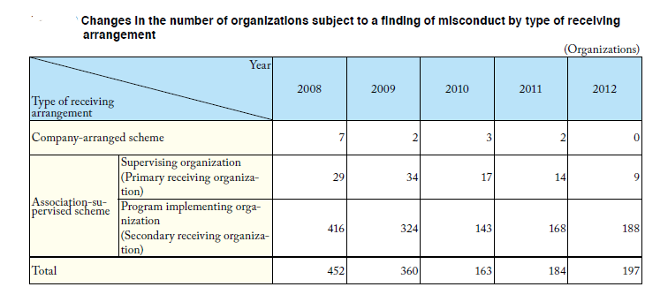Source: Immigration Bureau, Ministry of Justice, JAPAN (2013) Immigration Control 2013 report. Available at: http://www.moj.go.jp/nyuukokukanri/kouhou/nyuukokukanri06_00025.html
After the reform of trainee program in 2010 the situation with working conditions has slightly improved, however even in 2012 there were registered 197 cases of misconduct, which main forms were abuse of human rights, violation of labour-related laws/regulations, and name lending. The large mass media coverage also obtained incident with stabbing rampage at Hiroshima oyster-processing plant, when trainee killed the president of company and employee. As a motives for the crime the hard working conditions, abuses and exploitation are named.
Despite strong critique of the controversial program, government is even planning to expand it in order to meet labour demand in construction industries during preparations to the Olympics games in 2020. So we can see that instead of implementing such consistent policies which officially permit unskilled workers to enter Japan and work under coverage of Labour Standards Act and other labour protection laws, Japan often uses “side doors” immigrant and their often illegal or partly illegal work. This situation often leads to exploitation of workers, abuse of their rights, unsustainable working conditions and even multiethnic tensions.

Findings

Fail to answer the challenges
To sum up previous section the major tendencies in the current Japanese immigration policy can be outlined. Through the figures we can see that the most effective policies are connected to the regulation, management and control of the foreigners as well as deportation of the undesirable visitors, while tiny progress was achieved in such fields as internationalization and liberalization of local work market, attracting more labourers in view of approaching aging and shrinking of population, human right protection of foreigners and making a country desirable place to live for a foreigner. While promoting international cooperation, joining various international organisations promoting human rights (like ILO, WHO and others) and taking part in cross-countries discussions Japan frequently is reluctant to change significantly its immigration policy and accept international frameworks of dealing with immigrants, for example, legislation prohibiting racial discrimination.
One of the most significant handicaps of the current immigration policy is the lack of coordination and general vision in the sphere of management of labour recourses. On the one hand, it is believed that unskilled and illegal workers as well as medical ones are taking employment opportunities from the local people and menace security in the country. As there is no legal way to import into Japan low-skilled workers (there is not even appropriate category among residential statuses), most large Japanese companies are moving offshore in search of cheaper labour force. Meantime in response to the increasing amount of youth graduated Japanese unwilling to engage in manual work, an increasing influx of low qualified workers often illegal or under program of trainee comes to Japan in order to meet demand for undesirable work. Frequently these people work in substandard condition without proper regulation.
On the other hand, Japan welcomes only foreign high-skilled professionals and technicians, who along with revitalizing of economy, can also create excessive rivalry at the home labour market. In other words, if Japan continues to implement this kind of policy, she may face significant misbalance of the work force, when highly educated young citizens, who are reluctant to engage in manual may experience difficulties and severe concurrence in finding appropriate job, while there would be lack of people for providing care for the elderly people and work in the agriculture sector.
According to the estimations of United Nations, only for maintaining the same population and economic growth pace as Japan has at present time, it has to invite at least 17 million immigrants up to the year 2050. And for retaining the same workforce population it needs obtain about 33 millions. So, even if Japan tries to fulfil this gap with its own “latent resources” such as women and elderly people, it is unlikely that it would be possible without immigrants. Therefore there is a need to work out an immigration policy adjusted to the needs of labour force market.
As a result, we can see that in spite of the fact that such policies' objectives as active acceptance and harmonious coexisting with foreigners, maintaining vitality of society against backdrop population decline are being proclaimed as an objectives in the 4th Basic Plan, in reality small or controversially improvements have been undertaken. The country officially still strictly limits import of the great part of immigrants (even high-skilled ones, not speaking about low-skilled ones), despite the menace of the working force dropping in the nearest years. None of the special programs can be named successful: the amount of participants of bonus program for highly skilled professionals is twice as little as planned; the passing rate of nurses and caregivers slightly surpasses 10%. However, even if the objective figures were met, still it would not reverse the trend of the labour shortage. The programs for nikkeijin and trainees are much more numerous, however there are a strong concerns of human rights protection of their participants and how newcomers fit into the Japanese society. Moreover, often both nikkeijin and trainees become source for low paid unskilled labour force are therefore, the programs also do not achieve proclaimed original goals and contradict declared policies of acceptance only high skilled professional immigrants.
Moreover, although such goals are proclaimed, the current immigration policy does not contain the detailed plan of integration of immigrants and coexistence with them. Apart tiny programs as support measures for education of migrant children, Japanese language education for nikkeijin or publishing official documents concerning immigration policy in different languages, there is vacuum in programs concerning adaptation of foreign residents to Japanese environment. Besides, there is not any strategy on how Japanese society itself, their mentality and attitude toward foreigners should change in order to accept more foreigners within the country and recognize them as a part of one united society. So one can conclude, that at the present time Japan has not sufficient infrastructure for accepting more immigrants within its borders.
As a result, one can see, that in reality Japanese immigration policy does not accomplish the goals it set behind itself. Furthermore, despite strong incentives, implemented immigration policy have almost zero effect on the nearly all challenges of shrinking population, which were described in the second chapter of this paper (rising expenditures on welfare, rising burdens on working population, need in medical personnel and slowdown of economics development). Some steps toward improvement of working and living conditions of immigrants and resolution of up to date problems were being processed, nevertheless the tiny number of immigrant can not influence the demographic structure of population and lighten the future burdens on the working age population or make good the shortfall of workers.
So we can see, that although there are some shifts towards increasing and diversification of foreign residents and Japan is proclaiming using immigration policy tools to answer aging challenges, these steps are neither enough nor successful, and do not have effect on general situation

No general vision of immigration policy strategy
The current Japanese policy has its strong and weak points, but the most serious problem in it is the lack of the long run strategic vision of the future development of the policy that goes beyond ad hoc measures. The immigration bureau does not present any document or plans for future planning in 50 or at least 10 years. However, such incentives as shrinking workforce or ageing population demand to set measures that are more decisive and put things in a longer perspective. So Japan has to choose between large amount of immigrants within its borders or economic stagnation. However, each of these variants supposes the great changes and reorganization in Japanese society and has its drawback.
The big option assumes densely populated country along with acquiring a lot of immigrants. Under such option it would be easier for Japan to maintain economic growth and position on international arena, but country will have to reconcile with the problems of a multi-ethnic society.
The smaller variant represents a country with almost a half of today’s population inhabited mostly by the local residences. The decreasing of the population is often associated with the economic recession and pessimism within the country. However it does not seemed to be the most unfavourable variant, taking into consideration the modern large population density in Japan, environmental troubles and problems of the multi-ethnic policy, which are hardly avoidable as European example proofs. If Japan would be able to create a model of a society, where small relatively aged population manage to maintain welfare at the cost of high taxation, Japan would have a chance to show to the world an innovative path of development. Nevertheless, it is unlikely that under this variant country would be able to secure its leading international position as economic superpower and its authority in East Asia region may also decrease.
Looking at the current immigration policy, Japanese self-perception as an island homogeneous country and their attitude toward foreigners, it seems unrealistic that Japan would be able to accommodate in the nearest future an amount of 400 thousands immigrants a year in order to sustain the high temp economic development at that level, which she demonstrated in the middle of the previous century. On the other hand, the lately implemented policies of vitalizing Japanese economics and sustain growth of GDP (which receive name of Abenomics) is unlikely to be effective in long run perspective in the situation of declining population without support of increasing immigration.
Such goals of Japanese immigration policy as “smooth acceptance of foreign nationals vitalizing Japanese society” contribute to variant of “Big Japan”, however tiny number of foreign residence suppose the opposite variant. Therefore we can see that Japan implements rather controversial and ambiguous immigration policy, which hampers country to develop under a certain deliberately chosen strategy.
As a result, one can see that Japanese government has no consensus yet, should country develop further according to the variant of “Big Japan” or “Small Japan”, in other words, should it use immigration policy for answering aging and shrinking population policies or not. However, it is better to make decision in advance or in other words as soon as possible in order to avoid shock and secure the smooth transition.

Change in social consensus
The reluctance of Japan to respond on demographic challenges and construct effective program for accepting necessary workforce from abroad could be explained by several, mainly cultural, reasons. Many researchers point out the Japanes perception of itself as homogeneous country and discourse of homogeneity as the strongest constrain. However in course of time the situation is changing. In the current research as well the significant changes were shown.
Although current policies are not sufficient to answer challenges of aging and shrinking population, the progress is also observable. The steadily increasing number of foreign residents, facilitation of entrance procedures and visas regimes for some categories of foreigners and especially for high-skilled ones, rearrangement of the trainee program are the great leap forward the globalization of the country and the extension of the international connections with other countries. Nevertheless, such problems like strong nationalistic feelings and lack of integration of foreigners into Japanese society, approaching lack of workforce (especially in the sphere of the care for the elderly persons) and others still remain unsolved. Therefore, the inconsistences and ambiguity in the implementation of immigration policy may signify the changes in public conscience toward acceptance more immigrants and move away from homogeneous discourse. The undertaken public opinion polls also show changes in the Japanese society. So in the year 2004 only about 15% of respondents were in favor for accepting more foreign workers in case of labour shortage. However in similar poll in 2014 their number has risen up to 37%.
Apparently, Japan will not be able to become multiethnic country of immigrants like USA in the nearest future. However it can correct its policy and make it more efficient and realistic. Therefore, there is need in further public debates to reach new social consensus to what extent Japan should be opened to internationalization and immigrants. Guided by their results, the new immigration policy, which satisfy the requirements of demographic situation and social needs, could be constructed.

Conclusion
This paper has shown that pursuing the current immigration policy, Japanese government does not take the full responsibility for the immediate economic and social challenges. Nor she completely meets the objectives which were set in the 4th Basic Plan for Immigration Control. So I have shown that although Japan is proclaiming, that it is using immigration policy mechanism as a tool for solving problems of shrinking and aging population, in reality, these programs have almost no effect on the demographic situation.
Moreover, in the face of the upcoming drastic aging and shrinking of the population actions that are more consistent are expected from the government. However, current policy does not demonstrate long run vision of these problems. Thus the sooner authorities choose one of the development strategies – the strategy of the big country with large population and a great share of immigrants or of the small variant with almost only native population – the smother and more fruitful would be the future immigration policy and more prosperous life of future generations.
In other words unless new consensus on the issue on homogeneity and multi-ethnicity would be reached and Japan choose which way it should develop further, immigration policy could not be efficient and solve the upcoming problems. Thereby my work explains and emphasizes the importance of public debates and more mass media coverage of the issues of attracting more immigrants in connection with problem of shrinking and aging population to the successful and efficient implementation of immigration policy.

References

Primary sources
  - UN-DESA and the OECD, "World Migration in Figures" Joint UN/DESA and OECD publication for the HLD, October 2013. http://www.oecd.org/els/mig/World-Migration-in-Figures.pdf
  - Japanese Ministry of Justice. 2013. Press release on the number of foreign residents on the end of 2012 year. (平成２４年末現在における在留外国人数について) http://www.moj.go.jp/nyuukokukanri/kouhou/nyuukokukanri04_00030.html
  - Ministry of Health, Labour and Welfare. Report Simple outline of life in the year 2011. http://www.mhlw.go.jp/toukei/saikin/hw/life/life11/index.html
  - World Health Organization. 2014. World health statistics 2014. http://www.who.int/gho/publications/world_health_statistics/EN_WHS2014_Part3.pdf?ua=1
  - Figures according to Ministry of Health, Labour and Welfare. 2014. Vital Statistics in Japan -The latest trends. http://www.mhlw.go.jp/english/database/db-hw/dl/81-1a2en.pdf
  - Cabinet Office Japan. 2014. White paper on aging population for the 2013 year. http://www8.cao.go.jp/kourei/whitepaper/w-2013/zenbun/25pdf_index.html
  - Immigration Bureau, Ministry of Justice, JAPAN. 2012. The 18th report “2012 Immigration Control”. http://www.moj.go.jp/nyuukokukanri/kouhou/nyuukokukanri06_00025.html
  - Immigration Bureau, Ministry of Justice, JAPAN. 2013. The 19th report “2013 Immigration Control”. http://www.moj.go.jp/nyuukokukanri/kouhou/nyuukokukanri06_00025.html
  - Statistics Bureau of the Ministry of Internal affairs and communications of Japan. 2014. Japan statistical yearbook 2014. http://www.stat.go.jp/english/data/nenkan/index.htm
  - Cabinet Office Japan. 2014. White paper on decreasing number of children for the 2013. http://www8.cao.go.jp/shoushi/shoushika/whitepaper/measures/w-2013/25pdfhonpen/25honpen.html
  - Immigration Bureau, Ministry of Justice, JAPAN (2010) 4th edition of the Basic Plan for Immigration Control. Available at: http://www.immi-moj.go.jp/seisaku/keikaku_101006_english.pdf
  - Immigration Bureau, Ministry of Justice, JAPAN (2012) Leaflet on Points-based system that provides highly skilled foreign professionals with preferential immigration treatment Available at: http://www.immi-moj.go.jp/newimmiact_3/pdf/120416_01.pdf
  - Ministry of Health, Labour and Welfare, Japan (2013) White book on welfare and labour. Available at: http://www.mhlw.go.jp/wp/hakusyo/kousei/12/
  - Ministry of Health, Labour and Welfare report Simple outline of life in the year 2011. Available at http://www.mhlw.go.jp/toukei/saikin/hw/life/life11/index.html
  - Cabinet Office Japan. 2013. White paper on aging population for the 2012 year. http://www8.cao.go.jp/kourei/whitepaper/w-2013/zenbun/25pdf_index.html
  - Prime Minister of Japan and his cabinet, Japan Revitalization Strategy, June 14, 2013 http://www.kantei.go.jp/jp/singi/keizaisaisei/pdf/en_saikou_jpn_hon.pdf
  - Ministry of Health, Labour and Welfare Japan Annual Health, Labour and Welfare Report 2011-2012. Available at: http://www.mhlw.go.jp/english/wp/wp-hw6/index.html
  - The main points of the press conference of the minister of Justice. Site of the Ministry of Justice, 28.12.2011. Available at: http://www.moj.go.jp/hisho/kouhou/hisho08_00240.html
  - Ministry of Health, Labour and Welfare. About acceptance of foreign nurses and caregivers from Indonesia, Philippines and Vietnam. Available at http://www.mhlw.go.jp/bunya/koyou/other22/
  - Ministry of Health, Labour and Welfare. 2013. Considering social security – white paper of Ministry of Health, Labour and Welfare for year 2012. Available at: http://www.mhlw.go.jp/wp/hakusyo/kousei/13 /
  - Ministry of Health, Labour and Welfare. Report upon the results of national examination for nurses and caregivers candidates from foreign countries. 2014. http://www.mhlw.go.jp/file/04-Houdouhappyou-12004000-Shakaiengokyoku-Shakai-Fukushikibanka/0000041987.pdf
  - Ministry of Health, Labour and Welfare. March 27, 2014. Report upon the results of national examination for caregivers candidates from foreign countries. http://www.mhlw.go.jp/file/04-Houdouhappyou-10805000-Iseikyoku-Kangoka/0002_2.pdf
  - Ministry of Health, Labour and Welfare. Jan 18, 2010. The main points of the assistance for quitting the country for unemployed persons of Japanese origin. (日系人離職者に対する帰国支援事業の概要). http://www.mhlw.go.jp/houdou/2009/03/dl/h0331-10a.pdf
  - Ministry of Health, Labour and Welfare. 2012. Considering social security – white paper of Ministry of Health, Labour and Welfare for year 2011. Available at: http://www.mhlw.go.jp/wp/hakusyo/kousei/12 /
  - United Nations, Department of Economic and Social Affairs, Population Division (2013). Trends in International Migrant Stock: The 2013 revision (United Nations database, POP/DB/MIG/Stock/Rev.2013
  - Clear On Money, Japan Employment. Available at: http://www.clearonmoney.com/dw/doku.php?id=public:japan_employment./

Reference literature
  - UN Department of Economic and Social Affairs. 2013. Press release 232 million international migrants living abroad worldwide http://esa.un.org/unmigration/wallchart2013.htm
  - Markaryan, S. Moscow: Vost. Lit., 2012, “Immigrants in Japanese Society: Necessary, but Undesirable” Japan: the economy and society in the ocean problems. Ed. D. Streltsov.
  - Yoshio Okunishi, 1995. LABOUR MIGRATION IN ASIA. ASEAN Economic Bulletin, Vol. 12, No. 2.
  - Green, David, (2012)."Local autonomy in the face of central domination: an examination of Japanese immigration policy" Political Science Dissertations. Paper 10. http://hdl.handle.net/2047/d20002722
  - Mackie, Vera. Managing borders and managing bodies in contemporary. Japan Journal of the Asia Pacific Economy Vol. 15, No. 1, February 2010, 71–85
  - AFP-JIJI . 2014. “Narrowing gender gap could boost Japan’s GDP by 12.5%: Goldman Sachs”. Japan Times. May 7, 2014 edition. http://www.japantimes.co.jp/news/2014/05/07/business/economy-business/narrowing-gender-gap-boost-japans-gdp-12-5-goldman-sachs/#.U2-pOvl_sV_
  - Kingston, Jeff. 2013. Japan’s Immigration reform: Could this be Abe’s new growth strategy? The Japan Times. 19 may 2013. Available at: http://www.japantimes.co.jp/opinion/2013/05/19/commentary/immigration-reform-could-this-be-abes-new-growth-strategy/#.UZr-NrV7Lme
  - Kingston, Jeff. 2011. Contemporary Japan: History, Politics and Social Change Since the 1980s. Malden, MA: Wiley-Blackwell.
  - Kingston, Jeff.2013. Saving Japan: promoting women’s role in the workforce would help. The Japan Times. Apr 21. 2013. http://www.japantimes.co.jp/opinion/2013/04/21/commentary/saving-japan-promoting-womens-role-in-the-workforce-would-help/#.UZlqH7V7Lmd
  - Tomohiro Osaki. 2014. Foreign trainee program given OK for expansion, Japan Times, Apr. 04, 2014. http://www.japantimes.co.jp/news/2014/04/04/national/more-foreign-workers-to-be-allowed-to-work-in-construction-industry
  - Mary Beth Horiai, Beyond the demographic transition: the case of Japan. Graduate College University of Nevada, Las Vegas May 2010.
  - Andy Xie. 2010. Our Next Economic Plague: Japan Disease. Caixin Online March 03, 2010. http://english.caixin.com/2010-03-15/100126807.html
  - Reiji Yoshida. 2014. Success of ‘Abenomics’ hinges on immigration policy. Japan Times. May 18, 2014. http://www.japantimes.co.jp/news/2014/05/18/national/success- Icho -hinges-immigration-policy/#.U3-vXfl_stI
  - Debito, Arudou Japan’s revolving-door immigration policy hard-wired to fail. The Japan Times. Mar 6. 2012. Available at: http://www.japantimes.co.jp/community/2012/03/06/issues/japans-revolving-door-immigration-policy-hard-wired-to-fail/#.UZmlFbV7Lmc
  - Benny Enny Teh Cheng Guan. 2014. Give foreign nurses in Japan a boost by treating accord as long-term remedy for labor shortages. The Japan Times. Feb. 02, 2014. http://www.japantimes.co.jp/opinion/2014/02/02/commentary/japan-commentary/give-foreign-nurses-in-japan-a-boost-by-treating-accord-as-long-term-remedy-for-labor-shortages/#.U4J1zfl_stI
  - Junichi Goto, “ Latin Americans of Japanese Origin ( nikkeijin ) Working in Japan: A Survey, ” World Bank Policy Research Paper no. 4203, April 2007. P. 16 http://elibrary.worldbank.org/doi/book/10.1596/1813-9450-4203
  - Debito Arudou. 2009. ‘Golden parachutes’ mark failure of race-based policy. The Japan Times. Apr 7, 2009. http://www.japantimes.co.jp/community/2009/04/07/issues/golden-parachutes-mark-failure-of-race-based-policy/#.U5Ahdvl_stI
  - Ito, Masami Japan’s foreign trainee system said still plagued by rights abuses. The Japan Times. 09 apr 2013. Available at: http://www.japantimes.co.jp/news/2013/04/09/reference/foreign-trainee-system-said-still-plagued-by-rights-abuses/#.UZvsE7V7Lmd
  - Bustamante, Jorge Report of the Special Rapporteur on the human rights of migrants, Jorge Bustamante - Addendum - Mission to Japan. UN Commission on Human Rights 2011. Available at: http://daccess-dds-ny.un.org/doc/UNDOC/GEN/G11/121/27/PDF/G1112127.pdf?OpenElement
  - Tomohiro Osaki. 2014, Icho’s ethnic vitality poses future model for Japan. The Japan Times. May 18, 2014. http://www.japantimes.co.jp/news/2014/05/18/national/ichos-ethnic-vitality-poses-future-model-japan
  - United Nations (2000). Replacement migration: Is it a solution to declining and ageing population? New York: UN Population Division, Department of Economic and Social Affairs. Available at: http://www.un.org/esa/population/publications/migration/migration.htm
  - Japan and the Global Challenges: the Strategy of the struggle/ Chief of the Project – V.Pavlyatenko, Moscow, MAKS Press. 2008. 232p.
  - NGO Report Regarding the Rights of Non-Japanese Nationals, Minorities of Foreign Origins, and Refugees in Japan. Prepared for the 76th United Nations Committee on the Elimination of Racial Discrimination Session Solidarity Network with Migrants Japan (SMJ).February 2010. Available at: http://www2.ohchr.org/english/bodies/cerd/docs/ngos/SNMJ_Japan_76.doc
  - Sakanaka, Hidenory The Future of Japan’s Immigration Policy: a battle diary, 2005, translated by Andrew J. I. Taylor, Available at: http://www.japanfocus.org/-sakanaka-hidenori/2396

Appendix 1
Foreign population by country:
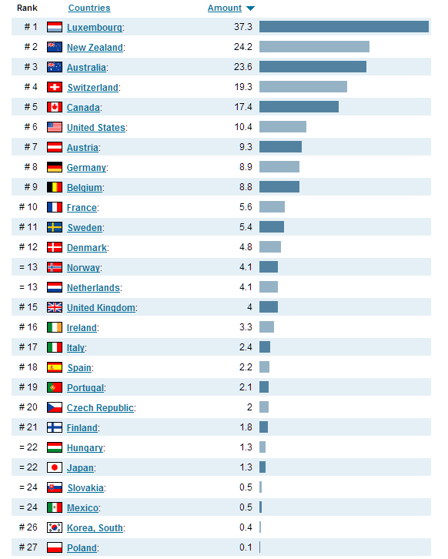
"Foreign population by country", 2008.OECD. Retrieved from http://www.NationMaster.com/graph/imm_for_pop-immigration-foreign-population

Appendix 2
Changes in the number of registered foreign nationals by status of residence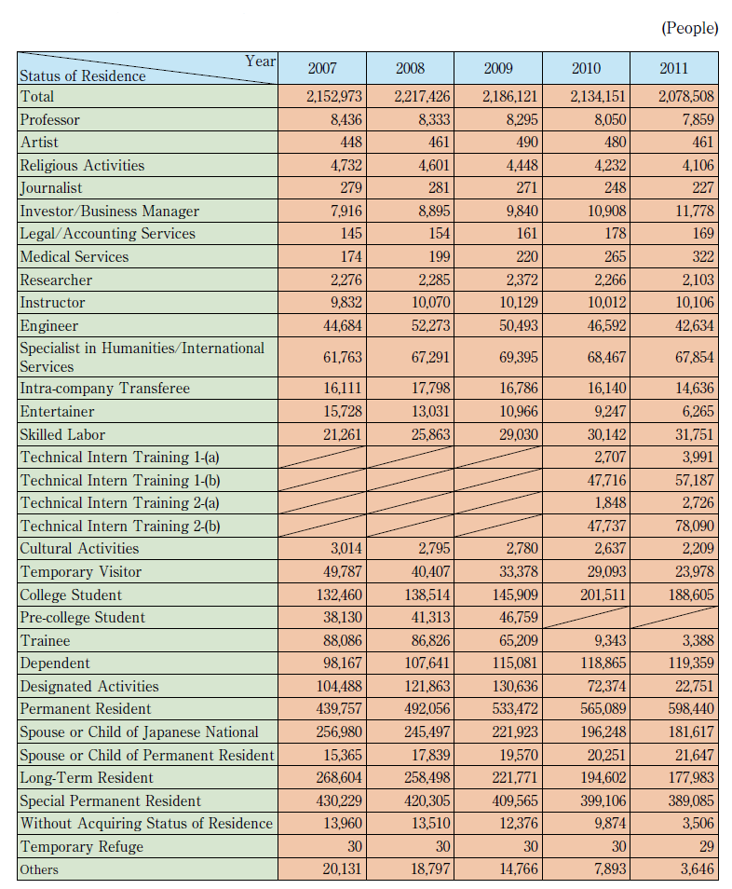
Source: Immigration Bureau, Ministry of Justice, JAPAN (2012) Immigration Control 2012 report. Available at: http://www.moj.go.jp/nyuukokukanri/kouhou/nyuukokukanri06_00025.html p. 25

Appendix 3
The outline of the major differences between the old and new trainee and internship programs.
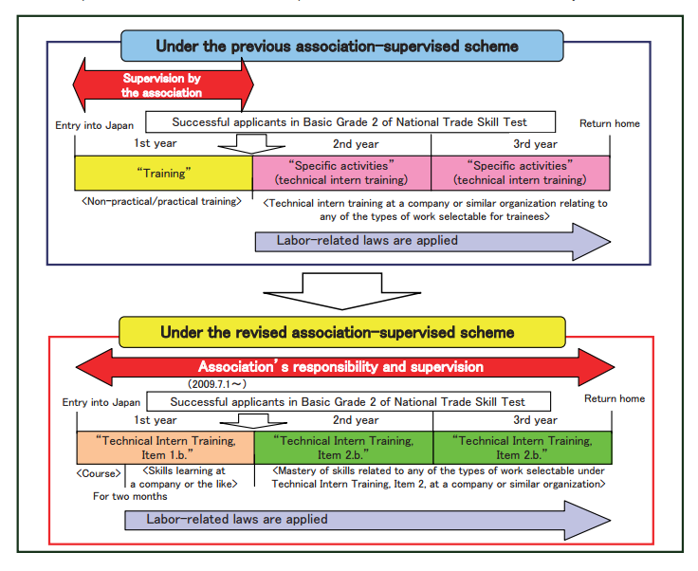
Source: Immigration Bureau, Ministry of Justice, JAPAN (2010) Immigration Control 2010 report. Available at: http://www.moj.go.jp/nyuukokukanri/kouhou/nyuukokukanri01_00015.html P. 90.

UN-DESA and the OECD, "World Migration in Figures" Joint UN/DESA and OECD publication for the HLD, October 2013., p.2 Available at: http://www.oecd.org/els/mig/World-Migration-in-Figures.pdf
Japanese Ministry of Justice. 2013. Press release on the number of foreign residents on the end of 2012 year. (平成２４年末現在における在留外国人数について) Available at: http://www.moj.go.jp/nyuukokukanri/kouhou/nyuukokukanri04_00030.html
79.44 years for men and 85.90 years for women. According to the Ministry of Health, Labour and Welfare. Report Simple outline of life in the year 2011. Available at http://www.mhlw.go.jp/toukei/saikin/hw/life/life11/index.html
UN Department of Economic and Social Affairs. 2013. Press release 232 million international migrants living abroad worldwide http://esa.un.org/unmigration/wallchart2013.htm
World Health Organization. 2014. World health statistics 2014. http://www.who.int/gho/publications/world_health_statistics/EN_WHS2014_Part3.pdf?ua=1
Figures according to Ministry of Health, Labour and Welfare. 2014. Vital Statistics in Japan -The latest trends. http://www.mhlw.go.jp/english/database/db-hw/dl/81-1a2en.pdf
All numbers according to the Cabinet Office Japan. 2014. White paper on aging population for the 2013 year. http://www8.cao.go.jp/kourei/whitepaper/w-2013/zenbun/25pdf_index.html
Figures are given according to Statistics Bureau of the Ministry of Internal affairs and communications of Japan. 2014. Japan statistical yearbook 2014. http://www.stat.go.jp/english/data/nenkan/index.htm
Markaryan, S. Moscow: Vost. Lit., 2012, “Immigrants in Japanese Society: Necessary, but Undesirable” Japan: the economy and society in the ocean problems. Ed. D. Streltsov. p. 141
Immigration Bureau, Ministry of Justice, JAPAN. 2012. The 18th report “2012 Immigration Control”, p.2. http://www.moj.go.jp/nyuukokukanri/kouhou/nyuukokukanri06_00025.html
Immigration Bureau, Ministry of Justice, JAPAN. 2013. The 19th report “2013 Immigration Control” p. 43. http://www.moj.go.jp/nyuukokukanri/kouhou/nyuukokukanri06_00025.html
Yoshio Okunishi, 1995. LABOUR MIGRATION IN ASIA. ASEAN Economic Bulletin, Vol. 12, No. 2, p. 139
Green, David, "Local autonomy in the face of central domination: an examination of Japanese immigration policy" (2012).Political Science Dissertations. Paper 10. http://hdl.handle.net/2047/d20002722 p. 64
Mackie, Vera. Managing borders and managing bodies in contemporary. Japan Journal of the Asia Pacific Economy Vol. 15, No. 1, February 2010, 71–85. p. 71
Mary Beth Horiai, Beyond the demographic transition: the case of Japan. Graduate College University of Nevada, Las Vegas May 2010.p. 10
Statistics Bureau of the Ministry of Internal affairs and communications of Japan. 2014. Japan statistical yearbook 2014. http://www.stat.go.jp/english/data/nenkan/index.htm p.636
Ibid. p. 635
Cabinet Office Japan. 2013. White paper on aging population for the 2012 year. http://www8.cao.go.jp/kourei/whitepaper/w-2013/zenbun/25pdf_index.html p.10
Ibid. p.15
Cabinet Office Japan. 2014. White paper on decreasing number of children for the 2013. http://www8.cao.go.jp/shoushi/shoushika/whitepaper/measures/w-2013/25pdfhonpen/25honpen.html p.23
AFP-JIJI . 2014. “Narrowing gender gap could boost Japan’s GDP by 12.5%: Goldman Sachs”. Japan Times. May 7, 2014 edition. http://www.japantimes.co.jp/news/2014/05/07/business/economy-business/narrowing-gender-gap-boost-japans-gdp-12-5-goldman-sachs/#.U2-pOvl_sV_
Kingston, Jeff. 2013. Japan’s Immigration reform: Could this be Abe’s new growth strategy? The Japan Times. 19 may 2013. Available at: http://www.japantimes.co.jp/opinion/2013/05/19/commentary/immigration-reform-could-this-be-abes-new-growth-strategy/#.UZr-NrV7Lme
Kingston, Jeff. 2011. Contemporary Japan: History, Politics and Social Change Since the 1980s. Malden, MA: Wiley-Blackwell. p. 52
Compare for example with France 10.2% or America 7.6%. Figures according to http://www2.ttcn.ne.jp/honkawa/3080.html
Kingston, Jeff.2013. Saving Japan: promoting women’s role in the workforce would help. The Japan Times. Apr 21. 2013. http://www.japantimes.co.jp/opinion/2013/04/21/commentary/saving-japan-promoting-womens-role-in-the-workforce-would-help/#.UZlqH7V7Lmd
Tomohiro Osaki. 2014. Foreign trainee program given OK for expansion, Japan Times, Apr. 04, 2014. http://www.japantimes.co.jp/news/2014/04/04/national/more-foreign-workers-to-be-allowed-to-work-in-construction-industry
For reference see Mary Beth Horiai, Beyond the demographic transition: the case of Japan. Graduate College University of Nevada, Las Vegas May 2010. p.29
Andy Xie. 2010. Our Next Economic Plague: Japan Disease. Caixin Online March 03, 2010. http://english.caixin.com/2010-03-15/100126807.html
Reiji Yoshida. 2014. Success of ‘Abenomics’ hinges on immigration policy. Japan Times. May 18, 2014. http://www.japantimes.co.jp/news/2014/05/18/national/success- Icho -hinges-immigration-policy/#.U3-vXfl_stI
"Local autonomy in the face of central domination: an examination of Japanese immigration policy" p. 61
Labour migration in Asia (November 1995) p. 139
Local autonomy in the face of central domination: an examination of Japanese immigration policy p. 61
Mackie, Vera. Managing borders and managing bodies in contemporary. Japan Journal of the Asia Pacific Economy Vol. 15, No. 1, February 2010. P. 77
Immigration Bureau, Ministry of Justice, JAPAN (2010) 4th edition of the Basic Plan for Immigration Control Available at: http://www.immi-moj.go.jp/seisaku/keikaku_101006_english.pdf p.2
Ibid p. 3
4th edition of the Basic Plan for Immigration, p. 35
Immigration Control 2012 report, p. 109
4th edition of the Basic Plan for Immigration Control p.108
Ibid p. 21
For more detailed information concerning content and criteria of points-based system see Leaflet on Points-based system that provides highly skilled foreign professionals with preferential immigration treatment Available at: http://www.immi-moj.go.jp/newimmiact_3/pdf/120416_01.pdf
4th edition of the Basic Plan for Immigration Control
4th edition of the Basic Plan for Immigration Control p.24
The 4th edition of the Basic Plan for Immigration Control, p. 29.
Immigration Control 2013 report, p. 78
Immigration Control 2013 report, p. 68
Ibid, p. 128
Debito, Arudou. 2012. Japan’s revolving-door immigration policy hard-wired to fail. The Japan Times. Mar 6. 2012. http://www.japantimes.co.jp/community/2012/03/06/issues/japans-revolving-door-immigration-policy-hard-wired-to-fail/#.UZmlFbV7Lmc
The main points of the press conference of the minister of Justice. Site of the Ministry of Justice, 28.12.2011. Available at: http://www.moj.go.jp/hisho/kouhou/hisho08_00240.html
Immigration Control 2013 report, p. 115
Prime Minister of Japan and his cabinet, Japan Revitalization Strategy, June 14, 2013 http://www.kantei.go.jp/jp/singi/keizaisaisei/pdf/en_saikou_jpn_hon.pdf p. 54.
Ministry of Health, Labour and Welfare. About acceptance of foreign nurses and caregivers from Indonesia, Philippines and Vietnam. Available at http://www.mhlw.go.jp/bunya/koyou/other22/
Ministry of Health, Labour and Welfare. 2013. Considering social security – white paper of Ministry of Health, Labour and Welfare for year 2012. Available at: http://www.mhlw.go.jp/wp/hakusyo/kousei/12 / p. 547
Calculated according to Ministry of Health, Labour and Welfare. Report upon the results of national examination for nurses candidates from foreign countries. 2014. http://www.mhlw.go.jp/file/04-Houdouhappyou-12004000-Shakaiengokyoku-Shakai-Fukushikibanka/0000041987.pdf and Ministry of Health, Labour and Welfare. March 27, 2014. Report upon the results of national examination for caregivers candidates from foreign countries. http://www.mhlw.go.jp/file/04-Houdouhappyou-10805000-Iseikyoku-Kangoka/0002_2.pdf
Benny Enny Teh Cheng Guan. 2014. Give foreign nurses in Japan a boost by treating accord as long-term remedy for labor shortages. The Japan Times. Feb. 02, 2014. http://www.japantimes.co.jp/opinion/2014/02/02/commentary/japan-commentary/give-foreign-nurses-in-japan-a-boost-by-treating-accord-as-long-term-remedy-for-labor-shortages/#.U4J1zfl_stI
4th edition of Basic Plan p. 23
Japan’s Immigration reform: Could this be Abe’s new growth strategy?
Junichi Goto, “ Latin Americans of Japanese Origin ( nikkeijin ) Working in Japan: A Survey, ” World Bank Policy Research Paper no. 4203, April 2007. P. 16 http://elibrary.worldbank.org/doi/book/10.1596/1813-9450-4203
Local autonomy in the face of central domination: an examination of Japanese immigration policy p.65
Ministry of Health, Labour and Welfare. Jan 18, 2010. The main points of the assistance for quitting the country for unemployed persons of Japanese origin. (日系人離職者に対する帰国支援事業の概要). http://www.mhlw.go.jp/houdou/2009/03/dl/h0331-10a.pdf
Debito Arudou. 2009. ‘Golden parachutes’ mark failure of race-based policy. The Japan Times. Apr 7, 2009. http://www.japantimes.co.jp/community/2009/04/07/issues/golden-parachutes-mark-failure-of-race-based-policy/#.U5Ahdvl_stI
Contemporary Japan: History, Politics and Social Change Since the 1980s. P. 171
See Ito, Masami. Japan’s foreign trainee system said still plagued by rights abuses. The Japan Times. 09 apr 2013. Available at: http://www.japantimes.co.jp/news/2013/04/09/reference/foreign-trainee-system-said-still-plagued-by-rights-abuses/#.UZvsE7V7Lmd
Bustamante, Jorge. Report of the Special Rapporteur on the human rights of migrants, Jorge Bustamante - Addendum - Mission to Japan. UN Commission on Human Rights 2011. Available at: http://daccess-dds-ny.un.org/doc/UNDOC/GEN/G11/121/27/PDF/G1112127.pdf?OpenElement p.10
Japan’s foreign trainee system said still plagued by rights abuses.
Tomohiro Osaki. 2014, Icho’s ethnic vitality poses future model for Japan. The Japan Times. May 18, 2014. http://www.japantimes.co.jp/news/2014/05/18/national/ichos-ethnic-vitality-poses-future-model-japan
See Considering social security – white paper of Ministry of Health, Labour and Welfare for year 2012. Ministry of Health, Labour and Welfare. Available at: http://www.mhlw.go.jp/wp/hakusyo/kousei/12/ p. 545-547
Report of the Special Rapporteur on the human rights of migrants, Jorge Bustamante - Addendum - Mission to Japan. p.5
Immigration Control 2013 report p. 46
Japan’s foreign trainee system said still plagued by rights abuses.
United Nations (2000). Replacement migration: Is it a solution to declining and ageing population? New York: UN Population Division, Department of Economic and Social Affairs. Available at: http://www.un.org/esa/population/publications/migration/migration.htm p. 53
13) Reiji Yoshida. 2014. Success of ‘Abenomics’ hinges on immigration policy. Japan Times. May 18, 2014
4th Basic Plan. P. 21
John Lie ’ s Multiethnic Japan , Cambridge, MA: Harvard University Press, 2001 and Chris Burgess. Multicultural Japan? Discourse and the ‘Myth’ of Homogeneity. Japan Focus. 2007. Available at: http://www.japanfocus.org/-Chris-Burgess/2389
Public opinion poll taken by Public relation office of Government of Japan. 2004. 05 http://www8.cao.go.jp/survey/h16/h16-foreignerworker/
Public opinion poll taken by Yomiuri online. 2014.04. 07 http://www.yomiuri.co.jp/feature/opinion/koumoku/20140407-OYT8T50343.html

