Мастер-файл - образец оформления препринта

SERIES: ECONOMICS
Nikolai P. Ivanov¹, Maria I. Petrova²

ECONOMIC THEORY AND
ECONOMIC REALITY³

The cyclical indicators approach has been used for decades but the last recession has once more rekindled an interest for them throughout the world. Several new techniques and indicators were introduced in recent years but the actual quality of these ‘newcomers‘ was not well established. During the last recession, performance of such ‘veterans’ as indexes by The Conference Board, ECRI, ISM, PhilFed, OECD, etc. has also not been checked in a comprehensive and comparable manner. Another problem with cyclical indicators is that their usage in real time has not yet been fully clarified. Contemporary global economic life is measured in days and hours, but most common economic indicators have inevitable lags of months and sometimes quarters (GDP). Is it possible for a leading indicator (which is monthly in most cases) to be timely?
Moreover, the real-time picture of economic dynamics may differ in some sense from the same picture in its historical perspective, because all fluctuations receive their proper weights only in the context of the whole. Therefore, it’s important to understand whether the existing indicators are really capable of providing important information for decision-makers.
In other words, could they be useful in real-time? What does the experience of the last recession tell us in this regard? This paper answers these questions for the USA as well as for Russia.

JEL Classification: E32.
Keywords: business cycle, recession, turning point, leading indicators, Russia.

Introduction
The 2008–2009 recessions as a ‘crash-test’ for various leading indicators
The cyclical indicators approach has been used for decades since [Burns & Mitchell, 1946] but in the wake of the last recession, the interest for it has been rekindled all over the world. Just for the USA alone, several new techniques and indicators were introduced in the past years (see, for example, [Evans et al., 2002], [Crone, 2006], [Chuavet and Hamilton, 2006], [Chuavet and Piger, 2008], [Novak, 2008], [Aruoba et al., 2009], [Wildi, 2009], [Stock and Watson, 2010b]) but the real quality of these ‘newcomers‘was not well established. During the last recession, the performance of such ‘veterans’ as indexes by The Conference Board, ECRI, ISM, PhilFed, OECD, etc. has also not been validated in comprehensive and comparable manner. Another problem with cyclical indicators is that their usage in real time has not yet been fully clarified. Contemporary global economic life is measured in days and hours, but most common economic indicators have inevitable lags of months and sometimes quarters (GDP). Is it possible for a leading indicator (which is monthly in most cases) to be timely? Moreover, the real-time picture of economic dynamics may differ in some sense from the same picture in its historical perspective, because all fluctuations receive their proper weights only in the context of the whole. Therefore, it’s important to understand whether the existing indicators are really capable of providing important information for decision-makers. In other words, could they be useful in real-time? What does the experience of the last recession tell us in this regard?
To answer this question we have to examine a series of more narrow ones. Among them: was the last recession expected? Did the leading indicators really give signs of the beginning (separately) the end of the recession in advance? Why could the experts hardly recognize the turning points in real time? Could and would a turning points’ forecasting is entirely objective? In our paper all of the problems are examined for two countries: Russia and the USA. Originally, we started our research with Russia1 and then added the USA as a country which is more traditional and more vital for business [Smirnov, 2010a] and [Smirnov, 2010b]. Such ‘doubling’ of analyses allow us to get more broad and convincing conclusions.
In Section 2 we cite some officials – just to remind of the situation as it was on the eve of the recession. The methodological approaches to detecting turning points in real time are discussed, the literature is surveyed and a simple ‘rule of thumb’ for comparisons of various cyclical indicators is suggested in Section 3. Then, we take a look at whether the cyclical indicators gave signals in advance in the USA (Section 4) and in Russia (Section 5).
Example of formulas:
, (1)
where is a price on the i-th domestic good, is a price level of domestic goods.

Example of graphs and figures:
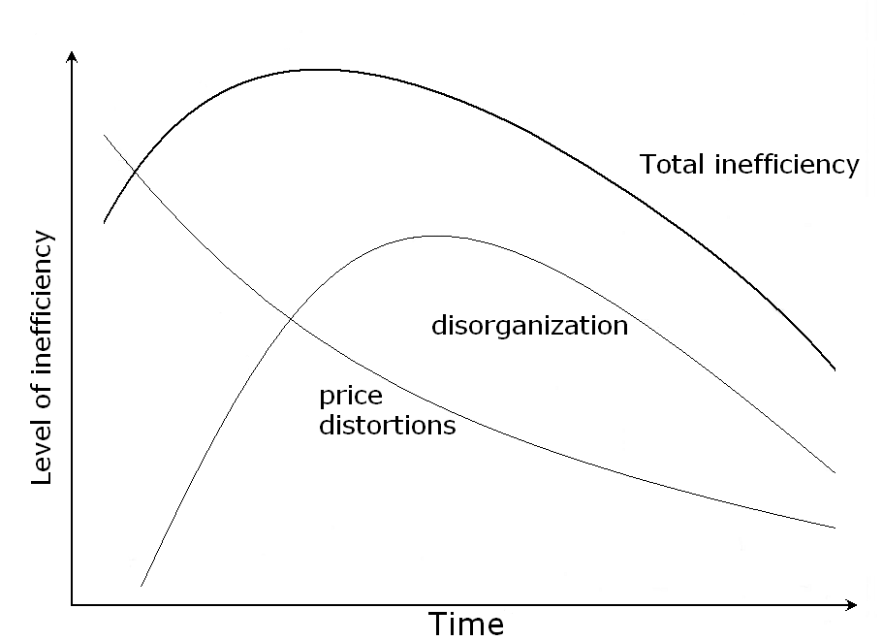
Fig. 1. Total inefficiency as a sum of disorganization and price distortions effects in the economy after the plan-market transition.

Example of table:
Tab. 1. Real value added growth rates decomposition in 1995-2006
(in percentage points)
 | 1995–2006 | 1995–1998 | 1999–2006
Real Value Added | 4.57 | -2.38 | 7.35
Labor | 0.58 | -2.33 | 1.11
Labor Productivity | 3.99 | -0.05 | 6.23
Notes: Numbers may not add up due to rounding.

Example of references (Harvard Style):
Book: Reid, DH, Parsons, MB & Green, CW 1989, Staff management in human services: behavioral research and application, Charles C. Thomas, Springfield.

Book section: Bernstein, D 1995, „Transportation planning‟, in WF Chen (ed.), The civil engineering handbook, CRC Press, Boca Raton, pp. 231-61.

Conference proceeding: Bourassa, S 1999, „Effects of child care on young children‟, Proceedings of the third annual meeting of the International Society for Child Psychology, International Society for ChildPsychology, Atlanta, Georgia, pp. 44-6.

Journal article: Huffman, LM 1996, „Processing whey protein for use as a food ingredient‟, Food Technology, vol. 50, no. 2, pp. 49-52.

Electronic article in EndNote Journal article with Electronic type chosen in Refworks: Daniel, TT 2009, 'Learning from simpler times', Risk Management, vol. 56, no. 1, pp. 40-44, viewed 30 January 2009, <http://proquest.umi.com/>.

Report: Mortimer, M & Cox, M 1999, Contaminants in mud crabs and sediments from the Maroochy River, Environment technical report no. 25, Queensland Department of the Environment, Brisbane.

Newspaper article: Simpson, L 1997, „Tasmania‟s railway goes private‟, Australian Financial Review, 13 October, p. 10.

Patent: Cookson, AH 1985, Particle trap for compressed gas insulated transmission systems, US Patent 4554399.

Example of contact details and disclaimer:

Nikolai P. Ivanov
National Research University Higher School of Economics (Moscow, Russia). “Development Center” Institute. Deputy Director;
E-mail: nivanov@hse.ru, Tel. +7 (495) 222-33-44

Any opinions or claims contained in this Working Paper do not necessarily reflect the views of HSE.

© Ivanov, 2014

¹National Research University Higher School of Economics. «Development Center» Institute. Deputy Director; E-mail: nivanov@hse.ru
²National Research University Higher School of Economics. «Development Center» Institute. E-mail: mpetrova@hse.ru
³The author is grateful to Andrey Yakovlev (Higher School of Economics), Philip Chen (Fiber) for providing papers and data, especially the archives of real-time.

