I2T-14, V.3, P.253-260

Development the automated gas mixture analysis subsystem AND design THE ARCHITECTURE OF THE RING LASERs production MANAGEMENT system

Belov A.V., Gavrichenkov A.E., Lopatkin D.V., Soloviova T.I., Akimtsev* Yu.V.
Moscow, MIEM NRU HSE
*Serpukhov, JSC ”Serpukhov plant “Metallist”

There is considered the development of analysis subsystem of the gas mixture correspondence to technological requirements being an important stage of the ring laser production management system creation. The problems and the results of designing a subsystem are analyzed. Proposed architecture of the unified production management system for the enterprise which is designing and manufacturing laser products is presented.
Key words: production control system, ring laser, gas mixture analysis

Introduction

In creation the projects on industrial enterprises automation the standard ISA 95 [1] is applied, which is one of the main international standards for factories automation. Its purpose is to propose the industrial enterprise’s unified information model to be used in automation process.
Application of the standard reduces the risks, costs and errors associated with implementing systems of enterprise scale and manufacturing operations management systems, and makes it easy to combine and interact above systems.
ISA 95 standard consists of three parts, which generally describe the typical automatable functions of industrial enterprise and its information model.
In the context of the information model to be proposed by the standard the automatable functions of industrial enterprise are divided into two levels:
• the upper level includes automatable functions related to the company and its constituent departments;
• the lower level, which contains the functions related to the processes of collecting the metrological information and control by industrial equipment.
Thus, as it follows from the provisions of the standard ISA 95, when designing the enterprise’s production management system there is appeared a problem of constructing a system architecture as a set of logically connected as the object information models, as the functions models, and above set forms the basis of the production process. CASE-tools are used for the construction of the proposed models. However, the use of CASE-tools becomes effective only if the mathematical models describing the main objects and functions involved in the enterprise’s production management system have been developed [1].
The final stage of construction of the production management system is the association of closely interacting subsystems with their local operating goals and objectives in a unified system to make possible not only automating the production process, but also bringing it to a higher level.
Production of the ring lasers is a science-based manufacturing process that uses modern technologies. Its efficiency and stability depend on arrangement of the information system supporting the process at all stages.
Current problems are as follows:
• traditionally arranged individual production facilities not to be interconnected with a unified information base and production management system;
• insufficient automation in production facilities, including manual entry of identification and metrological data;
• high scientific background of manufacturing procedures, that requires deep study of specific physical processes occurring in ring lasers at each stage of production, and taking into account this specificity in the development of data processing algorithms (for example, accurate knowledge of the maximum allowable time of experimental data evaluation);
• the need to combine in the analysis and management system two options: the mode providing the minimum time in estimation of product quality to achieve high efficiency in mass production and the mode corresponding to the implementation of accurate, not time-limited research in scientific experiments.
This paper describes the design phase of the ring lasers production management system related to one of the most important quality control stages – determination of the gas components ratio in working gas mixture that permits to evaluate the quality of the cavity and to predict its shelf life.
The purpose of this work is the development of subsystem with improvement the existing method of analysis of gas composition correspondence to technological requirements and exception the manual data processing.
Implementation of this subsystem will increase the speed of the analysis operation and as a result the entire production process speed as a whole, will exclude possible computational errors caused by human factor.
One of the requirements to the subsystem is the flexibility in producing different tests scripts. This will give the opportunity to use it most efficiently with considering the requirements of production to testing and ensuring a sufficiently high degree of subsystem versatility.
In this regard, the task of development of the automated analysis subsystem of the gas mixture composition correspondence to technological requirements is very actual. The concept of building this subsystem is proposed in this paper.

The essence of the analysis method of gas composition correspondence
to technological requirements

Researches were carried out for compact monoblock resonator of helium-neon laser, which is showed in Fig. 1.
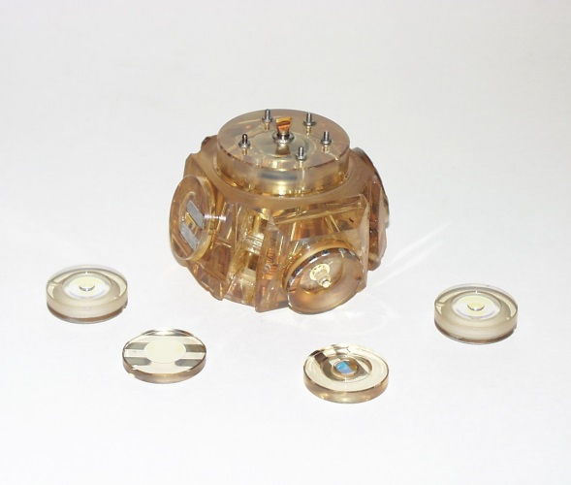
Fig.1. The ring laser
Helium-neon mixture is a medium which purity determines the accuracy characteristics of the device and its life time.
Manufacturing of devices from optical materials is technically difficult task, which does not exclude the possibility of the micro-defects appearance.
For manufacturing helium-neon lasers cavities there are selected the materials with low thermal expansion coefficient (TEC) and high hardness. When drilling channels in the cavity and the processing of parts to give them the desired shape the micro-defects are occurring on the channel walls and on the parts surface, the subsurface damaged layer is appearing. In that layer the gases are adsorbed which came into the cavity while manufacturing, and then during operation that gases are being emitted into the cavity internal volume.
Mirrors and other parts are connected to the cavity by optical contact. Due to microdefects the connections do not provide hermetically sealing of the cavity, so there is a leakage of the working gases (primarily He) from the interior of the cavity and the penetration of impurity gases from outside.
In addition, the reason for changing the gas composition in the cavity may be the adsorption properties of the aluminum cathode, which has a damaged layer with a lot of defects and pores.
Thus, the composition of the active mixture can vary during operation and storage, that can lead to malfunction of the device and ultimately to its failure.
One of the exploitation requirements of this device is shelf life for 15 years.
A prerequisite for this is insurance that during storage the gas mixture in the cavity will not change as for the main working gases He and Ne, and for impurity content.
Leakage flow for the device is determined by the relation [2]:
$Q=\frac{∆PV}{T} .$ (1)
Research proved to ensure shelf life for 15 years the admissible flow leakage must not exceed 2.7 ∙ 10⁻¹¹ Pa∙m³ / s.
The equipment to be currently used for vacuum processing cavities is not able to measure flow leakage less than 6.7 ∙ 10⁻¹³ Pa∙m³ / s, and therefore the procedure was developed for predicting cavity storage on leakage by spectral analysis [2].
This procedure allows to predict with high accuracy the time during which the gas mixture of the optical cavity will permit him to maintain the required exploitation performances.
Since the main reason in the considered cavities for deviations on impurity gases is the presence of nitrogen impurities, the experimental study was carried out for that gas.
In cavity selected for the experiment we measured nitrogen concentration immediately after the ignition of the discharge.

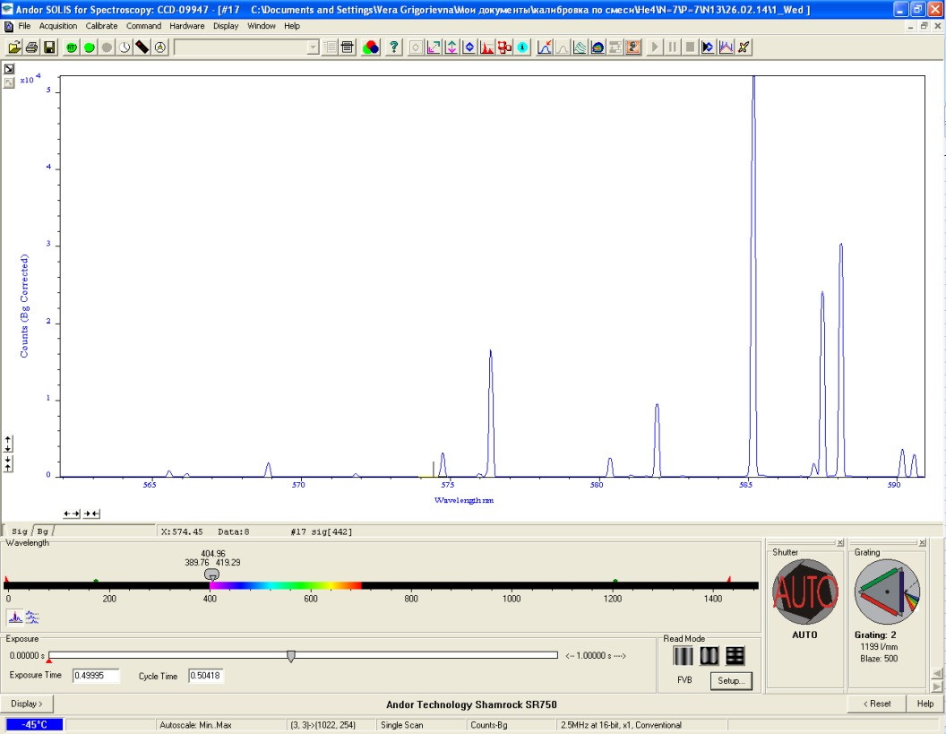
Fig. 2. The spectrum of the gas composition
Procedure of determining the composition of the working gas mixture for He-Ne ring lasers which uses emission spectral analysis have been proposed in [2]. It based on the measurement of the intensities of the helium lines 5016Å and 5876Å and neon line 5853Å in the spectrum of discharge gap spontaneous emission, calculation the ratio of the intensities α=
= I₅₀₁₆/I₅₈₇₆ and β = I₅₀₁₆/I₅₈₅₃, determination the pressure P and the ratio of the partial pressures of helium and neon $N= \frac{P_{He}}{P_{Ne}}$ on the calibrating dependences P = F (α) and N = = F (β, P).
Extrapolation of the experimental dependence of P = F (α) allows to derive the following formula to determine the pressure of the mixture:

$P = {10}^{(\frac{1}{0,9314}) ∙lg(\frac{0,75}{α})}$ (2)

Calibrating dependences N = F (β, P) are a family of linear functions β = kN + C, intersecting at a point M (N = 0, β = 0.028), the slope of which k depends on the pressure of the mixture.
Plotting the dependences of k = F (P) and extrapolating it, we obtain the following formula for the calculation N:
$N= \frac{(β-0.028)P^{2.0133}}{0.198} .$ (3)

The main goal of tests is to determine the leakage flow, which allows to predict the possible time of the tested device storage.
For this purpose, the following measurements and calculations are to be made:
• calculating the initial value $N_{r0}$

$N_{r0} =\frac{I_{N} - I_{Nnoise}}{I_{He}}$ ; (4)

• repeating the measurements and determining N_{rel1}.
If in the second measurement relative level of nitrogen N₂⁺ at wavelength 3914Å (N_{r1}) appears more than previously measured (N_{r0}) by an amount ΔN_{r} ≥0.013, where ΔN_{r}= N_{r1}- N_{r0}, the following steps are to be performed:
- estimate the value of flow leakage as follow:
  - determine Δ P_{N} on the calibrating dependence lgΔP_{N}=F(lgΔN_{r});
  - calculate the leakage flow by the formula:

$Q=\frac{ P_{N}∙ V}{ t} (\frac{Pa∙m3}{s}),$ (5)

where V – volume of the cavity (m³);
t – time between measurements;
ΔP_{N} – change of the nitrogen partial pressure, Pa.
- evaluate the device predicted life time on leakage of nitrogen:

$Т= \frac{P_{Nкр}∙V_{рез}}{Q}$ , (6)

where (P_{Nkr} ∙ V_{rez} ) = 1.33∙10⁻ ⁵Pa ∙ m³;
Q – flow leakage.
To calculate the leakage flow and the device predicted shelf time on leakage of nitrogen the computer program "Primes" may be used. Data are being entered manually in this program, that noticeably slows down the process of testing and can lead to significant errors.

Improvement the gas mixture analysis subsystem and design the architecture of the ring lasers production management system

Previously described procedure is proved to have computational complexity. Now at the enterprise there are separate software tools, allowing to calculate the ​​required parameters, but they are not integrated into the system. Because of this, the present method of analysis contains various operations with data performed by a man. Aside from the obvious influence the human factor on the process of testing the disadvantages described above also significantly slow the process. Moreover, existing software does not perform automatically a series of measurements and currently they are made by man. This causes difficulties in projecting of automated control system for ring lasers. Besides, testing time should be reduced to save the cavity being tested.
In this paper, the following investigations were carried out:
• research possibilities of upgrade the current software for gas composition analysis subsystem to create a unified control system for ring lasers;
• expansion software capability to enable experimental studies of gas mixture changing processes in the cavity, including an analysis of the most frequently occurred in cavities impurity gases such as oxygen, nitrogen, carbon monoxide and carbon dioxide, and hydrogen.
Considered in this paper the automated gas mixture analysis subsystem is related to the lower level of the standard ISA 95 and is an important part of ring lasers production management system.
Existing model of architecture of automated system corresponding to the technological process is presented in Fig. 3. Its occurrence is associated with the beginning of the period of transition to computer technology, when all laboratories have structured their own data and created their databases, which have allowed them to work with the information with greater efficiency.

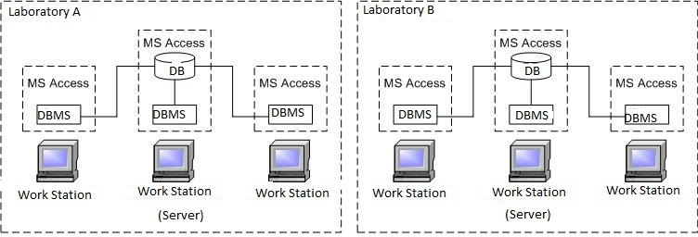

Fig. 3. Existing model of production automation system architecture

It is a collection of independent databases with information exchange between them through external drives and paper records. With this organization the data follow the same route as the objects to which they relate. Data flow model fully repeats the existing technological process and rigidly attached to him. However, considering that information is being entered at the user’s workplaces and stored in local DB with different logic structure the part of data is duplicated. As a result, any information changes require updating all the prototypes in the back direction of the information transmission route until the source. So, the existing informational model of the technological process needs in improvement [3].
To enable future upgrades of DB most productive, the following conditions must be observed:
1) DB structure at all stages of development must be changed by the same predetermined rules;
2) actions not required of human participation must be entered into the automation system;
3) DB model adequacy to subject area must be provided.
Obviously, modernization of the existing information system of the technological process at the enterprise needs qualitatively new informational model. For that a set of universal solutions can be formulated as follow:
1) automating the process of data exchange;
2) coordination of statistical research;
3) tracking of the status of all database’s elements at all technological stages;
4) introduction "browser" technology.
Operation with the data in the system with a single server will be implemented under the scheme: User - Browser - Web- server - DBMS - DB.
As a result of research the new informational model was developed. All information in this model is in a common database, all data are being sent over the network, and "browser-based" technology is used.
Fig. 4 shows the proposed new informational model on the example of two virtual laboratories A and B.

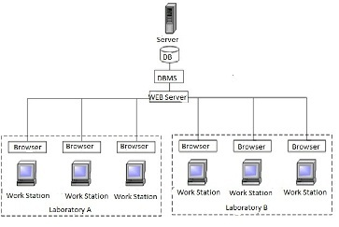

Fig. 4. New model of production automation system architecture

The transition from a model of local information system architecture realizing the corresponding technological operations to a model of system architecture with a single server (common database serving the total technological process) suggests the developer the following requirements to the projected model of the database:
- simplicity of using,
• portability,
• scalability.
Thus, the proposed concept of system architecture model with a single server will eliminate the disadvantages of the existing information model and will initiate the creating a unified ring lasers production control system. This will be able only with high automation of each manufacturing stage, possibility of including it in the common information system. That is the reason why the development of the automated analysis subsystem of the gas mixture composition correspondence to technological requirements is an actual problem.

Conclusion

Proposed in this article approach of designing subsystem of the gas mixture composition correspondence to technological requirements being a part of the ring lasers production management system is effective from technical and economical estimations.
However, analysis of the features of the ring lasers designing and technological cycle showed that manufacturing of high-tech products such as lasers in accordance with the requirements of ISO 9001:2000, is a complicated task and its solution is impossible without creating a unified information space at the enterprise. Forming of this information space is impossible without achieving a high degree of automation at the each stage of production including quality control. Therefore, development of a subsystem of the gas mixture composition correspondence to technological requirements is an important step towards the creation of integrated management system for ring lasers production.

Reference

- ISA-95: The international standard for the integration of enterprise and control systems.
2. Brugger V.E., Savelyev I.I., Sukhov E.V., Proleiko E.P., Mash L.D., Pchelintseva N.I. Absorption of impurity gases in the sealed-off atomic laser by titanium film obtained with cathode sputtering.// Naukoyomkie tekhnologii. 2012. №4.
3. Belov А.V., Smirnov V.А. Construct a mathematical model of the system analysis of the characteristics of quality information management systems enterprise-wide. // Kachestvo. Innovatsii. Obrazovanie. 2009. №4.
4. Belov А.V., Solovyova T.I., Savelyev I.I., Khlebnikov P.A. Projecting of ring laser production management system.//In book: Innovation information technologies: Materials of international scientific-practical conference/ Managing editor: I.A. Ivanov; General editor: S.U.Uvaisov. V.3. M.: MIEM NRU HSE. 2013. P.35-41.

I2T-14, V.3, P.253-260

