Anna A.Novikova
Nihon Suido Ko: (“Thoughts on Waters and Lands of Japan”) by Nishikawa Joken (1648 – 1724)
My present paper is dedicated to Nishikawa Joken’s (1648 – 1724) treatise Nihon Suido Ko:(“Thoughts on Waters and Lands of Japan”). The treatise was composed approximately in 1700 and published in Kyoto in the beginning of the 18th century. It was translated from kanbun into bungo and republished in the 1940s along with other Joken’s works on geography. Joken’s aim was, first of all, to give a geographical description of Japan adjusted by newly adopted Western knowledge of the world. Nonetheless, Nishikawa based his work on traditional East-Asian system of knowledge as well as on the European data. The result of such mixture was an original work, which one can hardly attribute both as a reproduction of Western science and as traditional Japanese treatise. Although an up-to-date work, Nihon Suido Ko due to various reasons also contained a range of false data. Rather than simply copying Western knowledge, he used it to balance other confronting views of the world – Confucian and Buddhist – and to create his own image of the world. In my report I shall touch the aspects which were borrowed from each of these paradigms. The final picture that he introduced in this treatise was partly true and close to the modern view, partly it was not – containing a number of mistakes brought with the Western science of the time and probably voluntary distortions in order to show Japan’s place in the world in a better way.
The author served as an interpreter in Nagasaki, and due to this fact he had opportunity to get acquainted with the Western view of the world. Nishikawa is considered to be one of the first scientists to introduce Western geography and astronomy in Japan. His works were widely known and it is thought that his other geographical work Kai Tsu:sho: ko: (“Thoughts on Trade with China the Southern Barbarians») and its later version Zo:ho: Kai Tsu:sho: ko: were composed at shogunate’s request. A person with broad range of interest, Nishikawa also wrote on astrology and social order in his other works, such as Hyakusho:- kaneko .
Nihon Suido Ko: consists of a short preface and the main text with no separate chapters. First Nishikawa explains what the world is like, what size it has. Then he describes the position of Japan within this world, and continues to explain why this position is unique and advantageous. The final phrases sound really patriotic, as Nishikawa writes that this kind of country no one can fail to love, appreciate and admire. The treatise is accompanied by two maps. The first one reproduces the Eastern hemisphere (see pic.1), the other one – Japan (pic.2).

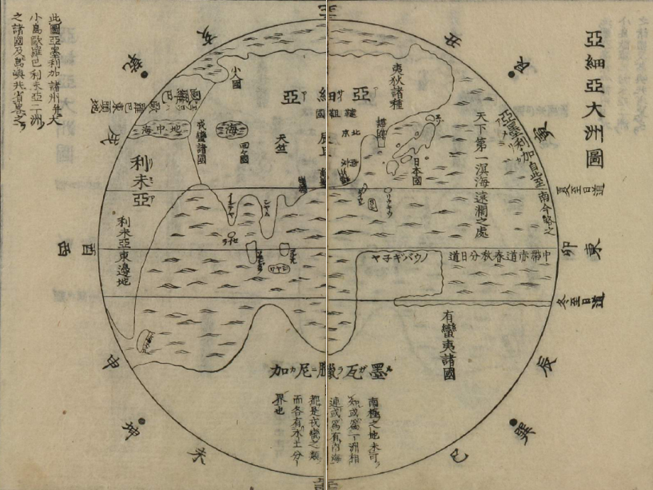
Picture 1. The Great Asian Continent. Map from Nihon Suido Ko:

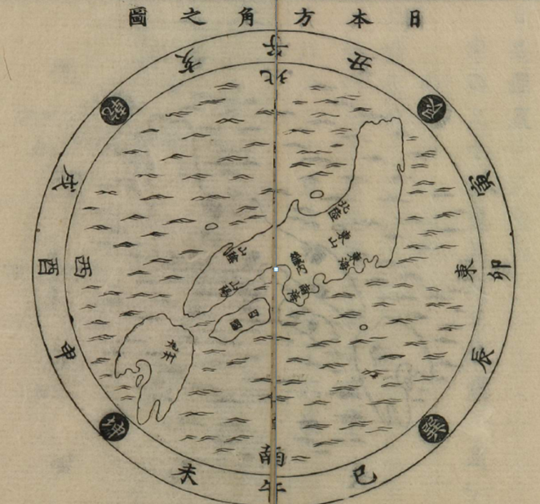
Picture 2. The Map of Entire Japan. The map from Nihon Suido Ko:

During the 17th century Matteo Ricci’s (1552 – 1610) works were the most influential source of geographic knowledge. The way Nishikawa describes the world supposes, he used his texts and maps primarily as a source of Western scientific data. He repeats after Ricci the structure of the world and names five continents: Asia, Europe, Libya (in place of Africa), America and Magellanica. The term he uses for a “continent” is unlike modern language the character 州(shu:). It is noteworthy that although Nihon Suido Ko: was composed approximately hundred years later than Ricci introduced the Western knowledge of the world to China, it is still Ricci whose data and mistakes as well Nishikawa reproduces in his work. He writes of semi-phantom Southern land (Magellanica, or Megaranika黒瓦臘尼加 in Japanese – the term probably introduced by Nishikawa for the first time in Japan), which was one of the greatest myths of the European geography. The continents are united into three “great zones” (三大界): the first one we should call the Old World, as it includes Asia, Europe and Libya. It is, according to Joken, situated to the North from equator. The second one is America lying both to the North and to the South from equator. The Southern hemisphere is occupied by Magellanica, which is the third zone. On his map Joken also shows New Guinea as a peninsula of the Magellanica continent, although Torres stray had been discovered in 1606 and was drawn on maps by Ricci’s successors in China, Jesuit fathers Nicolo Longobardi and Manuel Dias. It is to say that the influence of the Western science in the end of the 17th century was at the level of a more than a hundred years before.
Speaking of the structure of the world Nishikawa also notes that each island can be attributed to a continent. Japan is, consequently, a part of Asia not only in cultural, but also geographical (natural) sense.
Also borrowing the idea from Ricci’s works Joken names only three climates: temperate, a cold one and a hot one. Ricci himself interpreted the world map adopting Chinese idea of its central position in the world. It is remarkable how Joken united two foreign ideas – the idea of climatic zones and the Chinese idea of centrality and temperance – to show that Japan and its capital are situated precisely in the center of the most favorable climatic zone. This idea, although not quite true, was a success and thinkers of the 19th century beginning with Hirata Atsuntane (1776 – 1843) used it as well to show superiority of Japan.
In this country the four seasons follow each other regularly. Although the world is vast, countries with regular four seasons are scarce. Among the numerous islands of the Great Sea there are no like Japan with four season climate. All the countries situates 27 grades to the North and to the South from the equator are extremely hot countries. Only the countries situated between 27-28 and 42-43 grades counting from equator possess the climate with four regular seasons. The central part of Japan with its capital is situated 35 grades away from the equator, its Eastern edge – in 38-39 grades and its Western edge in 31-32 grades; it corresponds to the very central part of the temperate climate... Not to mention the fact that the position of Japans capital in the heart of the temperate zone is in all conscience rare thing.
Nishikawa was also acquainted with the idea of grade frame: he uses the term for grade in his work when he describes the climatic zones and he gives correct longitudes of several objects in Japan (Kyoto, Edo, Nagasaki and some other) and even abroad (Peking). Nevertheless the idea of grade frame was not correctly understood in Japan at the time. Earlier maps (such as the Sho:ho: map) based on Ricci’s work contain only an imitation of the frame. While the author of the Sho:ho: map used it just as a decoration, Nishikawa went slightly further in his understanding of this basic idea of geographic science and – it becomes obvious from the way he uses the term - took it as a new measure of distance, as he used the grade terms to describe interval between geographical objects and even to disprove the statement that Japan is a small country. Nishikawa, for example, mentions that one grade is equal to 40 ri. He goes further to state that although Japan is an island, it is the biggest island of all the existing in the world. Probably, to support the statement other islands (Java, Taiwan, etc.) are shown on his map much smaller than their real size, while Japan is bigger. On his map the grade frame was not entirely shown: he marked instead only the equator, Southern and Nothern tropics, that are parallel to each other, which means the idea of mathematical projection component was not adopted at the time and Joken’s map are no more than an imitation of the European originals he used.
In the very beginning of the treatise Joken writes of the spherical shape of the Earth in such a way that we can assume that the fact was obvious to him and needed no special grounding. It should be mentioned that earlier generations of Japanese thinkers such as Hayashi Razan (1583 – 1657) had laughed at it, so Nishikawa’s work was obviously a step forward. At the same time the idea had no practical meaning to him, he just integrates it into the discourse to prove once again the superiority of the position of Japan, using it together with traditional way of description.
While introducing European science and having rational approach on the whole (which we can see in his analysis of the origin of different names of Japan), Nishikawa at the same time widely used traditional Far-Eastern system of knowledge. Along with the imitation of the grade frame and the characters for the cardinal points, in his map he also uses I Ching trigrammes meaning different directions. Making use of this mixture of a European-style map and the traditional Far-Eastern language of geographical description, Joken “plays” with various meanings of the trigrammes, interaction of yin and yang and the five elements and comes to the conclusion that the position of Japan is unique and most favorable from the natural point of view. A position to the North-East from the mainland (here Joken contradicts his own argumentation, as he had previously written that on the spherical Earth there is no fixed place for East or West) means an exceptionally advantageous influence of the elements: in this country the yang energy arises and consequently brings the gods kami and all the auspicious natural forces to the islands. The arising yang energy determines every characteristic of the Japanese people: physical health of men and beauty of women, devotedness to the right rituals, military valor and even loyalty to the ruling dynasty.
This country is situated at the edge of the gon trigramme (艮, North-East) and the shin trigramme (震, East), and due to this it is here that yang ki energy arises. The things firstly born by yang energy demonstrate its youthful quality and the ki energy is abundant within them. Due to this reason the hearts of many of the Japanese people are full of humaneness and love, as this natural character is determined by the power of the Eastern shin trigramme… Those, who are inclined to martial valor, acquire this quality absorbing the spitrit of the North-Eastern trigramme gon and the great mountains. Due to this reason the people of Japan love everything pure, beautiful, heroic, and white and detest the emanations of blurred and impure yin; they celebrate many festive rites and few mournful; the New Year rites, the wedding ceremonies – all these festive rituals are correctly fulfilled even by the commoners; this distinguishes Japanese people from men of other countries… This is naturally determined character of the people of this country.
Nishikawa uses the logic of trigrammes not only to show Japans superiority, but simply to determine its place on the map. His maps contain trigrammes as well as the imitation of the grade frame.
To determine the place of Japan, one should move from the center of the First Great Zone in the direction of the trigramme gon 艮.
Following this logic, Joken finds Japan’s antagonist: some Oni-ga sima, or Devil island, situated to the East from America on the opposite side of the Earth (see pic.3). Consequently, it is yin energy that prevails in this land and attracts all kinds of demons.

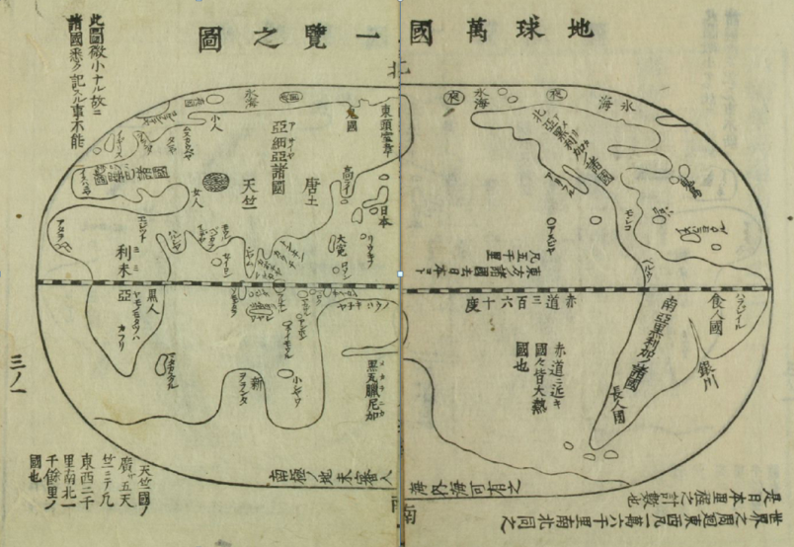
Picture 3. The Map of All the Countries of the World. Map from Zo:ho: Kai Tsu:sho: Ko:

The idea of the superiority of Japan, as it is remarkable for its interaction of different logical systems. From time to time Nishikawa shifts to the logic of the climatic zones or strategic position of the archipelago, but in his discourse the contradicting paradigms coexist quite peacefully. Japan is supreme due to various factors: first of all because it matches the Asian continent, which is without any doubt the greatest of all. It is supreme due to the unique geomantic position and at the same time because of its temperate climate. But above all Japan is supreme with its people’s character: truthful, virtuous, beautiful and healthy. The character is determined in its turn by the trigrammes and the five elements’ interaction and at the same time by the wonderful climate.
Buddhist influence on Nishikawa’s treatise is not as obvious as that of the European science or I Ching, still we can see it in the Buddhist terms for China and India used in the text and on the map. It is also remarkable that India (Tenjiku) on his map is not a peninsula, but is situated in the middle of the Asian mainland. Nishikawa rarely mentions Buddha in his work, but he tries to oppose the Buddhist term used for Japan – the millet grain size country.
To my mind, the reason why Nishikawa appeals to several paradigms at the same time is that in this particular work he pursued the aim of creating a new picture of the world, that could be opposed to the Buddhist and Chinese views, both placing Japan at the periphery of the world, but at the same time revealed in the same language. European knowledge served as a good instrument to show Japan’s advantages without abandoning the traditional view. In the preface to Nihon Suido Ko: Joken mentions that his purpose is to show his colleges the way how to speak of his country to the foreigners.
Speaking of foreign lands and geography of other countries one should not fail to rely upon the examination of the qualities of waters and lands. As among all the countries there are no such that would not try to flatter themselves. Taking into consideration this subjectivity the cartographers rely not upon this partial attitude, but upon exact knowledge. In this treatise of mine I describe the waters and lands of Japan in order to show my colleges the proper way to speak to the foreigners. Should one neglect this?
His aim was not to give the truthful image of Japan’s position in the world, but rather a favorable image.
Although almost unknown nowadays, the work seems to be one of the first to express the ideas which became very influential in the following centuries. Hirata Atsutane, for example, over a century later highly estimated Nishikawa’s works for being the first to introduce the Western learning in Japan. Even some Buddhist maps of the Tokugawa period, which were still quite far from reality, used names and distances between the foreign countries, borrowed from Nishikawa’s treatises. When the self-seclusion of Japan ceased the idea that Japan is unique in its people’s character, traditions, political structure and even appearance and that the reason of this uniqueness lies in the exceptional qualities of its waters and lands and are determined by nature itself, became even more spread through the modern system of education.
Many ideas of Joken were of course a deception, or rather a self-deception, a natural reaction to the new knowledge and an attempt to find a right place for one’s country in the world. They might be logically incorrect, but psychologically they were true. In the end, I’d like to mention that it is fascinating how the development of cartography – an exact science – can influence such an impractical and far from accuracy sphere as poetic comparison. Nishikawa writes, that before the shape of Japan was compared to kagero (Odonata dragonfly).
In ancient times the shape of Japanese islands was compared to the insect kagero:. But nowadays, when it is explored with the help o maps, it is compared to the neck of the flying dragon.
This comparison could be taken as a symbol of Nishikawa’s way of adopting Western knowledge on the whole: using an achievement of exact science to create new, greater poetical myth in order to replace an older and a smaller one.

Bibliography:
- Ayusawa, Shintaro. Geography and Japanese Knowledge of World Geography//Monumenta Nipponica. – Tokyo, 1964. – V.19, №3/4. – P.275 – 294.
- Keene, Donald. Hirata Atsutane and Western Learninng//T’oung Pao. - Second Series, Vol. 42, Livr. 5. - Leiden-Boston, 1954. - pp. 353-380.
- Muroga, Nobuo; Unno, Kazutaka. The Buddhist World Map in Japan and its Contact with European Maps//Imago Mundi. – Vol.16 (1962). – Pp.49 – 69.
- Nishikawa Joken. Nihon Suido Ko:. Suido Kaiben. Zo:ho: Kai Tsu:sho: Ko:. – Tokyo: Iwanami shoten, 1988. – 196 P.
- Ooms, Herman. Hakuseki's Reading of History// Monumenta Nipponica. - Vol. 39, No. 3 (Autumn, 1984). - Pp. 333-350.
- Sato, Masayuki. Imagined peripheries// Diogenes, №173. Vol 44/1. – Sprig, 1996. – pp.119 – 135.
- Wallis, Helen. The Influence of Father Ricci on Far Eastern Cartography//Imago Mundi. - Vol. 19 (1965). - P. 38-45
- Yamashita, Samuel Hideo. Reading the New Tokugawa Intellectual Histories//Journal of Japanese Studies. - Vol. 22, No. 1 (Winter, 1996). - pp. 1-48.

In my research I used the bungo translation: Nishikawa Joken. Nihon Suido Ko:. Suido Kaiben. Zo:ho: Kai Tsu:sho: Ko:. – Tokyo: Iwanami shoten, 1988. – 196 P. And the original publication kindly reproduced at the web-site of Waseda University: http://archive.wul.waseda.ac.jp/kosho/bunko08/bunko08_b0112/ (Septemder, 2010)
Yamashita, Samuel Hideo. Reading the New Tokugawa Intellectual Histories//Journal of Japanese Studies. - Vol. 22, No. 1 (Winter, 1996). - pp. 1-48. – P.29
Nishikawa Joken. Nihon Suido Ko. P.26
Wallis, Helen. The Influence of Father Ricci on Far Eastern Cartography//Imago Mundi. - Vol. 19 (1965). - P. 38-45. – P.39
Wallis, Helen. The Influence…. – P.40
Nishikawa Joken. Nihon Suido Ko. P.19
Ayusawa, Shintaro. Geography and Japanese Knowledge of World Geography//Monumenta Nipponica. – Tokyo, 1964. – V.19, №3/4. – P.275 – 294. – P.280
Keene, Donald. Hirata Atsutane and Western Learninng//T’oung Pao. - Second Series, Vol. 42, Livr. 5. - Leiden-Boston, 1954. - pp. 353-380. – P.363
Nishikawa Joken. Nihon Suido Ko. P.23
Wallis, Helen. The Influence … P.44
Nishikawa Joken. Nihon Suido Ko. P.24-25.
Nishikawa Joken. Nihon Suido Ko. P.19-20
Ayusawa, Shintaro. Geography … P.278
Ooms, Herman. Hakuseki's Reading of History// Monumenta Nipponica. - Vol. 39, No. 3 (Autumn, 1984). - Pp. 333-350. – P.338
Nishikawa Joken. Nihon Suido Ko. P.20-21
Nishikawa Joken. Nihon Suido Ko. P.21
Nishikawa Joken. Nihon Suido Ko. P.20
It is not clear where the idea of such an island came from. The legend of Devil islands had existed in Japanese culture before. However imagined lands were present in Jesuits’ works in Chinese as well. (See: Sato, Masayuki. Imagined peripheries// Diogenes, №173. Vol 44/1. – Sprig, 1996. – pp.119 – 135. – P.130) Here, as elsewhere in his writing Nishikawa could use the mixture of Eastern and Western ideas.
This treatise is also reproduced at the Waseda University web-site. http://www.wul.waseda.ac.jp/kotenseki/html/i13/i13_00581/index.html (September, 2010)
Nishikawa Joken. Nihon Suido Ko. P.13
Keene, Donald. Hirata Atsutane … P.361
Muroga, Nobuo; Unno, Kazutaka. The Buddhist World Map in Japan and its Contact with European Maps//Imago Mundi. – Vol.16 (1962). – Pp.49 – 69. – Pp. 58-60.
Nishikawa Joken. Nihon Suido Ko. P.23-24

