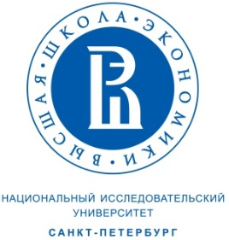

Application form for the Summer School “Comparative Studies of Power and Diversity in Historic Empires”
Russia, Saint-Petersburg, June 5-11.

Please complete all sections and attach all supporting documentation required.

1. Personal Information

Name: | Citizenship
Position and Institution:
Email: | Degree (if any)
For graduate students:

University or academic institute:

Year of study:

2. Proposal

Title of the presentation

3. Travel, if required: Estimated Costs

Please give a description of travel and estimated cost. The organizers can only reimburse the economy fare (air fare economy couch or train where applicable). There is a limited number of travel fellowships available.
Travel: (please give details) | Total: RUB

This form should be emailed to isodnomova@hse.ru

The application should be in English and consist of CV, sample writing or publication, motivation letter (no more than 1000 words) and an application form. Participants will be expected to present their current research in the field of comparative studies of empire and colonialism.

