Еженедельный семинар Лаборатории Алгебраической геометрии и ее приложений
Семинар состоится 5 июня 2015 года. Начало в 17:00.
Семинар будет проходить по адресу: ул. Вавилова, д.7, аудитория 1001, 10 этаж.

На семинаре выступит  Sorin Dumitrescu  (Universite Nice-Sophia Antipolis)  с докладом: | 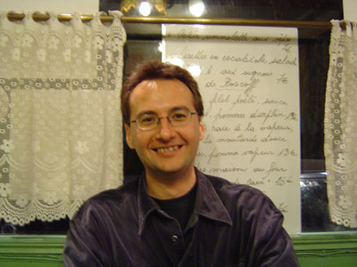

Quasihomogeneous real and complex geometric structures

Abstract: The talk deals with rigid geometric structures which are quasihomogeneous, in the sense that they are locally homogeneous on an open dense subset of a manifold, but not on all of the manifold. Our motivation comes from Gromov's open-dense orbit theorem and its application to prove the differential rigidity of some smooth Anosov systems. More precisely, we will present the classification of quasihomogeneous real analytic connections on surfaces (collaboration with A. Guillot)and the case of real analytic Lorentz metrics on three folds (collaboration with K. Melnick). We will also present the corresponding classification results on complex manifolds.
Приглашаются все желающие!

