HSE University – St. Petersburg, School of Economics and Management

Bachelors Module Description for 2015/16

Applied Health Economics

Bachelors, 4th Year: 4 credits, 42 contact hours

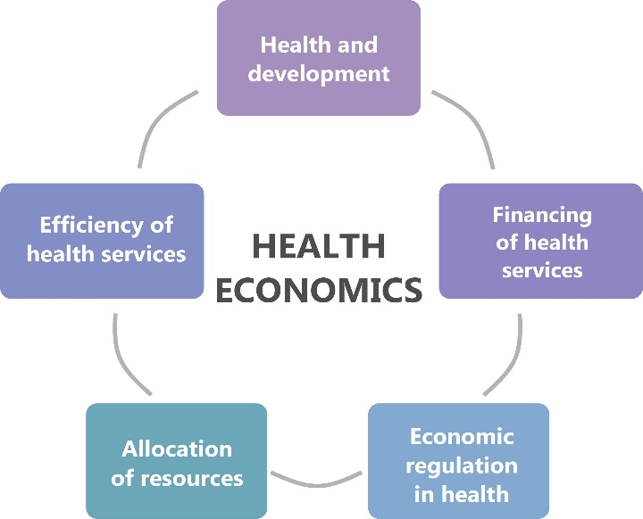

Professor Christopher J Gerry

2015-16

- Module Summary

Health is the most fundamental measure of economic progress. There is increasing interest in health and health care as well as the role of government in securing these for their populations. Ambitious and controversial health care reform programmes are being introduced or are on-going across Russia, Central and Eastern Europe, and Central Asia as well as in the UK, the US and across the BRICS, most notably in China. This course in ‘Applied Health Economics’ is a 4 credit module serving as an introduction to a sub-discipline of economics which is relatively new to Russia. By teaching you to look at the health sphere through the lens of the economist, this module will transform the way you think about health and health care. The course builds a theoretical framework which provides the tools for examining some of the most challenging and interesting problems in the health care sector and which illuminates the complexities faced by policy makers trying to improve the delivery and effectiveness of health care.

Defining questions of the course include:

- Why are some people healthy and others are not?
- Why don’t individuals simply buy and sell as much health as they need?
- How can and do societies supply health care and services?
- How should society spend its health resources?

As far as time allows, the module draws on examples from across the globe but pays particular attention to (the often unique) health dynamics and evolution of policy in Russia and other post-Communist countries of Eastern and South-Eastern Europe and Central Asia.

- Module logistics

This is a four credit module taught during the third quarter. The course is delivered through a mix of formal lectures and exercise based practical sessions (seminars).

Lectures: there is one 80 minute lecture per week. Lecture guides will be posted on LMS in advance of lectures, and/or as follow up to lectures. The lecture notes will provide the main source of material for the course. You should download and read these carefully each week.

The lectures take place on Friday 12.10-13.30, Kantemirovskaya 3A, 346.

Practicals: seminars will involve a variety of teaching and learning formats including presentations, individual and group exercises, discussions, debates and games and will normally also involve some formal lecturing time to ensure that the appropriate amount of material is covered during the module.

The practicals take place on Monday 10.30-11.50 and 12.10- 13.30, Kantemirovskaya 3A, 346.

You are expected to attend all sessions of this short but intensive course. Attendance will be recorded and monitored. Absences should be explained via email to cgerry@hse.ru.

The course starts on Friday 29th January and continues until Friday 25th March

- Module assessment

Summative assessment is in two parts. There will be a two-hour written exam during the end of module exam period. This will contribute 50% of your final mark. Additionally, there will be an in semester coursework assessment which will contribute 50% to your final overall mark. This will involve submitting at least one coursework tasks out of the two offered during the module: if you submit both pieces (as I recommend), your best mark will count.

Formative assessment is ongoing through your preparation and submission of work for the practicals as well as through the optional additional coursework.

- Contact details and office hours

Professor Christopher Gerry
Office: 406, Kantemirovskaya 3A
Email: cgerry@hse.ru
Office hours: Friday 13.30 – 14.30

- Textbooks and Internet resources:

The lectures for this course are based on two well-known textbooks – I will try to arrange certain core chapters to be scanned/copied for your convenience:

Folland, S., Goodman, AC. and Stano, M. (2014) The Economics of Health and Health Care, Seventh
edition, Pearson.
Bhattacharya, J., Hyde. T. and Tu, P. (2014) Health Economics, First edition, Palgrave Macmillan.

In addition there are a range of other excellent Health Economics textbooks that cover broadly the same materials.

Morris, S., Devlin, N. and Parkin, D. (2012) Economic Analysis in Health Care. John Wiley and Sons.
2nd edition.
Glied, S. and Smith, PC. (2011) The Oxford Handbook of Health Economics. Oxford.
Phelps, CE. (2010) Health Economics. Fourth edition, Pearson (International Edition).
Olsen, JA. (2009) Principles in Health Economics and Policy. Oxford.
Jones, AM. (2006) The Elgar Companion to Health Economics. Edward Elgar.

- Module outline

Week 1 (January 29th):

Friday January 29th (2): Introducing Health Economics
- Monday February 1st (4): The demand for health care and the Grossman model

Week 2 (February 5th):

- NO FRIDAY CLASS
- Monday February 8th (4): xxxx

Week 3 (February 12th):

Friday February 12th (4): xxx
- Monday February 15th (4): xxx
COURSEWORK I RELEASED

Week 4 (February 19th):

- NO FRIDAY CLASS
- NO MONDAY CLASS

Week 5 (February 26th):

Friday February 26th (4): xxx
- Monday February 29th (4):xxx

Week 6 (March 4th):

Friday March 4th (2): xxx
- NO MONDAY CLASS

Week 7 (March 11th):

Friday March 11th (2): xxx
- Monday March 14th (4):xxx

COURSEWORK II RELEASED

COURSEWORK RELEASED

Week 8 (March 18th):

Friday March 18th (2): xxx
- Monday March 21st (4):xxx

Week 9 (March 25th):

Friday March 25th (2): xxx
- NO MONDAY CLASS

