Семинар Лаборатории Алгебраической геометрии и ее приложений
Семинар состоится в пятницу 27 ЯНВАРЯ 2017 года.
Начало в 17:00.
Семинар будет проходить по адресу: ул. Усачева, д.6, аудитория 306

На семинаре выступит Миша Вербицкий | 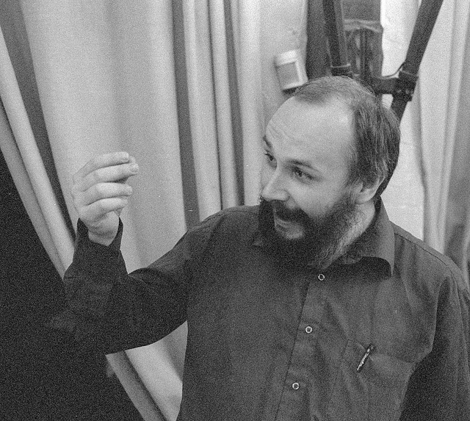
(HSE and ULB) с докладом:

Algebraic and Kahler dimension of nilmanifolds
Abstract: Let M be a complex nilmanifold, that is, a quotient of a nilpotent Lie group with left-invariant complex structure by a cocompact lattice, and h the dimension
of its space of holomorphic differentials. S. Salamon has shown that \dim M >= h > 0 for any nilmanifold, with equality realized if and only if M is a torus.
Algebraic dimension a(M) is transcendental dimension of the field of meromorphic functions on M. It is known that algebraic dimension is bounded from above by the usual dimension. I will show that a(M) is bounded by h (dimension of the space of holomorphic differentials)
and explain when this bound is realised and how a(M) can be computed explicitly in terms of the Lie algebra. Also I would show that h bounds the Kahler dimension of
M, that is, the maximal dimension of a compact Kahler manifold X such that there exists a dominant meromorphic map M -> Х, and explain when this bound is realized. This
is a joint work with Gueo Grantcharov and Anna Fino

Приглашаются все желающие!

