To install updates on a computer running Windows 10, please do the following:
- Click the ‘Start’ button and select ‘Settings’ (the icon in the lower left corner) 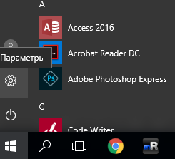

- In the open window, click ‘Update & Security’ 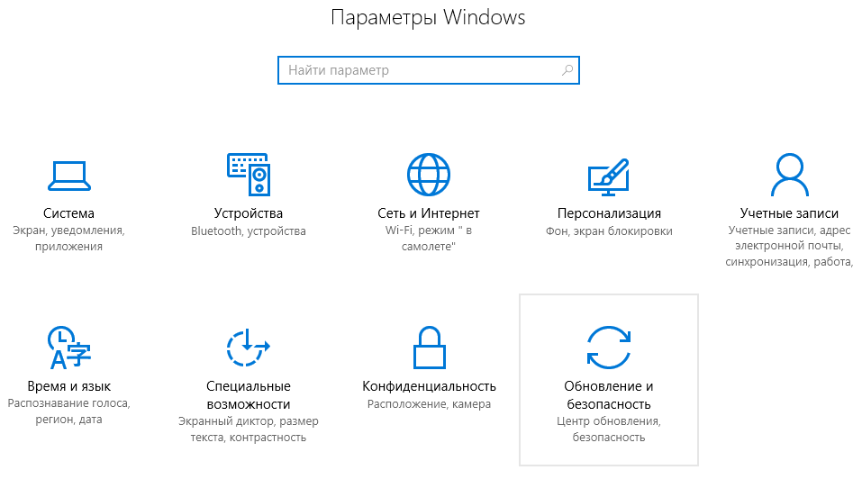
- Click ‘Check for Updates’ and, if updates are found, click ‘Install Updates’

