To install the updates on a computer running Windows 7, please do the following:
- Click the ‘Start’ button, select ‘Computer’ and click it with the right button. Then, click ‘Properties’ in the pop-up window.
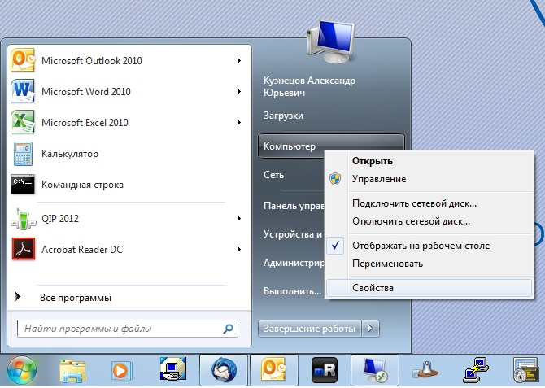

- In the open window in the lower left corner, click ‘Windows Update’
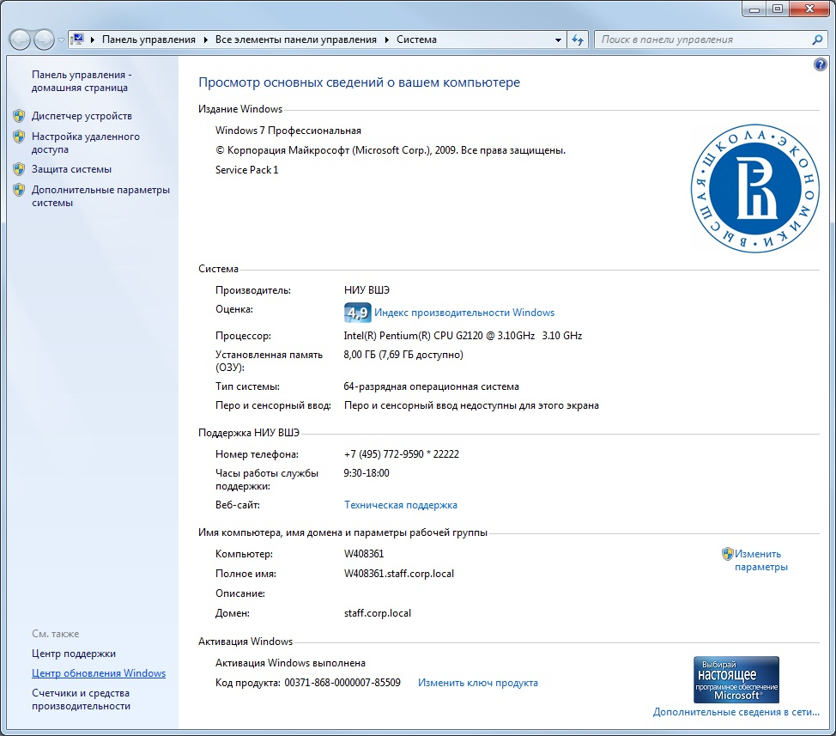
- Click ‘Check for Updates’ and, if updates are found, click ‘Install Updates’ 