Семинар Лаборатории Алгебраической геометрии и ее приложений
Семинар состоится в пятницу 09 июня 2017 года.
Начало в 17:00

Семинар будет проходить по адресу: ул. Усачева, д.6, аудитория 306

На семинаре выступит Charles Fougeron (Paris) | 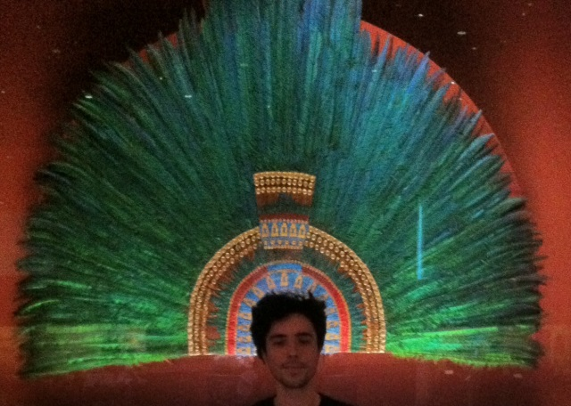
с докладом:
Lyapunov exponents for hypergeometric equations
Abstract: Lyapunov exponents and their Oseledets flag decomposition are a very useful tool for describing dynamical systems. They are presented sometimes as dynamical
variation of Hodge structures. My main motivation here is to understand their link to algebraic invariants of variation of Hodge structure when it exists.
In the 90's, M. Kontsevich observed that the sum of Lyapunov exponents associated to translation surfaces are equal to the degree of some holomorphic subbundle for a variation of Hodge structure associated to its Teichm"uller geodesic. It is remarkable that this relation arises from wider properties like ergodicity and some algebraic rigidity on the variation of Hodge structure which is true in a much more general setting.
Recently, a similar result was observed on higher width variation of Hodge structure (which decomposition has more flags), A. Eskin, M.Kontsevich, M. Möller and A. Zorich showed indeed a lower bound of their associated Lyapunov exponents given by the parabolic degrees of their variation of Hodge structure.
I will present this result on the example of variation of Hodge structure yielded by hypergeometric equations of arbitrary order. Starting with the computation of their degrees, and presenting some computer experiments. This will motivate questions about the equality case.

Приглашаются все желающие!

