

**Are you a Master student interested in gaining hands-on experience in European projects and office management in an international NGO?**

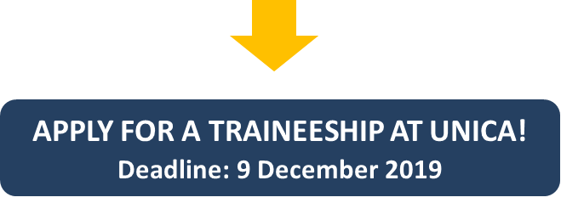

**Priority is given to Erasmus+ Placement holders**

**coming from**[**UNICA member universities**](http://www.unica-network.eu/page/members-and-contacts)

As a trainee, you will take active part in the day-to-day running of our small but multinational office, have a chance to improve your communication & language skills by working closely with our team, and get exposure to the varied activities and projects of our Network that have a real impact on the functioning of Higher Education institutions.

**TIME & COMMITMENT**

* **Start date**: The internship will preferably start in **January 2020**.
* **Duration of the internship**: minimum 3 months. Commitments of longer duration (6 months or longer) are preferred.
* **Working hours**: 30 hours per week (5 days x 6 hours).

**LOCATION**: UNICA Secretariat, c/o University Foundation, Rue d'Egmont 11, Brussels, Belgium

**REIMBURSEMENT OF EXPENSES**: Please note that this is a **non-remunerated position**. Apart from Erasmus+ traineeship grant, our trainees receive a **monthly reimbursement of expenses (€350) and a monthly public transportation pass.**

**DESIRED PROFILE**

**Priority is given to Erasmus+ Placement holders coming from**[**UNICA member universities**](http://www.unica-network.eu/page/members-and-contacts)

**Required**

* Master student;
* Very good verbal and written command of English;
* Very good writing and communication skills, with an ability to distinguish between formal and informal registers;
* Initiative and enthusiasm to learn, ability to take initiative and to work independently as well as within a team.

**Desirable:**

* Experience with/notion of European Project management;
* Proven interest in the EU affairs and European policies in the area of Higher Education and Research;
* Knowledge of French is an asset.

**SUPERVISION**: The trainee will work closely with the members of the Secretariat team.

**TASKS**

* Supporting the management of ongoing EU projects in which UNICA is coordinator or partner;
* Supporting the organisation of UNICA events;
* Updating & managing content of the UNICA websites, database and online platforms;
* Drafting UNICA publications;
* Occasionally attending Brussels-based events organized by the European Commission, European Parliament, and other partner organisations;
* Other office and/or administrative duties as required.

**HOW TO APPLY?**

* Please send your CV and a cover letter to: [office@unica-network.eu](mailto:office@unica-network.eu) with subject: “Application UNICA Project & office management traineeship” **by  9 December 2019**;
* Your cover letter should state clearly your motivation to work at UNICA and your suitability for the position; generic cover letters or applications without cover letters will not be taken into consideration;
* Please note that **only shortlisted candidates will be contacted for an interview.**

**Any questions?** Please contact: [office@unica-network.eu](mailto:office@unica-network.eu)