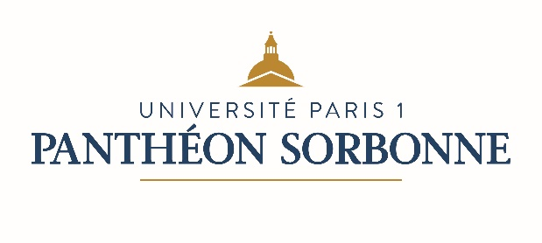

Fact Sheet for Erasmus and Exchange students
Academic year 2019/2020

International Relations Department
Université Paris 1 Panthéon-Sorbonne
Erasmus Code – EUC Number : FPARIS001
Address : Maison Internationale, 58 boulevard Arago, 75013 Paris (France)
Opening hours : Monday 2pm-5pm / Tuesday 9.30am-12.30pm /Wednesday 9.30am-12.30pm / Thursday 2pm-5pm / Friday 9.30am-12.30pm
Telephone : 00 33 (0)1 44 07 75 37 / Email : relinter@univ-paris1.fr
Website : https://www.pantheonsorbonne.fr/
Course Catalogue: http://www.pantheonsorbonne.fr/fr/international/etudiants-etrangers/candidature-en-echange-licence-master/liste-des-cours-ouverts-aux-etudiants-en-echange/

Mobility Office Contacts
Sonia Miranda-Pignal  Head of Mobility Office  00 33 (0)1 44 07 76 71  mobiliteri@univ-paris1.fr |  | Matthieu Hulbert  Incoming Erasmus students / Non-Erasmus exchanges  00 33 (0)1 44 07 76 75  incoming@univ-paris1.fr
Cécile Lafani  International Credit Mobility  00 33 (0)1 44 07 81 29  cecile.lafani@univ-paris1.fr |  | Philippe Larochette  Accomodation contact person  00 33 (0)1 44 07 78 95  rilogement@univ-paris1.fr
Academic Calendar
1st term: September 16th 2019 – January 18th 2020
2nd term: January 20th 2020 – Avril 27th 2020

Examination periods
1st term: January 6th 2020 – January 17th 2020
2nd term: May 4th 2020 – May 18th 2020
(re-sit, if any: June 12th 2020 – July 1st 2020)

Nomination and Application Process
Nomination deadlines
1st term : May 15th 2020
2nd term : October 15th 2020

Application deadlines
1st term : May 30th 2020
2nd term: October 30th 2020

Email for nominations : incoming@univ-paris1.fr

After nomination deadline students will receive the application procedure. They will be asked to fill in the online application form and attach the following documents : a copy of passport, a certificate of French language proficiency, a learning agreement, the transcripts of records, a resume, a motivation letter and two recommendation letters. Students will then receive an admission letter and information on the necessary steps for the online administrative registration.

Language of courses  French | Recommended level for Bachelor / Master degree  B2/C1

Exchange related information
Integration week for incoming students  Languages courses available to international students  Website for incoming students  Accommodation | One week before the beginning of the semester  http://www.pantheonsorbonne.fr/en/ufr/ddl/  http://www.pantheonsorbonne.fr/international/etudiants-etrangers/candidature-en-echange-licence-master/  https://www.pantheonsorbonne.fr/international/foreign-students/accommodation/
Additional useful information
Website : www.univ-paris1.fr

