Acquisition of the Russian case system by monolingual and bilingual children: psycholinguistic approach
Ladinskaya N.S¹ , Chrabaszcz A.V.^{1,2}, Lopukhina А.А.¹
¹ National Research University Higher School of Economics (Moscow, Russia)
² University of Pittsburgh (Pittsburgh, USA)
nladinskaya@hse.ru
Keywords: Russian case, L1 acquisition, bilinguals
Previous longitudinal studies have shown that the acquisition of the Russian case system presents a challenge for both monolingual and bilingual children - it is related to the syncretism of case forms, the number of cases, allomorphism and the distinction of grammatical vs. semantic cases (Ceitlin 2000; Gvozdev 1961; Gagarina and Voeikova 2009, Schwartz and Minkov 2014). An additional challenge for the acquisition of the Russian case system in the bilingual context is due to linguistic interference The present study espouses the pre-/protomorphological view (e.g., Bittner et al. 2011; Stephany and Voeikova 2009) that describe stages of acquiring inflection morphology, started from using “frozen” forms to a fully functional paradigm. We will follow the process of acquiring the Russian case system by monolingual and bilingual children from 2 to 6 years old. The goal is to identify at what age monolingual and bilingual children learn to generalize rules of nominal case usage. If bilingual children experience linguistic interference during case acquisition, we expect them to make more errors in the production of case inflections compared to monolingual children across different age groups. Additionally, the results will inform which case inflections present the most challenge for bilingual and monolingual case acquisition.
Method. For this study, we recruited 35 monolingual Russian-speaking children residing in Moscow, age range 2 to 5 years old and 10 Russian-English bilingual children residing in Pittsburgh, USA, age range 4 to 5 years old. Children performed a picture-based sentence completion task with real words and pseudowords. Frames were constructed to bias the children’s responses towards the use of a noun form in one of the five oblique Russian cases, across three declensions in singular and plural forms. In the first part of the experiment, the participants named real objects with real words. The objects were drawn by an artist for presentation in isolation (to elicit naming responses) and for the presentation of situations (to elicit oblique case markings). The words denoted everyday objects and animals and were familiar to children at 2 years of age according to (Essex et al. 2002), e.g., стул-∅ (chair_{NOM}). In the second part of the experiment, the participants named nonexisting objects with pseudowords. The pictures were selected from the Novel Object and Unusual Name Database (NOUN; Horst and Hout 2016) and redrawn by the same artist who created the real objects stimuli. For constructing pseudowords we switched the consonants in the stimulus realwords, e.g. смук-∅ (smuk_{NOM}). Thus, we retained the same properties for the novel words—length, phonological form, and morphological structure.
Procedure. All testing was performed on a Samsung tablet. In the first part, the experimenter showed a picture of an object in isolation to the child and asked to name it. After responding, the experimenter showed the second screen, on which the same object was depicted in a situation. For instance, one picture may show a train, and the second picture will show children riding the train. The child was asked to complete the sentence “The children are riding the …” with the required form of the noun (i.e. train in the prepositional case). In the second part of the experiment, the experimenter named the object in isolation (e.g. “vomaka”) and asked the child to complete the sentence with the required form of the pseudoword using the inflection that s/he considered fit for this word. We recorded and scored the answers of the children.
Results. Plural case forms presented the most difficulty for monolingual and bilingual children from 2 to 5 years old compared to singular forms (see Fig. 1 and Fig. 2). This finding is in line with previous studies (e.g., Schwartz and Minkov 2014). Noun case endings of the 3rd declension also presented difficulty, resulting in a high error rate across all children’s age groups, especially in the instrumental case. In addition, we found that children tend to substitute zero-inflection case endings in the plural form with the more salient, transparent and stressed –ov,-ev endings, supporting the idea of ‘inflectional imperialism’ (Slobin 1966). Younger monolingual children (2-3 year-olds) tended to substitute oblique cases with the nominative case endings, while 4-5-year-old children did not make such errors. Compared to monolinguals, bilingual children tend to substitute oblique cases with the nominative case even at 4-5 years of age. We did not find significant differences between the use of case endings in words vs. pseudowords block. This result suggests that both monolingual and bilingual children are able to extract and apply complex morphological rules to novel input early on in language development (see Fig. 1 and Fig. 2). However, from a qualitative point of view, our groups of children have the same strategies of acquiring the Russian case system, but this process can be longer for bilingual children due to the difficulty of the interaction between languages. We will continue to collect data to confirm our results.
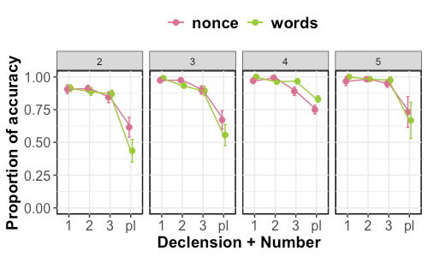  Fig. 1. Quantitative results of monolinguals. | 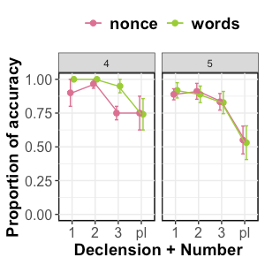  Fig. 2. Quantitative results of bilinguals.
References

Bittner D., Dressler W. U., Kilani-Schoch M. (ed.). Development of verb inflection in first language acquisition: A cross-linguistic perspective. – Walter de Gruyter, 2011. – Т. 21.
Ceitlin S. N. Jazyk i rebёnok: Lingvistika detskoj reći [Language and the child: Linguistics of child speech] //Moscow: Vlados. – 2000.
Essex M. J. et al. The confluence of mental, physical, social, and academic difficulties in middle childhood. II: Developing the MacArthur Health and Behavior Questionnaire //Journal of the American Academy of Child & Adolescent Psychiatry. – 2002. – Т. 41. – №. 5. – С. 588-603.
Gagarina N., Voeikova M. Acquisition of case and number in Russian //Development of nominal inflection in first language acquisition: A cross-linguistic perspective. – 2009. – С. 179-215.
Gvozdev A. N. Voprosy izucheniia detskoi rechi [The study of children's speech] //Moscow, APN RSFSR Publ. – 1961.
Horst J. S., Hout M. C. The Novel Object and Unusual Name (NOUN) Database: A collection of novel images for use in experimental research //Behavior research methods. – 2016. – Т. 48. – №. 4. – С. 1393-1409.
Stephany U., Voeikova M. D. (ed.). Development of nominal inflection in first language acquisition: A cross-linguistic perspective. – Walter de Gruyter, 2009. – Т. 30.
Slobin D. I. The acquisition of Russian as a native language //The genesis of language: A psycholinguistic approach. – 1966. – С. 129-148.
Schwartz M., Minkov M. Russian case system acquisition among Russian–Hebrew speaking children //Journal of Slavic Linguistics. – 2014. – С. 51-92.

