Electronic passes' issue for postgraduate students and students

Since October 1, 2020 the issue of the electronic passes takes place on:

Bol'shoy Trekhsvyatitel'skiy per., 3, room 114
(metro Kitay-gorod, Kurskaya, Chistye prudy)

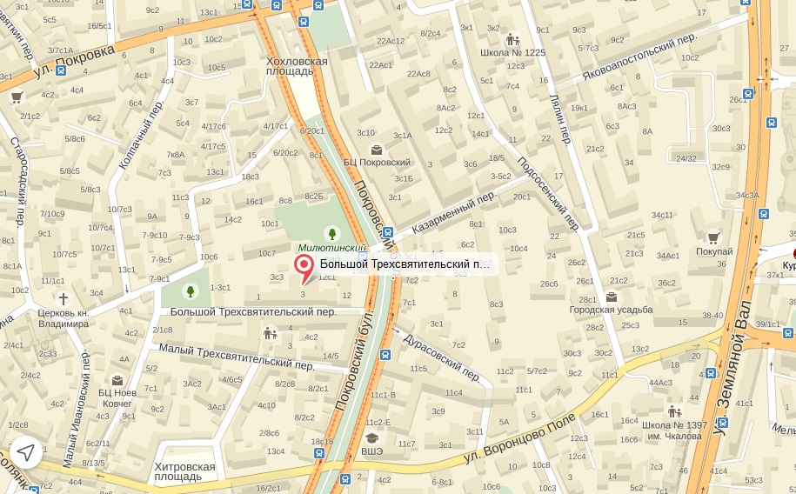

Working hours:
Monday - Friday 10:00 - 17:30
Technical break 13:00 - 14:00
Saturday, Sunday - closed

For the electronic pass' issue it is necessary to carry with you:

For postgraduate students - certificate of the postgraduate student;

For students - student card (renewed) or certificate from the study office (if student card is lost).

Information update: September 29, 2020

