Learning Management System (LMS)

Enter LMS http://lms.hse.ru/ with your HSE email as the login.
The password: Edu + the number of your student ID card (no dots, slashes, etc.). The system will ask you to change this automatic password after your first login.
Press the “En” button on the upper right-hand corner. Choose “Thesis/Paper” (“ВКР/КР” if in Russian).
You will see your topic in Russian and in English. Check, that it’s correct. If not, let me know. You can’t change it by yourself. Press on the topic.
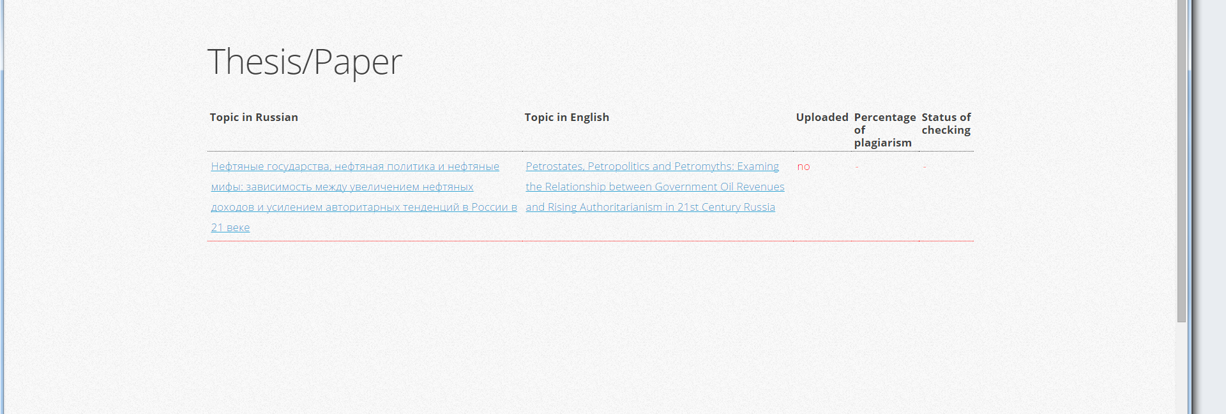
You will see the form of uploading. Check all information, add your phone number. Change the language of your dissertation to English.
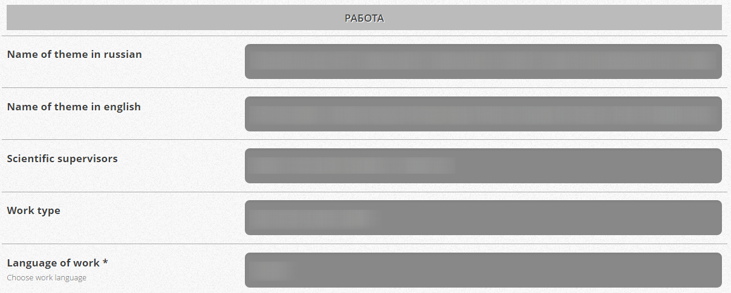
Insert the annotation (abstract) both in English and Russian. If your knowledge of Russian language is not enough to translate your abstract, ask your supervisor to help you. If your supervisor can’t help you, ask Maxim Bratersky.
The next important field is “Publication agreement”. If you choose “allow”, your dissertation will be published here https://www.hse.ru/edu/vkr/ You may not allow that, then indicate the reason.
Also you may write your opinion about your supervisor (not obligatory).
Choose the dissertation file with the button «Выберите файл». Then press “Upload”.
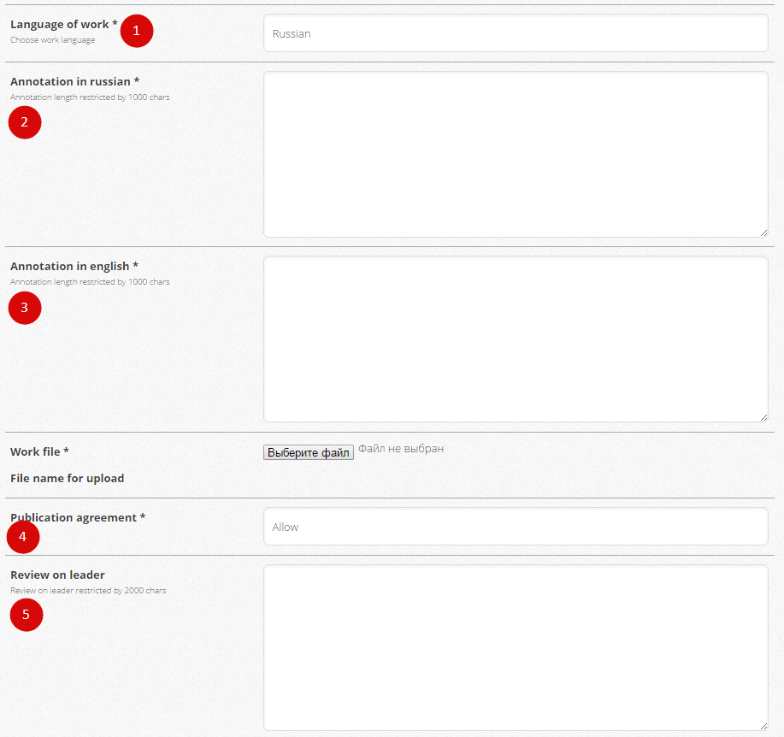
Few days later the system will create pdf-file of confirmation with QR-code. You need to print it, sign and bring to the office with the printed copy of your dissertation.
Please check everything very carefully, you can upload your dissertation only ONCE.

