6.18.1-01/231122-7
November 23, 2022
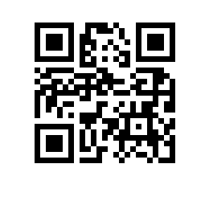
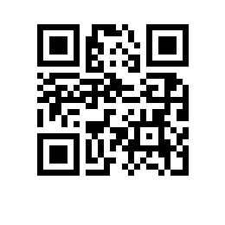

On the Student Outreach Event Calendar at National Research University Higher School of Economics for the 2022/2023 Academic Year

For the purpose of implementing Federal Law No. 304-FZ “On Introducing Amendments to the Federal Law ‘On Education in the Russian Federation’ Regarding the Education of Students”, dated July 31, 2020,

I hereby ORDER

The approval of the Student Outreach Event Calendar at National Research University Higher School of Economics for the 2022/2023 Academic Year (Appendix)

Deputy Vice Rector I.O. Yaskov

