The hotels which have easy walking access to NRU HSE on Trifonovskaya str.

Holiday Inn Suschevsky Hotel, 4****
74 Suschevskiy Val (metro station Rizhskaya)

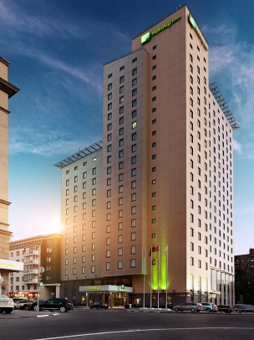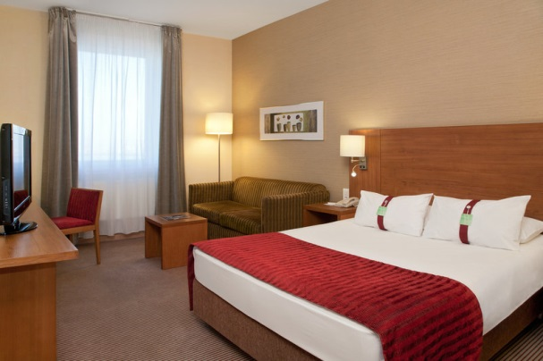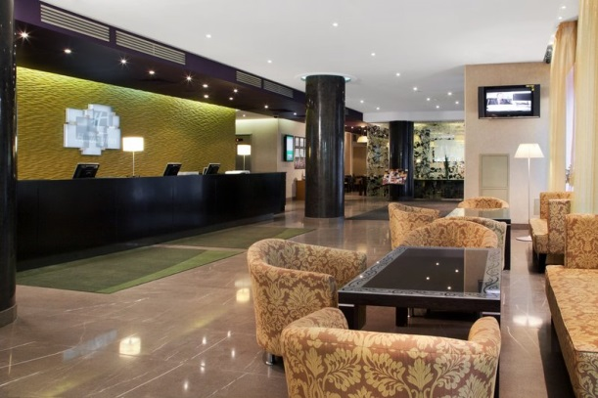

The newly built Holiday Inn Suschevsky Hotel is an ideal place for both business and leisure travelers. This conveniently located new Moscow hotel is a short drive from the Moscow Kremlin. The Holiday Inn Suschevsky Hotel is within easy access to the Moscow metro and rail networks. The hotel offers spacious and modern rooms, which are designed to ensure the utmost in comfort. A wide range of amenities is offered. High speed Internet access is available in all guest rooms. The lobby area and meeting rooms are equipped with Wi-Fi.
The Holiday Inn Suschevsky Hotel is situated from 5 to 7 minutes walking distance from the NRU HSE on 57 bld. 1-2 Trifonovskaya str.

5-7 minutes

Period: from 08 till 09 July 2015
9 280 / 10 480 rubles per night for single/double use including breakfast and VAT.
Period: from 09 till 10 July 2015
7 680 / 8 880 rubles per night for single/double use including breakfast and VAT.
Period: from 10 till 12 July 2015
4 480 / 5 680 rubles per night for single/double use including breakfast and VAT.

Book Holiday Inn Suschevsky Hotel online

Raikin Plaza Hotel, 4****
6 building 1, Sheremetievskaya str. (metro station Maryina Roscha)
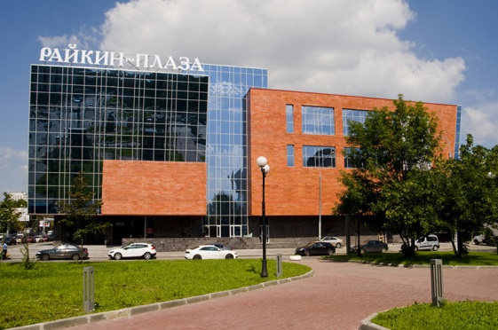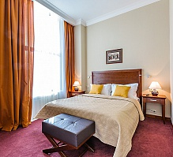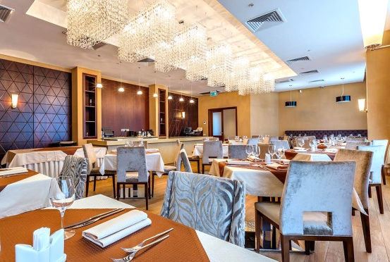

Boutique hotel Raikin Plaza is located in a quiet green area of Moscow — Maryina Roscha, close to business and cultural center of Moscow. Raikin Plaza hotel is situated next to Satiricon theater and KVN center, in a minute walk from "Maryina Roscha" metro station and Raikin Plaza shopping mall.
The hotel is situated 20 minutes walking distance from the place the conference is held (57 bld. 1-2 Trifonovskaya str.).
20 minutes
Period: from 08 till 10 July 2015
5 880 / 6 980 rubles per night for single/double use including breakfast and VAT.
Period: from 10 till 12 July 2015
4 280 / 5 280 rubles per night for single/double use including breakfast and VAT.
Book Raikin Plaza Hotel online

Hotels situated up to 30 minutes to the NRU HSE on Trifonovskaya str.
Cosmos Hotel, 4****
150 Prospect Mira (metro station VDNH)
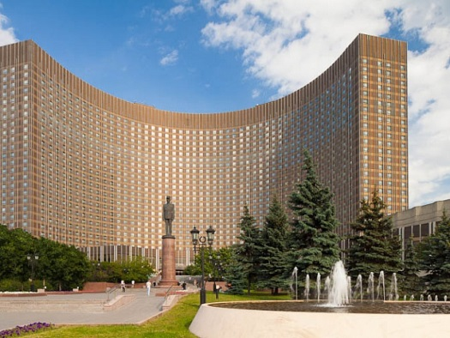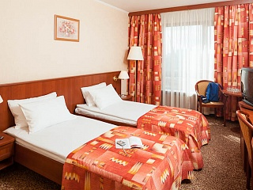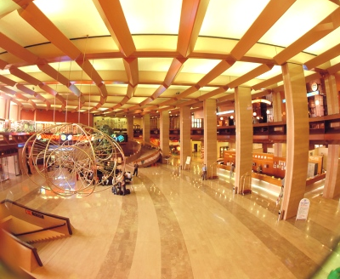

The Cosmos hotel is a many-storied building of glass and metal located in the northeast of Moscow in one of the main roads of the capital, Prospect Mira, 20 minutes’ drive from the city center. The All-Russian Exhibition Center, Ostankinskaya TV tower and Sheremetiev’s Palace are situated across the road. Olimpiysky Sports Complex and Culture and Exhibition Center Sokolniki are located not far from the hotel. You can see almost all the city of Moscow from the top floors of the Cosmos hotel. Rooms to anybody’s taste are perfect for work and rest.
Metro station VDNH is situated 5 minutes from the hotel. You can reach NRU HSE on 57 bld. 1-2 Trifonovskaya str.by metro (2 stations).

20-25 minutes

Period: from 08 till 12 July 2015
3 280 / 3 480 rubles per night for single/double use including breakfast and VAT.

Book Cosmos Hotel online

Zolotoy Kolos Hotel, 3***
bld. 3, 15 Yaroslavskaya str. (metro station VDNH)

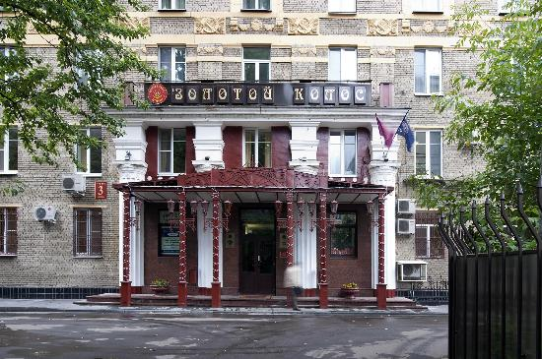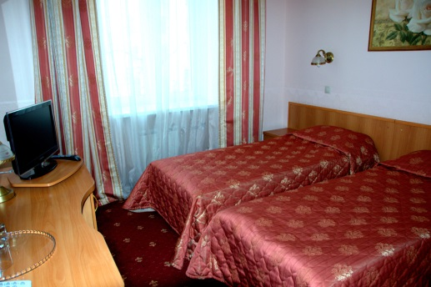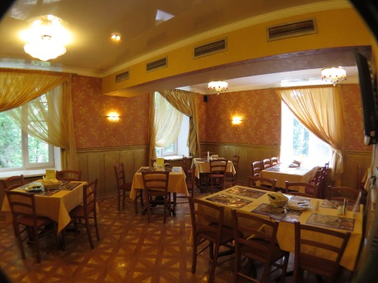
The Zolotoy Kolos Hotel, which consists of several buildings, was opened in 1954. In 2004 the buildings were renovated. New furniture and bathroom equipment was installed in the rooms. The hotel is located in Prospect Mira, in the northeast of Moscow. Not far from the hotel there are such places of interest as The All-Russian Exhibition Center, Botanic Garden, Ostankino television center, Olympiyskiy sports complex. The nearest metro station is within 5 minutes of walking distance from the hotel.
There are 321 rooms at the hotel. Every room has a telephone, a TV set, a fridge, an air conditioner, and comfortable furniture.
Metro station VDNH is situated 5 minutes from the hotel. You can reach NRU HSE on 57 bld. 1-2 Trifonovskaya str. by metro (2 stations).

20-25 minutes

Period: from 08 till 12 July 2015
2 580 / 2 580 rubles per night for single/double use including breakfast and VAT.

Book Zolotoy Kolos Hotel online

