INSTRUCTIONS ON USING THE EXAMUS TESTING SERVICE

Table of Contents

1. Rules for Using the “Examus” Proctoring System (hereinafter, referred to as the Proctoring System). 3
2. Examination Procedure with the Use of the Examus Service 4
3. Requirements for the User’s PC 4
4. Getting Started 6
4.1. Authentication 6
4.2 Computer Check 7
4.3 Signing up for Proctoring 8
5. Start the test 10
6. Identification of the participant 11
7. Testing Process 11
8. End of Testing 15
9. Technical Support 15
10. FAQ 15
10.1 Problems with Logging In 15
10.2 Checking is Not Happening 16
10.3 Problems during the Exam 18

1. Rules for Using the “Examus” Proctoring System (hereinafter, referred to as the Proctoring System).
1. Testing Regulations

- Users are admitted to a test if they are registered in the Proctoring System or in any other partners' platform.
- After logging into the the Proctoring System, by using an internal account or a partner's platform account, the User gets an access to a list of available tests/exams (or to the partner’s webpage), where he/she can choose an available exam (or perform other actions according to the partner platform’s rules).
- After choosing the exam, the User goes through the identification process, according to the instructions of the system and the proctor.
- After successful identification, the Proctoring System gives an access to the test.
- During the test, the Proctoring System records video and audio of all of the User’s actions, records the desktop of the User’s PC (hereinafter, referred to as the “Materials”), and transfers the Materials to the Proctor.
- After the test/exam, the Materials can be presented to third parties (e.g. the test organizers) for further analysis.

2. User Requirements

- The User agrees not to pass the access details of his/her account to third parties.
- The User must meet all necessary conditions for the operations of the Proctoring System:
  - an adequate level of illumination and a low noise level;
  - a document identifying the User;
  - no interference in the transmission of video and audio signals;
  - fulfillment of technical requirements for the User’s equipment (see below).
- The User agrees that the Person, whose ID and image were stored in the Proctoring System after the first login, shall be the owner of the account in the Proctoring System.
- The User should use the original ID for his/her identification.
- The User must not leave the observed zone of the webcam during the test.
- The User must keep the microphone switched on during the test.
- During the test, the User agrees to use only one display device (a monitor, a TV, or a projector), one keyboard, and one pointing device (a computer mouse, TrackPoint, etc.).
- The User must concentrate on the tasks and is not allowed to look at other objects for 15 seconds of more.
- The User is not allowed to get third parties' assistance during the test.
- The User is not allowed to give an access to his/her computer to third parties during the test.
- The User is not allowed to participate in conversations with third parties, use reference materials (books, cheat sheets, audio recordings), cell phones, pagers, calculators, tablets and computers, except for the one that is used directly during the test.
- The User agrees that the Proctor has the right to terminate the testing process if these Rules are breached or if he/she violates ethical standards.

3. Requirements for the User’s Equipment

- ОS Windows 7, 8, 8.1, 10, Mac OS 10.9 and higher;
- Google Chrome web browser or Yandex.Browser (the latest version);
- Working and switched on webcam (including built-in cameras in laptops);
- Working and switched on microphone (including built-in microphones in laptops);
- Installed Chrome app “Examus”;
- Stable internet connection with data rates of not less than 5 Mbps;
- Ability to transfer video using WebRTC protocol (you can check at https://test.webrtc.org/).

2. Examination Procedure with the Use of the Examus Service
  - Install the Yandex.Browser or the Google Chrome web browser (https://www.google.com/chrome/);
  - Using the Yandex.Browser or Google Chrome web browser, go to the following page:
  - https://hse.student.examus.net and click on ‘Entrance Examination’, log in and have your e-mail account verified;
  - On the examination day, at the appointed time (or 10 minutes before it), go to https://hse.student.examus.net and click on the name of the test you wish to take;
  - Take a photo of your identification document and send it to the Proctor for verification;
  - You can now start the exam;
  - Upon the completion of the exam click on ‘End the Exam’ button;
  - Close the Examus tab.

3. Requirements for the User’s PC
- A PC or a laptop (mobile devices are not supported);
- Windows operating system (Windows 7,Windows 8,Windows 8.1,Windows 10) or
Mas OS X Yosemite (version 10.10, or a newer version);
- You should have the latest version of the Yandex.Browser or the Google Chrome web browser (at the moment when you take the test) installed (for the latest updates of the web browser, please see chrome://help/);
- Your computer (or laptop) must be equipped with a functioning external or built-in web cam;
- You need to make sure that the mic is functioning and has been switched on (including built-in mics);
- You should have a steady Internet connection with a speed no slower than 5 Mbps per second;
- Your computer should successfully pass the ‘Computer setup’ test. This test is available after the installation of the ‘Examus’ application. You need to install the application and log in using your login and password;
- You need to make sure that your network is set up for the following ports:

443/TCP;
80/TCP;
3478/UDP; 3478/TCP;
are open to the following IP addresses:
188.128.30.79;
188.128.30.71;
188.128.30.72;
81.177.100.134
81.177.100.135.
IMPORTANT: If your computer does not meet these requirements or fails to pass the ‘Computer setup’ test, the option of taking an exam with proctoring services shall not be available.

How to prepare your workplace before taking a test:
- Make sure your room is properly lit;
- Check if your webcam and mic are on and the camera lens is not covered;
- Have your ID document on hand;
- Plug your laptop in (battery operation can affect the device’s performance);
- Clear the browser’s cache;
- Restart the computer;
- Using Task Manager (Ctrl+Shift+Esc), shut down unused or running programs, especially those that rely on the webcam or mic (the Processes tab);
- You cannot use the VPN service or a remote management service (e.g., TeamViewer, RAdmin, Windows Remote Desktop, etc.);
- Deactivate the antivirus’ function to filter network traffic;
- If, during testing, you experience problems with video or webpages downloading, restart your browser (to do this, please input chrome://restart in a new tab and press ‘Enter’).

ESET Antivirus Settings
If ESET Antivirus is installed on your computer, it is necessary to change its settings.
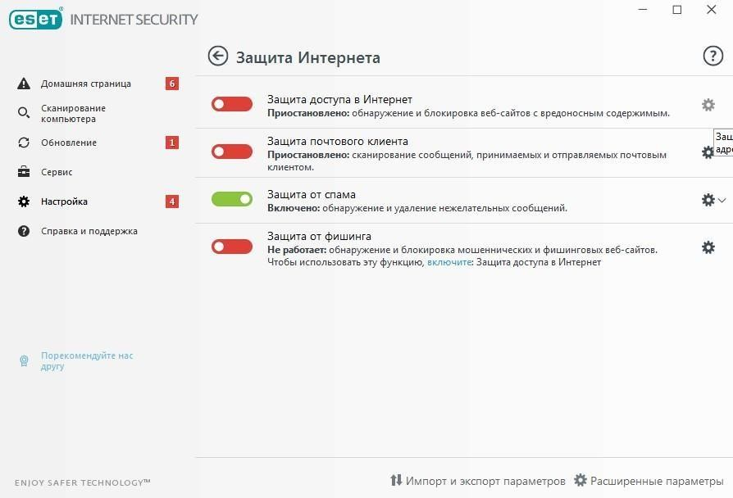
ESET
operation panel

-
>

Settings
-
>
Internet access protection
-
>
gear icon

On the advanced settings page, in the “Internet and Email” section, uncheck “Enable SSL / TLS protocol filtering”
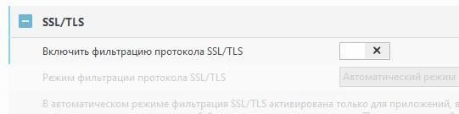

Next, click “OK”.

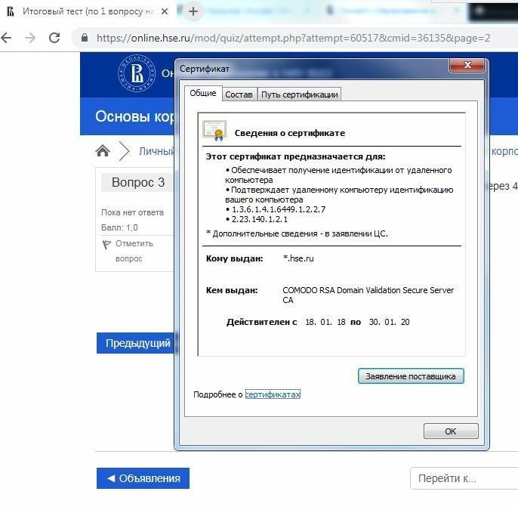
In this mode, no question can be completed with an error. Please complete an attempt correctly.

To notify us about any problems, please contact the HSE University Technical Support Department at exam@hse.ru, or the “Examus” Technical Support Service at help@examus.net, support@examus.net.

4. Getting Started

4.1. Authentication

- Open the https://hse.student.examus.net webpage and log on by clicking on the Entrance Examination button.

Important! Do not use the Examus button for authentication!

- In a window appeared, enter your passport and login. Press Enter.

- If you wish to log out, click on ‘Logout’ (as shown below):

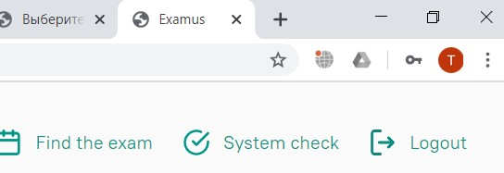

4.2 Computer Check
Important! You need to check your computer’s settings in advance (at least a day before testing), so that you have the time to refer to the User Support Service, should any problems arise. Before running the check, make sure that:
- the webcam and mic are on;
- the webcam’s lens is not covered or plastered over;
- the room is well-lit;
- you have a steady internet connection.

- Press the ‘System Check (Проверка)‘ button:

- In the pop-up window, to request access to the mic and webcam, press ‘Allow (Разрешить)‘:

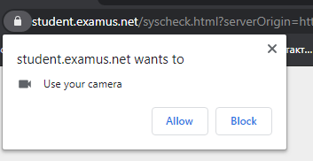

- In the pop-up window, to request access to the desktop press ‘Share (Поделиться)‘:

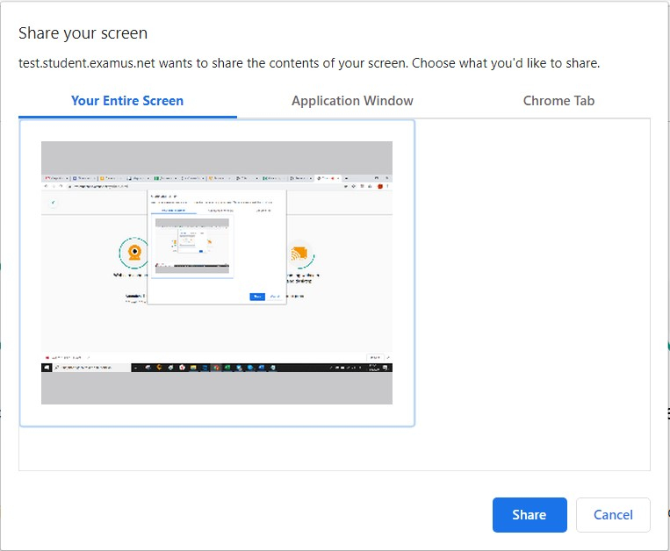

IMPORTANT! Do not disregard this step! Otherwise, it will be impossible to run the check.

If the ‘Share (Поделиться)‘ button is disabled (unclickable), click on the image of the desktop so that it would be highlighted by the blue frame (see the screenshot above).

- Wait for the completion of the checking process. If the checking process fails (i.e., a red symbol appears against one of the points, or the checking process freezes), refer to the recommendations set out in p. 10.2 Checking Is Not Happening and repeat this process.

4.3 Signing up for Proctoring
In order to take an exam, you need to confirm your registration for the proctoring.
- When the button ‘Find an exam and sign up‘ is clicked, a window with a calendar pops up where there are available slots for you to sign up for an exam.
- Loading the list of your exams might take some time. However, if after waiting you still do not see your exam, click on ‘Refresh‘ at the top left corner.
- The first step is choose an exam. You need to choose one from the list of available variants.
- Pay attention to the following: on the right of this page you will see a list of exams that you signed up for. If you click on an exam from this list, this will cancel your registration.
You can cancel your registration for an exam no later than 24 hours before it starts.
- After you choose an exam, a page with a calendar will be available with the slots for signing up for proctoring. The grey slots are not available, i.e., other people have already taken these places.
- Pay attention to the fact that proctoring for each exam is limited to the dates that the University sets, as well as depends on whether any proctors may be available at a particular time.
- Remember that if you want to sign up for the next week, you need to choose a date in a calendar at the top of the right column.
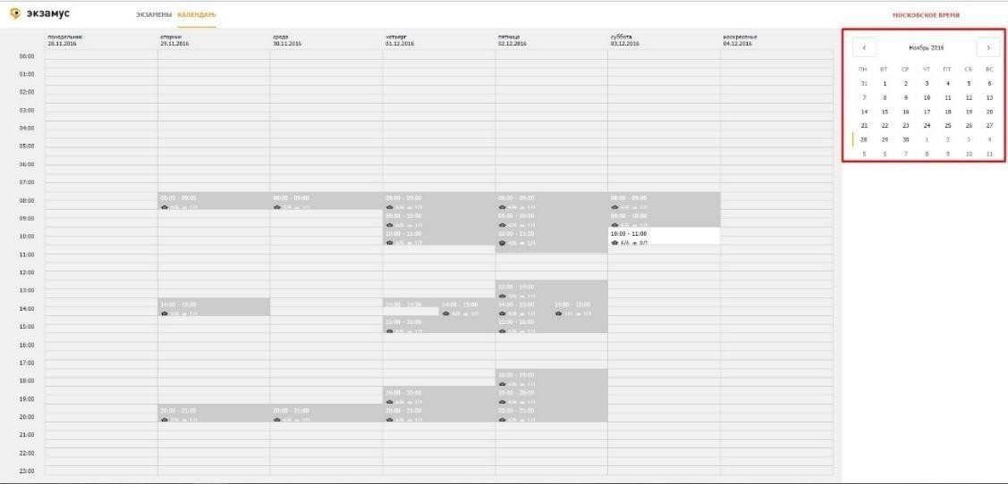
Important: It is the Moscow time zone in this calendar – keep this in mind when picking the time for an exam.

- To sign up, you need to click on the slot once to select it, and then click on it once more,
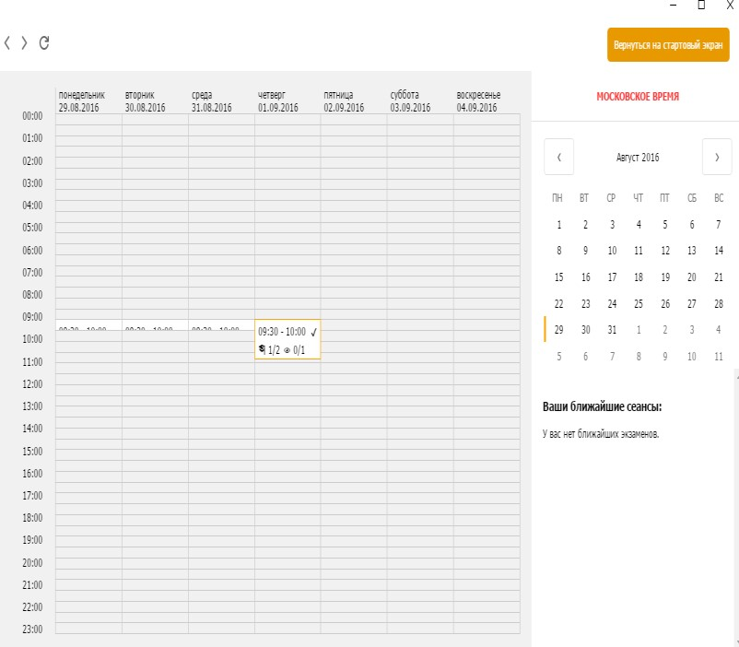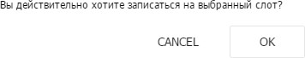
Then confirm your choice in the pop
-
up

window:

- A new notification will appear in the field “Your nearest sessions”. The space with the session will become yellow.
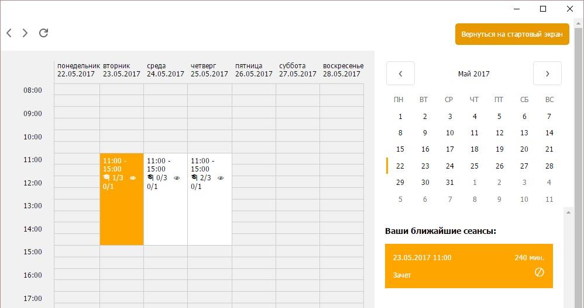

- If this space does not turn yellow, refresh the page by clicking on the button at the top left corner.
- To change the time you signed up for, you need to click on the time you have picked and confirm your cancelation. After that, you can pick a new slot.
- Do not click on the chosen exams any further! Otherwise, you may accidentally cancel your registration.
- If you want to sign up for another exam, click the ‘Previous‘ button at the top left corner or use the ‘Return to the start screen‘ button.
Please remember that you can cancel your registration no later than 24 hours before the exam starts. For example, you cannot cancel your registration for Wednesday morning on Tuesday evening.
- If your exam is not in the list, click the ‘Do not see your exam?‘
Button and you will receive respective instructions.
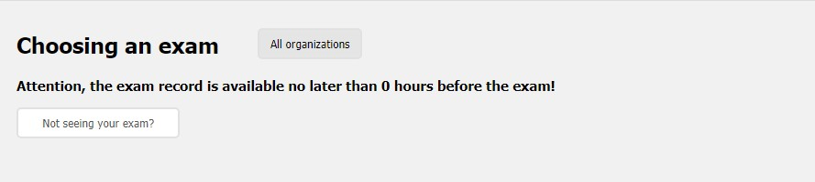

5. Start the test
- In Yandex.Browser or the Google Chrome web browser, go to https://hse.student.examus.net and log in by clicking on Entrance Examination. If you wish to start the test, press ‘Start (Начать)’.

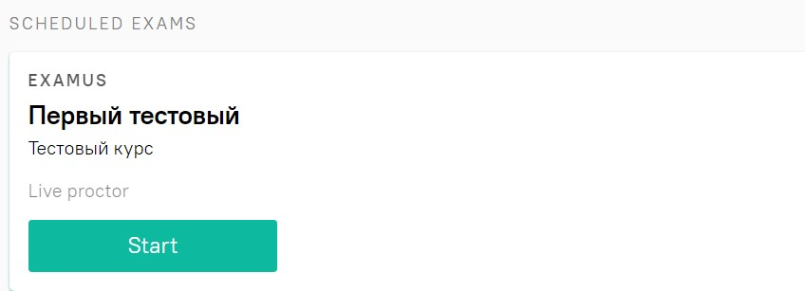
Important! The test will appear in the window no earlier than 10 minutes before the start time of the examination.

- Please read the exam procedure, requirements for users, technical requirements for the equipment, confirm that you agree with the rules for the online testing and press ‘Continue
(Продолжить) ‘:

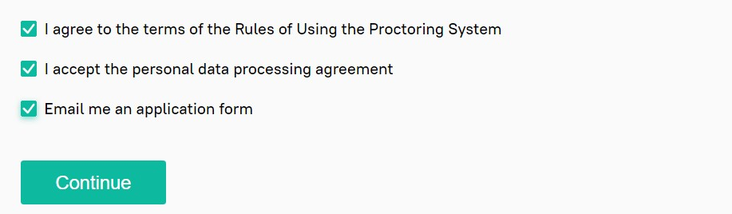

- You will then have the window Syscheck opened for your computer settings to be checked. This will offer following the same steps as in the process activated by clicking on ‘Check (Проверка)’ from the start screen (see Computer’s check).

- After the computer’s check is complete, press ‘Next (Продолжить)’, and you will be re- directed to the ID verification process.

6. Identification of the participant

- Bring the ID document close to the webcam and press ‘Make a Photo (Сфотографировать)’, and then ‘Send (Отправить)’:
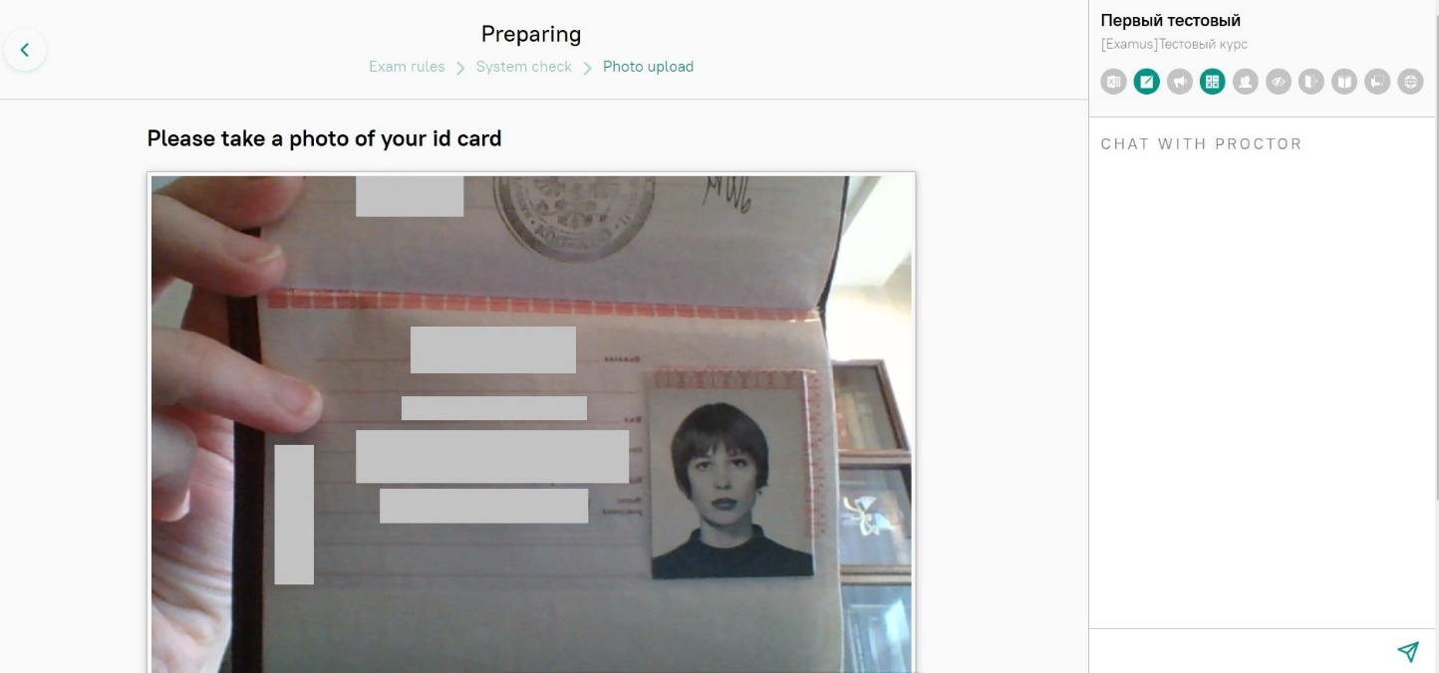

IMPORTANT: If you do not see the buttons reading ‘Make a photo‘, ‘Retake photo‘ and ‘Send‘ (‘Сфотографировать‘, ‘Перефотографировать‘ and ‘Отправить‘, respectively), scroll down the page.

- If the photo is not clear enough hand/or if the text is blurred, press ‘Retake photo‘ and then ‘Send‘ (‘Перефотографировать‘ and ‘Отправить‘, respectively).
- Next, the proctor will ask you to show the workplace.

7. Testing Process
- Once the ID document has been sent, the page will refresh and the website with the test shall be made available. Please find the button ‘Start the Test (Начать тестирование)‘.

- In the right section of the screen, you will see the Examus sidebar, which features (from the top down): a window with the video of you, the exam title, the academic institution’s name, and the exam rules.

If you need to hide or unhide the Examus sidebar, press the button with the arrow to the left of the sidebar:

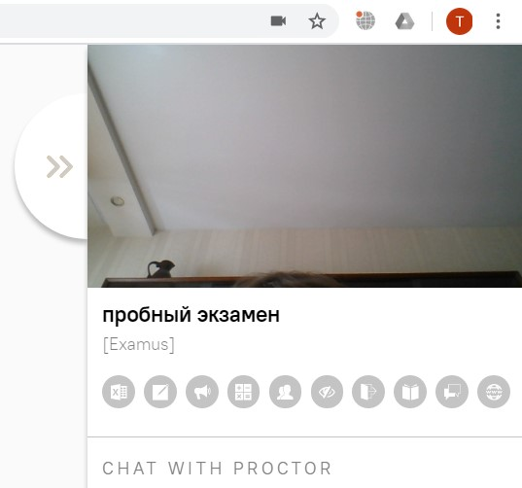

- After access to the webcam is allowed, your image will appear in the top section of the Examus sidebar.

IMPORTANT! During the exam process, you need to be properly visible on the screen:

RIGHT WRONG

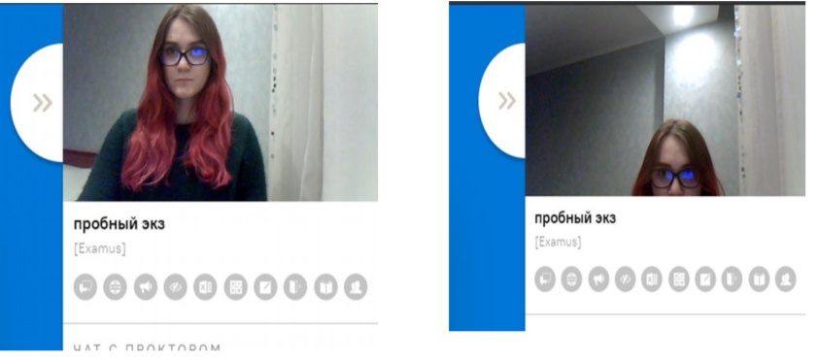

- Above the chat feed, you will see the examination rules. The active options are highlighted in colour, while the inactive options are colorless. To see the function for a respective icon, hover the mouse pointer over the icon and wait for the pop-up tip.

- In the window with the test, press ‘Start the Test (Начать тестирование)‘ and get started. Pay attention to the timer displaying the time remaining before the end of the exam:
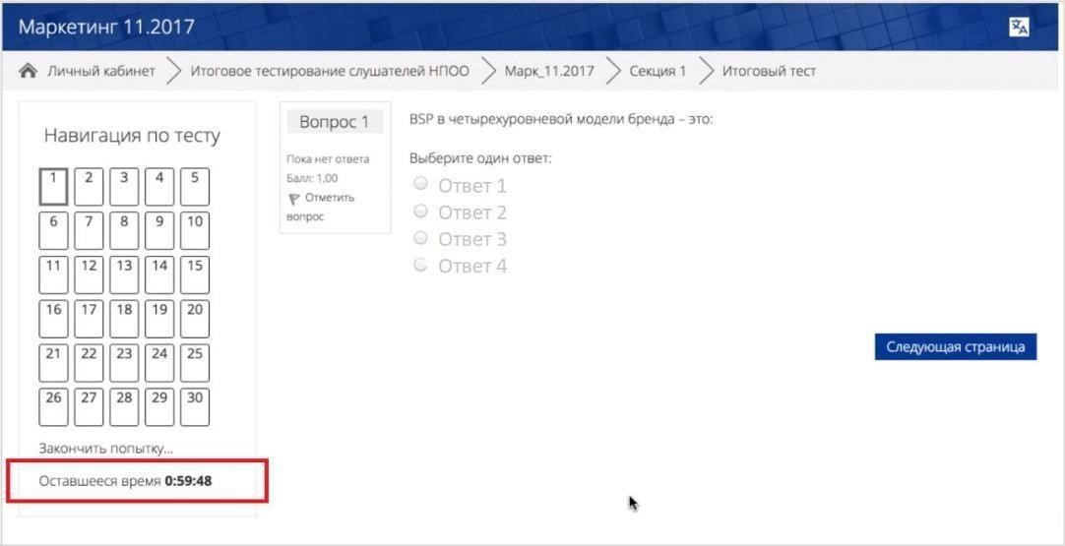
If during the test, you wish to go back to one of the test questions, use the navigation block in the left section of the screen:
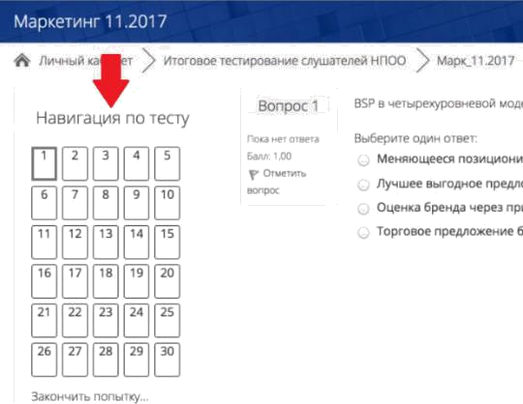

The tasks that you do by writing answers on sheets of paper must be uploaded as files. Write the answers on paper, then make a photo of or scan the sheets, and then upload them from the desktop as a .jpg/.pdf/.heic file right before finishing the test.

You can use a mobile phone to photograph the complete tasks. It will not be considered as the violation of the rules.

You should remember the procedure of sending a file from your phone to the computer in advance.

To upload the file, press the icon of adding file as it is shown on the screen:

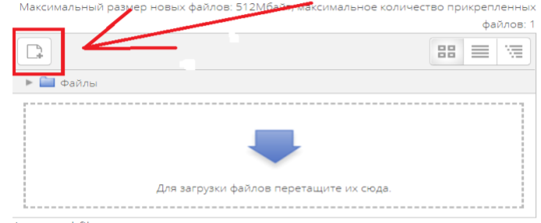

In the window, press the button ‘select file/выберите файл’
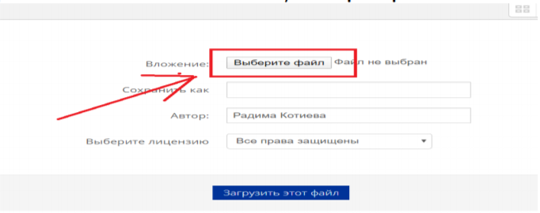

Choose files with the answers and press the button ‘upload file/загрузить этот файл’

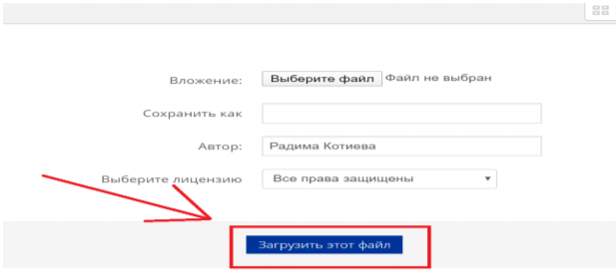
You can drag files from your desktop to the area for answer. Your files should appear in the area.
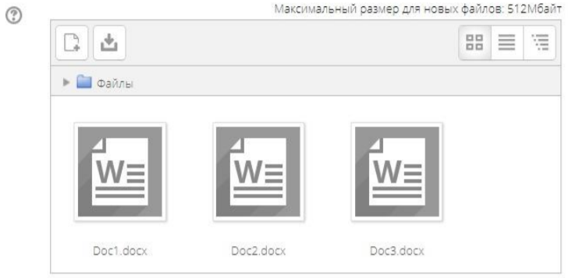

8. End of Testing

- If you are confident in your answers and are ready to send them for marking, press ‘End the Test (Закончить попытку)‘:

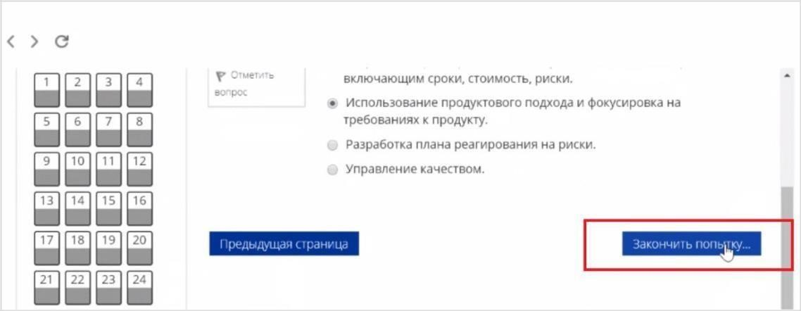

- You will see the page with your preliminary testing results. The accumulated points will be considered the final result after the proctor confirms your compliance with the exam procedures.

- Close the Examus tab in your browser.

9. Technical Support
Should any problems arise, please contact HSE University’s Learners’ Support Services at exam@hse.ru or support@examus.net.

10. FAQ

10.1 Problems with Logging In
The system does not accept your login and/or password
- Close the Examus tab and try logging on to the HSE website using your browser. If this fails, go to the section ‘Forgot login or password?’ (‘Забыли логин или пароль?’) and change your password.
- If you have successfully logged into the website using your browser, make sure that you access Examus by clicking on the ‘Entrance Examination‘ button. You should not use the Examus button to log in!

When trying to recover your password, you do not get an e-mail with the link to reset your access: To get your account details restored, you need to log out of Examus, open up the HSE website and use the form for resetting your password to the website. After you complete the password recovery procedure, you can go back to work with Examus.

10.2 Checking is Not Happening
- Make sure that you use the latest version of the Google Chrome browser (or Yandex.Browser). For this, type in chrome://help in the URL bar and, if needed, upgrade the browser;
- Clear the cache (Ctrl + Shift + R for Windows, Command + Shift + R for MacOS) and restart your browser (input on the new tab chrome://restart and press Enter), and re-enter after this;
- Check the version of the operating system (OS) of your computer. For the correct operation of the software, the OS must be one of the following: Windows 7, Windows 8, Windows
8.1, Windows 10 or Mac OS X Yosemite (10.10, and newer);
- Press the ‘Repeat Checking (Повторить проверку)‘ button several times (sometimes checking can start only after the second or third attempt);
- Checking may be hindered if your room is scarcely lit or your camera lens is plastered over;
- Please make sure that at the start of the checking process, you press in the window
“Allow access to the screen” the ‘Share (Поделиться)‘ button. If the Share button is inactive, click on the image in the center of the window to get it highlighted by the blue frame (see the picture below):

- Ensure that, at the start of the check, you allow Examus access to your webcam and mic in the pop-up windows (you should check if pop-windows are allowed in the browser’s settings at chrome://settings/content/popups);
- With Lenovo devices, webcam operation can be blocked by internal software. In such cases, please contact technical support at help@examus.net to get instructions on how to set your webcam up;
- For Windows 10: Check in the Windows settings if the camera and mic on your computer are on and they are allowed to access the applications (Settings> Confidentiality> Camera, Settings > Confidentiality > Microphone)

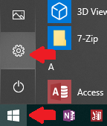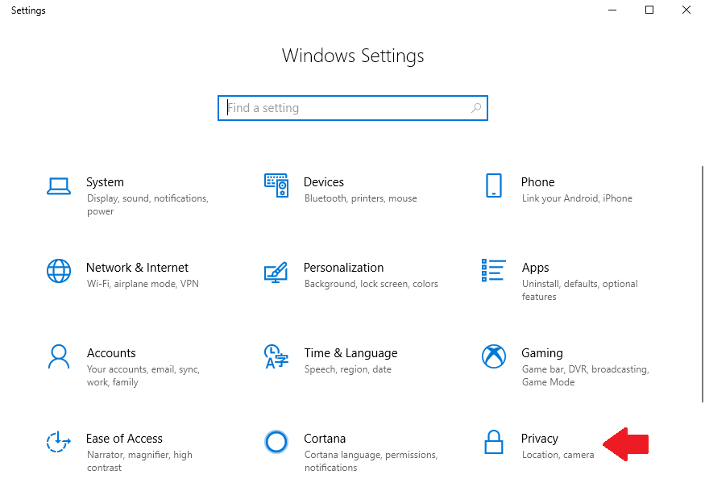

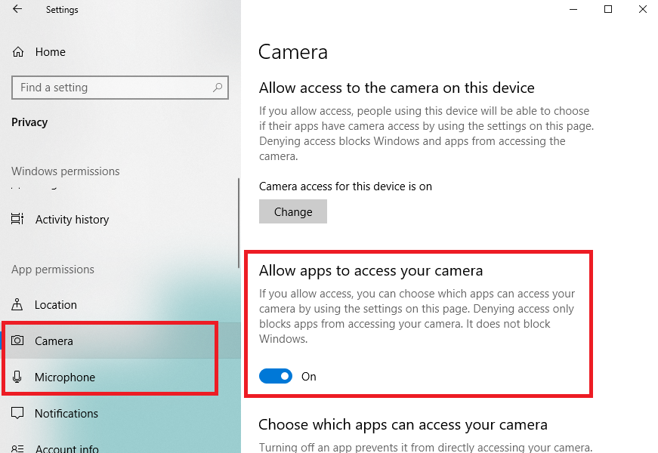

- Make sure that, in the Chrome browser settings (on the webpages chrome://settings/content/camera and chrome://settings/content/microphone), the https://hse.student.examus.net website is not listed among ‘Blocked’ sites (if it is on this list, delete it from there);

The website may be allowed to access the webcam by using the icon on the right section of the browser’s URL tab:
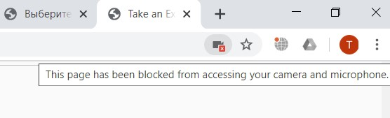

Click on the icon with the webcam, and allow access for the website in the new window. Then, close the tab with the test (or the entire browser), re-open it and again log in to the test by following the link provided by organizers.

- Check if there are any other running applications that may use video streaming (e.g., Skype, Webcammax etc.) To close these applications properly, go to Task Manager
(press Ctrl+Shift+Esc, select the application and choose ’End the Process (Снять задачу’);
- If you are completing the test with the use of the corporate laptop and/or internet connection, refer to the system administrator if data transmission from the webcam and/or mic is not disabled;
- Try to check if the antivirus/brandmauer is off; this can possibly block data transmission from the webcam and microphone.

If the specified actions do not help, you can be checked at https://test.webrtc.org/. Please send a full screenshot with the results to help@examus.net. In addition, please specify in the e-mail which point of the Examus check is highlighted in red.

10.3 Problems during the Exam
Instead of the page with the test, the Personal Account page is opened
- Make sure that all mandatory fields in the Personal Account have been filled in (including file attachments);

- Shut down the browser and try logging in again.

The buttons or test interface do not work, the page freezes, or images failed to upload

If the page with the test has frozen or the interface buttons (e.g., Save, Check etc.) do not respond when clicked, refresh the page (F5 for Windows, key combination cmd+r for MacOS), or restart the browser (input in the new tab chrome://restart and press Enter). Before doing so, we suggest that you memorize or write down your answers as they might be erased (unless you have previously saved them).

Testing has been disrupted (due to a failed internet connection, the device was switched off, or other reasons)
You can re-enter the test within the five minutes after your session went down. If more than five minutes have passed, you cannot re-enter (this is an anti-cheating measure). Request a repeat try from the test’s organizer at exam@hse.ru and give a detailed explanation of the technical disruption.

