Step-by-step instructions for the applicant

Rules for the entrance exam in the direction of training "Applied Mathematics and Computer Science".

If something went wrong during the exam: please urgently write an email to helpexam@hse.ru. Record all problems you encounter with screenshots!

General Provisions

The rules determine the procedure of the entrance exam in the direction of training "Applied Mathematics and Computer Science" (hereinafter - the Examination) applicants for master's degree educational program "Master of Science in Data Science" in the academic year 2023.

It is the applicant's responsibility to familiarize himself or herself with these rules prior to the examination and to abide by them until the end of the examination.

The total duration of the exam is 90 minutes.

- Open the link https://et.hse.ru/
- To log in use your account details. Your login=email=password (Which you have registered in personal cabinet)
As the information below is related exactly to the exam, you can check your equipment in advance via that link https://hse.proctoring.online/#!/check (it will check you computer and cameras). For you not to have any problems during the exam, it is vital to use GOOGLE CHROME as browser (in incognito mode if you wish)

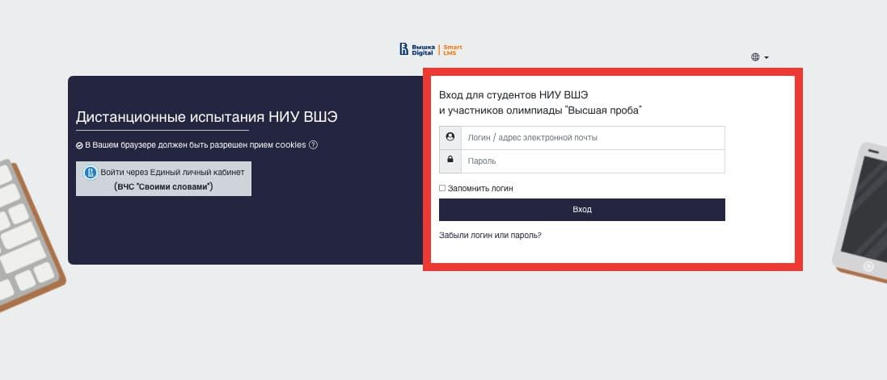
- In the window that opens, in the "My Courses" section, click on the required course.
If in this section you did not find the exam you need, please write to the technical support helpexam@hse.ru
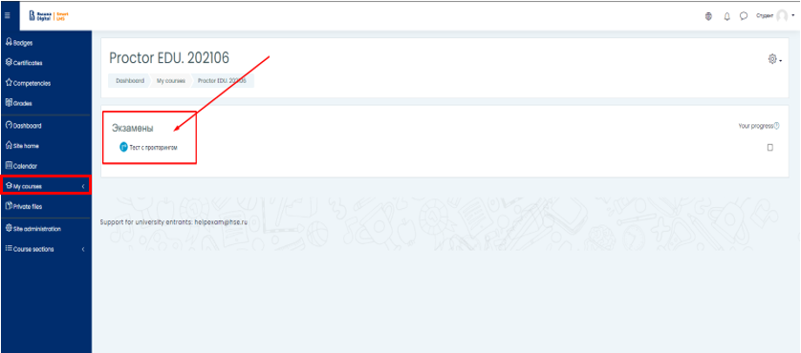
- To start the examination, read the rules and agree to the examination conditions

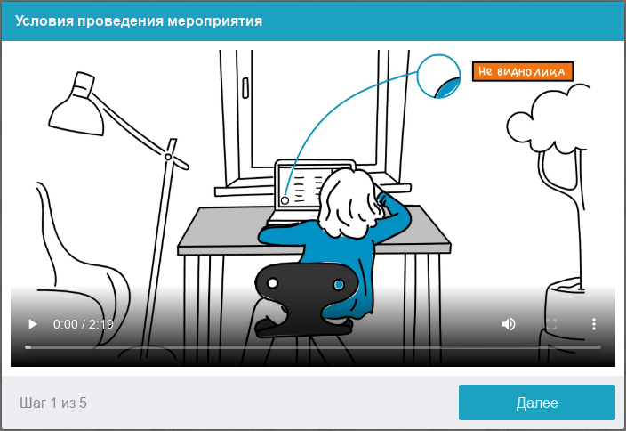
- The system automatically sets an assessment of the level of confidence in the exam results, which depends on the factors described below.
Compliance with the following guidelines throughout your session will help you get the most credibility score in your exam results:
- you consent to audio and video recording and subsequent storage of the entire exam;
- the webcam must be installed strictly in front of the face, it is not allowed to install the camera from the side;
- the head must completely fit into the frame, partial or complete vanishing from the camera's coverage area is not allowed;
- the face must be in the center of the webcam's coverage area and occupy at least 10% of the space captured by the camera throughout the session;
- the face should be evenly lit, the light source should not be directed towards the camera or illuminate only one half of the face;
- hair, clothing, hands or anything else should not cover the face area;
- you are not allowed to wear sunglasses, you can only use glasses with clear lenses;
- there should be no other people in the room;
- it is forbidden to leave your workplace during the exam;
- there should be no voices or noise in the background, the exam has to be taken in complete silence;
- passing the exam must be carried out in a browser, the window of which must be maximized to full screen. You are strictly prohibited to switch to other applications (including other browsers) or minimize the browser, you cannot open third-party tabs (pages) or close the browser;
- all programs that use the webcam, except for the browser, must be disabled on the computer;
- you need to ensure the stable Internet connection;
- it is forbidden to record in any way the materials and contents of the exam, as well as transfer them to third parties;
- it is prohibited to use sound, visual or any prompts;
- in case the system or the proctor detect an attempt to deceive, the results of the exam are canceled.
- Before the start of each session, a computer and network check is launched to identify possible technical problems before the beginning of an actual exam. The check is carried out automatically, user intervention is required only in case of problems.
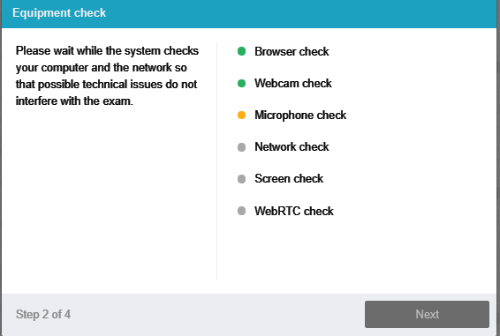
There are the following stages of verification:
- At the stage of checking browser compatibility, it is checked that your browser meets the minimum requirements of the proctoring system. Make sure the browser window is maximized to full screen;
- At the stage of checking the webcam, you need to give access to the camera in the browser if such a request appears. If the camera is working correctly, then the check will be successful;
- At the stage of checking the microphone, you need to give access to the microphone in the browser if such a request appears. If the microphone volume is set high enough, the test will be successful;
- At the screen verification stage, the correctness of the screen capture is checked, where you need to give access to the entire screen. If access is not given to the entire screen or an additional monitor is connected, then the check will be completed with an error;
- At the stage of checking the connection, the possibility of transmitting video traffic in your network using WebRTC technology is checked. The check will be successful if the traffic is not blocked.
- Face photo
The proctoring system will require a photograph of your face to be taken through your webcam. A photograph of your face is part of te procedure for verifying your identity.
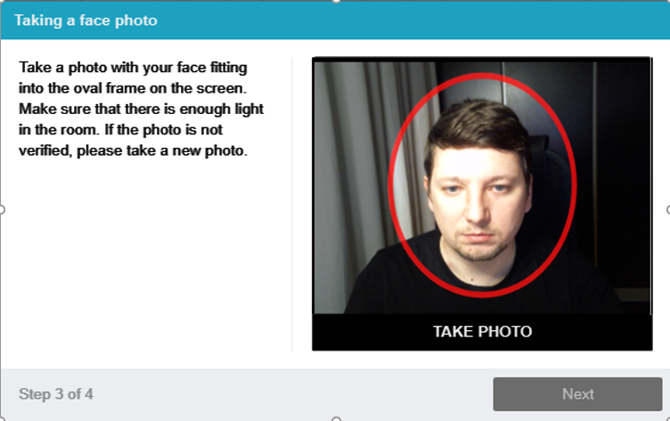
- Photo of the document
The proctoring system will need a photo of your identity document (ID card/passport), which needs to be taken via a webcam. The passport is automatically checked by the proctoring system for correctness and readability, and the photo in the passport is checked against your face. Photo of the document is part of the procedure for verifying your identity
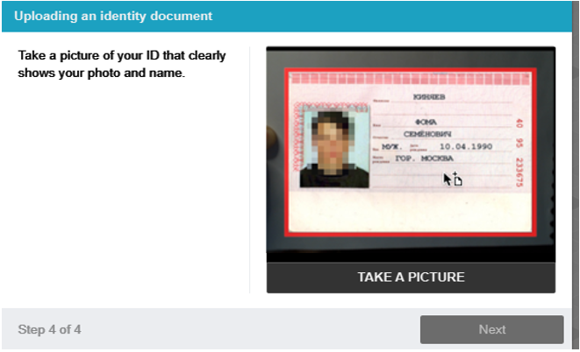

- Connecting a mobile camera
For a more complete overview of the workplace it is necessary to connect an additional camera. To do this, you need to scan the QR-code displayed on the screen of the computer from your phone, and then open in the browser (recommended browsers for the phone: Safari, Google Chrome) on your phone the link obtained by the code. If the camera is successfully connected, you should see "Camera successfully connected" on the phone screen.
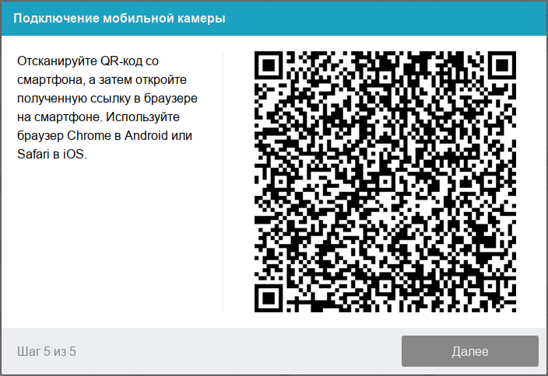

After connecting the mobile camera, you should use it to show the space around you and your workspace. To do this, move the camera slowly as if you were taking a panoramic picture. Try to get your entire workspace on video in the end.

- Passing the exam
After successfully completing the previous steps, the exam page will open. The exam (test) page opens in the central part of the window and a small circle in the lower left corner, where a picture from your camera is displayed.
During the exam, make sure that your face fits completely in the circle and is well lit. Notifications may appear next to the circle if some exam rules are not followed. To start the exam, you must click the "Start Testing" button.

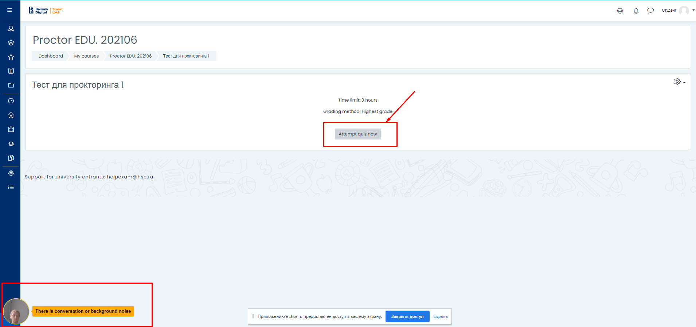
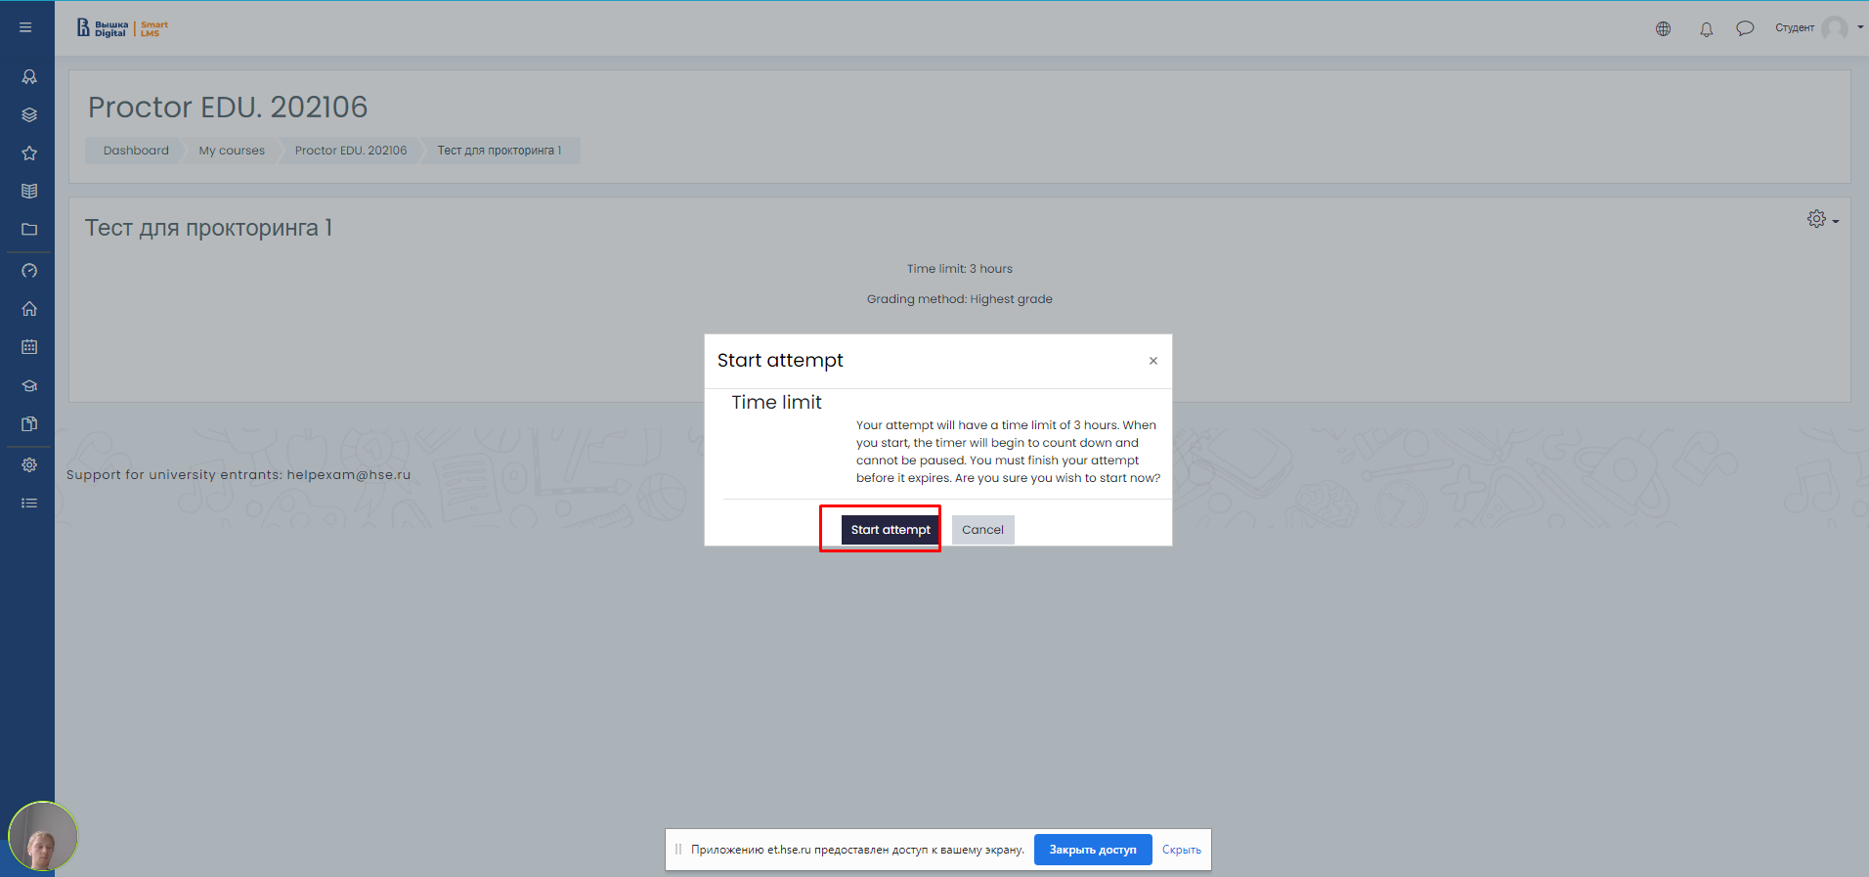
- After starting the exam, follow the steps outlined in the exam. The time until the end of the exam is shown in the right window
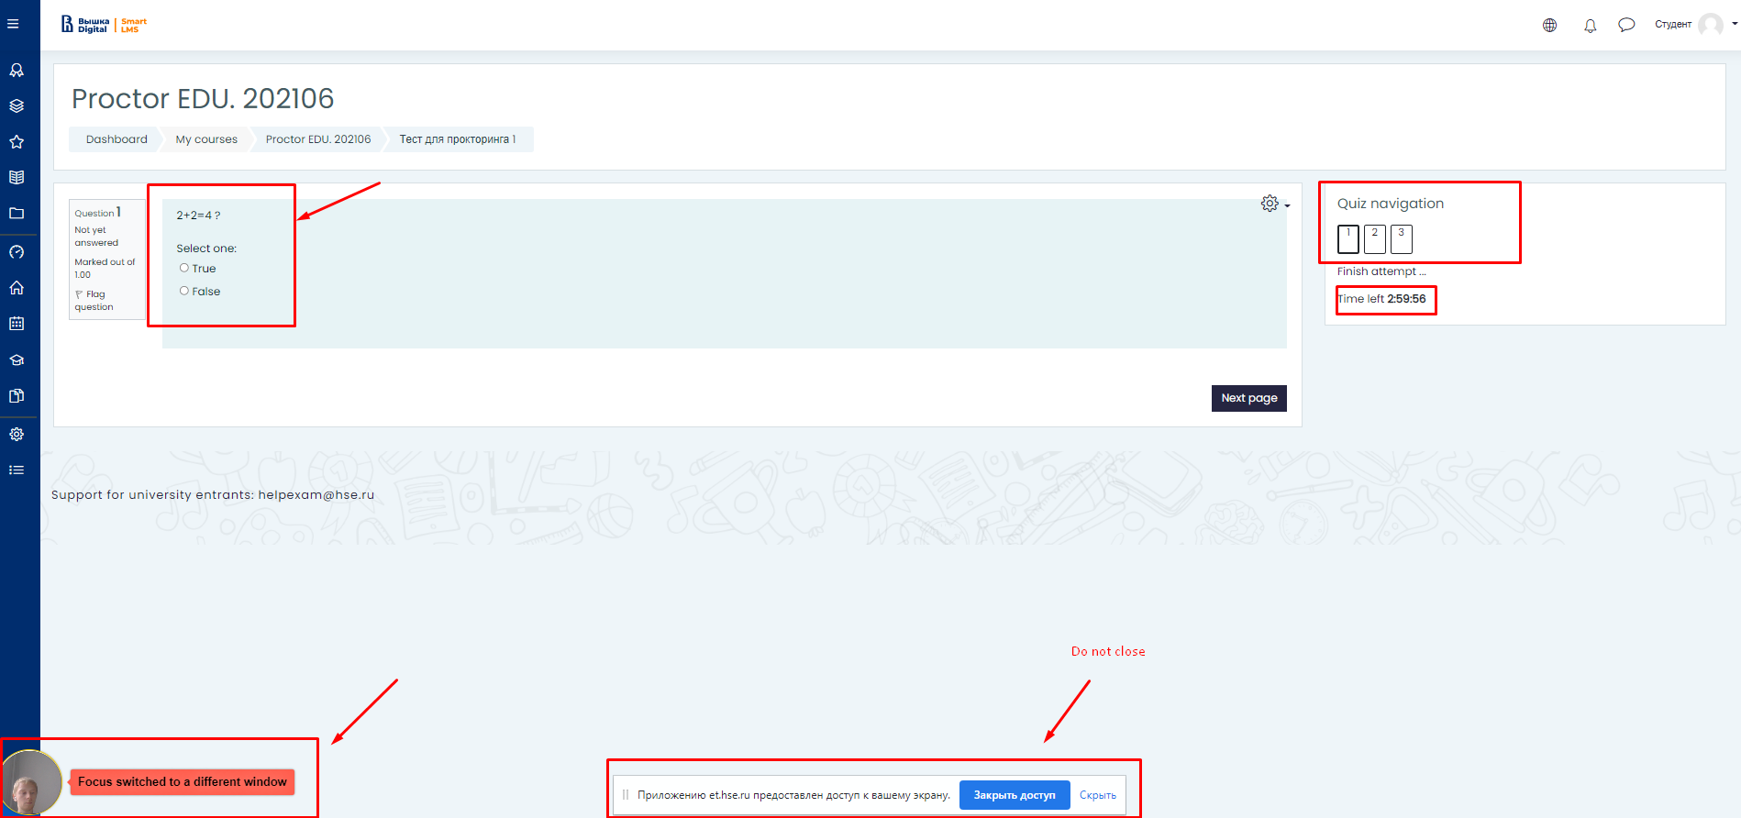

- End of the exam
Having accomplished all the assignments provided, finish the exam. To do this, click the "End attempt" button.
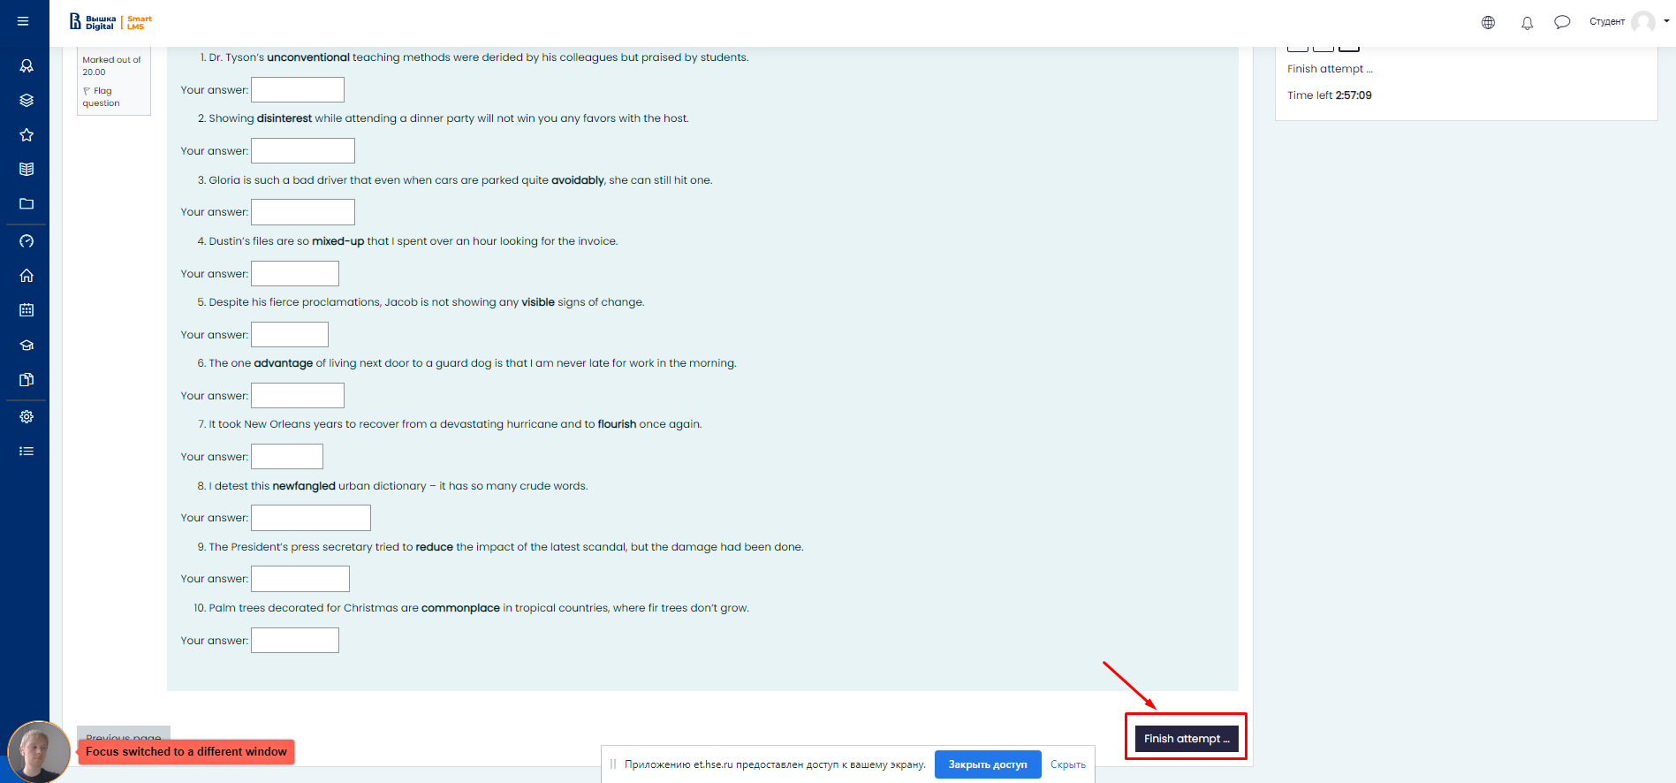

- After pressing this button, the system will ask you if you really want to complete the attempt, after confirmation you will not be able to start it again.

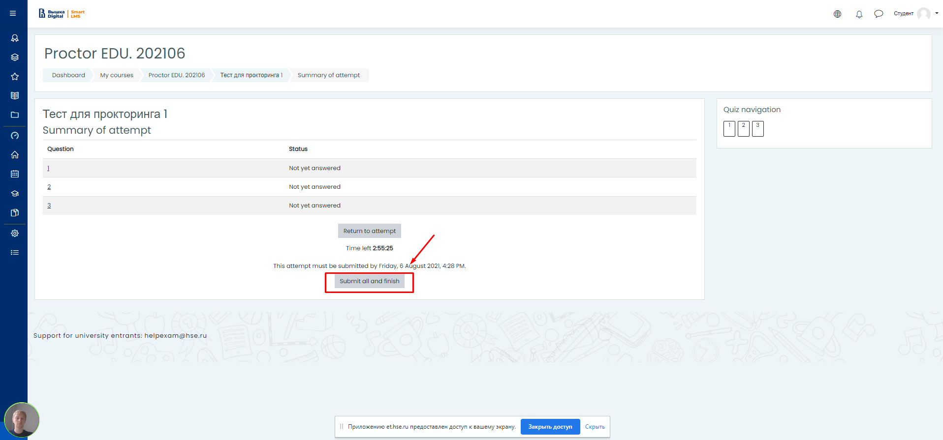

11. The examination shall be completed automatically after the expiry of the time allotted for the examination.
All audio, video, and text messages, as well as recorded bugs, are stored in the system and linked to the scrolling protocol. After the examination, the results are checked and a final opinion is given by the organizers.

